Multi-Agent AI
Deep Researcher

Technical Design, State Diagrams & Code Documentation
LangGraph | LangChain | Pydantic | ArXiv | Tavily | Streamlit

Version 1.0 | April 2026

Table of Contents

1. Project Overview
The Multi-Agent AI Deep Researcher is a production-grade system that automates multi-hop, multi-source research investigations. Given a complex research question, it decomposes the query, retrieves from academic papers, web articles, and encyclopedias, critically analyzes findings, cross-validates claims, generates original insights, and compiles a structured report with citations.

1.1 Architecture Overview
The system consists of 7 specialized agents orchestrated by a LangGraph StateGraph with conditional routing for gap-filling loops.
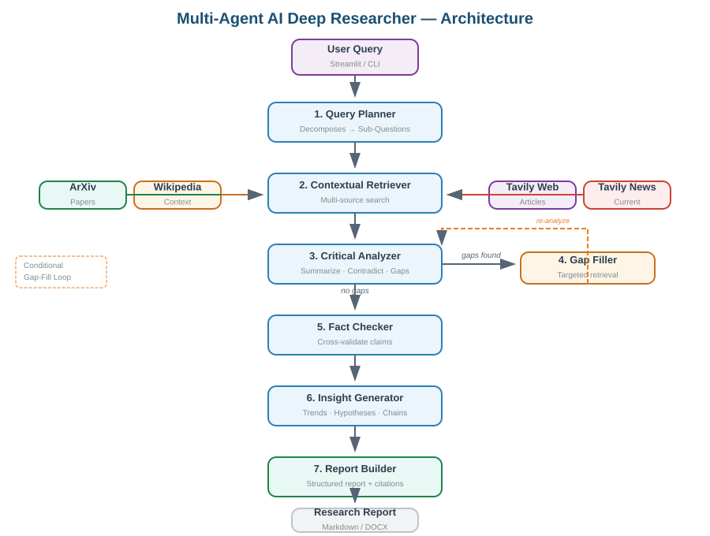
Figure 1: Architecture Overview — 7 agents with conditional gap-filling loop

1.2 Agent Responsibilities
Agent | Responsibility | Key Output
Query Planner | Decomposes complex query into 3-7 MECE sub-questions with priority ranking | QueryPlan, SubQuestion[]
Contextual Retriever | Searches ArXiv, Wikipedia, Tavily Web + News; deduplicates by URL/title | Source[]
Critical Analyzer | Summarizes sources, finds contradictions, identifies gaps, extracts consensus | AnalysisResult
Fact Checker | Cross-validates key claims across all sources with confidence scoring | FactCheckResult
Insight Generator | Identifies trends, generates hypotheses with reasoning chains | InsightResult
Gap Filler | Targeted retrieval for critical information gaps (conditional loop) | Additional Source[]
Report Builder | Compiles structured report with inline citations and confidence assessment | ResearchReport

1.3 Technology Stack
Layer | Technology | Purpose
Orchestration | LangGraph StateGraph | Directed graph with conditional edges and loop
LLM | OpenAI GPT-4o via LangChain | Structured output for all agents
Structured Output | Pydantic v2 | 15 models for type-safe data flow
Research Sources | ArXiv API, Wikipedia, Tavily | Academic papers, encyclopedia, web/news
UI | Streamlit | Dashboard with tabbed results
CLI | Rich | Pretty-printed terminal output
Testing | Pytest + unittest.mock | Mocked LLM and API tests

2. LangGraph Pipeline Flow
The pipeline is defined as a LangGraph StateGraph where each agent is a node and edges define the execution flow. A key feature is the conditional gap-filling loop that enables iterative refinement.

2.1 State Flow Diagram
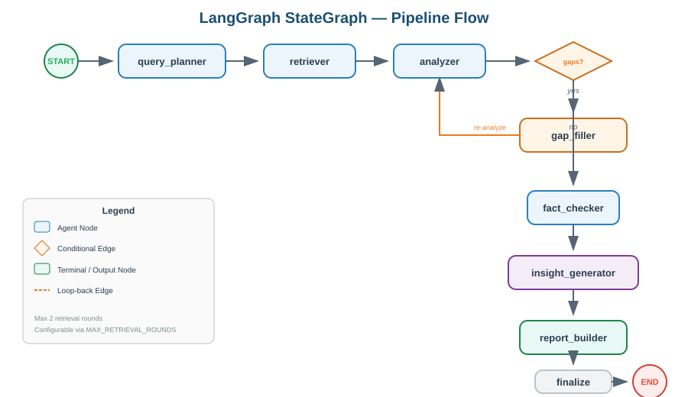
Figure 2: LangGraph StateGraph — nodes, edges, and conditional routing

2.2 Execution Sequence
The pipeline follows this deterministic sequence with one conditional branch:

- START — Pipeline begins with the user query and depth setting
- query_planner — Decomposes query into prioritized sub-questions with search keywords
- retriever — For each sub-question, searches ArXiv + Wikipedia + Tavily Web + News
- analyzer — Summarizes each source, finds contradictions, identifies gaps, extracts consensus
- Conditional Branch — If critical gaps exist AND retrieval_round < MAX_RETRIEVAL_ROUNDS:
- YES: Routes to gap_filler for targeted retrieval, then loops back to analyzer
- NO: Proceeds to fact_checker
- fact_checker — Cross-validates key claims, assigns VERIFIED/CONTRADICTED status + confidence scores
- insight_generator — Generates trends, hypotheses with reasoning chains, future research directions
- report_builder — Compiles everything into a structured report with inline citations
- finalize — Sets pipeline status, aggregates metrics
- END — Final state available for UI display or export

2.3 Conditional Routing Detail
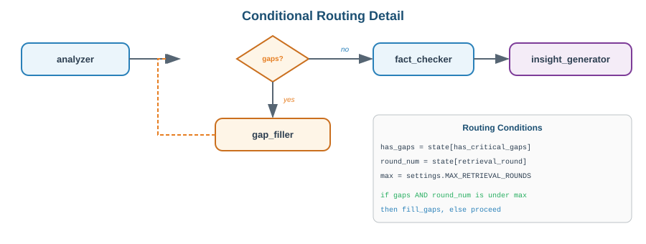
Figure 3: route_after_analysis() — conditional gap-filling loop

The routing function checks three conditions:
- has_critical_gaps — Set by the analyzer when it finds significant missing information
- ENABLE_GAP_FILLING — Configuration setting (can be disabled for faster runs)
- retrieval_round < MAX_RETRIEVAL_ROUNDS — Prevents infinite loops (default max: 2)

2.4 Graph Construction Code
The graph is built in agents/orchestrator.py:

graph = StateGraph(ResearchState)

graph.add_node('query_planner', plan_query)
graph.add_node('retriever', retrieve_sources)
graph.add_node('analyzer', analyze_sources)
graph.add_node('gap_filler', fill_gaps)
graph.add_node('fact_checker', check_facts)
graph.add_node('insight_generator', generate_insights)
graph.add_node('report_builder', build_report)
graph.add_node('finalize', finalize)

graph.add_edge(START, 'query_planner')
graph.add_edge('query_planner', 'retriever')
graph.add_edge('retriever', 'analyzer')

# Conditional gap-filling loop
graph.add_conditional_edges('analyzer',
route_after_analysis,
{'fill_gaps': 'gap_filler', 'proceed': 'fact_checker'})
graph.add_edge('gap_filler', 'analyzer') # Loop back

graph.add_edge('fact_checker', 'insight_generator')
graph.add_edge('insight_generator', 'report_builder')
graph.add_edge('report_builder', 'finalize')
graph.add_edge('finalize', END)

3. State Schema & Pydantic Models
The state schema in state/__init__.py is the backbone of the system. It defines the shared state that flows through all agents and the 15 Pydantic models that ensure type-safe LLM responses.

3.1 ResearchState — Agent Read/Write Map
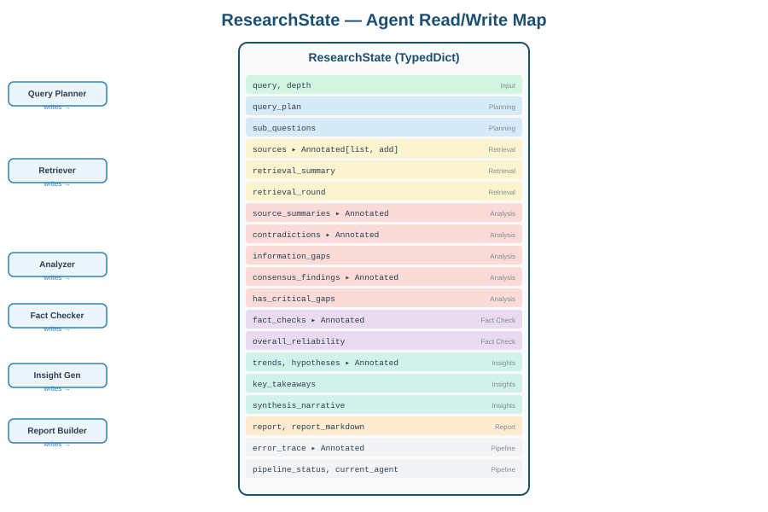
Figure 4: ResearchState TypedDict — which agents write which fields

3.2 Key Design Decisions
- TypedDict for LangGraph: LangGraph requires TypedDict (not Pydantic BaseModel) for its StateGraph because it needs to merge partial state updates from each agent node.
- Annotated[list, operator.add]: List fields marked with operator.add get APPENDED to (not overwritten) when an agent returns a partial state update. This is critical for sources, fact_checks, and error_trace which accumulate across agents and retrieval rounds.
- Pydantic for LLM output: Used with with_structured_output() to get validated, type-safe responses. If the LLM returns invalid data, Pydantic raises a ValidationError instead of passing bad data downstream.
- Enums (SourceType, ConfidenceLevel, ClaimStatus): Controlled vocabularies that ensure consistent values across all 7 agents.

3.3 Data Transformation Flow
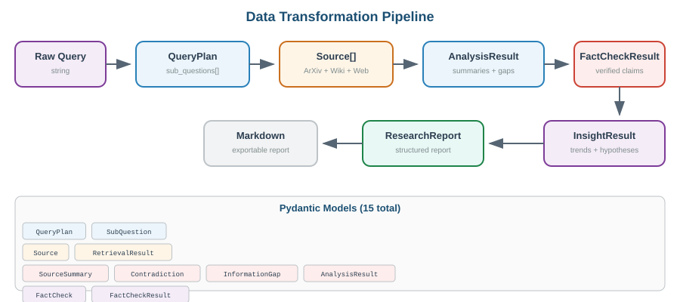
Figure 5: Data flows from raw query through 15 Pydantic models to final report

3.4 All 15 Pydantic Models
Model | Used By | Key Fields
SubQuestion | Query Planner | id, question, search_keywords, priority (1-5)
QueryPlan | Query Planner | original_query, research_scope, sub_questions[]
Source | Retriever | id, title, source_type, url, content, relevance_score
RetrievalResult | Retriever | sources[], total_retrieved, sources_by_type
SourceSummary | Analyzer | source_id, key_findings[], credibility, limitations[]
Contradiction | Analyzer | claim, source_a_id, source_b_id, resolution
InformationGap | Analyzer | description, importance, suggested_queries[]
AnalysisResult | Analyzer | summaries[], contradictions[], gaps[], consensus[]
FactCheck | Fact Checker | claim, status (enum), confidence (0-1), sources
FactCheckResult | Fact Checker | checks[], overall_reliability, summary
Trend | Insight Gen | title, description, evidence[], confidence, timeframe
Hypothesis | Insight Gen | statement, reasoning_chain[], testability, novelty
InsightResult | Insight Gen | trends[], hypotheses[], future_directions[]
ReportSection | Report Builder | heading, content, citations[]
ResearchReport | Report Builder | title, executive_summary, sections[], references[]

4. Agent Implementation Details

4.1 Query Planner (agents/query_planner.py)
The first agent in the pipeline. Takes a complex research question and produces a structured plan.

4.1.1 Structured Output Pattern
Every agent follows the same core pattern for reliable LLM integration:

llm = ChatOpenAI(model='gpt-4o', temperature=0.3)
structured_llm = llm.with_structured_output(QueryPlan)
prompt = ChatPromptTemplate.from_messages([...])
chain = prompt | structured_llm
result: QueryPlan = chain.invoke({...})

The with_structured_output() method instructs the LLM to return JSON matching the Pydantic schema, then automatically validates and parses the response.

4.1.2 MECE Decomposition
The system prompt instructs the LLM to create Mutually Exclusive, Collectively Exhaustive sub-questions. Three depth levels control the decomposition: quick (3-4 sub-questions), standard (4-6), deep (5-7). Sub-questions are sorted by priority and each includes search keywords optimized for the retrieval tools.

4.1.3 Fallback Strategy
If the LLM fails to parse the query, the agent falls back to using the original query as a single sub-question. This ensures the pipeline continues with degraded but functional output.

4.2 Contextual Retriever (agents/retriever.py)
The most complex agent. For each sub-question, it searches across four source types and deduplicates results.

4.2.1 Multi-Source Search Strategy
Source | Tool | When Used | Relevance Default
ArXiv | search_arxiv | Every sub-question | 0.8 (academic)
Wikipedia | search_wikipedia | Every sub-question (max 2) | 0.6 (context)
Tavily Web | search_web | Every sub-question | From API score
Tavily News | search_news | Only priority 1-2 sub-questions | From API score

4.2.2 Deduplication
Sources are deduplicated by URL (exact match) and title (case-insensitive). This prevents the same paper or article from appearing multiple times when different sub-questions find it.

4.2.3 Source ID System
Each source gets a unique ID like arxiv-001, web-003, or gap-002 (for gap-filling results). These IDs flow through analysis, fact-checking, and into the final report as inline citations.

4.2.4 Resilience
If any individual tool fails (ArXiv down, Wikipedia disambiguation error, Tavily rate limit), the agent logs the error and continues with the remaining tools. The pipeline never crashes due to a single source being unavailable.

4.3 Critical Analyzer (agents/analyzer.py)
Takes all retrieved sources and performs deep analysis:
- Source Summaries: Key findings, credibility assessment (HIGH/MEDIUM/LOW), and limitations for each source
- Contradictions: Where sources disagree, with specific claims and positions from each side, plus a resolution assessment
- Information Gaps: What the sources DON'T cover, with suggested queries to fill each gap
- Consensus Findings: Claims supported by multiple independent sources (highest confidence)

The analyzer sets has_critical_gaps = True when it finds 3+ gaps or any gap marked as critical/essential. This triggers the conditional gap-filling loop in the orchestrator.

4.4 Fact Checker (agents/fact_checker.py)
Extracts the 5-10 most important factual claims and verifies each against all sources:

Status | Criteria | Confidence Range
VERIFIED | 2+ independent sources confirm | 0.9-1.0
PARTIALLY_VERIFIED | 1 credible source, no contradictions | 0.7-0.9
UNVERIFIED | No source directly confirms | 0.3-0.5
CONTRADICTED | At least one source contradicts | Below 0.3

The overall_reliability score is the weighted average of all claim confidences. This score appears in the final report and the Streamlit dashboard.

4.5 Insight Generator (agents/insight_generator.py)
Goes BEYOND summarizing to generate original insights:

4.5.1 Trend Identification
Finds patterns across sources: what is gaining traction, what is declining, temporal scope. Each trend gets a confidence level (HIGH/MEDIUM/LOW/CONFLICTING).

4.5.2 Hypothesis Generation
The most intellectually demanding agent. For each hypothesis:
- Reasoning Chain: Explicit step-by-step logic: 'Because A [source-id], and B [source-id], therefore C'
- Counter-Evidence: Evidence that could weaken the hypothesis
- Testability: How the hypothesis could be validated
- Novelty: What makes it original (not just restating sources)

Temperature is set to 0.4 (slightly creative) for this agent, versus 0.0-0.2 for the more factual agents.

4.6 Gap Filler (agents/gap_filler.py)
A lightweight agent that only triggers when the analyzer detects critical gaps. It uses the suggested_queries from InformationGap objects to do targeted web searches for the top 5 gaps (2 queries per gap). New sources get IDs prefixed with 'gap-' for traceability.

4.7 Report Builder (agents/report_builder.py)
Compiles all accumulated evidence into a publication-quality report:
- Executive Summary: 3-5 sentences covering key findings
- Methodology: Description of the multi-agent approach
- 3-6 Finding Sections: Each with inline citations using [source-id] format
- Conclusions: Synthesized answer to the research question
- Confidence Assessment: Based on fact-check results
- Limitations: What the research could NOT answer
- References: All source IDs with titles and URLs

The report is rendered as both a Pydantic ResearchReport object and a Markdown string for export.

5. Research Tool Definitions

5.1 ArXiv Tool (tools/arxiv_tool.py)
Uses the arxiv Python package to search for academic papers. Returns title, summary (truncated to 2000 chars), authors, URL, publication date, and categories. Results are sorted by relevance.

5.2 Wikipedia Tool (tools/wikipedia_tool.py)
Uses the wikipedia package. Handles DisambiguationError and PageError gracefully by skipping problematic pages. Returns both summary and full content (truncated to 4000 chars).

5.3 Tavily Tools (tools/tavily_tool.py)
Two tools using the Tavily AI search API:
- search_web: General web search with 'advanced' depth. Returns title, content, URL, relevance score.
- search_news: News-specific search using Tavily's topic='news' filter. Only used for high-priority sub-questions.

All tools use LangChain's @tool decorator for seamless agent invocation and include proper error handling with fallback to empty results.

6. User Interface

6.1 Streamlit Dashboard (ui/app.py)
The Streamlit UI provides:
- Input: Text area for research queries + depth selector (quick/standard/deep)
- Sample Queries: 5 pre-built research questions for quick testing
- Metrics Row: Sources count, Fact Checks, Reliability %, Trends, Hypotheses
- 6 Result Tabs: Report, Sources, Analysis, Fact Checks, Insights, Raw State
- Export: Download report as Markdown file

6.2 CLI (main.py)
Rich-formatted terminal output with tables, panels, and color-coded results. Key flags:

python main.py --query 'Your research question' --depth standard
python main.py --query '...' --depth deep --export-report report.md
python main.py --query '...' --output results.json

7. Testing Strategy
4 test files with comprehensive coverage using unittest.mock to replace all external dependencies.

Test File | Scope | Key Tests
test_planner.py | Query Planner + QueryPlan model | Successful planning, empty/whitespace queries, priority bounds validation
test_retriever.py | Retriever + dedup logic | Source ID generation, URL/title dedup, multi-tool retrieval, graceful tool failure
test_analyzer.py | Analyzer + Fact Checker + models | Source formatting, analysis with mock LLM, fact-check flow, confidence bounds
test_orchestrator.py | Routing + graph structure | Gap-fill routing conditions, max-round cutoff, disabled gap-fill, graph node verification

7.1 Running Tests

# Windows PowerShell
$env:PYTHONPATH = '.'
pytest tests\ -v

# Specific file
pytest tests\test_retriever.py -v

8. Setup & Configuration

8.1 Windows Setup

# 1. Unzip and navigate
Expand-Archive -Path deep-researcher.zip -DestinationPath .
cd deep-researcher

# 2. Create virtual environment
python -m venv venv
.\venv\Scripts\Activate.ps1

# 3. Install dependencies
pip install -r requirements.txt

# 4. Configure
copy .env.example .env
# Edit .env with OPENAI_API_KEY (required) + TAVILY_API_KEY (recommended)

# 5. Set PYTHONPATH
$env:PYTHONPATH = '.'

# 6. Run
python main.py --query 'Your question' --depth standard
streamlit run ui\app.py

8.2 Environment Variables
Variable | Required | Purpose
OPENAI_API_KEY | Yes | LLM for all 7 agents
TAVILY_API_KEY | Recommended | Web + news search (free tier available)
LLM_MODEL | No (gpt-4o) | Model for all agent LLM calls
MAX_RETRIEVAL_ROUNDS | No (2) | Max gap-filling iterations
ENABLE_GAP_FILLING | No (true) | Enable/disable gap-fill loop
LANGCHAIN_TRACING_V2 | No | Enable LangSmith observability

8.3 Extending the System
- New agents: Create agent function accepting ResearchState, add node in orchestrator.py, wire edges
- New sources: Add tool in tools/, call from retriever.py, assign new source_type
- Switch LLM: Replace ChatOpenAI with ChatAnthropic, update model name in .env
- Production: Add LangSmith tracing, Redis for state persistence, authentication for Streamlit

