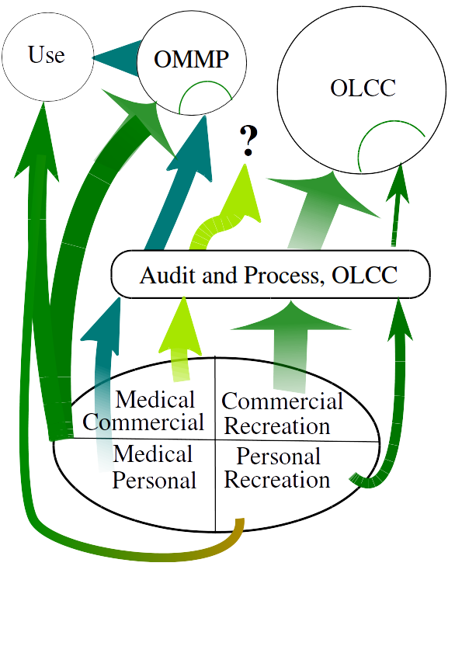
Oregon Marijuana Matrix, OMM
FREE and open source system.
https://github.com/greenpdx/cannaudit
Computer model available

Problem:
OLCC wants to audit everything, Recreational
HIPPA prevents auditing, Medical

OMM is a system to audit both Recreational and Medical.

Oregon Cannabis Credit, OCC
is a unit of marijuana.

Anonymous Chain Cryptography, ACC
is Chain-of-Custody protocol.

Version 1 available by July 1!

OMM is a system designed to create a Chain-of- Custody using cryptography.
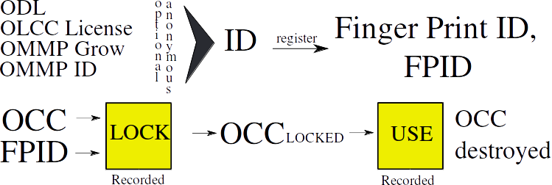

First register to receive Finger Print ID.
Request OCCs, *lock now or later
Submit OCC to next stage to “sign”.
At every event, the OCC is signed.
OCC “USE” at retail or personal

Oregon Marijuana Matrix is a model of marijuana in Oregon. It was created to solve some of the issues Measure 91 created. It separates Medical from Recreational and differentiates between personal and commercial. It uses Crypto-Accounting to audit marijuana. Anonymous Chain Cryptography, ACC is the protocol being submitted to IETF. The basic Oregon Cannabis Credit, OCC is a x509 token that represents a unit of marijuana. This OCC is worthless before being locked to ID. Once the OCC is locked, that ID is responsible for that marijuana. OCCs are combined into a wallet, called Stash. Now bulk OCCs can be processed. Version 1 only defines simple growing and ends at the retails store or processor. Version 2 will support Chain-of-Custody, CoC tracking the OCC from LOCK to USE using a signature list. The biggest issue with tracking marijuana is Oregon is Federal Law preventing the use of federal financial institutions. A state charter public bank would solve the marijuana issue and open possibilities to help Oregonians.

