Oregon needs a Public Bank
Legal marijuana has to have legal stable finance system*
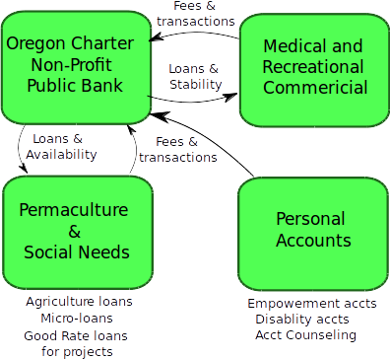
Article XI Section 1. Remove.

Reduce Cash, Increase Safety!

Every transaction makes money
for Oregon.

Buffer for poor financial times.

Legislative initiated constitutional change to remove the prohibition on state bank,
Article XI, Section 1.!
People vote on it this November.

Empower the People.
Disability accounts, Managed accounts for disabled
Micro-Loans $10 - $500 small loans
Offer financial counseling Free
Empowerment accounts

A Oregon State Chartered Non-Profit Public Bank is needed. The structure and abilities of credit unions are different than banks. Credit Union do not fulfill the requirements.

* Colorado and Washington are having issues.
Oregon Marijuana Matrix: A system to manage marijuana in Oregon.
Computer model of the flow of marijuana in Oregon.
https://github.com/greenpdx/cannaudit

