SLPP 2028 Doctrine Series, No. 9
Every Card a Vote
A Member Franchise for the SLPP: an open strategic paper to the National Executive Council and party authorities
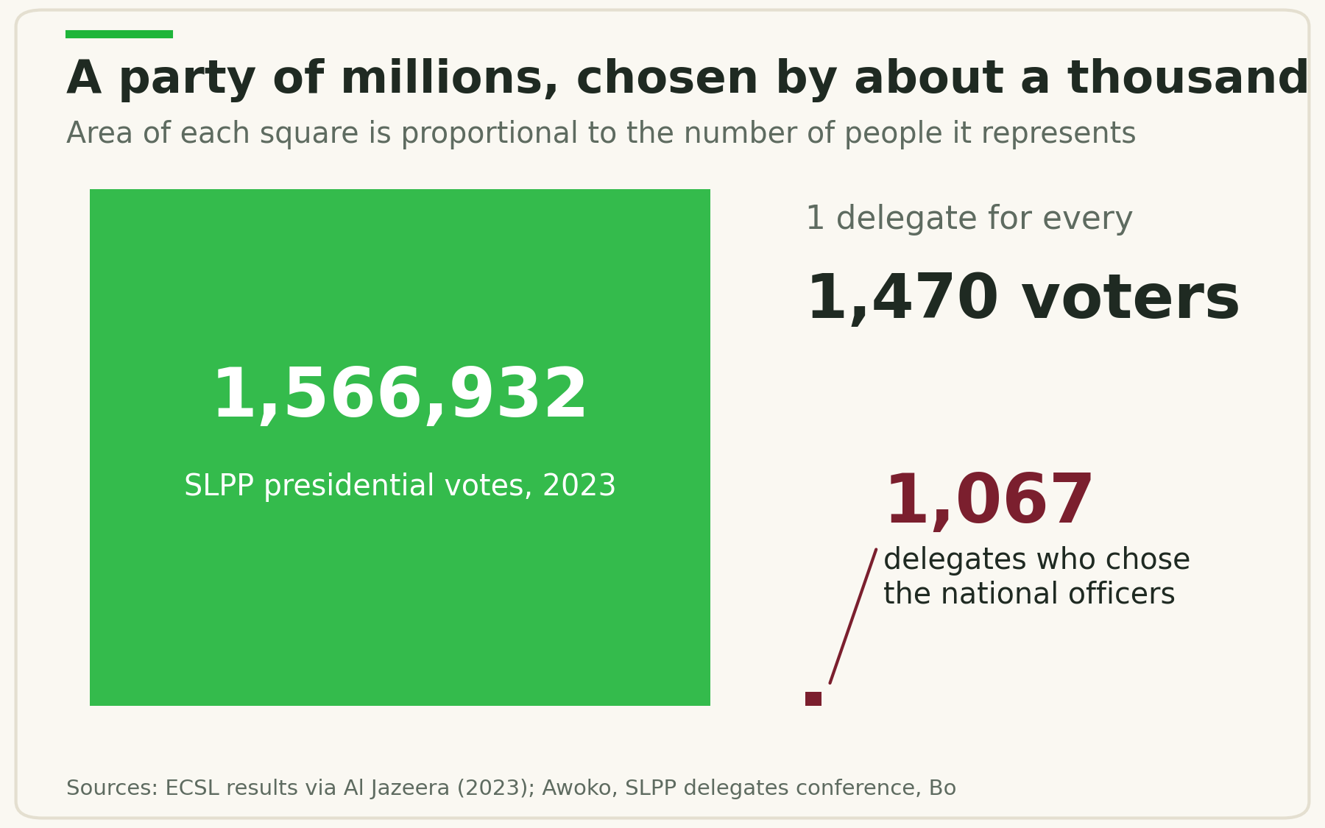
In 2023, 1,566,932 Sierra Leoneans voted for the SLPP ticket. About a thousand delegates choose the party's national leadership.
By Fomba Kassoh
Secretary General, SLPP North America, New York Chapter
The Green Professionals | October 13, 2026

To the Party Authorities
To the National Chairman, the National Secretary General, the National Executive Council, and the Regional and District Executives of the Sierra Leone People's Party:
I write, in fraternity and in the open, to propose one reform: give every registered, dues-paying member of the SLPP a vote in the selection of regional executives, national executives, and the flag bearer. The hierarchy can keep real influence through nomination and, during a transition, through limited weighting. The principle that matters is that the ordinary card-holder is counted, and counts.
This is not a complaint about how the party has chosen its leaders. It is an argument that the same reform which deepens internal democracy also solves two practical problems we already have: a membership register that is thinner than our electoral base, and a funding base that leans on too few shoulders. A member who votes is a member who renews, pays, and turns out.
I offer it as a contribution to debate ahead of the 2028 cycle, and I welcome correction from those with fuller knowledge of the party's records.

Executive Summary
The SLPP should adopt a Member Franchise: every verified, dues-paying member in good standing votes for regional executives, national executives, and the flag bearer. The hierarchy keeps its authority where it matters most, in qualifying and nominating candidates, while members own the final ballot.
The reform delivers three payoffs at once:
- A larger, cleaner register. When a membership card carries a real vote, people seek the card, renew it, and defend its integrity.
- A broader funding base. Affordable annual dues tied to voting rights convert supporters into regular small contributors. When Britain's Labour Party moved to one member, one vote, membership fee income rose from about £9.5 million in 2015 to £14.4 million in 2016.
- Stronger legitimacy and cohesion. A flag bearer chosen with the visible consent of the rank and file is harder to contest, and losing camps accept a result they helped produce.

Weighting by hierarchy remains available as a transition, but within strict limits. The modelling in this paper shows that once delegates hold 25 percent or more of a contest, they can overturn a clear ten-point win among members. A member who learns that will ask what the dues bought. The governing principle is therefore simple: give the hierarchy influence over qualification and nomination; give the membership the decisive final vote.
The regional legal tide is moving the same way. On July 29, 2026, Ghana's Supreme Court ruled delegate-only selection of presidential and parliamentary candidates unconstitutional and gave parties one year to adopt member voting. The SLPP can lead this change rather than be compelled into it.

The Problem: A Party of Millions Chosen by About a Thousand
In June 2023 the SLPP presidential ticket received 1,566,932 votes, or 56.17 percent of the valid vote. The national delegates conference that preceded that campaign, held in Bo, published a list of 1,067 delegates voting for 15 national positions. That is roughly one delegate for every 1,470 SLPP voters.
One delegate for every 1,470 SLPP voters.
The delegate system is not illegitimate. Delegates are elected through lower-level elections, and they carry real responsibility. But a franchise this narrow creates three predictable weaknesses.
It makes membership optional. If a card confers no decision right, there is little reason to buy one, renew it, or check that your name is on the register. The party's true membership is therefore unknown, and the register becomes an administrative afterthought rather than a living asset.
It concentrates money where the votes are. When about a thousand people decide the flag bearer, campaign spending flows to those thousand. Aspirants finance delegates rather than the party. The party treasury sees little of it.
It invites disputes about the list. Past contests show how contested the delegate list itself becomes. Ahead of the 2017 convention, a senior party member publicly alleged that over 200 of about 605 delegates had not emerged through a transparent process. Whatever the merits of that claim, a small electorate makes every name on the list a battleground.
One honest caveat: the party does not publish a verified national membership figure. This paper therefore argues from the electoral base and delegate counts, and its first recommendation is a credible register.

The Legal Ground Is Shifting
Sierra Leone's 1991 Constitution, in section 35(2), requires the internal organisation of a political party to conform to democratic principles. It does not prescribe one member, one vote, so a carefully designed weighted system is not ruled out on its face. But the direction of law and regulation in the region favours members, not delegates.
The PPRC now actively supervises internal elections. Under the Political Parties Act 2022 (Act No. 25 of 2022), the PPRC gazettes parties' internal electoral regulations for 30 days of public objection, as it did for the Unity Party in July 2026. In May 2026 it ruled on petitions from the APC's ward elections and ordered reruns where venue changes broke the party's own rules. Any SLPP reform must therefore be written into approved, gazetted rules well before voting begins.
Ghana's Supreme Court has drawn a clear line. In Prof. Kwabena Frimpong-Boateng and Others v. NPP, NDC and Others, decided July 29, 2026, the Court ruled 5 to 2 that delegate systems for choosing presidential and parliamentary candidates are unconstitutional. It ordered parties to let every member in good standing vote directly, gave them one year to comply, and let past decisions stand. Ghana's government backed a constitutional amendment to guarantee members equal voting rights.
The Ghana judgment does not bind Sierra Leone's courts. Its constitutional language is close to ours, however, and it is a serious warning against any design that lets a small hierarchical body overrule members in choosing a candidate for public office.
What Sierra Leone's own democracy assessment says. The State of Democracy in Sierra Leone Assessment 2025, produced for the National Commission for Democracy with International IDEA, finds three things this paper must take seriously:
- Internal democracy is weak in both major parties, with a few powerful figures shaping direction. It credits the SLPP with historically greater internal democracy, because nationwide delegates are the voting blocs any flag bearer must win, but notes this has also fed factional splits, as in 2007 and 2017.
- Finance rules are widely flouted. The Political Parties Act 2022 lets the PPRC cap contributions and demand disclosure, but the PPRC had not yet published regulations on either.
- Donations from people not qualified to vote in Sierra Leone are forbidden under the Act. Diaspora dues must therefore be designed so that every payment comes from a member who is a citizen qualified to vote. This needs a specific legal opinion before any diaspora tier is launched.

What this paper has not reviewed. The authenticated current text of the SLPP Constitution, in force since August 2020, and the certified Political Parties Act 2022 were not available for this analysis. The party's legal advisers should conduct a section-by-section review of both before any amendment is drafted. This paper is strategic analysis, not a legal opinion.

The Proposal: Members Decide, the Hierarchy Qualifies
Each contest should move to a member franchise matched to the office's territory: regional members choose regional officers, and the national membership chooses national officers and the flag bearer.
Contest | Recommended destination | Transitional option if weighting is needed | Where the hierarchy's role sits
Regional executives | One verified member, one vote, among members registered in the region | 80% members, 20% elected officers of that region | Vetting of aspirants; officers campaign and endorse
National executives | One member, one vote nationwide | 80% members, 20% structured college of elected officers, for one cycle | Vetting; nomination thresholds
Flag bearer | One member, one vote, with a run-off if no one passes 50% | Not recommended; at most 80/20 if consensus requires it | Nomination: endorsements from district and regional executives across several regions, plus member signatures

The central compromise is to move hierarchy upstream. To reach the flag bearer ballot, an aspirant would need endorsements from a set share of district and regional executives across several regions, together with verified member signatures. Once qualified, the final choice belongs equally to every member in good standing. This keeps the officers' judgement in the process without letting a small body override the membership. Exact thresholds should be set only after the party knows its verified membership.

Why the weights matter
In a weighted college, each bloc's result is converted to a percentage before weights are applied:

Here α is the members' share of the final result. Consider a two-candidate race where Candidate A wins members 55 to 45 but loses delegates 35 to 65.
Members' weight | Delegates' weight | Candidate A | Candidate B | Outcome
100% | 0% | 55.0% | 45.0% | A wins
90% | 10% | 53.0% | 47.0% | A wins
80% | 20% | 51.0% | 49.0% | A wins
75% | 25% | 50.0% | 50.0% | Tie
70% | 30% | 49.0% | 51.0% | Delegates overturn members
60% | 40% | 47.0% | 53.0% | Delegates overturn members

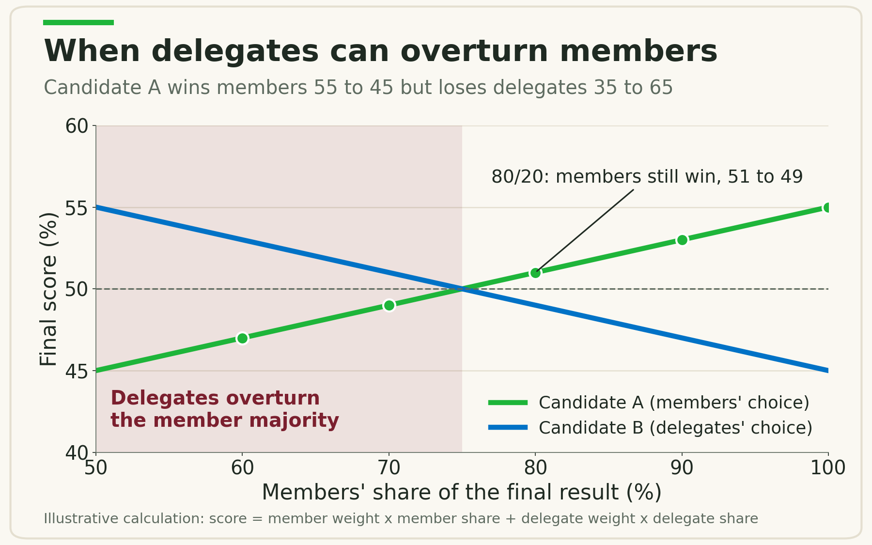
From a 25 percent delegate share upward, delegates can overturn a ten-point member win.
From 25 percent upward, delegates can erase a ten-point member victory. That is why 80/20 is the outer limit for any transitional college, and why this paper recommends against weighting the final flag bearer ballot.

If individual ballots are weighted instead
Some may prefer a single ballot in which officers' votes count more. Suppose 100,000 ordinary members, 5,000 branch officers weighted at 1.25, 1,000 district officers at 1.5, and 300 senior officers at 2. Ordinary members would still hold about 92 percent of the effective vote. If this route is chosen, four safeguards are essential:
- One person, one weight. Multiple offices never add up; the highest tier applies once.
- A hard floor. Ordinary members keep at least 85 to 90 percent of effective voting power, however many offices exist.
- A ceiling. No individual vote counts more than twice an ordinary member's.
- No financial weighting. Patron categories, donations, or higher dues never buy extra votes.

Who counts as a member in good standing
A member must be identity-verified, hold one SLPP Member ID, have joined before the published cut-off, have paid the current year's dues or hold an approved hardship waiver, and not be under suspension. Each member has one electoral home: a diaspora member votes in national contests through a recognised chapter, and never also through a home district.

How the Franchise Grows the Register and the Funding Base
The vote is the product; the card and the dues are the price of admission. One rule governs the finances: money may establish good standing at an affordable minimum, but money never buys extra political power.
Aspirants become recruiters. Under a delegate system, an aspirant courts about a thousand people. Under a member franchise, the fastest route to victory is to register new members before the cut-off and keep them in good standing. Every leadership contest becomes a recruitment drive the party does not have to fund.
Branches get paid for growth. Dues and small donations should flow back automatically to the units that recruit and keep members. An illustrative split: 40% to the originating branch or ward, 20% to the district or constituency, 10% to the region, 25% to national headquarters, and 5% to a protected fund for the register, audits, and internal elections. A branch with 500 retained members then holds a financial asset, not just a mobilisation claim.
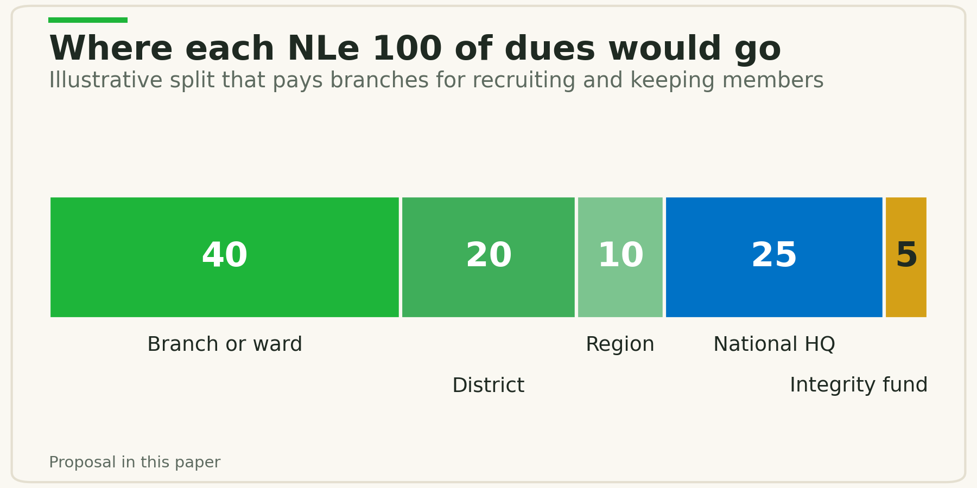
Illustrative split of dues income across the party's levels.
Small money replaces big money. The table below is illustrative only. It shows annual dues income if a share of the party's 2023 presidential vote of about 1.57 million registers and pays.
Share of 2023 SLPP voters who register | Members | At NLe 25 a year | At NLe 50 a year | At NLe 100 a year
5% | about 78,000 | NLe 2.0M | NLe 3.9M | NLe 7.8M
10% | about 157,000 | NLe 3.9M | NLe 7.8M | NLe 15.7M
20% | about 313,000 | NLe 7.8M | NLe 15.7M | NLe 31.3M

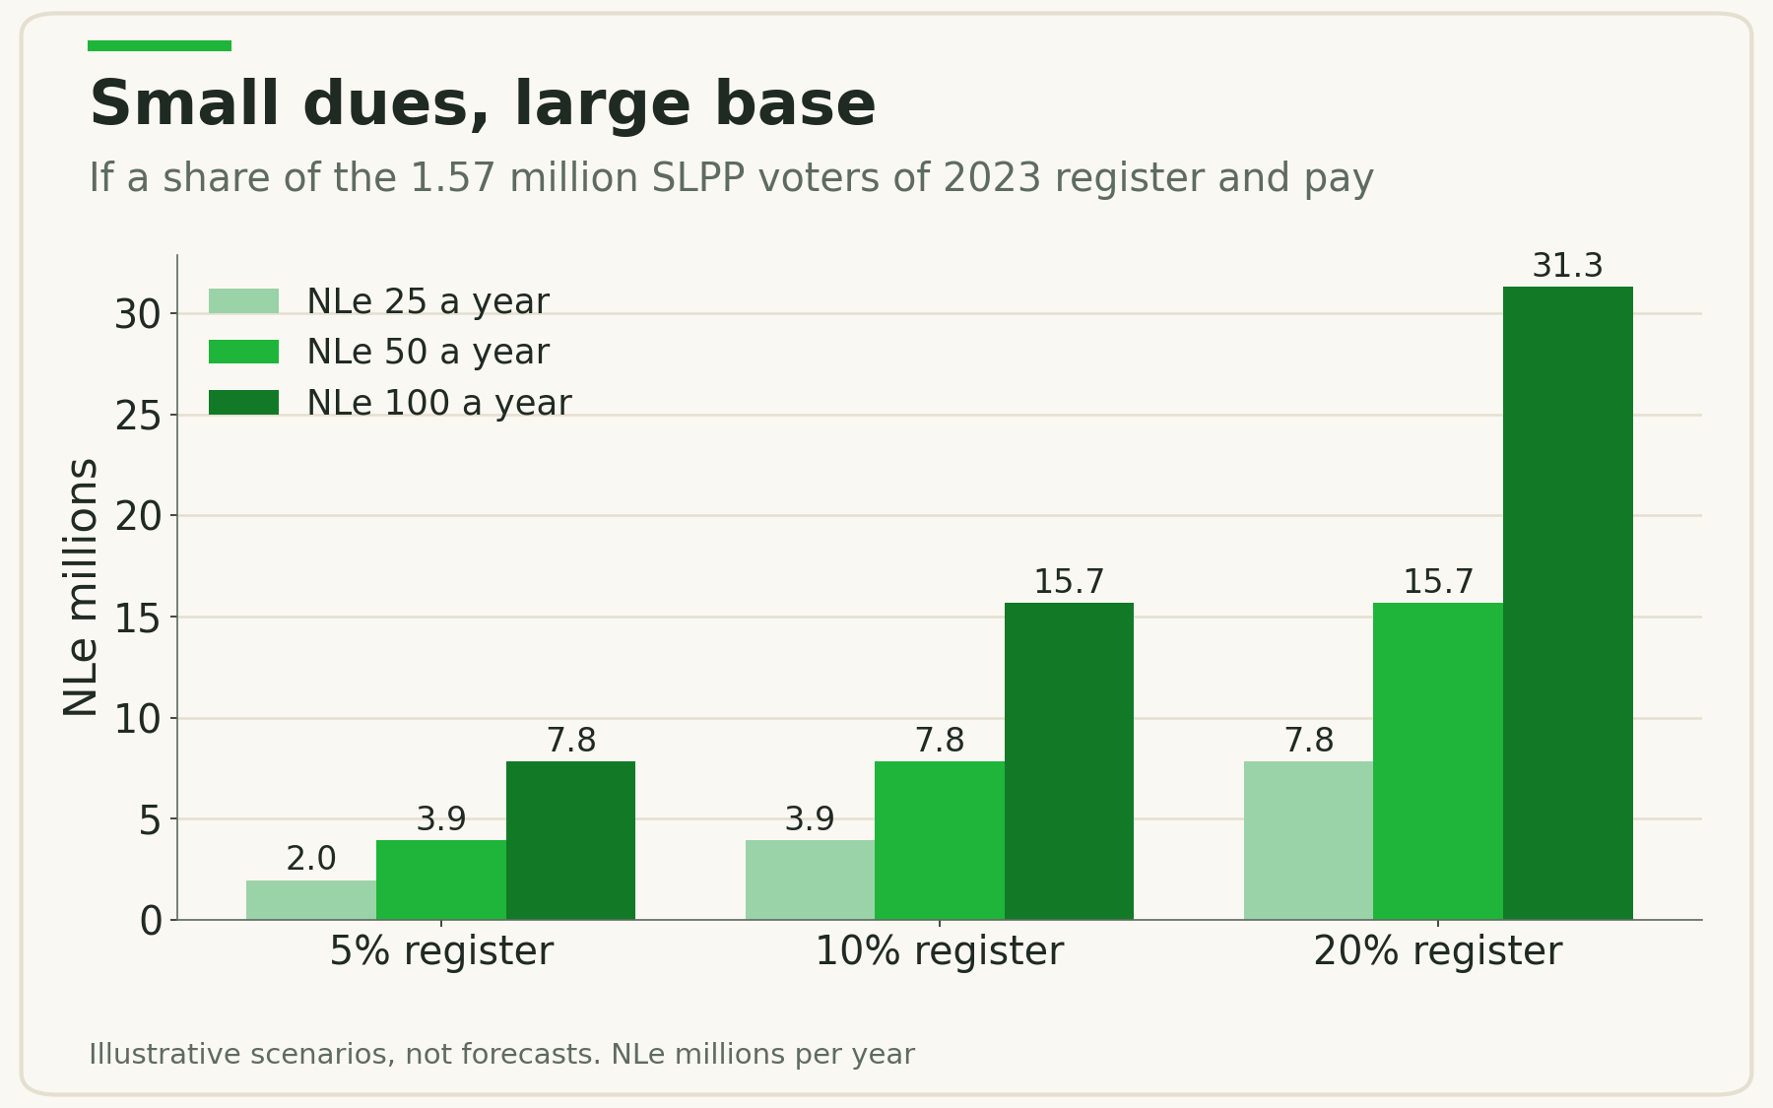
Illustrative dues income under three registration scenarios.
The British evidence shows the scale is real. After Labour adopted one member, one vote, its membership fee income rose 51 percent, from £9.5 million in 2015 to £14.4 million in 2016, as membership passed half a million. A hard-fought leadership contest drove much of that surge, so the rule change should be seen as the channel, not the sole cause.
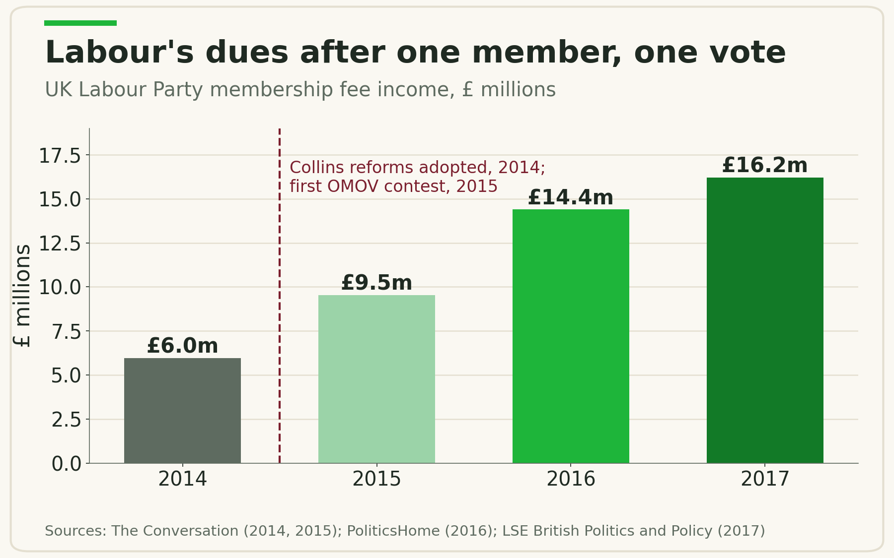
UK Labour Party membership fee income before and after one member, one vote.
Three income streams, kept separate. Membership dues establish good standing. Voluntary donations support the party but confer no extra vote. Aspirant filing fees should cover the cost of administering the contest, not become the party's main income.
Candidates may not buy members. No aspirant, officeholder, or agent may pay the dues of an identifiable member during the pre-election period. Members who cannot pay should be covered by a centrally run hardship fund under published rules, so support never comes with a name attached.
Diaspora chapters can carry a higher dues tier in foreign currency, with a fixed share returned to home constituencies, provided each contribution comes from an identifiable member who is a Sierra Leonean qualified to vote, since the Political Parties Act 2022 forbids donations from anyone else.
The register becomes a campaign asset. A verified list of members by ward is exactly what a 2028 turnout operation needs. It shows where the party is thin and which swing districts, such as Kono, need investment before polling day.

Comparative Evidence from Africa and Beyond
Member franchises can produce participation on a scale no convention can match, but they fail when the register is weak or money goes unpoliced.
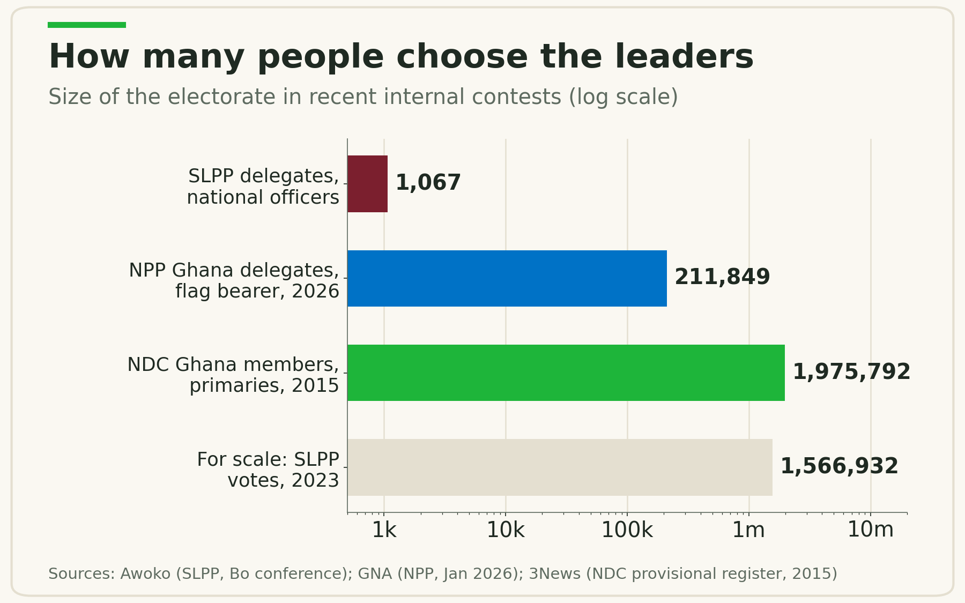
How many people choose party leaders in recent West African contests.
Party and period | What it did | What happened | Lesson for the SLPP
National Democratic Congress, Ghana, 2015 | Opened presidential and parliamentary primaries to all registered card-bearing members | Provisional register of 1,975,792 members; voting in 8,234 centres across 274 constituencies | A West African party ran a member primary at national scale
National Democratic Congress, Ghana, 2015 to 2016 | Same reform, after the vote | Inducements shifted from delegates to ordinary members; the party later voted to scrap the register after an internal review, and reverted to delegates | Build a trusted register and enforce spending rules before widening the franchise
New Patriotic Party, Ghana, 2025 to 2026 | Expanded its electoral college to polling station executives, former officers, MPs, and diaspora branch delegates | 211,849 delegates voted at 333 centres in January 2026, with the national Electoral Commission running the count | A large delegate college is workable, but six months later Ghana's courts required member voting anyway
Ghana Supreme Court, July 2026 | Ruled delegate selection of presidential and parliamentary candidates unconstitutional, 5 to 2 | Parties given one year to adopt direct member voting; the Court found broad franchises reduce exposure to targeted inducements | The regional legal standard is moving toward members choosing candidates
All People's Congress, Sierra Leone, 2026 | Ward-level internal elections under PPRC-supervised rules | PPRC ruled on petitions and ordered reruns where venue changes broke the rules | At home, internal elections are now reviewable; procedure must be watertight
Labour Party, UK, 1981 to 2014 | Leader chosen by a college: one third MPs, one third unions, one third members | Workable for decades, but criticised for making MPs' votes worth far more than members' | Weighted colleges function, but erode members' sense of ownership
Labour Party, UK, 2014 to 2016 | Replaced the college with one member, one vote; MPs kept the nomination threshold | Membership passed 500,000 and fee income rose 51% to £14.4 million | Nomination gatekeeping plus member voting can grow both membership and money
Democratic Party, Italy, 2007 to 2023 | Open primaries for party leader, available to non-members | Turnout fell from 3,554,169 in 2007 to 1,838,938 in 2017, and to about 1 million in 2023 | One-day open primaries mobilise crowds but do not build lasting membership
Liberal Party, Canada, 2012 to 2016 | A free supporter class for leadership votes, then free registration replacing the $10 membership fee | About 300,000 people signed up as supporters for the 2013 leadership vote | Free sign-up widens participation but gives up dues as a revenue stream

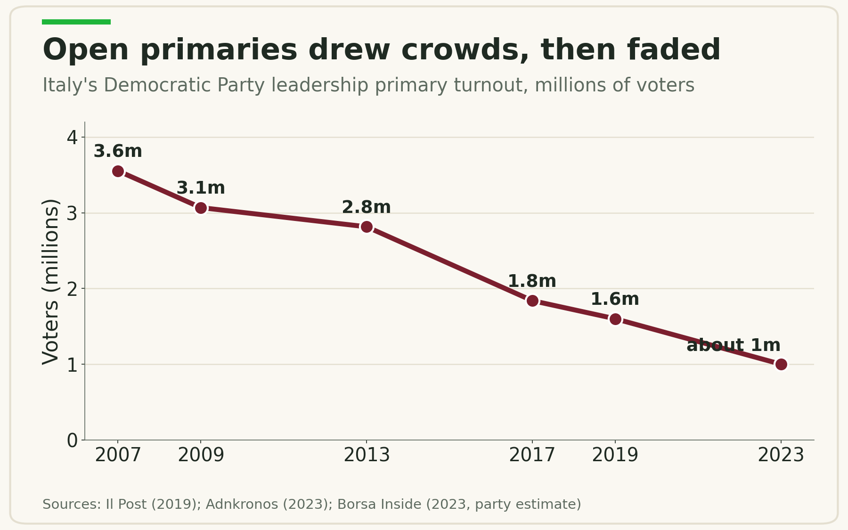
Italy's Democratic Party open primary turnout fell steadily without a membership base.
Together these cases point to one conclusion: tie the vote to verified, paid membership, not to a one-day open primary or an ever-larger delegate college. Ghana shows the path in both directions: the NDC widened the franchise without a trusted register and retreated; the NPP built a large delegate college and was overtaken by the courts.

Risks and Safeguards
A larger electorate with a disputed register is more dangerous than a small convention. The safeguards must be in the rules from the start.
Risk | Safeguard
Ghost, duplicate, or inflated registers | One national register, not regional spreadsheets. Verify identity against the National Identification Number where lawful, deduplicate centrally through a protected token, and issue a separate SLPP Member ID so raw NINs never circulate. Suspected duplicates go to a review queue, not automatic deletion.
Instant members created before a vote | Membership cut-offs: about 180 days before a flag bearer election and 90 days before other contests. Provisional roll open to members and candidates for correction and challenge, then frozen.
Aspirants buying dues or votes | No candidate-paid dues; hardship support only through a blind central fund; published spending caps; no gifts at voting venues; disqualification enforced by an independent committee.
Opposition entryism | Cut-off dates, a declaration of no other party membership, and ward-level challenge procedures.
Exclusion of the poor | Low rural, youth, and student dues tiers and a documented hardship waiver, so poverty never becomes disenfranchisement.
A contested count | An independent internal electoral authority with fixed terms, separate from membership and finance administration. Paper ballots checked against an electronic roll; results signed and posted at each centre before transmission; candidate agents at every centre.
Slow or partisan dispute resolution | A separate complaints tribunal with fixed deadlines: initial objections in 48 to 72 hours, substantive petitions within seven days, one narrow appeal.
Data misuse | Collect only what party administration needs, encrypt identity data, log every administrator change, and build to the standards of Sierra Leone's forthcoming data protection law.
Factional and regional polarisation | Code of conduct, nomination breadth across regions, and a run-off so the winner has majority support.
Legal non-compliance | Adopt by constitutional amendment after legal review, with rules gazetted by the PPRC before any binding vote.

The hardest truth is internal: the reform asks current delegates to share power they now hold alone. In return, they keep control of nomination, the officer class shares in dues income, and a transition period lets everyone see the system work before the flag bearer contest depends on it.

Implementation Roadmap
The register comes first, low-stakes tests come second, and the flag bearer contest comes last. The rule should drive the calendar, not the calendar drive the rule.
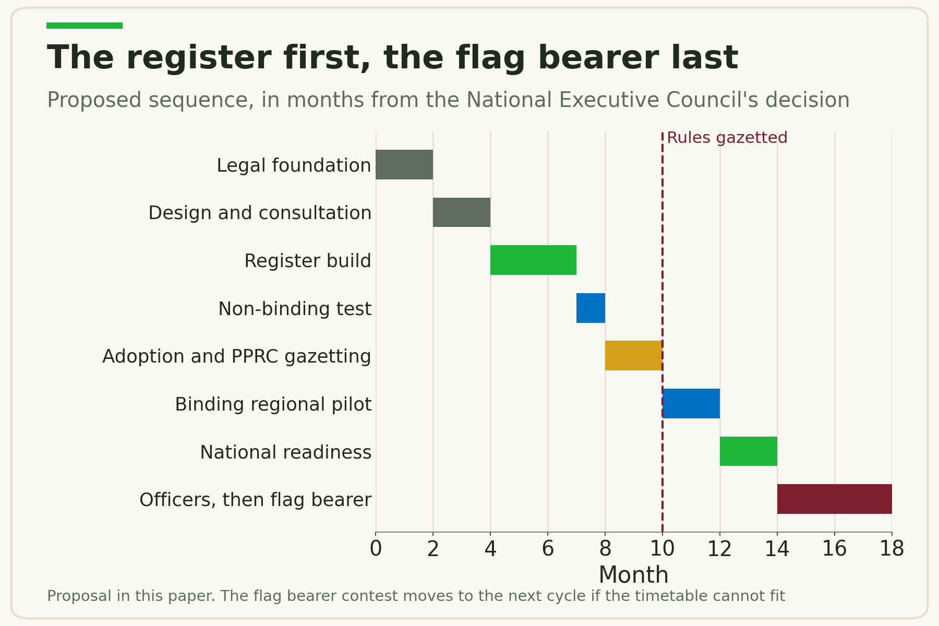
The proposed sequence: register first, flag bearer last.
- Legal foundation (months 0 to 2). Obtain the authenticated SLPP Constitution and the certified Political Parties Act 2022; commission a legal opinion; establish a Membership and Franchise Reform Committee drawn from all levels, including women, youth, and diaspora.
- Design and consultation (months 2 to 4). Choose the franchise model, draft membership, finance, and election rules, consult branches and regions, and open discussions with the PPRC.
- Register build (months 4 to 7). Clean existing records, build the central register with ID verification and integrated dues receipts, and train registrars.
- Non-binding test (months 7 to 8). Run a member ballot on a policy question and shadow-count it under one member, one vote, an 80/20 college, and capped weighting, so the party can see whether weighting changes outcomes.
- Adoption (months 8 to 10). Ratify amendments through the SLPP Constitution's own procedure and complete PPRC gazetting.
- Binding pilot (months 10 to 12). Elect regional or lower-level officers under the new rules, with an independent audit and a public dispute report.
- National readiness (months 12 to 14). Fix weaknesses, stress-test the national roll, and publish recruitment and finance results.
- Full use (month 14 onward). National officers first; the flag bearer only after independent certification and the full membership cut-off period.

If the 2028 flag bearer timetable cannot accommodate these steps, the party should use the franchise for regional and national officers first and for the flag bearer in the following cycle. A rushed register would do more harm than the current system.

Measures of success
Baselines should be set in the first six months; these first-cycle standards are illustrative.
Objective | Measure | Illustrative standard
Clean register | Active members with completed identity verification | 98% or more before a national ballot
No duplication | Unresolved probable duplicate records | Below 0.5%
Durable membership | Annual renewal rate after the first full cycle | 70% or more
Participation | Turnout among eligible members in a major national contest | 60% or more
Fair process | Complaints resolved within published deadlines | 90% or more
Member trust | Members rating the process fair or mostly fair in a post-election survey | 70% or more

The party should publish an internal election report after every contest, whoever wins. A reform becomes an institution only when it survives a contest that powerful people lose.

What I Ask of the Party Authorities
I respectfully ask the National Executive Council to take six decisions:
- Place the Member Franchise on the agenda of its next meeting for formal debate.
- Establish a Membership and Franchise Reform Committee that includes regional, district, youth, women's, and diaspora representation.
- Commission a legal review of the SLPP Constitution and the Political Parties Act 2022, and open early consultation with the PPRC.
- Commission an audit of current membership records and publish the national total.
- Approve a non-binding member ballot, followed by a binding pilot in one region or tier.
- Invite written submissions from every chapter, at home and abroad, on the model, weights, and safeguards.

For the committee's consideration, three principles could anchor the eventual amendment:
On voting rights. Every verified member of the Sierra Leone People's Party in good standing shall have the right to vote by secret ballot in the election of party officers for the member's registered jurisdiction and in the election of the Party's presidential candidate, subject to reasonable and uniform requirements on identity, length of membership, dues or approved hardship exemption, and disciplinary status. No member's vote shall be increased because of the amount of dues, donations, or contributions that member has made.
On party finance. Membership dues shall be collected through a transparent national system and shared under an approved formula among the units that recruit, serve, and retain members, with a protected share for the register, audits, and internal elections.
On election integrity. No candidate, aspirant, campaign, or agent shall pay or reimburse the dues of an identifiable member during the prescribed pre-election period. Hardship support shall be administered impersonally by the Party under published rules.
Final wording must be drafted against the authenticated SLPP Constitution and the Political Parties Act 2022.
The SLPP has always said that the party belongs to its members. A Member Franchise turns that conviction into a rule. It gives the ordinary member a reason to join, a reason to pay, and a reason to defend the party's choice in 2028. A party that trusts its members with its leadership will find its members trusting it with their votes.
In the service of the party,
Fomba Kassoh
Secretary General, SLPP North America, New York Chapter

About the Author
Fomba Kassoh is Secretary General of SLPP North America, New York Chapter. He is a data scientist and a railway service planning and operations professional with over two decades in rapid transit, and an adjunct lecturer in AI and Business Analytics. He holds advanced degrees in Civil, Water Resources, and Transportation Engineering and an M.S. in Data Science from CUNY. He is an oil palm farmer in Kambia District and partners with communities to build elementary schools. He publishes the SLPP 2028 Doctrine Series on The Green Professionals.

Sources
- Al Jazeera: Sierra Leone's Bio re-elected as president, avoids run-off (June 2023)
- Awoko: SLPP Delegates Conference Commences, Bo
- Sierra Leone Telegraph: commentary on the 2017 SLPP delegates list
- Premier Media: PPRC gazettes Unity Party electoral regulations (July 2026)
- Awoko: PPRC hands over APC elections verdict (May 2026)
- Citi Newsroom: Delegate system creates fertile ground for targeted inducements, Supreme Court (August 2026)
- Citi Newsroom: Government backs Supreme Court ruling to end delegate system (July 2026)
- GBC: Nyaho-Tamakloe, Frimpong-Boateng sue NPP, NDC, EC over delegate system (2026)
- Graphic: NPP overhauls Electoral College (July 2025)
- GNA: NPP primaries, 211,849 delegates to vote in 333 centres (January 2026)
- 3News: NDC to clean voters' register (2015)
- GhanaWeb: NDC votes today (November 2015)
- GhanaWeb: Cash rules NDC race (2015)
- 3News: NDC never had a biometric register
- Jim Hancock: It Won't Be Like Wembley 1981
- PoliticsHome: Surge in membership helped Labour raise twice as much as Tories (2017)
- The Conversation: Huge rise in Labour membership figures (2016)
- LSE British Politics and Policy: The financial health of British political parties (2018)
- Il Post: Come andarono le precedenti primarie del PD (March 2019)
- Adnkronos via Ecoseven: PD primary turnout, 2007 to 2019
- Borsa Inside: Primarie PD 2023 turnout
- Liberal Party of Canada: Towards a more open Liberal Party (2016)
- HuffPost Canada: Liberal convention and the Registered Liberal model (May 2016)
- International IDEA and National Commission for Democracy: State of Democracy in Sierra Leone Assessment 2025

