

WEBP

Magento module for images conversion to webp format


Table of Contents
I Requirements 3
II Installation 3
1) Webp support 3
2) Vips extension 3
3) Module 3
4) Memory limit 4
III Usage 4
1) Config 4
2) Conversion 5
3) Cron 6
IV Dev notes 7
1) Conversion time 7
2) Directory 7
3) Commands 7
4) Log files 8
V Sources 8

I Requirements
- PHP >= 7.1
- Cwebp >= 0.5.2
- libvips >= 8.4.5
- Magento >= 2.3
- Memory limit >= 8GB

II Installation

1) Webp support
sudo apt-get install libwebp-dev
sudo apt-get install webp

Enable GD-support.

Make sure that You have this extension.

sudo apt-get install phpX-gd

where X is PHP version (i.e. 7.1)

Last but not least configure PHP to enable support for webp format.

--with-webp-dir=DIR

2) Vips extension
sudo apt-get install libvips-dev
pecl install vips

Add extension=vips.so to php.ini file.

composer require reqjcupitt/vips

3) Module
php bin/magento module:enable Greenrivers_Webp
php bin/magento setup:upgrade
php bin/magento setup:di:compile
php bin/magento setup:static-content:deploy -f

4) Memory limit
Increase memory limit to minimum 8 GB.
To achieve this add in app/boostrap.php:
php ini_set(‘memory_limit’, ‘8192M’);

III Usage

1) Config
Stores → Configuration → GREENRIVERS → Webp
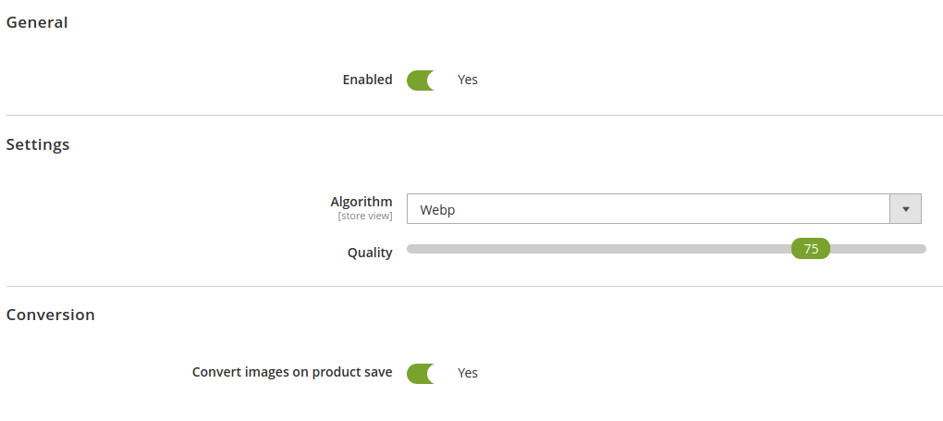
General → Enabled - module activation

Settings → Algorithm - choose one from three conversion methods (Webp, Cwebp, Vips)

Settings → Quality - quality of converted image

Conversion → Convert images on product save - after uploaded images on product edit page and save it, all images assigned to current product will be converted automatically (due to caching images sometimes requires to save product again for convert all images)

2) Conversion
Content → Conversion → Convert now
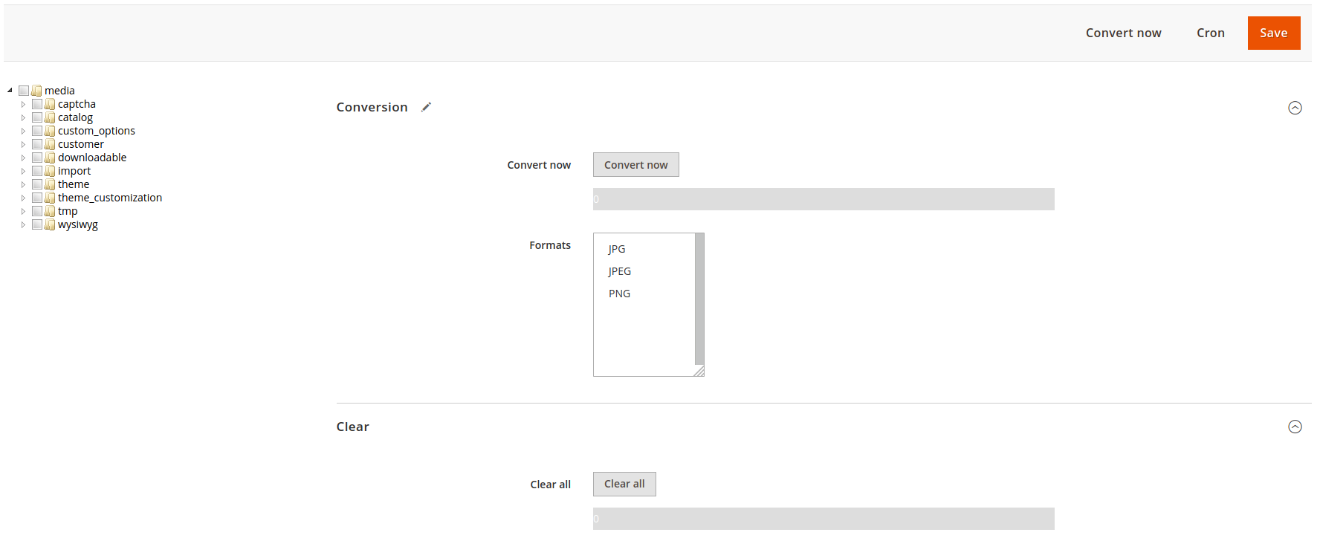
Tree nodes (left side) - select in which catalogs images should be converted.

Conversion tab – select image extensions which should be converted, click on Convert now button to start operation (this operation can take long time, please wait patiently). After finish You should see modal popup with conversion summary.

Clear tab – click on Clear all button to remove all webp images. After finish You should see modal popup with clear summary.

Click on Save button to remember settings.
You must flush Magento cache after all of those operations.

3) Cron
Content → Conversion → Cron
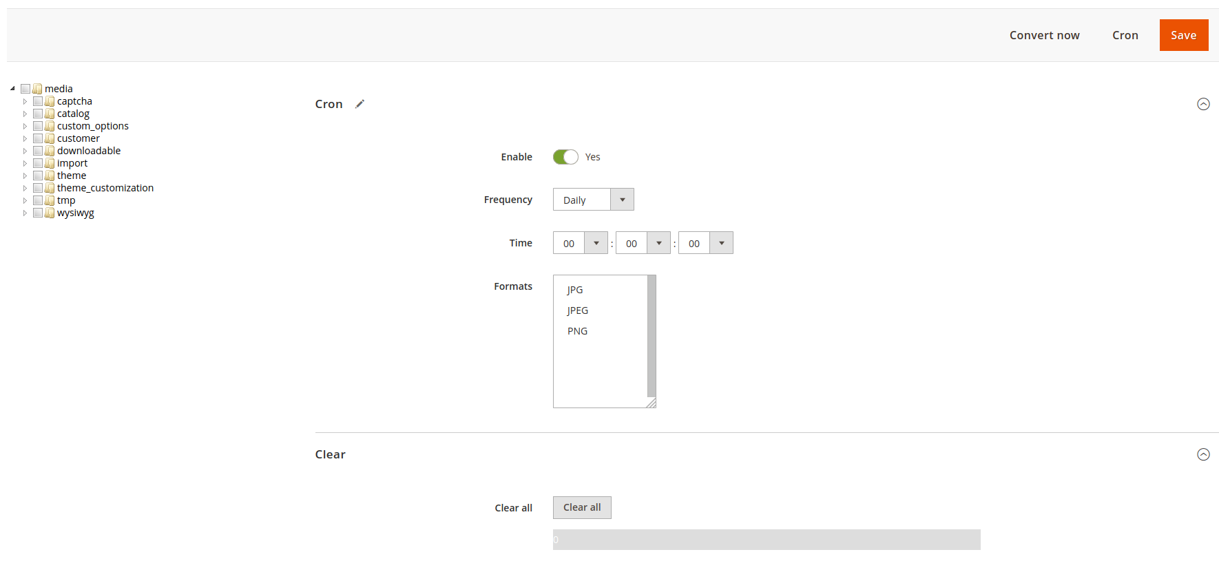
Tree nodes (left side) - select in which catalogs images should be converted when cron running.

Cron tab – select cron frequency, time scheduled and image extensions which should be converted.

Clear tab – click on Clear all button to remove all webp images. After finish You should see modal popup with clear summary.

Click on Save button to schedule cron operation with choosen settings.

You must flush Magento cache after all of those operations.

IV Dev notes

1) Conversion time
Average time for conversion take 50 000 images / hour.
Please note that it depends on images size.

2) Directory
Webp images are created in pub/media/greenrivers/webp folder.
This catalog mapping pub/media folders structure.
Example:
We have image: pub/media/catalog/product/g/r/greenrivers.jpg
Their equivalent in webp format has been created in pub/media/greenrivers/webp/catalog/product/g/r/greenrivers.webp

3) Commands
There are 2 commands which works the same as operations from admin backend.
greenrivers:webp:convert
It has two arguments:
- ext – determine images extensions
- dir – specify catalogs
To convert images in all folders with all available extensions (jpg, jpeg, png) run command without parameters.
Example:
We want to convert all png images in folders:
- pub/media/captcha
- pub/media/customer
- pub/media/wysiwyg
To achieve this run below command:
greenrivers:webp:convert --ext=png --dir=captcha,customer,wysiwyg
greenrivers:webp:clear
Run to remove all webp images.

4) Log files
Errors are logged in var/log/greenrivers/webp.log file.

V Sources

https://www.php.net/manual/en/image.installation.php

https://developers.google.com/speed/webp

https://github.com/libvips/libvips

https://github.com/libvips/php-vips

