Don Jacobs and Lum Farr; innovators in forensic science for the state of Texas

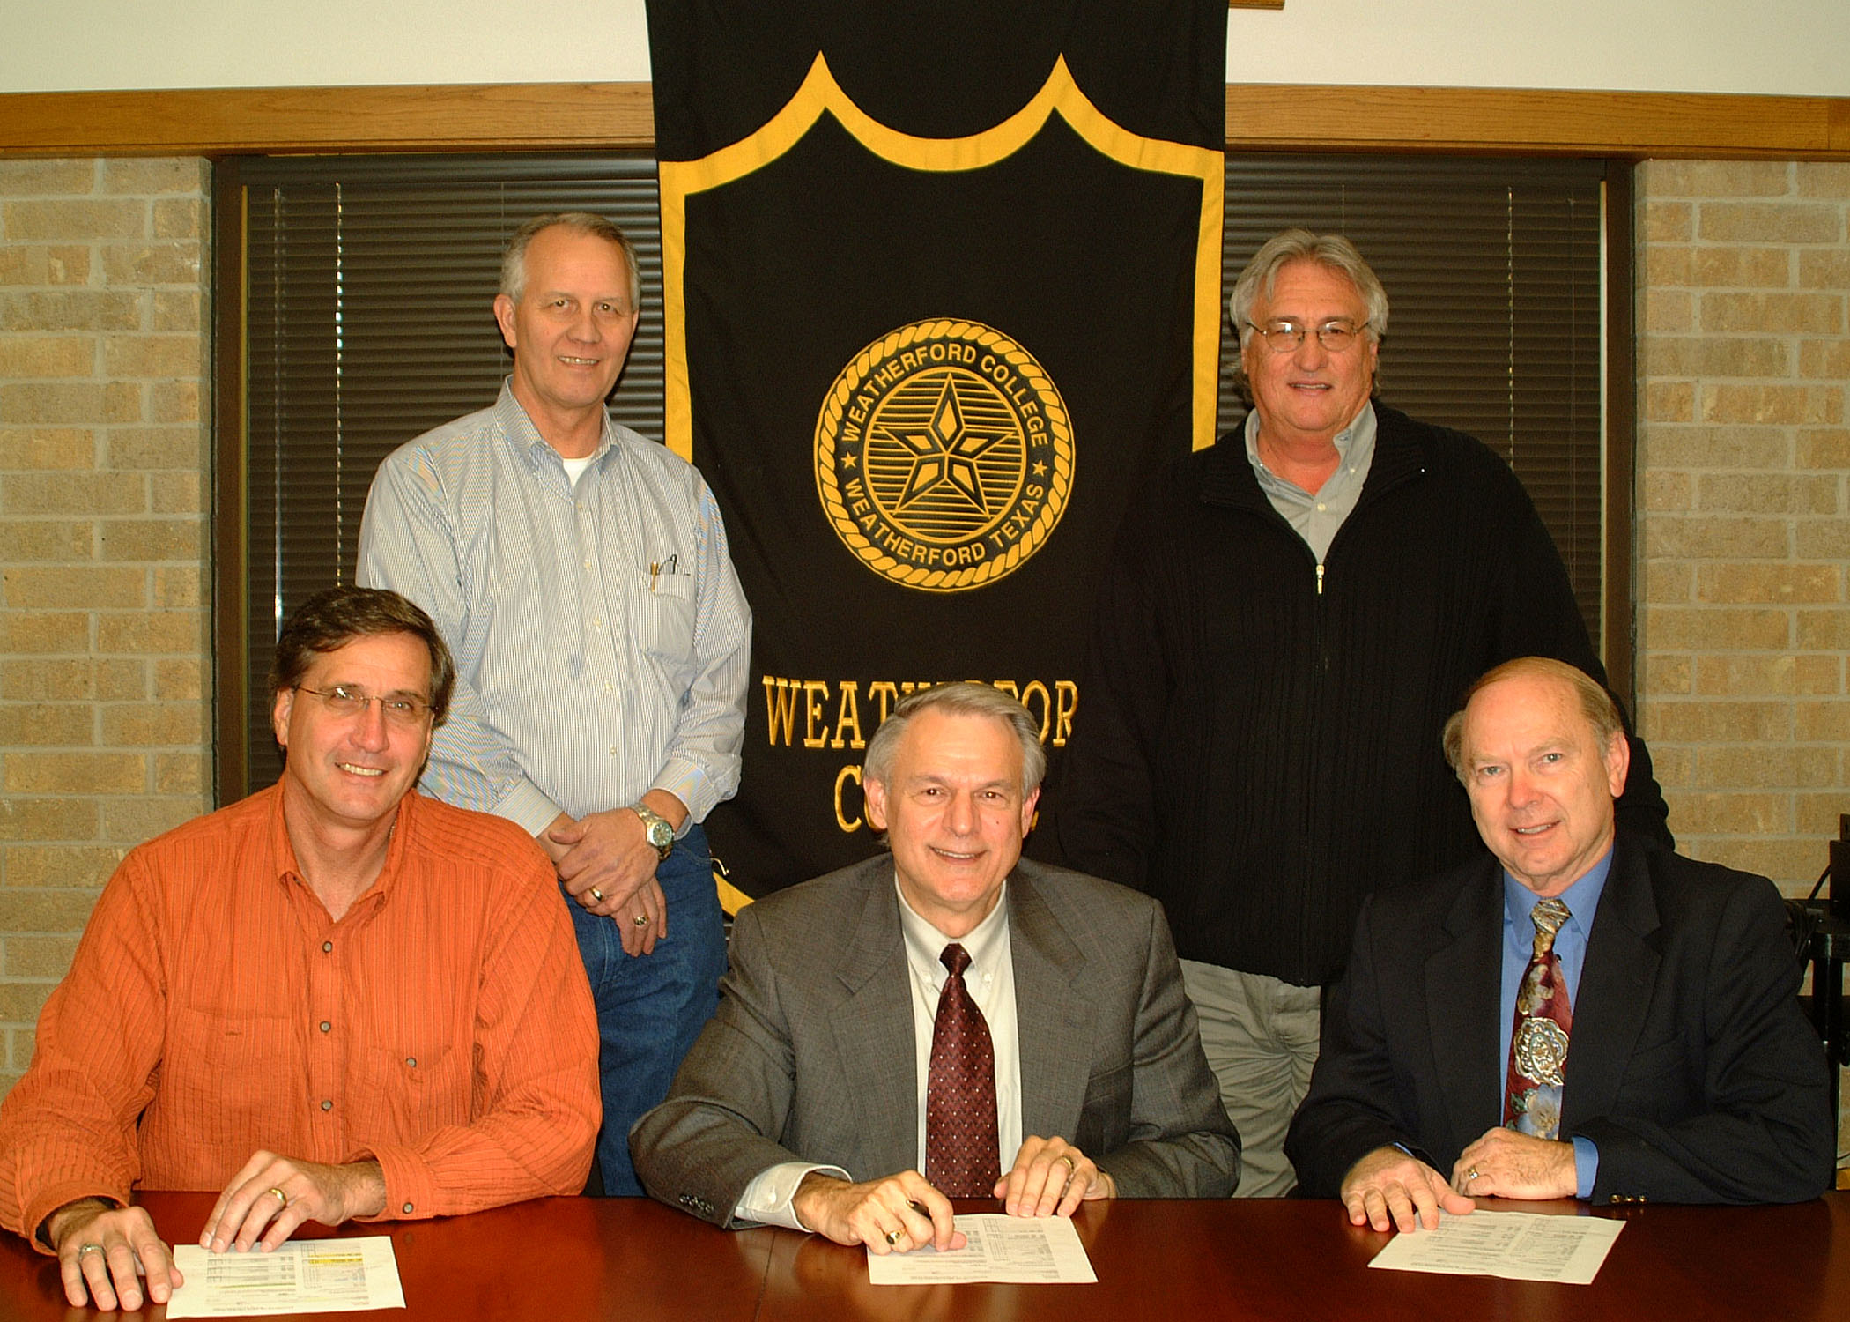

Seated: Left to Right
Dr. Don Tomas – Senior Vice President – Weatherford College
Dr. Allen Repko – Dean of Interdisciplinary Studies -The University of Texas at Arlington
Dr. Richard Bowers – Dean of Math, Science & Technology – Weatherford College

Standing Left to Right
Lum Farr – Department Chair of Criminal Justice – Lab Director – Weatherford College
President of American Crime School
Don Jacobs – Department Chair of Psychology and Forensic Science
Vice – President of American Crime School

Official Signing of Articulation Agreement with The University of Texas at Arlington.

Lum Farr and Don Jacobs, founders of American Crime School and with their colleague Erin MacKenzie created the first forensic science degree program for a Community College in the State of Texas.

Additionally, Mr. Jacobs and Mr. Farr helped establish a seamless degree transfer program to the University of Texas at Arlington. Through an articulation agreement with UTA students from all over Texas and the world can now attend UTA and complete their studies with one of the most creative degree programs in the world.

This interdisciplinary degree program is tailor made for the forensic students. No matter what the student’s interest, UTA helped us develop a Bachelor of Art or Bachelor of Science degree to fit their needs.

In the photo, Dr. Allen Repko (center), dean of Interdisciplinary Studies at The University of Texas at Arlington, is pictured with Weatherford College Senior Vice-President of Instruction and Student Services Don Tomas (left), finalizing an agreement between Weatherford College Forensic Science and UTA.

The articulation agreement allows students a seamless transfer from WC to UTA beginning in the spring semester 2007. UTA will offer WC students two innovative interdisciplinary degrees. The Bachelor of Science degree will focus on Criminalistics, or the laboratory application of forensic science.

“This is exactly what Weatherford College needed to take our program to the next level,” said Dr. Richard Bowers (right), WC dean of math, science, and technology. “Our alliance with UTA will give our students the perfect interdisciplinary degree to expand their knowledge in so many exciting fields within forensic science.”

Dr. Repko remarked that he was “very pleased with the WC alliance. Additionally, we will offer a three-hour intern course that will allow students to pursue on-the-job training prior to graduation. This type of experience has never been available before. In fact, our agreement with WC will be used as a model for additional articulations with other campuses in the future,” he said.

In March 2004, with the vision of Don Jacobs, (Department Chair of Psychology, and Forensic Science), Erin MacKenzie (Micro-biologist and Forensic Science Lab Director) and Lum Farr (Department Chair of Criminal Justice and Forensic Science Lab Coordinator), Weatherford College became the first community college in Texas to offer a fully transferable Associate of Arts emphasis in forensic science. Since the, 10 colleges throughout the state have followed the WC model.

Don Jacobs and Lum Farr, seen standing in the photo, both state that they are extremely pleased with this alliance. “This is just one step in the many steps we have taken and plan to take in developing forensic science for the two year Institutions in the state of Texas. The development of the AA degree and the alliance with a major university are just some of the rewards we have felt throughout the past three years. The founding of American Crime School and all the networking throughout the state has been very rewarding for both of us”, said Lum Farr.

