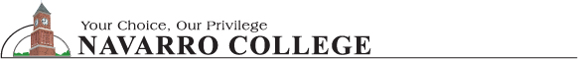
3200 W. Center Avenue ~ Corsicana, Texas 75110
“Forensic Science Conference”
November 10, 2006
8:00 a.m. to 5:00 p.m.

REGISTRATION FORM

Please provide the following information:
Please print or type:
Name and Title:____________________________________________________________
E-mail Address: ____________________________________________________________

Agency/Company Name_____________________________________________________

Mailing Address:___________________________________________________________

City, State, Zip:____________________________________________________________

Business Phone ____________________________________________________________
REGISTRATION FEE: $100.00 per person
Students $50.00
Please make check(s) payable to:
AMERICAN CRIME SCHOOL
Please mail payment along with registration form to:
AMERICAN CRIME SCHOOL, Attn. LUM FARR
P. O. BOX 6,
WEATHERFORD, TEXAS 76086
Navarro College Contact Information: Susan Johnson (903) 874-7339

For Additional Information, please contact:
Karen Pearson – 817-776-2388
Lum Farr
817-598-6312
farr@wc.edu
Don Jacobs
817-598-6431
djacobs@wc.edu

