Question All:

1. **Inspect the file ethernet-ARP-trace -1.pcap and comment on the ARP request and response.**

*Request*: The 192.168.1.105 is requesting the physical address of 192.168.1.1.

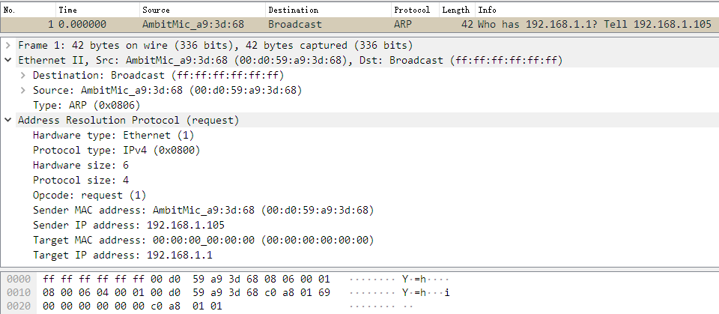

*Response*: The 192.168.1.1 tell 192.168.1.105 that my physical address is 00:06:25:da:af:73

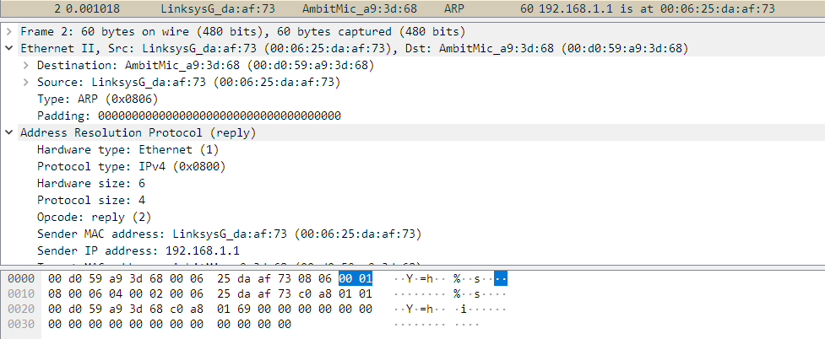

1. **Record your own ARP request response Wireshark file. To do it you might either need to clear the ARP table/cache with arp –d (you need to be an administrator) or reboot your PC to have the ARP table/cache.**

I use wireshark to capture the follow packets, it shows that 172.16.158.1 is requesting the 172.16.156.244’s physical address, and the target responses its physical address 78:11:dc:ca:14:2f.

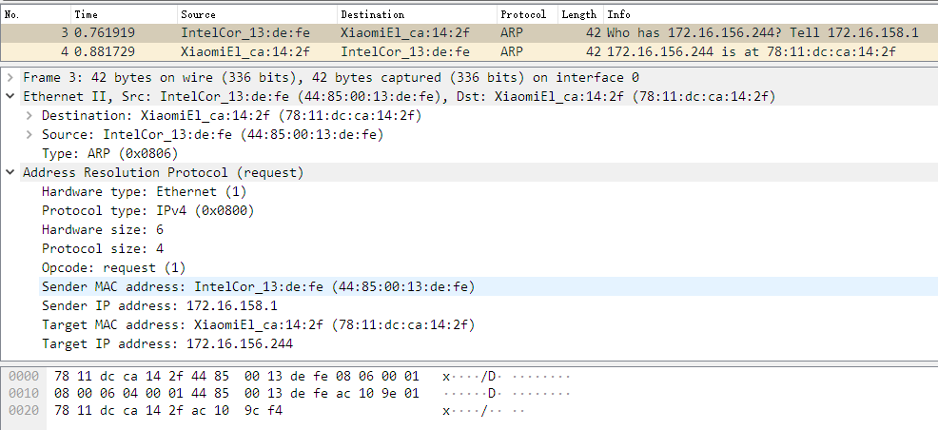

Question3:

1. **Why is an ARP query sent within a broadcast frame?**

Because the sender doesn't know the target's physical address, so it broadcast it to all hosts in this subnet.

1. **Why is an ARP response sent within a frame with a specific destination MAC address?**

Because responder know the sender's physical address, it can send the respond directly to the destination instead of broadcast.

Question4:

Question5:

Question6: