**Question 10.**

**How do VLAN switches create their forwarding tables?**

­Just like a layer 2 switch, the VLAN switch learns Ethernet addresses as it sends and receives messages. Steps of how do VLAN switches create their forwarding tables as follow:

* Suppose a VLAN switch has just been turned on and has an empty forwarding table.
* It receives an Ethernet frame, looks up the destination address in the forwarding table, and does not find where to send it.
* Smater than a layer-2 switch which would send the frame to all ports, a VLAN switch treats the frame as a broadcast frame and sends it to all the computers in the same subnet, which in VLAN terms means all the computers with the same VLAN lD.
* As a VLAN switch receives information from other switches, it inserts the Ethernet addresses of computers attached to them into its forwarding table along with the correct trunk to use to send frames to them.

Here is a example of VLAN switch forwarding tale.

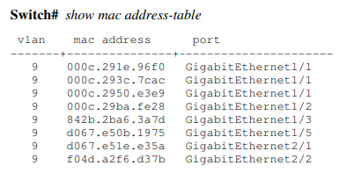

**Question 11.**

**Explain how broadcast messages like ARP are processed in a VLAN**

By assigning a port as a trunk and adding VLAN tag into header of Ethernet frame.

A trunk is a port interconnecting two switches, through which frames are forwarded to other switches. The VLAN tag is used to identify which VLAN the frame belongs to.

If a host wants to broadcast a frame, the switch connected to the host send this frame over trunk to other switches, adding proper VLAN tag. The receiver switches parse the VLAN tag, sending it to appropriate hosts, i.e. hosts with same VID.

**Question 12.** Consider an example of a multi-switch Virtual Local Area Network (VLAN) presented below.

Assume that a computer with an IP address 179.58.10.101 (switch 1) sends a packet to a computer with an IP address 179.58.10.50 (switch 3).

Assume that the 179.58.10.101 PC has just been switched on and does not know any MAC addresses.

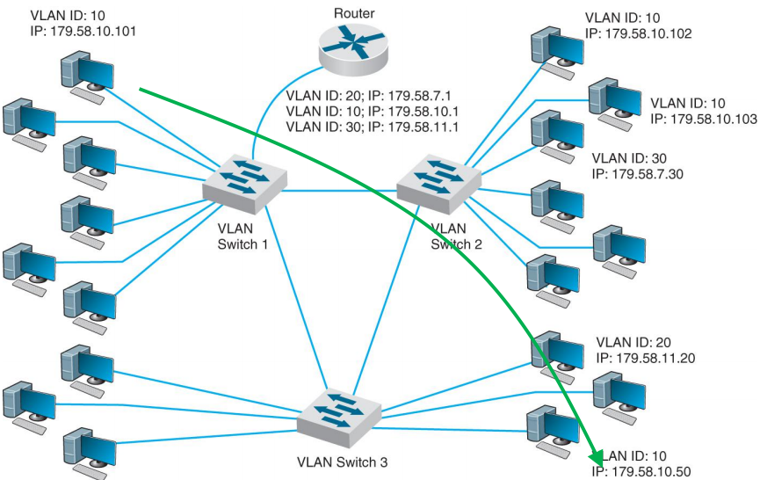

a) Give a step by step explanation of the flow of packets/Ethernet frames and

b) draw the related IP/Eth/1Q packets (add MAC addresses to the involved devices)

Step1: broadcast in VLAN:

|  |  |  |  |  |
| --- | --- | --- | --- | --- |
| e-dst | e-src | ScrIP | DesIP |  |
| FF-FF | 10.101’s MAC | 10.101 | 10.50 | ARP |

Step2: Switch 1 changes frame by inserting the VID and priority code into tag and send it to switch 3.

|  |  |  |  |  |  |
| --- | --- | --- | --- | --- | --- |
| e-dst | e-src | ScrIP | DesIP | VID |  |
| FF-FF | 10.101’s MAC | 10.101 | 10.50 | 10 | ARP |

Step3: Switch 3 remove the VID and priority code and send it to 10.50:

|  |  |  |  |  |
| --- | --- | --- | --- | --- |
| e-dst | e-src | ScrIP | DesIP |  |
| FF-FF | 10.101’s MAC | 10.101 | 10.50 | ARP |

Step 4: 10.50’s computer response to the ARP:

|  |  |  |  |  |
| --- | --- | --- | --- | --- |
| e-dst | e-src | ScrIP | DesIP |  |
| 10.101’s MAC | 10.50’s 1 MAC | 10.101 | 10.50 | response |

Step 5: Switch 3 changes frame by inserting the VID and priority code, then send it to switch 1.

|  |  |  |  |  |  |
| --- | --- | --- | --- | --- | --- |
| e-dst | e-src | ScrIP | DesIP | VID |  |
| 10.101’s MAC | 10.50’s 1 MAC | 10.101 | 10.50 | 10 | response |

Step 6: Switch 1 remove the VID and priority code and send it to 10.101’s computer:

|  |  |  |  |  |
| --- | --- | --- | --- | --- |
| e-dst | e-src | ScrIP | DesIP |  |
| 10.101’s MAC | 10.50’s 1 MAC | 10.101 | 10.50 | Response |

Step 7: 10.101 send packet to 10.50

|  |  |  |  |  |
| --- | --- | --- | --- | --- |
| e-dst | e-src | ScrIP | DesIP |  |
| 10.50’s MAC | 10.101’s MAC | 10.101 | 10.50 | Packet |

Step 8: Switch 1 changes frame by inserting the VID and priority code, then send it to switch 3.

|  |  |  |  |  |  |
| --- | --- | --- | --- | --- | --- |
| e-dst | e-src | ScrIP | DesIP | VID |  |
| 10.50’s MAC | 10.101’s MAC | 10.101 | 10.50 | 10 | Packet |

Step 9: Switch 3 remove the VID and priority code and send it to 10.50:

|  |  |  |  |  |
| --- | --- | --- | --- | --- |
| e-dst | e-src | ScrIP | DesIP |  |
| 10.50’s MAC | 10.101’s MAC | 10.101 | 10.50 | Packet |

**Question 14.**  For the modified VLAN based network from Question 13 consider and draw the flow of packets as in three cases presented in Lecture 6, slides 10 to 16, namely:

* Case 1a: Known Address, Same Subnet (e.g. Client 2 to web server B)

Client2->VLAN2->VLAN1->Server B

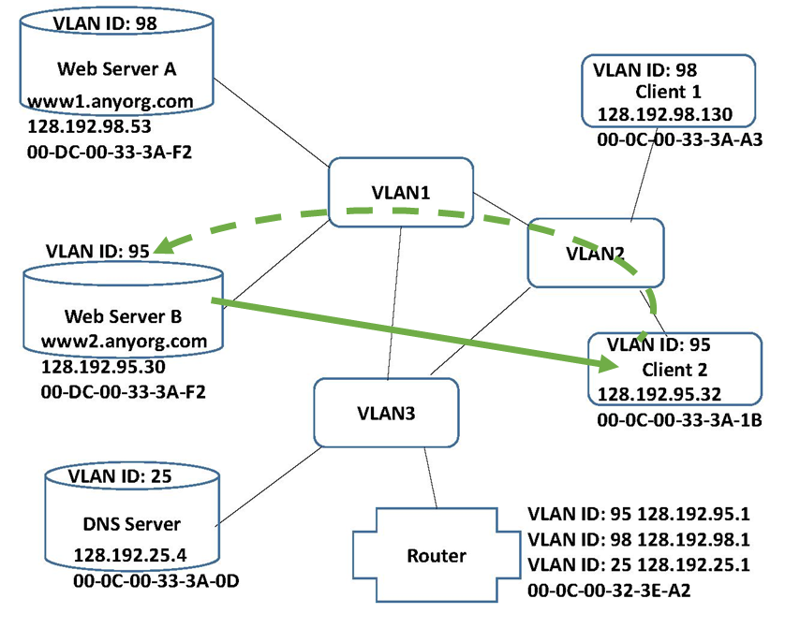

* Case 1b: HTTP response to client

Server B->VLAN1->VLAN2->Client2

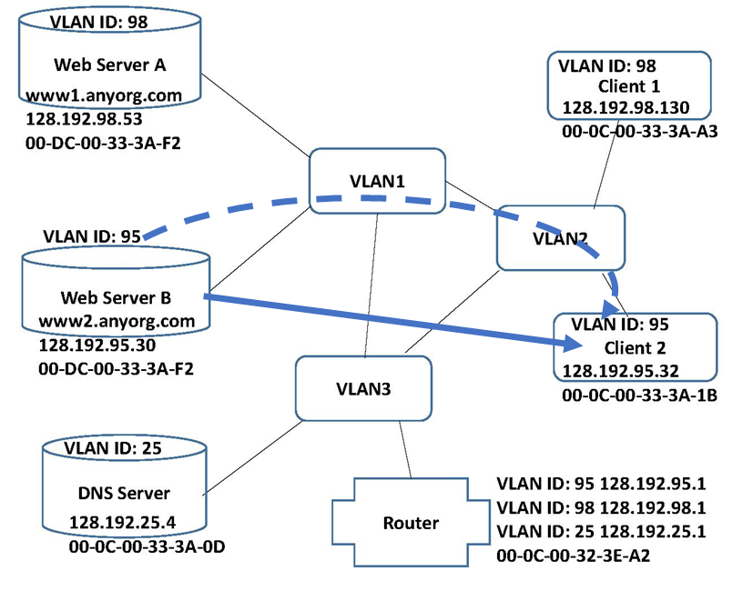

* Case 2: Known Address, Different Subnet (e.g. Client 1 to web server B)

Client1->VLAN2->VLAN3->Router->VLAN3->VLAN1->Server B

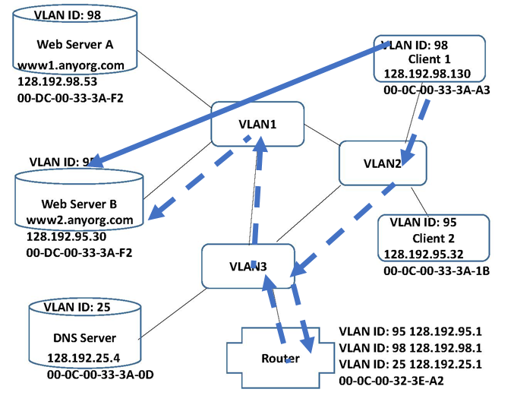

* Case 3: Different Subnets, Unknown Addresses(e.g. Client 1 to web server B)

1. Client1->VLAN2->VLAN3->Router->VLAN3->VLAN2->Client(ARP: get MAC address of Router)
2. Clinet1->VLAN2->VLAN3->Router->VLAN3->DNS Server->VLAN3->Router->VLAN3->VLAN2->Clinet2 (DNS: get IP address of Server B)
3. Client1->VLAN2->VLAN3->Router->VLAN3->VLAN1->Server B

