

Readiness and
Preparatory Support

Direct Access Proposal Template

Country Support Window

Proposal title
Strengthening Guinea's national climate finance architecture - National coordination platform, direct access accreditation and pipeline of transformational projects

Country(ies)
Guinea

Proposal Details

Title of the Direct Access Proposal
Strengthening Guinea's national climate finance architecture - National coordination platform, direct access accreditation and pipeline of transformational projects

Total Requested Amount (in USD)
$2,620,590

Implementation Period (in months)
36 months

Country Information
☒ Single country
☐ Multi-country

Country
Guinea

NDA / focal point name
Ministry of Environment and the Sustainable Development

Name of contact person
Mamadou Oury Barry

Contact person’s position
Executive Secretary

Contact person’s email
barry8763@gmail.com

Additional email addresses that need to be copied in correspondences
akaloga@gcfund.org

Participating Country Information

- If the proposal involves multiple countries (regional/multi-country), please list each one below, adding as many rows as necessary. The entry listed above serves as the lead for the multi-country proposal. Please upload the letters of intent on the GCF Partner Platform.

Participating Country | NDA/Focal Point Name | Name of Contact Person | Contact Person's Position | Contact Person's Email | Budget
N/A | N/A | N/A | N/A | N/A | N/A

Type of Access
● Direct Access by Designated Agency

1. Summary of the proposal

Guinea has established important foundations for addressing climate change through its Nationally Determined Contribution, National Adaptation Plan process and sectoral development frameworks. However, the country's capacity to translate these strategic orientations into bankable climate investments remains constrained by fragmented institutional coordination, absence of a national entity accredited for direct access to the Green Climate Fund, insufficiently consolidated monitoring and reporting systems, and a climate project pipeline that remains relatively immature.
This Readiness proposal aims to strengthen Guinea's national climate finance architecture through an integrated approach focused on four priorities: (1) the institutionalization of a National Climate Finance Coordination Platform; (2) the effective operationalization of the role of the Ministry of Economy and Finance and the Central Bank in climate finance governance; (3) capacity strengthening for ANAFIC and Access Bank Guinea with a view to their accreditation to the Green Climate Fund; and (4) the development of a pipeline of transformational climate projects aligned with national priorities, Country Programme and GCF programming objectives.
The programme will be implemented under the strategic leadership of the National Designated Authority (NDA), with ANAFIC designated as the national readiness delivery partner and as one of the candidate direct access applicants to be strengthened. It will strengthen the NDA's capacities for coordination, no-objection, portfolio oversight, reporting and knowledge management. It will formalize the role of the Ministry of Economy and Finance in integrating climate priorities into economic planning, budget programming, identification of co-financing and tracking of climate finance flows. It will also formalize the Central Bank's contribution to green finance, engagement of the banking sector, integration of climate-related financial risks and structuring of risk-reduction instruments.
The programme will provide targeted technical support to ANAFIC and Access Bank Guinea to address institutional gaps related to fiduciary standards, environmental and social safeguards (ESS), gender, anti-money laundering and combating the financing of terrorism (AML/CFT), risk management, monitoring and evaluation (M&E), reporting and project cycle management. This support will combine individualized diagnostics, the deployment of an embedded accreditation technical advisor working in-house at Access Bank Guinée over 120 days, adoption of internal policies and procedures (ESMS, gender policy, financial management, procurement), establishment of GCF units, continuous compliance dashboards, project coaching, a mock accreditation panel review and system stress-testing in order to prepare the two institutions for accreditation and for the rapid submission of quality projects after accreditation.
It will maintain alignment with Guinea's existing and emerging Country Programme through the National Climate Finance Coordination Platform and Climate Finance Roadmap, structure priority investment windows, organize project maturation clinics, prepare at least five investment-grade Concept Notes (CNs) in total, all firm-developed to investment-grade standard, and advance three Funding Proposals (FPs) to submission-ready stage and, subject to NDA validation and completion of required annexes, submit them for GCF screening, without presenting GCF approval as a guaranteed target of the Readiness programme.
The expected impact is a significant improvement in Guinea's capacity to directly access climate finance, mobilize public and private resources, effectively coordinate stakeholders and develop transformational climate investments aligned with national priorities.

2. Country Context


This section provides an overview of the country context, including planned climate investments and priority areas for funding by the GCF and other sources of climate finance. It also highlights the country's key climate priorities, challenges, policies and institutional structures as well as gender considerations and stakeholder engagement.

2.1 Country(ies) Climate Challenges
Guinea ranks among the countries most exposed to climate change, largely because its economy and the livelihoods of its population depend heavily on natural resources that are highly sensitive to climate variability. Furthermore, limited infrastructure and insufficient institutional capacity reduce the country's ability to anticipate and effectively manage climate risks. The diversity of its geography—ranging from coastal zones and dense forests to savanna landscapes and large river basins—means that different regions of the country face multiple, often interconnected, climate hazards.
Vulnerability to climate change is closely linked to structural development challenges. High levels of poverty, heavy reliance on rainfed agriculture, and rapid, often unplanned urbanization increase exposure to climate shocks. Many rural households rely on agriculture, fishing, and forestry for their livelihoods, making them particularly vulnerable to variations in precipitation and temperatures (FAO, 2022; UNEP, 2021). Women and youth are disproportionately affected due to their limited access to productive assets, services, and decision-making spaces. Environmental degradation, notably deforestation and unsustainable land management practices, further exacerbates this vulnerability by weakening natural defenses against climate impacts.
Exposure to extreme weather events has intensified in recent years. Floods have become more frequent and severe, particularly in urban centers such as Conakry, where inadequate drainage systems and rapid urban expansion exacerbate these risks (AfDB, 2022). Coastal areas are increasingly threatened by sea-level rise, storm surges, and erosion, affecting housing, infrastructure, and ecosystems. Inland regions are experiencing more irregular rainfall, prolonged dry spells, and localized droughts, disrupting agricultural cycles and contributing to food insecurity. These climate shocks often damage transportation networks, housing, and essential public services, while also degrading water quality and sanitation conditions (IPCC, 2022).
The implications for sustainable economic development are profound. Climate change poses significant risks to key sectors such as agriculture, energy, water resources, mining, and infrastructure—all of which are essential to Guinea's growth trajectory. Rainfall variability compromises agricultural productivity, reduces rural incomes, and increases reliance on food imports. Hydropower, which plays a strategic role in the national energy mix, is vulnerable to fluctuations in river flows and increased sedimentation. Climate-related disasters also place increased pressure on public finances by driving up the need for emergency response and reconstruction, while climate risk uncertainty can deter long-term private investment.
Without strengthened climate governance, increased investment in resilient infrastructure, and greater economic diversification, climate change risks exacerbating socio-economic inequalities and slowing progress toward sustainable development. Addressing these challenges requires coordinated action aimed at strengthening adaptive capacity, protecting vulnerable communities, and promoting inclusive, climate-resilient growth trajectories nationwide.

2.2 Policy Framework
Guinea’s readiness proposal is firmly aligned with the country’s national climate policy framework and responds to the institutional and financial gaps that currently limit the transformation of climate priorities into bankable, GCF-aligned investments.
At the national level, the proposal supports the implementation of Guinea’s latest Nationally Determined Contribution, the CDN 3.0 of the Republic of Guinea, prepared in October 2025 and recorded in the UNFCCC NDC Registry as active on 6 November 2025. The CDN 3.0 covers the 2026–2035 period and builds on the 2021 CDN 2.0 by raising Guinea’s mitigation and adaptation ambition, strengthening climate finance instruments, and improving monitoring, reporting and verification arrangements. Under its mitigation component, Guinea sets a 2035 target of reducing greenhouse gas emissions by 9.7% unconditionally and 20% conditionally for the energy, waste and IPPU sectors excluding AFAT, and by 17% unconditionally and 49% conditionally economy-wide including AFAT, compared with the BAU scenario. These targets are structured around seven mitigation commitments covering renewable electricity generation, renewable heat and wood-energy modernization, sustainable forest management and protected areas, low-carbon mining, transport efficiency, urban waste recovery and low-emission agriculture.
The proposal is also aligned with Guinea’s adaptation priorities under the CDN 3.0, which consolidates the three adaptation commitments already included in the 2021 CDN—water resources and natural ecosystems; coastal ecosystem protection, economic revitalization and resilience of coastal populations; and resilience of agricultural, pastoral and fisheries systems—and adds four further commitments on climate-resilient health and WASH services, climate education and social protection, resilient infrastructure and territorial planning, and climate-related mobility. These seven adaptation commitments provide a stronger national framework for translating climate vulnerability priorities into investment-ready programmes in agriculture, water resources, coastal zones, resilient infrastructure, local development, health, education and climate-sensitive territorial planning.
The readiness support will directly operationalize these CDN commitments by strengthening the NDA’s coordination function, improving climate investment screening and prioritization, supporting climate finance tracking and MRV systems, and preparing investment-grade Concept Notes and three Funding Proposals aligned with GCF investment criteria and Guinea’s national climate priorities. This is consistent with the CDN 3.0 implementation approach, which calls for consolidated climate governance, climate-sensitive budgeting, an integrated MRV system, annual public reporting, and the preparation in 2026 of a CDN 3.0 Investment and Operationalization Plan linked to annual operational plans and the State budget framework.
The proposal is further consistent with Guinea’s National Adaptation Plan process. The 2021 CDN indicated that the National Adaptation Plan was under preparation and would serve as Guinea’s adaptation communication under the Paris Agreement. The 2025 CDN 3.0 now frames Guinea’s seven adaptation commitments as aligned with the National Adaptation Programme/Plan and the Global Goal on Adaptation. The proposal therefore supports the practical implementation of this evolving national adaptation framework by strengthening institutional coordination, improving the use of climate information, integrating climate risks into sectoral and local planning, and developing a pipeline of GCF-ready adaptation investments that can translate national adaptation priorities into financed programmes benefiting vulnerable communities, women, youth and climate-exposed territories.
Although a fully operational Long-Term Strategy is not yet reflected in the available documents, the proposal contributes to Guinea’s progressive transition toward a low-emission and climate-resilient development pathway. It will strengthen policy coherence between the NDC, NAP, Country Programme, sectoral investment plans, public finance systems and private-sector green finance instruments. This includes support to the Ministry of Economy and Finance for climate finance tracking and co-financing analysis, and support to the Central Bank for green finance dialogue and climate-related financial risk awareness.
The proposal addresses key policy and institutional barriers, including fragmented climate finance coordination, limited operationalization of NDA procedures, weak integration of climate finance into budget and public investment systems, absence of a national GCF-accredited direct access entity, insufficiently mature project pipelines, and limited integration of ESS, gender and social inclusion into project preparation. By addressing these gaps, the proposal strengthens country ownership, improves policy coherence, supports direct access and creates the enabling conditions for Guinea to move from climate strategy formulation to investment-grade programming.

2.3 Institutional Framework, Capacity and Coordination
Guinea's institutional system for climate finance is being structured, but it remains characterized by coordination, operational capacity and financial mobilization constraints. The National Designated Authority, housed within the Ministry of the Environment and Sustainable Development, plays a central role in strategic guidance, stakeholder coordination, management of the no-objection process and monitoring of the country's engagement with the Green Climate Fund. However, its capacities remain limited by insufficient harmonized operational procedures, weak digital monitoring tools, lack of specialized staff and the absence of a fully functional permanent mechanism for climate finance coordination.
The Ministry of Economy and Finance is an essential actor for integrating climate priorities into economic planning, budget programming, public investment management and the identification of co-financing. Its role in climate finance should, however, be further formalized in order to enable systematic tracking of climate finance flows, better articulation between climate priorities and budget decisions, and more structured participation in the prioritization of climate projects.
The Central Bank also represents a strategic actor for mobilizing the financial sector. Its involvement is necessary to encourage the gradual integration of climate risks into the financial system, support dialogue with commercial banks, contribute to the structuring of national green finance and facilitate the development of financial instruments conducive to climate investments. At this stage, its role in the national climate finance architecture remains to be institutionalized.
Guinea does not yet have a national entity accredited to the Green Climate Fund. ANAFIC and Access Bank Guinea have been identified as candidate institutions to be strengthened for direct access. Preliminary assessments highlight significant needs in fiduciary systems, procurement, audit, risk management, environmental and social safeguards, gender, monitoring and evaluation (M&E), reporting and project cycle management. Strengthening these two institutions is an essential condition for improving national ownership of climate finance and creating sustainable direct access channels.
AGER is a key technical actor for pipeline development, particularly in the areas of renewable energy and rural energy access. However, national project preparation capacities remain limited, particularly for climate rationale, vulnerability studies, financial structuring, ESS/gender integration and the preparation of proposals compliant with GCF investment criteria.
In this context, the establishment of a National Climate Finance Coordination Platform will bring together the NDA, the Ministry of Economy and Finance, the Central Bank, sector ministries, ANAFIC, Access Bank Guinea, AGER, financial institutions, the private sector, civil society organizations, women's organizations and technical and financial partners. This platform will constitute the central instrument for coordination, prioritization, pipeline monitoring, financing alignment and strategic dialogue on climate finance.

2.4 Gender Equality Analysis
Guinea has made legal progress toward gender equality (e.g., a 30% constitutional quota for women in decision-making), yet significant disparities remain, particularly in climate-vulnerable rural areas. Women constitute approximately 70% of the agricultural workforce but hold limited land rights and access to climate information, credit, and extension services. Climate shocks (droughts, floods) disproportionately increase women’s unpaid care work (e.g., water collection) and reduce their livelihood opportunities in rain-fed agriculture and small-scale trading. The absence of sex-disaggregated data in climate finance tracking further obscures these impacts and limits the design of responsive interventions.
The proposal documents do not yet include a consolidated gender-disaggregated baseline for all targeted institutions and beneficiaries. This is a gap that should be explicitly acknowledged and addressed during the inception phase. The readiness support will therefore include a targeted gender gap assessment covering the NDA, ANAFIC, Access Bank Guinea, relevant ministries, financial institutions, project pipeline sectors and stakeholder consultation processes. The assessment will identify gender-specific barriers to accessing climate finance, participating in project preparation, benefiting from climate investments and influencing climate finance governance.
Gender-specific barriers to climate finance in Guinea include limited participation of women-led organizations in national climate finance discussions; weak access of women entrepreneurs and producer groups to formal financial services; limited inclusion of women’s priorities in early-stage project design; insufficient sex-disaggregated data in climate investment planning; low representation of gender specialists in technical project preparation teams; and limited availability of gender-responsive budgeting tools within climate finance institutions
Gender Mainstreaming in this Proposal:
This proposal will implement the GCF’s Gender Policy and Action Plan by integrating gender considerations across all three objectives.
- Specific Activity: Under Output 2.3.1 (ESS & Gender systems), a dedicated Gender Gap Assessment for Climate Finance Access will be conducted during months 1-4. This assessment will produce sex-disaggregated data on beneficiaries, map gender-specific barriers, and establish a baseline for gender-responsive indicators.
- Indicator: By project end, 100% of capacity-building workshops will have at least 40% female participation (disaggregated by urban/rural), and all concept notes developed will include a mandatory gender action plan and gender-responsive budget.
- Institutional Capacity: ANAFIC’s accreditation support includes a dedicated module on the GCF’s Gender Policy, ensuring that the entity’s project cycle management integrates gender from screening through to evaluation.

This approach is aligned with the GCF Gender Policy and Gender Action Plan by ensuring that climate finance programming is gender-responsive, evidence-based, participatory, inclusive and supported by adequate institutional capacity. The proposal will also ensure that gender mainstreaming is reflected in the budget through dedicated resources for gender expertise, gender gap assessment, gender-responsive consultations, capacity building, and integration of gender indicators into monitoring and reporting systems.

2.5 Stakeholder Engagement
During the preparation of this readiness proposal and the associated direct access discussions, ANAFIC, in coordination with the NDA hosted by the Ministry of Environment and Sustainable Development, engaged key national stakeholders through institutional consultations, technical exchanges, bilateral discussions, document reviews and targeted capacity/gap assessment discussions. These engagements took place during the proposal preparation period in 2025 and the first half of 2026.
The stakeholders engaged included the NDA Secretariat, ANAFIC, the Ministry of Economy and Finance, the Central Bank, Access Bank Guinea, AGER, parliament, relevant sector ministries, technical services involved in climate programming, financial sector actors, and institutions concerned with accreditation readiness, climate finance tracking, project pipeline development, ESS, gender and monitoring and evaluation. Engagements also drew on previous consultations and institutional assessments related to the strengthening of candidate direct access entities and the development of Guinea’s climate finance pipeline.
The engagement methods included bilateral meetings with institutional actors; technical discussions on direct access, fiduciary standards, ESS, gender, risk management and monitoring requirements; review of existing procedures and institutional capacity gaps; collection of inputs on priority sectors for the project pipeline; and targeted exchanges on the role of the Ministry of Economy and Finance and the Central Bank in climate finance governance. Consultations with ANAFIC and Access Bank Guinea helped identify accreditation-related gaps, including the need to strengthen environmental and social safeguards, gender systems, grievance mechanisms, monitoring and reporting, procurement traceability, internal risk management and knowledge management systems.
Key feedback received during these engagements shaped the final design of the proposal in four main ways. First, stakeholders confirmed the need to move from fragmented climate finance coordination toward a permanent National Climate Finance Coordination Platform with clear mandates, terms of reference and decision-tracking mechanisms. Second, the Ministry of Economy and Finance and financial-sector actors highlighted the importance of climate finance tracking, co-financing identification and stronger integration of climate priorities into public investment and budget processes. Third, candidate direct access institutions confirmed the need for hands-on support to meet GCF accreditation standards, especially on fiduciary systems, ESS, gender, risk management and reporting. Fourth, sector institutions emphasized the need to move beyond general capacity building and support a concrete pipeline of investment-grade concept notes and one advanced funding proposal.
Past engagement has therefore directly informed the proposed approach. The proposal responds to the institutional needs identified by stakeholders and converts them into a structured readiness package covering NDA strengthening, climate finance coordination, direct access accreditation, policy coherence, green finance, project pipeline maturation, ESS/gender mainstreaming and knowledge management.

2.6 Complementarity with Other Initiatives (GCF and non-GCF)
Please list past and current GCF readiness grants, and relevant capacity-building initiatives funded by other agencies and funds
GCF Readiness Activities

Title & Reference Number | Start and End Dates | Amount Approved | Status | Objectives | Key Outcomes & Results | Complementarity with the readiness proposal
Accelerating the financing and implementation of low-carbon & climate-resilient priorities in African Countries - AFR-RS-002 | 5 May 2022 - 5 Feb 2025 | N/A | Disbursed | Accelerate access to climate finance and strengthen the ability of African countries to translate low-carbon and climate-resilient priorities into implementable investment opportunities. | Supported African countries, including Guinea, to accelerate climate finance programming and implementation of low-carbon and climate-resilient priorities. The support contributed to strengthening readiness for climate investment planning, coordination, and preparation of climate finance pipelines at regional and country levels. | The proposed Guinea readiness builds on this regional support by operationalizing it at country level. It focuses specifically on Guinea's NDA system, direct access accreditation pathway, institutional procedures, ESS/gender readiness, and development of a prioritized GCF pipeline. It therefore complements AFR-RS-002 by moving from broad regional climate finance acceleration to concrete national programming and project-preparation capacity.
StrengtheningECOWASinstitutionalcapacitiesandMemberStatesaccesstoclimatefinancetosupporttheimplementationoftheagriculturesectoralprioritiesoftheECOWASRegionalClimateStrategy - AFR-RS-004 | 27 Oct 2023 - 26 June 2026 | N/A | Disbursed | Support regional coordination and climate finance access for agriculture-sector priorities under the ECOWAS climate agenda. | Strengthened ECOWAS institutional capacity and supported Member States, including Guinea, to improve access to climate finance in line with the ECOWAS Regional Climate Strategy. | The proposed Guinea readiness does not duplicate this regional support. It translates regional climate finance priorities into Guinea-specific institutional strengthening, direct access support, national pipeline development and GCF programming. (greenclimate.fund)
Institutional and technical support for REDD readiness in West Africa - AFR-RS-005 | 29 Mar 2023 - 29 Mar 2025 | 3,254,301 | Disbursed | Strengthen countries' capacity to develop climate-resilient agriculture and food-security-related programming. | Supported strategic frameworks, pipeline development, knowledge sharing and learning across selected West African countries, including Guinea. | The proposed readiness builds on regional agriculture and food-security readiness by focusing on Guinea's national systems, NDA coordination, DAE accreditation pathway, and preparation of country-owned bankable concept notes. (UNFCCC)
Readiness Support for the Africa Union Multi-Country Program to Accelerate Readiness for Water and Climate Resilience Investments with GWPO - AFR-RS-008 | 31 July 2024 - 30 July 2026 | N/A | Disbursed | Strengthen national capacities for climate programming and improve access to GCF resources. | Supported strategic frameworks and pipeline development across several African countries, including Guinea. | The proposed readiness deepens the Guinea-specific dimension by moving from general capacity support to operational tools, institutional procedures, direct access readiness, and a prioritized project pipeline. (UNFCCC)
Parliamentarians for Climate Finance - AFR-RS-010 | 29 Mar 2024 - 29 Mar 2026 | N/A | Disbursed | Strengthen political ownership and enabling conditions for climate finance programming. | Enhanced awareness and institutional engagement of national stakeholders, including parliamentarians and policy actors, on climate action and climate finance. | The proposed readiness complements this by focusing on executive and operational institutions: NDA, Technical Committee, Secretariat, candidate DAEs, sector ministries, local governments and private-sector actors.
NDA Strengthening + Country Programming - GIN-RS-001 | 11 Oct 2016 - 31 Oct 2018 | 292,029.34 | Completed | Establish minimum NDA capacity and improve national engagement with GCF processes. | Initial strengthening of Guinea's NDA and country engagement with the GCF, including basic institutional readiness and country programming foundations. | The proposed readiness is a second-generation support. It moves beyond initial NDA strengthening toward operational SOPs, stronger no-objection procedures, portfolio management, direct access accreditation support and measurable pipeline delivery.
Supporting the Achievement of National Development Policies by Building Climate Adaptive Capacity and Planning in Guinea - GIN-RS-002 | 17 Aug 2020 - 15 Nov 2023 | 1,629,716.5 | Disbursed | Strengthen Guinea's ability to identify and structure climate priorities for GCF engagement. | Supported Guinea's climate planning and readiness foundations, including elements linked to adaptation planning and national programming. | The proposed readiness uses these foundations to operationalize a more mature programming system, linking NAP/NDC priorities to bankable GCF concept notes and future funding proposals.
Strengthening technical and institutional capacity of NDA and national stakeholders for climate finance and enhancing the Country Programming process in Guinea - GIN-RS-003 | 8 July 2022 - 6 Sept 2024 | 509,982.09 | Completed | Improve technical readiness, institutional knowledge and project-preparation capacity. | Built technical capacity for climate finance engagement and strengthened selected national institutions' ability to interact with GCF processes. | The new proposal addresses remaining gaps identified after earlier capacity support, especially the need for structured institutional procedures, DAE accreditation roadmaps, ESS/gender systems, and a results-based pipeline.
NAPReadinessProcessforAgricultureForestryWaterResourcesandCoastalareasSectorsforGuinea - GIN-RS-004 | 18 Apr 2025 - 18 Apr 2027 | 756,604 | Disbursed | Advance medium- and long-term adaptation planning and integration of adaptation priorities into national systems. | Supports Guinea's National Adaptation Plan process and strengthens adaptation planning capacity. | The proposed readiness is complementary because it focuses on translating NAP priorities into GCF programming, direct access readiness, investment concept notes and institutional delivery capacity.
Support for accreditation gap assessment and action plan to the Agence Nationale de Financement des Collectivits ANAFIC - PwC | N/A | 33,846.15 | Completed | Support potential national entities to understand and address GCF accreditation requirements. | Provided targeted support for accreditation-related diagnostics and institutional capacity assessment. | The proposed readiness builds directly on this work by preparing structured accreditation action plans for selected national entities, especially ANAFIC and Access Bank Guinea, including ESS, gender, fiduciary, risk, procurement and MEL gaps.
Build the technical and institutional capacity of the Designated National Authority NDA-GCF to access Green Climate Fund financing in communities and benefit the country at all levels through the integration of Green Climate Fund Financing into lo - 2502-17969 | N/A | N/A | Revision under review | Potential related initiative. | Not budgeted under this proposal; to be screened during inception and portfolio coordination. | The readiness will screen complementarity during inception and portfolio coordination to avoid overlap in

Other capacity-building initiatives funded or commissioned by parties other than GCF

Title | Start and End Dates | Status | Funding Agency | Main objectives | Complementarity with the readiness proposal

2.7 Project Pipeline and Priorities
Guinea has identified several priority areas for GCF investment, guided by its NDC and emerging Country Programme. Key priorities include climate-resilient rural energy access through scaling up solar mini-grids and other renewable energy solutions to provide clean, reliable energy to rural communities, leveraging AGER's PNER pipeline. Sustainable agriculture and water management is a priority, promoting climate-smart agriculture and improving water resource management for smallholder farmers. Forest conservation and REDD+ is a focus, developing an Emission Reductions Program to access results-based payments. Green mining is an emerging area, exploring opportunities to decarbonize the extractive sector and promote sustainable mining practices. Resilient infrastructure is also a priority, integrating climate resilience into infrastructure planning.

Ongoing project preparation includes concept notes developed under the AU-GCF Readiness Programme, particularly in the water and agriculture sectors.
Concept-level project idea | Sector and GCF results area | Alignment with national priorities and GCF investment criteria | Indicative scale | Potential accredited entity / implementation pathway | Current readiness level
Climate-resilient rural energy access through decentralized solar mini-grids and productive-use energy services | Mitigation and adaptation co-benefits; energy access; resilient livelihoods | Supports renewable energy access, rural development, productive uses for agriculture and SMEs, reduced reliance on diesel and biomass, and improved resilience of local services. Strong alignment with country priorities on rural electrification and AGER’s pipeline. GCF fit: paradigm shift, mitigation impact, sustainable development, needs of recipient and country ownership. | USD 30–70 million | Potential AE:, AfDB, UNDP or another suitable AE in the short term; national execution through AGER and relevant ministries; possible future role for ANAFIC after accreditation for local infrastructure components. | Pre-concept / pipeline identification; stakeholder mapping initiated; requires feasibility studies, demand assessment, financial structuring and ESS/gender screening.
Climate-smart agriculture, water management and resilient local development for vulnerable rural territories | Adaptation; agriculture, water security, livelihoods and local infrastructure | Supports NDC/NAP priorities on agriculture, water, food security and local adaptation. Builds on ANAFIC’s local development mandate and the need to mainstream climate resilience into local planning and financing. GCF fit: adaptation impact, needs of vulnerable populations, country ownership, efficiency and effectiveness. | USD 40–90 million | Potential AE: IFAD, FAO, AfDB, BOAD or ANAFIC once accredited; execution by ANAFIC, agriculture/water ministries, local governments and producer organizations. | Concept-level priority; local development financing pathway identified; requires climate risk analysis, beneficiary targeting, economic analysis and gender-responsive design.
Integrated coastal resilience and mangrove ecosystem-based adaptation for Maritime Guinea | Adaptation; coastal resilience, ecosystems, livelihoods | Responds to coastal erosion, saline intrusion, flooding, mangrove degradation and vulnerability of coastal communities. Aligns with adaptation, biodiversity, land-use and livelihood priorities. GCF fit: paradigm shift through ecosystem-based adaptation, sustainable development co-benefits, gender-responsive community resilience and strong climate rationale. | USD 25–60 million | Potential AE: UNDP, UNEP, FAO, AfDB or BOAD; national execution by environment, fisheries/agriculture institutions and local governments. | Early concept / evidence base emerging; requires geospatial assessment, climate rationale, ESS screening, community consultations and economic valuation of avoided losses.
Green finance and climate-compatible SME investment facility | Cross-cutting mitigation/adaptation; private sector mobilization | Supports the role of the Central Bank, commercial banks and Access Bank Guinea in green finance, climate-related financial risk management and climate-compatible lending. Aligns with the proposal’s objective to mobilize private finance and strengthen the financial sector’s role in climate investment. GCF fit: paradigm shift, private-sector mobilization, financial innovation, country ownership and sustainability. | USD 20–50 million | Potential AE: Access Bank Guinea once accredited or another suitable private-sector AE; possible partnership with regional financial institutions. | Pre-feasibility / institutional dialogue stage; requires market assessment, green taxonomy criteria, product design, risk-sharing structure and gender-responsive SME targeting.

2.8 Specific Readiness needs
The main readiness needs concern the consolidation of the NDA's institutional capacities, the institutionalization of a permanent climate finance coordination platform, the formalization of the role of the Ministry of Economy and Finance and the Central Bank, the strengthening of candidate direct access entities and the maturation of a pipeline of bankable climate projects.
Guinea needs a strengthened operational system to enable the NDA to effectively perform its coordination, no-objection, oversight, reporting and knowledge management functions. This system should include standardized procedures, a pipeline registry, a screening and prioritization process, and digital monitoring tools.
The country also needs an institutional mechanism enabling the Ministry of Economy and Finance to track climate finance flows, identify co-financing and integrate climate priorities into economic and budget planning. The Central Bank will need support to define its role in green finance, the integration of climate-related financial risks, dialogue with commercial banks and support for the development of risk-reduction instruments.
ANAFIC and Access Bank Guinea require targeted support to address accreditation-related gaps: fiduciary systems, procurement, audit, risk management, ESS, gender, AML/CFT, grievance redress mechanism, monitoring and evaluation (M&E), reporting and project cycle management. These reforms should be accompanied by individualized gap assessments, roadmaps validated by governance bodies, adopted policies and manuals, internal GCF units, continuous compliance dashboards, project coaching, advanced Concept Notes and robustness tests of institutional systems.
Finally, Guinea must strengthen its capacity to develop bankable climate projects. This involves maintaining alignment with the existing and emerging Country Programme through the National Climate Finance Coordination Platform and Climate Finance Roadmap, structuring priority investment windows, carrying out technical studies, organizing project maturation clinics, preparing Concept Notes and developing Funding Proposals (FPs).

3. Statement of Objectives


This section aims to clearly define the objectives and scope of the readiness support being sought. It outlines: (1) the anticipated impact of readiness support on climate programming and direct access, highlighting how the support will enhance the country's capacity to design and implement climate projects; (2) the alignment of the readiness support with national climate goals, including the implementation of NDCs, NAPs, and LTS, and (3) specific areas of readiness support required, addressing capacity gaps and aligning with the objectives and outcomes of the 2024-2027 readiness strategy.

To form a statement of the objectives for the readiness support, consider the optional Guide for Countries on Strategic Planning of Readiness Support.

3.1 Objectives of the Readiness Support
This Readiness proposal pursues three interconnected objectives.
The first objective is to strengthen national climate finance coordination and create an enabling environment for integrated climate investment. This will involve consolidating the NDA's capacities, institutionalizing the National Climate Finance Coordination Platform, formalizing the participation of the Ministry of Economy and Finance and the Central Bank, and developing instruments to better track, prioritize and mobilize climate finance.
The second objective is to strengthen direct access and national climate programming. This will involve supporting ANAFIC and Access Bank Guinea in their preparation process for GCF accreditation, while strengthening their fiduciary, ESS, gender, AML/CFT, risk management, monitoring and evaluation, reporting, project cycle management and internal programming systems. It will also involve developing a pipeline of bankable climate projects aligned with the Country Programme, the NDC, the NAP and national priorities.
The third objective is to strengthen knowledge management, institutional learning and South-South cooperation. This will involve establishing a national climate knowledge portal, producing knowledge capitalization notes and knowledge products, organizing learning forums, and establishing regional partnerships on climate finance, accreditation and project preparation.

Capacity-building for climate finance coordination and setting up the enabling environment for integrated climate investment
☒ | 1.1. Developing countries, through NDAs or focal points, have enhanced capacity to fulfil their roles, responsibilities and policy requirements, including coordination mechanisms to engage relevant stakeholders to develop, advance, and implement NDCs, NAPs and LTSs.
☒ | 1.2. Developing countries design and implement strategic frameworks (including NDC/NAP/LTS), policies and instruments, including climate investment plans, to create enabling environments for integrated climate investments.
☒ | 1.3. Direct access applicants and accredited entities (DAEs) have met and maintained the accreditation standards of the GCF and strengthened their programming capacities, as evidenced by the development of GCF-funded activities.

Objective 2. Paradigm-shifting GCF pipeline development and implementation for adaptation and mitigation, based on country needs and guided by USP-2
☒ | 2.1. Developing countries have developed or updated their country programmes to guide GCF investment.
☒ | 2.2. Developing countries have developed high-quality concept notes linked to approved GCF proposals for adaptation and mitigation that are aligned with the USP-2 results, including through DAEs, that build on readiness support and country programmes.
☒ | 2.3. NDAs and DAEs have enhanced processes and systems to effectively oversee the implementation, financial management, monitoring and reporting of climate programmes and projects.

Objective 3. Knowledge-sharing and learning to enhance national and regional cooperation on climate programming and financing
☒ | 3.1. Developing countries, through NDAs or focal points, have made use of knowledge products to address policy gaps and integrated climate investment programming and implementation.
☒ | 3.2. Enhanced collaboration among developing countries on climate change issues, evidenced by transboundary and regional cooperations/South-South cooperation.

3.2 Anticipated Impact on Climate Programming and Direct Access
The programme is expected to significantly improve Guinea's capacity to programme, mobilize, manage and oversee climate finance. The institutionalization of a National Climate Finance Coordination Platform will enable a shift from ad hoc and fragmented coordination to a permanent, inclusive and investment-oriented mechanism. This platform will facilitate alignment between national priorities, public finance, private finance, technical partners and opportunities offered by the GCF and other climate funds.
The formal integration of the Ministry of Economy and Finance will strengthen coherence between climate priorities and public planning, budgeting and investment systems. It will also improve the tracking of climate finance flows and more effectively identify co-financing needs. The participation of the Central Bank will contribute to creating a more enabling environment for green finance, mobilizing commercial banks and encouraging the integration of climate risks into the financial sector.
Support to ANAFIC and Access Bank Guinea is expected to accelerate Guinea's progress towards direct access. By the end of the programme, the two institutions should have strengthened systems, policies, procedures and tools compliant with key GCF requirements, operational internal GCF units, continuous compliance dashboards and practical project preparation capacities. At least one entity is expected to have a credible and sufficiently documented accreditation dossier ready to advance in the GCF accreditation process, while two advanced entity-led Concept Notes will be prepared, one led by ANAFIC and one led by Access Bank Guinea.
The programme will also strengthen the national pipeline. Maintaining Country Programme alignment through the National Climate Finance Coordination Platform and Climate Finance Roadmap, organizing project maturation clinics, preparing five firm-developed Concept Notes and advancing three Funding Proposals (FPs) to submission-ready packages and, subject to NDA validation and completion of required annexes, submitting them for GCF screening will help increase the quality, coherence and maturity of climate investments proposed by Guinea, while maintaining a measurable and realistic target under the RRMF.

3.3 Alignment with NDC/NAP/LTS Implementation
The programme will contribute directly to the implementation of Guinea’s NDC, National Adaptation Plan process and national climate-resilient development priorities by strengthening the institutional systems required to coordinate, mobilize, access and manage climate finance. Through the establishment and operationalization of the National Climate Finance Coordination Platform, the programme will strengthen the capacities of the NDA, relevant ministries, public institutions, candidate Direct Access Entities, financial sector actors, civil society organizations, local government representatives and community stakeholders to translate national climate priorities into coordinated programming decisions, investment pipelines and financing instruments. The platform will provide a structured mechanism for improving inter-institutional coordination, screening and prioritizing climate investments, tracking climate finance flows, and supporting implementation monitoring across adaptation and mitigation sectors.
The programme will further strengthen Guinea’s climate investment pipeline through the preparation of five investment-grade Concept Notes and three Funding Proposals advanced to submission-ready stage, subject to NDA validation and completion of the required GCF annexes. These pipeline outputs will be explicitly aligned with Guinea’s NDC, adaptation priorities, GCF investment criteria, environmental and social safeguards, gender equality and social inclusion requirements, and climate transformation objectives. By moving selected national priorities from strategic intent to structured project design, the programme will create a practical pathway for mobilizing future climate finance for resilient agriculture, water resources, renewable energy access, resilient infrastructure, community-based adaptation, local development and private sector engagement.
Accreditation readiness support to ANAFIC and Access Bank Guinea, in coordination with the relevant Access Bank group structures and subject to further consultation with the GCF Accreditation Team, will lay the institutional groundwork for Guinea to strengthen its use of the Direct Access modality beyond the programme period. This support will address institutional, fiduciary, environmental and social safeguards, gender, monitoring and reporting, and project development capacities required for national entities to progressively channel climate finance directly to priority sectors and vulnerable communities. It therefore represents a qualitative shift from externally driven project preparation toward a more nationally owned climate finance architecture.
The Ministry of Economy and Finance will contribute to stronger alignment between climate priorities, public investment planning and budget processes, while the Central Bank will support the emergence of a more enabling financial environment for green and climate-resilient investments. Together with the NDA, ANAFIC, Access Bank Guinea and other national stakeholders, these institutions will help ensure that climate finance programming is better coordinated, more transparent, more inclusive and more capable of generating investment-ready projects aligned with Guinea’s long-term climate-resilient development pathway.

4. Approach, Methodology, and Implementation Activities


This section presents the technical approach, methodology and implementation plan for addressing the country needs and gaps through the Direct Access modality.

4.1 Theory of Change
The first step in articulating the programme's objectives as well as the logic behind the delivery of its intended results is the formulation of a TOC. Please provide a TOC which highlights key challenges being addressed, as well as the step-by-step pathways to achieving the expected results. Key steps to designing a TOC are outlined in the RRMF Handbook.

The programme theory of change is that if Guinea strengthens the institutional capacity of the National Designated Authority (NDA), operationalizes an inclusive National Climate Finance Coordination Platform, formalizes the roles of the Ministry of Economy and Finance and the Central Bank, and upgrades candidate direct access institutions to meet GCF accreditation requirements, then the country will be able to move from fragmented climate finance coordination to a functional, country-owned system for integrated climate investment planning and direct access. This is because strengthened governance, harmonized procedures, fiduciary and ESS/GESI systems, and a prioritized Country Programme will provide the institutional conditions required to originate, screen, mature and submit high-quality Concept Notes and Funding Proposals aligned with national priorities, the GCF investment criteria and USP-2 targeted results.
The results chain is structured as follows: activities under Objective 1 produce strengthened NDA systems, an institutionalized coordination platform, green finance instruments and direct access readiness; these outputs contribute to the outcomes on country ownership, enabling environment and accreditation readiness. Activities under Objective 2 update the Country Programme, prioritize investment windows, prepare studies, mature five firm-developed Concept Notes and advance three Funding Proposals to submission-ready packages and, subject to NDA validation and completion of required annexes, submit them for GCF screening, thereby strengthening Guinea's transformational pipeline. Activities under Objective 3 generate knowledge products, learning platforms and South-South cooperation, reinforcing institutional learning and the sustainability of climate programming.
The main assumptions are that the NDA maintains strategic leadership; the Ministry of Economy and Finance and the Central Bank designate and retain active focal points; ANAFIC and Access Bank Guinea adopt required policies and systems through their governance bodies; sector ministries provide data and technical inputs; and the selected Funding Proposal pathway remains feasible for GCF screening within the Readiness period. The key risks are addressed through formal mandates, steering committee oversight, compliance gateways, quarterly reporting, independent technical review where needed, and early ESS/GESI screening of the pipeline.
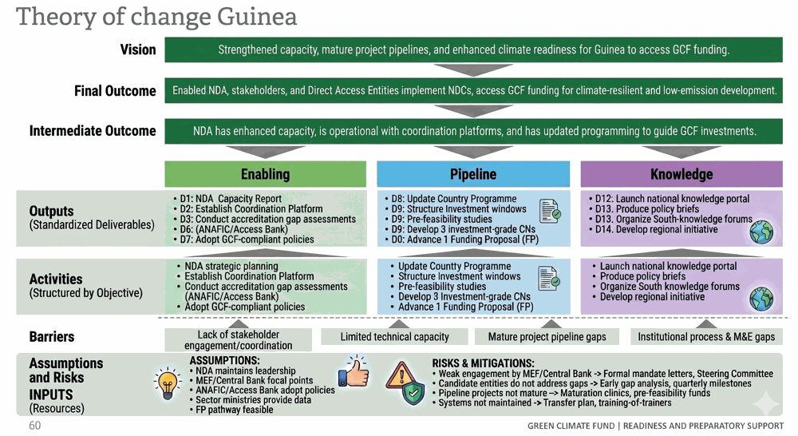
The Theory of Change diagram summarizes the same logic in five linked layers: persistent barriers such as fragmented coordination, limited technical capacity, immature project pipelines and weak institutional/M&E processes are addressed through targeted readiness inputs; these inputs finance activities under enabling environment, pipeline development and knowledge pillars; the activities generate standardized deliverables D1–D14; the deliverables strengthen the intermediate outcome of an operational NDA-led coordination architecture and a prioritized investment pipeline; and this enables the final outcome of national stakeholders and candidate direct access entities implementing climate priorities and accessing GCF finance for climate-resilient and low-emission development.

4.2 Beneficiaries
The direct beneficiaries are the NDA, the Ministry of Economy and Finance, the Central Bank, ANAFIC, Access Bank Guinea, AGER, sector ministries, commercial banks and national financial institutions.
The NDA will benefit from strengthened procedures, digital tools, an institutionalized coordination mechanism and an improved portfolio monitoring system. The Ministry of Economy and Finance will benefit from climate finance tracking tools, procedures for integrating climate into planning and strengthened co-financing capacities. The Central Bank will receive support to structure its role in green finance and dialogue with the banking sector.
ANAFIC and Access Bank Guinea will benefit from targeted institutional strengthening with a view to their accreditation. AGER and sector ministries will receive accompaniment in the preparation of bankable climate projects. Indirect beneficiaries include local governments, rural communities, women, youth, SMEs, civil society organizations and vulnerable populations, who will benefit from better access to more inclusive and better-structured climate projects.

4.3 Implementation Activities
Please list all proposed activities under their corresponding outputs. For each activity:
- Assign a unique identifier using the format aligned with the output (e.g., activities under Output 1.2.1 should be labelled as 1.2.1a, 1.2.1b, 1.2.1c, etc.).
- Ensure these activity labels match those referenced in the Financial Proposal to maintain consistency and traceability.
- Provide a clear and detailed description of each activity, specifying the exact actions that will be undertaken.
The activities below are coded consistently with the Implementation Plan and the RRMF outputs. All activities and milestones will be completed within the confirmed 36-month implementation period.
Output 1.1.1 — NDA and stakeholder capacity. 1.1.1a Develop and operationalize the NDA four-year strategic and operational plan; 1.1.1b establish the NDA Secretariat operational system; 1.1.1c conduct an institutional assessment of climate-coordination capacity; 1.1.1d deliver a modular capacity-building programme.
Output 1.1.2 — Coordination mechanism. 1.1.2a establish and institutionalize the National Climate Finance Coordination Platform; 1.1.2b formalize Ministry of Economy and Finance participation; 1.1.2c formalize Central Bank participation; 1.1.2d establish coordination, screening, prioritization and no-objection procedures; 1.1.2e organize periodic dialogues with financial actors and climate partners.
Output 1.2.1 — Strategic frameworks and policy instruments. 1.2.1a develop a national climate-finance roadmap; 1.2.1b establish a climate-finance tracking mechanism; 1.2.1c develop a preliminary green taxonomy; 1.2.1d design risk-reduction mechanisms; 1.2.1e develop sectoral climate-investment roadmaps; and prepare the NAP, NDC and LTS status products represented by D3-D5.
Output 1.3.1 — Direct-access readiness. 1.3.1a conduct individualized gap assessments for ANAFIC and Access Bank Guinea; 1.3.1b support review and adoption of GCF-compliant policies with embedded technical assistance; 1.3.1c translate future Panel conditions into action plans; 1.3.1d establish internal GCF units; 1.3.1e organize project clinics and coaching; 1.3.1f stress-test systems and strengthen reporting to the NDA.
Output 2.1.1 — Country Programme. No standalone activity or budget is requested for D8. Country-programming functions are absorbed into Outputs 1.1.2 and 1.2.1.
Outputs 2.2.1 and 2.2.2 — Pipeline preparation. 2.2.1a deliver practical project-preparation capacity building; 2.2.1b organize pipeline-maturation clinics; 2.2.1c undertake pre-feasibility studies and technical analyses; 2.2.2a prepare five investment-grade Concept Notes; 2.2.2b prepare three submission-ready Funding Proposals and submit them for screening only after NDA validation and completion of required annexes; 2.2.2c apply a quality-screening process before submission.
Output 2.3.1 — Oversight systems. 2.3.1a establish a national ESS, gender and fiduciary compliance gateway; 2.3.1b develop a national climate-finance portfolio dashboard; 2.3.1c strengthen reporting systems at ANAFIC and Access Bank Guinea; 2.3.1d establish continuous capacity building for candidate and accredited direct-access entities, where applicable.
Output 3.1.1 — Knowledge and learning. 3.1.1a roll out a national climate knowledge-management portal; 3.1.1b produce policy briefs and knowledge-capitalization products; 3.1.1c organize annual knowledge-sharing forums.
Output 3.2.1 — South-South cooperation. 3.2.1a formalize South-South climate-finance partnerships; 3.2.1b participate in regional communities of practice; 3.2.1c develop a regional or cross-border climate initiative.

4.4 Stakeholder Engagement Strategy
The stakeholder engagement strategy will be based on continuous, inclusive and documented participation linked to programming decisions. The National Climate Finance Coordination Platform will serve as the main engagement mechanism and will regularly bring together public institutions, financial actors, candidate direct access entities, sector ministries, the private sector, women's organizations, CSOs, technical partners, concerned communities and, where relevant, representatives of vulnerable groups and Indigenous Peoples or affected local communities.
Consultations will be organized around platform meetings, technical working groups, financial dialogues, project clinics and annual knowledge forums. Stakeholder contributions will be documented in minutes, decision registers, consultation reports and recommendation-tracking matrices. Particular attention will be given to the participation of women, youth, vulnerable communities and civil society organizations.

4.5 Risk Assessment and Mitigation measures
This section summarizes the potential risks and the proposed risk monitoring plan.
- Please list the key identified and potential risks as well as the mitigation measures proposed. The potential risks could include, for example, delays, disruptions, cost and market risks, inadequate coordination/participation, lack of political support, money-laundering/terrorist financing, and prohibited practices.
- Please indicate the probability of occurrence (low/medium/high) and impact level (low/medium/high) for each potential risk.
- Where activities are managed remotely, the same control framework applies to identify, assess, monitor and mitigate money-laundering, terrorist-financing and prohibited-practice risks.
- The proposal applies the measures below to identify, assess, monitor and mitigate money-laundering, terrorist-financing, prohibited-practice and other integrity risks.
Risk Category | Specific risk(s) / Risk(s) description | Probability of occurrence | Impact level | Mitigation action(s) | Entity(ies) responsible to manage the risk(s)
Regulatory | Weak sustained engagement by the Ministry of Economy and Finance (MEF) or the Central Bank | Medium | High | Formal designation letters, integration into the Steering Committee, specific institutional deliverables | NDA, MEF, Central Bank
Operational | Coordination: The platform remains a dialogue space without operational authority | Medium | High | Adoption of ToR, annual calendar, decision register, quarterly monitoring | NDA
Operational | Accreditation: Candidate entities do not address gaps within the required timeframes | Medium | High | Early gap analysis, intensive coaching, quarterly milestones, independent quality review | NDA, ANAFIC, Access Bank Guinea
Financial | Fiduciary: Persistent weaknesses in procurement, audit or internal control | Medium | High | Revision of procedures, training, pilot tests, annual audit | ANAFIC, Access Bank Guinea
Environmental | ESS & Gender: Systems remain document-based and weakly applied | Medium | High | Screening simulations, grievance mechanism, pilot reports, practical training | ANAFIC, Access Bank Guinea, NDA
Regulatory | Private Finance: Weak participation of commercial banks | Medium | Medium | Mobilization of the Central Bank, regular dialogues, risk-reduction instruments | Central Bank, NDA, MEF, ACCESS BANK
Operational | Pipeline: Identified projects are not sufficiently mature | Medium | Medium | Maturation clinics, pre-feasibility studies, pipeline scoring | NDA, AGER, sector ministries
Social | Inclusion: Weak participation of women, CSOs and communities | Medium | Medium | Reserved seats on the platform, targeted consultations, public documentation | NDA, CSOs
Technological | Data: Insufficient data to justify projects | Medium | High | Knowledge portal, technical studies, sector validation | NDA, sector ministries
Operational | Sustainability: Tools are not maintained after the programme | Medium | Medium | Transfer plan, training of trainers, institutional maintenance budget | NDA, MEF, Central Bank
Integrity — AML/CFT | Risk that programme funds are diverted through consultants, subcontractors or payment mechanisms to illicit actors, particularly in a context where formal financial systems are developing and due diligence capacity is limited. | Medium | High | All consultants and firms subject to AML/CFT due diligence before contracting: identity verification, beneficial ownership disclosure, database cross-check. All payments exclusively through formal banking channels; no cash payments. ANAFIC compliance unit maintains register of contracted parties with documented evidence and conducts spot checks. | ANAFIC, NDA
Integrity — Sanctions | Risk that a contracted party is subject to UNSC sanctions or applicable national or donor sanctions regimes, making engagement or payment unlawful. | Low | Critical | All contracted parties screened against the UNSC consolidated list and applicable national/donor sanctions regimes before contracting, and at regular intervals thereafter. Positive match triggers immediate suspension and notification to NDA and GCF Secretariat. All screening evidence documented and retained. | ANAFIC, NDA
Integrity — Prohibited Practices (Fraud, Bribery, Corruption, Collusion) | Risk of fraudulent reporting, bribery in procurement, corruption in fund management, or collusion among bidders. Risk elevated given competitive procurement of consulting services across multiple outputs. | Medium | High | Zero-tolerance policy consistent with GCF requirements. All staff, consultants and partners sign COI and anti-corruption declarations before engagement. Procurement follows ANAFIC procurement manual and GCF guidelines with mandatory independent review above agreed thresholds. Confidential reporting channel available. Credible allegations trigger investigation; substantiated cases lead to suspension and referral to competent authorities. | ANAFIC, NDA
Integrity — Conflict of Interest (NDA/ANAFIC structural COI) | Structural conflict of interest: ANAFIC serves simultaneously as Delivery Partner (managing funds) and as a direct access entity candidate benefiting from Output 1.3.1 accreditation readiness support, which may undermine objectivity of self-assessment and credibility of reported institutional progress. | Medium | High | Independent technical reviewer (separate from ANAFIC-contracted accreditation specialist) will assess ANAFIC institutional gap assessment and accreditation roadmap. NDA National Technical Committee validates all ANAFIC-related outputs under Output 1.3.1 before acceptance. Procurement of services for ANAFIC own capacity development reviewed and approved by NDA. COI register maintained and disclosed to GCF Secretariat on request. | NDA, ANAFIC

5. Logical Framework (output)

The validated 36-month RRMF results framework is set out below and is mirrored in the separate logframe and GPP entry package. Primary RRMF indicators are distinguished from supplemental programme-management indicators. GCF screening or approval is reported only when formally confirmed.

Objective: Capacity-building for climate-finance coordination and setting up the enabling environment for integrated climate investment.
Outcome 1.1. NDAs/focal points and stakeholders have enhanced capacity to fulfil their roles and coordinate climate action.
Outcome indicator. Extent to which the NDA/focal point and stakeholders have developed, advanced and implemented NDCs, NAPs and LTSs; baseline 1, target 3.
Output 1.1.1: NDA/focal point and other climate stakeholders have enhanced capacity to develop, advance and implement NDCs, NAPs and LTSs.
Indicator OI 1.1.1.1: Proportion of NDA/focal point, Coordination Mechanism and other stakeholders reporting enhanced capacity (Individuals: X/total).
Baseline: 0%. Target: at least 70% of 120 participants report enhanced capacity.
Unit: Percentage; denominator 120 participants. Disaggregation: sex, stakeholder group and NDC/NAP/LTS workstream. Means of verification: D1 status report and pre/post assessments. Frequency: annual. Responsibility: NDA/ANAFIC.
Strategic Framework | Baseline | Target
Aggregate NDC/NAP/LTS capacity participants | 0 | 120
Participants reporting enhanced capacity | 0% | ≥70%
Disaggregation | — | Sex; stakeholder group; strategic framework
Output 1.1.2: An inclusive Coordination Mechanism has enhanced capacity to fulfil its mandate. Outcome indicator baseline 0, target 3.
Indicator OI 1.1.2.1: One inclusive Coordination Mechanism/Country Platform established or strengthened.
Baseline: 0. Target: 1 National Climate Finance Coordination Platform.
Unit: number of mechanisms/platforms. Means of verification: D2 status report, approved terms of reference and decision records.
Effectiveness Status | Baseline | Target
Establish | 0 | 1
Indicator OI 1.1.2.2: Number of coordination meetings or dialogues undertaken with climate stakeholders.
Baseline: 0. Target: 9 meetings/dialogues. Unit: number of meetings/dialogues. Disaggregation: participant sex and stakeholder group.
Effectiveness Status | Baseline | Target
Establish | 0 | 9
Frequency: annual. Responsibility: NDA/ANAFIC. Means of verification: agendas, attendance records, minutes and D2 status report.
All nine meetings/dialogues will be completed within Months 1-36.
GPP entry uses the same baseline, target, unit and disaggregation.
Expected Deliverables
☒ Status report on capacity building of NDA and climate stakeholders in Guinea to develop, advance, and implement NDCs, NAPs and LTS.
☒ Status report on country coordination mechanism, country (or regional) platform for enhanced climate finance access to develop, advance, and implement NDCs, NAPs and LTS in the Country.
Outcome 1.2. Developing countries design and implement strategic frameworks, policies and instruments; outcome indicator baseline 1, target 3.
Output 1.2.1. Inclusive strategic frameworks and policy instruments are created, updated and/or strengthened.
Indicators and targets. OI 1.2.1.1: 3 strategic frameworks advanced (NAP, NDC and LTS). OI 1.2.1.2/1.2.1.3: at least 1 policy, regulation or mechanism developed or enhanced to incentivize private-sector engagement. Baseline: 0 for each output indicator.
Verification/responsibility. D3-D6 status reports; annual; NDA/ANAFIC.
Expected Deliverables
☒ Status report on the national adaptation plan (NAP).
☒ Status report on the nationally determined contribution (NDC).
☒ Status report on the long term climate strategies (LTS).
☒ Status report on policies, regulations and mechanisms developed or enhanced to incentivize private sector engagement in the Country.
Outcome 1.3. Direct access applicants and DAEs have met/maintained relevant GCF standards and strengthened programming capacities.
Output 1.3.1. Institutional gaps of direct access applicants and DAEs are addressed.
Indicator and target. OI 1.3.1.1: number of entities with strengthened capacity, systems, policies and tools; baseline 0, target 2 (ANAFIC and Access Bank Guinea, subject to GCF Accreditation Team confirmation).
Verification/responsibility. D7 status report and institutional records; annual; NDA/ANAFIC.
Expected Deliverables
☒ Status report on capacity building of direct access applicants and accredited entities to meet GCF accreditation requirements.
Objective: Paradigm-shifting GCF pipeline development and implementation for adaptation and mitigation, based on country needs and guided by USP-2 programming targets.
Outcome 2.1 / Output 2.1.1. Not applicable as a standalone deliverable. D8 remains unticked and unbudgeted; related functions are absorbed into Outputs 1.1.2 and 1.2.1.
Baseline/target. N/A.
Expected Deliverables
☐ Country Programme Document — Not applicable (removed per GCF comment 2.1.1; function absorbed into Output 1.1.2 National Climate Finance Coordination Platform and Output 1.2.1 Climate Finance Roadmap).
Outcome 2.2. Developing countries have developed high-quality Concept Notes and Funding Proposals aligned with national priorities.
Output 2.2.1 primary indicator. OI 2.2.1.1: number of studies, assessments and actions supporting investment-grade CNs/FPs; baseline 0, target at least 5.
Output 2.2.1 supplemental indicator. 60 participants complete project-preparation capacity building, with at least 70% reporting enhanced capacity; disaggregated by sex and stakeholder group.
Output 2.2.2 indicator. Number of investment-grade Concept Notes prepared and NDA-validated and number of submission-ready Funding Proposals prepared and NDA-validated; baseline 0, target 5 CNs and 3 FPs. GCF screening/approval status will be reported separately and only when formally confirmed.
Verification/responsibility. D9-D10 products, NDA validation records and any GCF screening correspondence; annual; NDA/ANAFIC/participating entities.
Expected Deliverables
☒ Concept Note and studies, assessment, reports, etc. to support the development of investment-grade Concept Notes.
☒ Funding Proposal and studies, assessment, reports, etc. to support the development of investment-grade Funding Proposals.
Outcome 2.3. NDAs and DAEs have enhanced processes and systems for implementation, financial management, monitoring and reporting; outcome indicator baseline 1, target 3.
Output 2.3.1 primary indicator. Number of institutions reporting enhanced processes, systems, knowledge and skills; baseline 0, target 3 institutions (NDA and 2 candidate entities).
Supplemental indicator. Number of systems/process packages established or strengthened; baseline 0, target 3: national ESS/gender/fiduciary gateway, portfolio dashboard and entity reporting-system package.
Verification/responsibility. D11 status report and system records; annual; NDA/ANAFIC.
Expected Deliverables
☒ Status report on capacity building of NDA and DAEs in the Country/Region in project/ program design, implementation and oversight.
Objective: Knowledge-sharing and learning to enhance national and regional cooperation on climate programming and financing.
Outcome 3.1. Developing countries have made use of knowledge products; outcome indicator baseline 1, target 3.
Output 3.1.1 indicators. OI 3.1.1.1: at least 5 inclusive knowledge products/resources produced and disseminated; baseline 0. OI 3.1.1.2: at least 4 knowledge-sharing events and 1 platform; baseline 0.
Verification/responsibility. D12-D13 products, portal analytics and event records; annual; NDA/ANAFIC.
Expected Deliverables
☒ Knowledge Products / Compendium of Knowledge Products produced (Policies, Programme, NDC, NAP, LTS, L&D, TNA and others related).
☒ Status report on the knowledge sharing events and knowledge sharing platform promoted by the Country.
Outcome 3.2. Enhanced regional/South-South collaboration; outcome indicator baseline 0, target 2.
Output 3.2.1 indicator. Number of regional or South-South partnerships, programmes, policies, MOUs or collaboration mechanisms established; baseline 0, target 2 (Morocco and Senegal).
Verification/responsibility. D14 status report, signed cooperation records and event documentation; annual; NDA/ANAFIC.
Expected Deliverables
☒ Status report on the regional or South-South partnerships, programmes, policies, MOUs and/or collaboration mechanisms promoted by the Country or Region.

6. Implementation Arrangements

6.1.1 Partnering under the Direct Access
The implementation of this readiness support programme is designed to remain fully country-led, while ensuring practical, efficient, and fully compliant delivery in line with the expectations of the Green Climate Fund (GCF). The National Designated Authority (NDA) will focus on its core role of coordination, strategic guidance, and oversight, while ANAFIC will assume responsibility for the operational implementation of the programme on the ground. This clear separation between strategic supervision and operational execution reflects good practice and contributes to the long-term strengthening of national systems.
To ensure that the programme delivers concrete results, ANAFIC will collaborate with a range of specialized partners and consultants. These will be mobilized to support specific areas such as accreditation readiness, the development of climate finance tools, project concept note preparation, and digital systems. This approach allows the programme to remain firmly anchored in national institutions while benefiting from the technical expertise required to meet GCF standards, including environmental and social safeguards, gender integration, and results-based management.
The roles of each institution are clearly defined. The NDA will provide the overall strategic direction of the programme, ensure that activities remain aligned with national priorities such as the NDC and NAP, and facilitate coordination across ministries and stakeholders. It will also validate key outputs, including policy documents and project proposals, through its no-objection function. At the same time, it will not be involved in day-to-day implementation, while retaining a strong role in supervision and decision-making.
ANAFIC will lead programme implementation. It will manage the budget, oversee procurement, recruit and supervise consultants, coordinate activities, and ensure that all work meets GCF requirements. It will also prepare technical and financial reports and retain all supporting documentation. Building on its experience working with partners such as the World Bank and AFD, as well as its nationwide presence, ANAFIC is well positioned to manage implementation effectively.
The national financial capacity assessment confirms that ANAFIC already has strong systems in place for financial management, procurement, and audit. Some areas still require strengthening, particularly environmental and social safeguards, gender integration, and risk management. These gaps are directly addressed through the programme itself, allowing ANAFIC to continue improving toward full GCF accreditation standards. All additional partners and consultants will be subject to appropriate due diligence checks before contracting.
The programme will operate through a clear coordination and reporting system. ANAFIC will manage contracts with technical partners and ensure that all deliverables are produced on time and to the required standards. The NDA will oversee the process, ensuring coherence and facilitating coordination across institutions. A Programme Steering Committee, chaired by the NDA and including key stakeholders, will guide major decisions and validate important outputs. Day-to-day coordination will be ensured through a Technical Implementation Unit within ANAFIC. Reporting to the GCF will follow standard requirements. ANAFIC will prepare regular technical and financial reports, including annual progress reports and outputs aligned with the results framework. These will be reviewed by the NDA before submission to the GCF through the Partner Portal. The NDA will remain responsible for the overall quality and accuracy of reporting. Progress will be tracked through clear indicators, and lessons learned will be systematically documented to allow adjustments where needed.
At field level, implementation will build on existing national structures. ANAFIC already has a strong operational footprint and established relationships with local authorities and sector institutions. Activities will combine central coordination with local-level work, ensuring that national priorities are effectively translated into action. The Technical Implementation Unit will coordinate daily work, supported by national experts and regular field engagement. Monitoring will be carried out through coordination meetings, field visits, and joint reviews by ANAFIC and the NDA.
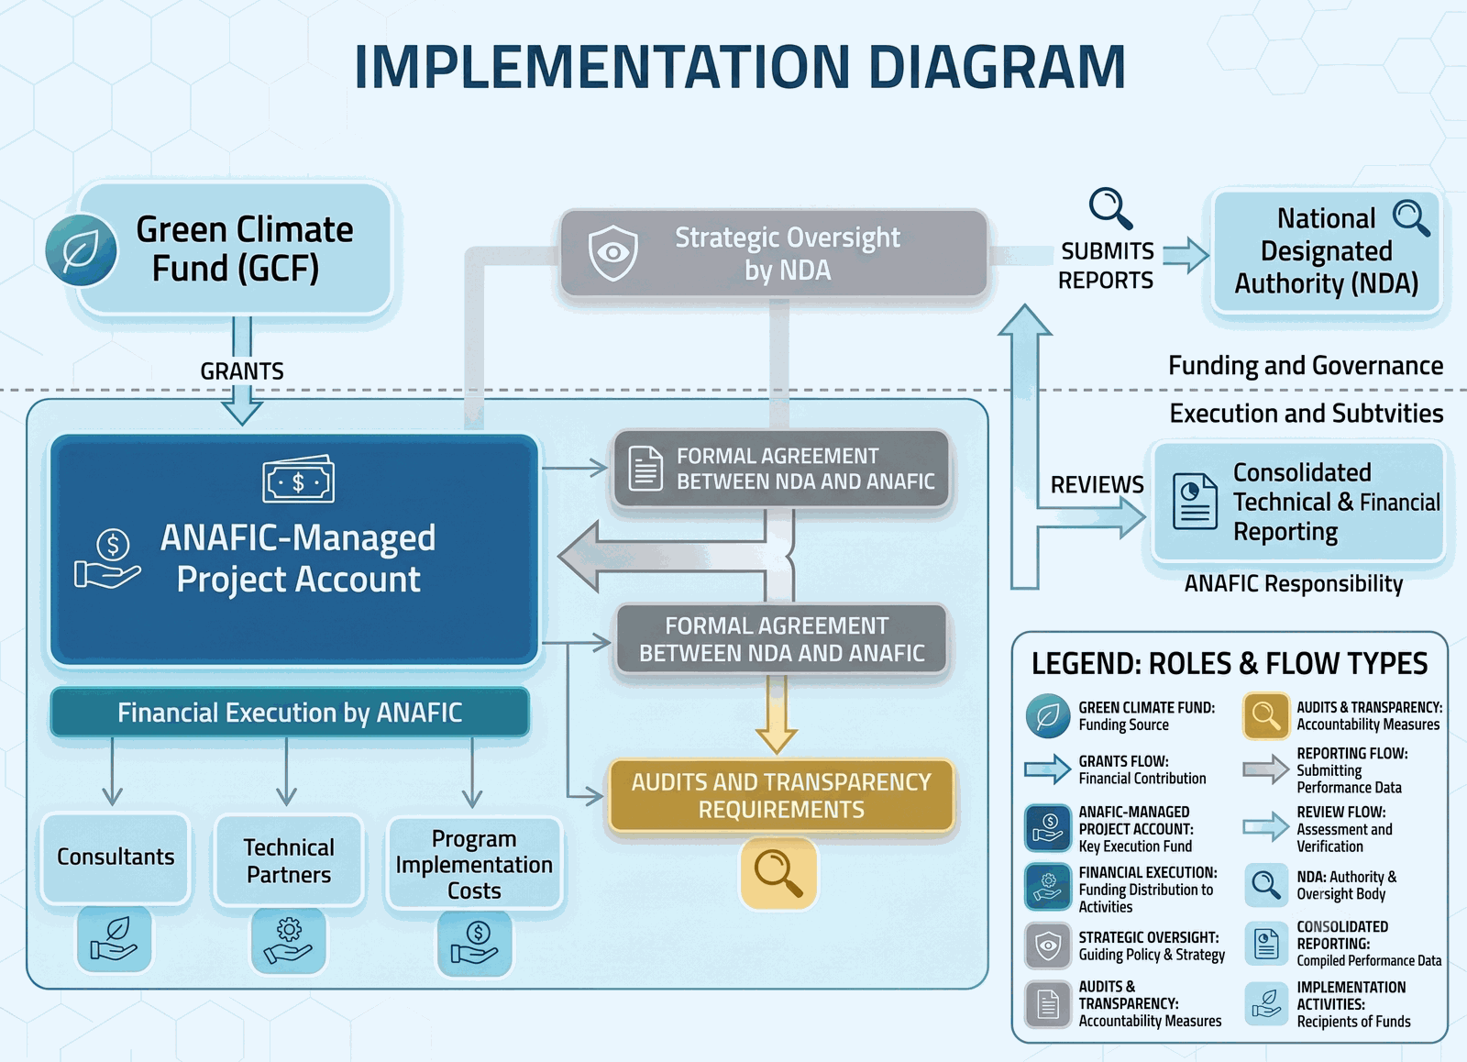The NDA’s internal structures, including the National Steering Committee and the National Technical Committee, will be actively involved. The Steering Committee will provide strategic guidance and ensure alignment with national priorities, while the Technical Committee will review technical outputs and formulate recommendations, particularly on accreditation and project preparation. The NDA Secretariat will serve as the main coordination point among all actors.
Financial management will be ensured by ANAFIC, which will manage the project account, process payments, and maintain all financial records. A formal agreement between the NDA and ANAFIC will clarify responsibilities and accountability. All reports prepared by ANAFIC will be reviewed by the NDA before submission. The structural conflict-of-interest risk linked to ANAFIC's dual role is acknowledged and mitigated through NDA review, independent technical review, audit, segregation of duties and transparency requirements.
Overall, this implementation architecture creates a balanced system in which responsibilities are clear, national institutions are strengthened, and execution remains efficient. It supports long-term capacity development, improves coordination, and creates a strong foundation for Guinea to access and manage larger volumes of climate finance in the future.

6.1.2 Framework Agreements
Under this Direct Access modality, the National Designated Authority, hosted by the Ministry of Environment and Sustainable Development, will provide the overall strategic leadership, national ownership and institutional oversight of the Readiness support. The NDA will ensure that all activities remain aligned with Guinea’s national climate priorities, the GCF Country Programme, the NDC, the NAP, and the objectives of this proposal. It will validate annual workplans, approve key deliverables, chair the Steering Committee and the National Climate Finance Coordination Platform, issue no-objection letters for relevant project activities and ensure that reporting to the GCF reflects national priorities and implementation progress.
To ensure efficient, timely and high-quality technical and fiduciary delivery, the NDA will select and contract a Delivery Partner. The Delivery Partner must be a reputable organization with a proven track record in climate finance readiness, GCF accreditation support, institutional capacity building in West Africa and fiduciary management. A key prerequisite for the Delivery Partner will be a satisfactory Financial Management Capacity Assessment, or equivalent evidence demonstrating its ability to manage funds transparently and in accordance with GCF requirements.
The Delivery Partner will be responsible for the day-to-day operational, administrative, fiduciary and technical management of the Readiness support. This will include procurement, contracting of consultants and service providers, management of activity implementation, preparation of technical and financial reports, maintenance of supporting documentation, and timely submission of progress information to the NDA. The Delivery Partner will also provide direct technical assistance to the NDA Secretariat, candidate direct access entities, AGER, sector ministries, parliamentary committees, financial institutions and other relevant stakeholders, as defined in the approved workplan.
The NDA and the Delivery Partner will operate under clearly defined and complementary responsibilities. The NDA will retain strategic oversight, validation authority and responsibility for national coordination and reporting to the GCF. The Delivery Partner will ensure operational delivery, fiduciary compliance, procurement management, consultant supervision, financial reporting and documentation. Where activities relate to the institutional strengthening of ANAFIC as a candidate direct access entity, enhanced NDA oversight and, where necessary, independent technical review will be applied to prevent conflicts of interest and ensure credibility of results.
For reporting, the Delivery Partner will submit quarterly operational and financial reports to the NDA. The NDA will review these reports, provide guidance where needed, and approve consolidated progress reports before transmission to the GCF through the appropriate reporting channel. Annual progress reporting will be completed in accordance with the GCF reporting calendar and the provisions of the legal agreement. Annual supervision missions will be conducted jointly by the NDA and the Delivery Partner to review implementation progress, validate results, address bottlenecks and agree on corrective actions.

6.2 Organisation and Staffing
The organisation and staffing arrangements are designed for a 36-month Direct Access Readiness programme and preserve separation between strategic oversight, implementation and independent assurance.
Governance and oversight. The NDA, hosted by the Ministry of Environment and Sustainable Development, will provide strategic leadership, approve annual workplans and budgets, oversee delivery, validate technical products and submissions, and serve as the principal interface with the GCF.
Delivery partner. ANAFIC will manage day-to-day implementation under the NDA-ANAFIC Implementation Agreement, including procurement, consultant management, financial management, safeguards coordination, stakeholder logistics, monitoring and preparation of technical and financial reports.
Programme management. A National Project Management Coordinator will provide operational coordination for the full 36-month period. Financial-management and reporting support will maintain accounts, expenditure controls, reconciliations and reporting. Detailed qualifications and deliverables will be specified in competitively procured terms of reference.
Technical workstreams. Specialist firms and individual consultants will be mobilized for coordination systems, climate policy, accreditation, ESS/gender/fiduciary systems, pipeline preparation, knowledge management and South-South cooperation. Participating institutions will designate focal points for each workstream.
Independent assurance. Independent auditors will conduct the required financial audits, and an independent evaluator will undertake the final evaluation. These functions will remain separate from programme management and implementation.
Reporting lines. The Programme Coordinator and technical workstream leads will report operationally to ANAFIC. ANAFIC will report to the NDA through quarterly implementation and financial reports. The NDA will validate annual reports and formal submissions to the GCF.

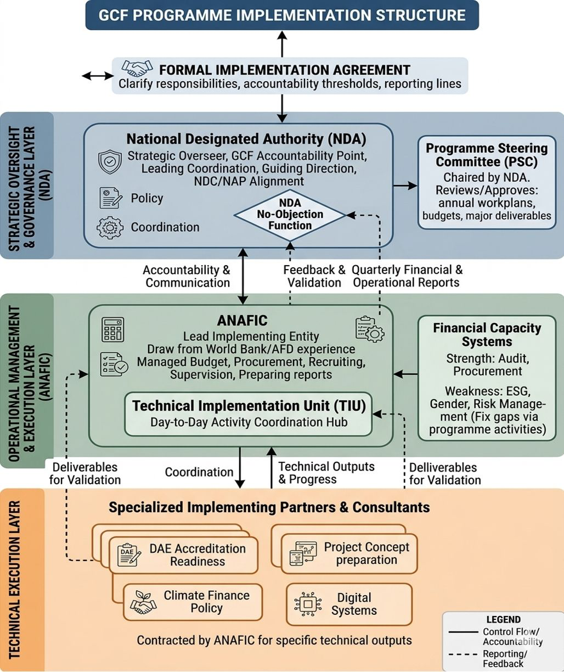

6.3 Fund flow arrangements
GCF grant funds for this programme will be disbursed to the Republic of Guinea’s National Designated Authority (NDA) under a grant agreement between the GCF and the NDA. The NDA will transfer programme resources to ANAFIC under a formal NDA–ANAFIC Implementation Agreement that specifies responsibilities, accountability arrangements, financial management procedures, and reporting lines.
DEDICATED PROJECT ACCOUNT: ANAFIC will open and maintain a dedicated USD-denominated project account at Access Bank Guinea exclusively for the receipt and management of GCF grant transfers under this programme. This account will require dual authorization for all transactions.
LOCAL CURRENCY ACCOUNT: For domestic operational expenditures denominated in Guinean Francs (GNF), ANAFIC will maintain a separate GNF-denominated programme sub-account at the same institution. Transfers from the USD project account to the GNF sub-account will be made against approved quarterly GNF cash plans at prevailing exchange rates, documented at the time of each transfer.
INTER-ACCOUNT TRANSFER PROCEDURES: Transfers from the NDA to ANAFIC will follow an approved annual work plan and quarterly expenditure plan. Transfers above USD 20,000 require prior NDA written approval. All disbursements will be documented with supporting payment vouchers, bank statements and financial reports. ANAFIC will prepare quarterly financial reports for NDA review before submission to the GCF.
FOREIGN EXCHANGE RISK MANAGEMENT: The programme acknowledges the risk of GNF/USD exchange rate volatility over the 36-month implementation period. The following measures will be applied: (i) the USD project account will minimize unnecessary conversion into GNF; (ii) conversion will be made on an as-needed basis against quarterly GNF expenditure plans; (iii) exchange rate movements will be monitored quarterly and reported in financial progress reports; (iv) the programme’s contingency provision provides a buffer to absorb moderate exchange rate impacts on GNF-denominated costs; (v) in the event of significant rate movements affecting programme delivery, a budget revision request will be submitted to the NDA and GCF Secretariat.
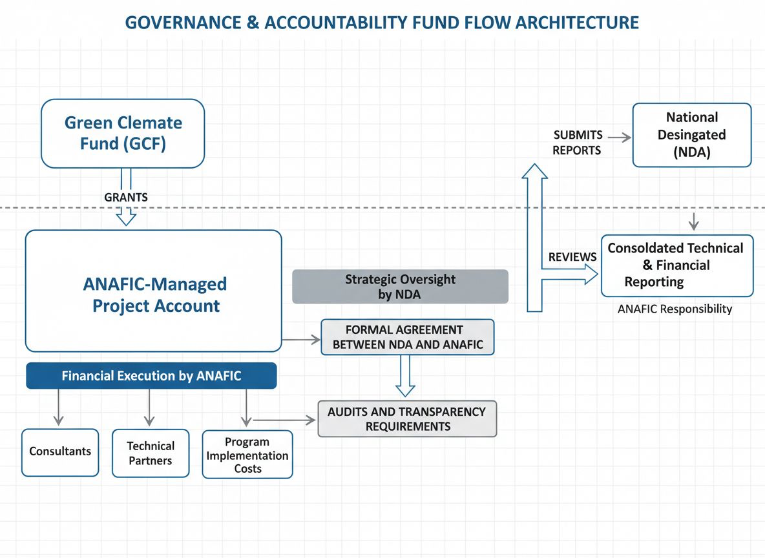
AUDIT AND REPORTING: Annual independent financial audits will be conducted by an auditor approved by the GCF. All programme accounts will be subject to GCF audit rights. The overall fund flow pathway is: GCF grant → NDA (grant agreement) → ANAFIC USD project account → GNF sub-account (as needed) → payments to consultants, vendors and implementation partners → NDA review of financial reports → submission to GCF Portal.
Overall, the current implementation arrangement provides a solid governance and fiduciary accountability framework, but it does not yet constitute a full operational fund flow manual. Detailed provisions related to bank accounts, transfer procedures, signatory arrangements, local currency conversion, and foreign exchange risk management will need to be further elaborated in the formal NDA–ANAFIC agreement and the programme’s financial procedures documentation.

7. Monitoring, Evaluation and Reporting


The RRMF has been revised to align with the objectives and outcomes outlined in the 2024-2027 readiness strategy, with the view to (1) simplify and streamline monitoring and reporting procedures; (ii) appropriately capture and reflect the systemic approach and strategic, programme-based methodology for planning and implementing readiness support; and (iii) establish a clear connection between readiness support and the enhanced programming capacities of developing countries and DAEs to effectively access and utilise climate finance.

Please note that there are as per the Revised RRMF, there are two levels of monitoring and reporting. The first is at the programme/project level, and the second is at the Country level. Outlined below are the monitoring and reporting requirements and responsible parties.

7.1 Programme Monitoring and Reporting (Output-Level)
Responsibility & Tasks:
- In the case of direct access, the NDA/focal point, an agency designated for direct access, or a Framework Agreement (FWA) holder is responsible for monitoring the programme/project’s implementation and preparing relevant reports that detail the progress of output-level results and deliverables as articulated in the programme/project logframe.

Financial Reporting:
- Regular financial reporting is the principal reporting mechanism under Readiness. Reports should provide an overview of funds received and expended and a comparison of planned versus actual expenditure with rationale for any variances. All financial reports must be presented in USD, in line with the approved programme budget. The detailed reporting requirements, including content and format, will be specified in the implementation-related templates.

Reporting Frequency:
- Annual progress reports, including financial reporting, are to be submitted to the GCF Secretariat by 31 March of each year, unless otherwise agreed to in the respective legal agreements. Upon project closure, a completion report must be submitted within six [6] months of the completion of the activities

☒ By checking this box, I acknowledge awareness of reporting tasks, including frequency and content

7.2 Financial Audits
Responsibility:
- Independent, third-party auditor commissioned by the NDA/focal point or designated agency, as applicable under the final grant agreement.

Task:
- Regular financial audits to ensure responsible and transparent fund management, preventing misuse or mismanagement and ensuring compliance with GCF and national requirements.

Reporting Frequency:
- Annual financial audit reports must be submitted to the GCF Secretariat by 31 March of each calendar year, unless an alternative frequency and deadline is agreed upon at the conclusion of the legal agreement. The completion financial audit report to be submitted to the GCF Secretariat within three months of completing the activities.

Auditor type selected for budgeting purposes
☒ | Private Auditor
☐ | Public Auditor (such as Country Supreme Audit Institution (SAI) or other)
N/A
N/A

☒ By checking this box, I acknowledge awareness of financial audit responsibilities, including frequency

7.3 Implementation Learning Review (36-month programme)
A separate four-year mid-term review is not applicable. A structured implementation learning review will be included in the Year 2 annual progress report. It will assess design adequacy, progress toward objectives, delivery-partner performance, risks, expenditure and corrective actions for the remaining implementation period. All final evaluation and closure activities will be completed by Month 36.
☒ By checking this box, I acknowledge awareness of reporting tasks, including frequency and content

7.4 Final Evaluation
Responsibility:
- An independent evaluator will be commissioned by the NDA/focal point, a designated agency or a FWA holder.

Task:
- Upon completion of the project implementation period, an independent evaluation will be conducted to assess the overall impact of the readiness activities. This evaluation will measure the contribution of these activities to the country's objectives and GCF outcomes, guided by the GCF Evaluation Policy and Standards. It will include an impact assessment and document lessons learned to inform future project planning and readiness support. If the country selects two programmes, the GCF Secretariat and the country may consult to explore the rationale and feasibility of conducting a single evaluation for both programmes.

Reporting Frequency:
- The final evaluation report will be submitted to the GCF Secretariat within three months of completing the Readiness activities.
If the country is considering two programmes, please confirm under which programme the final evaluation cost will be included in the budget:
☒ The final evaluation cost is included in this programme.
☐ The final evaluation cost is included in the other programme.
☒ By checking this box, I acknowledge awareness of reporting tasks, including frequency and content

7.5 Sanctions and Restrictive Measures
Guinea is not subject to any sanctions or restrictive measures or any UNSC or other applicable sanctions regimes.

7.6 Grievance Redress Mechanisms
ANAFIC has a broader national grievance mechanism validated and under operationalization through the Mécanisme National de Gestion des Réclamations (MNGR). The MNGR Manual and its Procedures Manual were validated in Conakry on 25 February 2026, following a national workshop involving ANAFIC, the World Bank and partner projects. The mechanism aims to harmonize grievance management across Guinea’s 375 urban and rural communes, covering both ordinary and sensitive complaints, and builds on local grievance committees established since 2018.
For this GCF readiness grant, the project-level grievance redress mechanism will be anchored in the MNGR and adapted to readiness activities, including consultations, trainings, institutional assessments, procurement-related concerns, stakeholder engagement, ESS and gender-related issues, access to information, and the conduct of consultants or service providers.
ANAFIC will designate a GRM focal point within the readiness implementation team. Complaints may be submitted through physical forms during activities, by email, phone, ANAFIC offices, local grievance committees where available, or digital channels established under the MNGR. All complaints will be recorded in a grievance register, acknowledged within 15 calendar days, screened according to their nature and sensitivity, and resolved within 30 calendar dayswhere feasible.
Complaints that cannot be resolved at project level will be escalated to ANAFIC’s relevant complaints committee or senior management structure under the MNGR, with the NDA informed where issues relate to GCF compliance, ESS, gender, stakeholder rights or implementation integrity. Sensitive complaints, including gender-based violence, harassment, retaliation or discrimination, will be handled confidentially and referred to competent services where required.
If complainants are not satisfied with the outcome, they may escalate the matter to the NDA and will be informed of the possibility of accessing the GCF Independent Redress Mechanism. ANAFIC will review grievance records quarterly to identify recurring issues, corrective actions and lessons learned, and will use this feedback to improve stakeholder engagement, information disclosure, ESS and gender screening, procurement communication and overall readiness implementation.

8. Budget

8.1 Budget
The detailed budget is presented in the Excel file required by the GCF and structured around the RRMF deliverables. The total amount requested, USD 2,620,590, finances the essential functions required to consolidate the national climate finance architecture: specialized technical assistance, development of institutional systems, consultations, legal and policy support, digital tools, strengthening of candidate direct access entities, preparation of Concept Notes, advancement of three Funding Proposals (FPs) to submission-ready stage and, subject to NDA validation and completion of required annexes, submission for GCF screening, monitoring and evaluation, audits and closure reporting. The accompanying budget workbook has been restructured in the official GCF Readiness Financial Proposal Template (Direct Access modality). Disbursements are milestone-based, triggered by the completion of key RRMF deliverable milestones (D1.1, D1.2, etc.), ensuring that GCF disbursements are linked to verified results. The contingency is set at 3% of eligible direct costs (USD 67,800), consistent with the GCF minimum threshold. The deliverable budget has been rebalanced to a 30% / 60% / 10% split across Objectives 1, 2 and 3; local consultant day-rates are standardised at USD 350 per day; the project management cost is USD 168,000 (7.43%, within the 7.5% Readiness threshold); and the independent evaluation is set at USD 60,000. The revised total reduces the overage above the indicative USD 2,500,000 Readiness ceiling to USD 120,590, which the NDA has validated for submission. International consultant day-rates are set at USD 500 per day, in full alignment with GCF comment #5 and the international consultant rate approved for Guinea in 2025. The disbursement schedule has been verified: the cumulative total equals exactly USD 2,620,590.
Resources are directed towards the executive, financial, operational and institutional functions directly linked to the RRMF outcomes and direct access requirements. The budget structure follows the RRMF output nomenclature, links each cost line to the coded activities in section 4.4 and ensures full traceability between the budget, procurement packages, deliverables, means of verification and expected results. The financial phasing first supports governance, systems and institutional baselines; then reforms and accreditation; and finally advancement of the three Funding Proposals, consolidation of oversight systems, knowledge products and final reporting.
 Download template
Budget source

Of the total amount requested under this proposal, please outline how much is requested from the country window and how much from NAP origination or implementation, if applicable
☒ | Country window: USD 2,620,590 (100% of the total amount requested)  $ 2,620,590
☐ | NAP Origination: Not applicable  N/A
☐ | NAP Implementation: Not applicable  N/A
Budget plan (provided in the separate budget workbook)

While developing the budget, please consider the ineligible costs as per page 13 of the Initial Guide for Countries to Access Readiness Support

9. Other relevant information

9.1 Exit and Sustainability Strategy
Programme sustainability will rest on the institutionalization of tools, procedures and capacities within national institutions. The National Climate Finance Coordination Platform will be maintained through approved terms of reference, an annual calendar and a decision-tracking mechanism. The portfolio dashboard and knowledge portal will be transferred to the NDA with management and update protocols.
The climate finance flow tracking tools will be integrated into the practices of the Ministry of Economy and Finance. The green finance roadmap, preliminary taxonomy and banking dialogue protocols will be integrated into the work of the Central Bank. The accreditation policies, manuals and procedures developed for ANAFIC and Access Bank Guinea will be adopted by their internal governance bodies and used in their operational procedures.
A training-of-trainers mechanism will be established to maintain knowledge on accreditation, ESS, gender, project cycle management, reporting and financial structuring. South-South partnerships will extend institutional learning beyond the programme.

9.2 Readiness Programme Closure
At programme closure, the tangible and intangible assets developed will be transferred to the relevant national institutions. The assets will include digital platforms, dashboards, databases, manuals, policies, screening tools, prioritization matrices, reporting templates, training materials, knowledge products and technical dossiers.
Asset | Beneficiary institution | Transfer modality
National climate portfolio dashboard | NDA | User training, maintenance protocol, technical transfer
Climate knowledge portal | NDA | Transfer of ownership, management guide, administrator training
Climate finance flow tracking tools | Ministry of Economy and Finance | Training, user manual, integration into internal practices
Green finance roadmap and preliminary taxonomy | Central Bank | Technical validation, transfer workshop, update plan
Accreditation policies and manuals | ANAFIC and Access Bank Guinea | Institutional adoption, archiving, internal training
Concept notes and Funding Proposal (FP) | NDA and lead institutions | Complete dossiers, annexes, submission follow-up plan
Knowledge products | NDA and platform | Publication, dissemination, digital archiving

