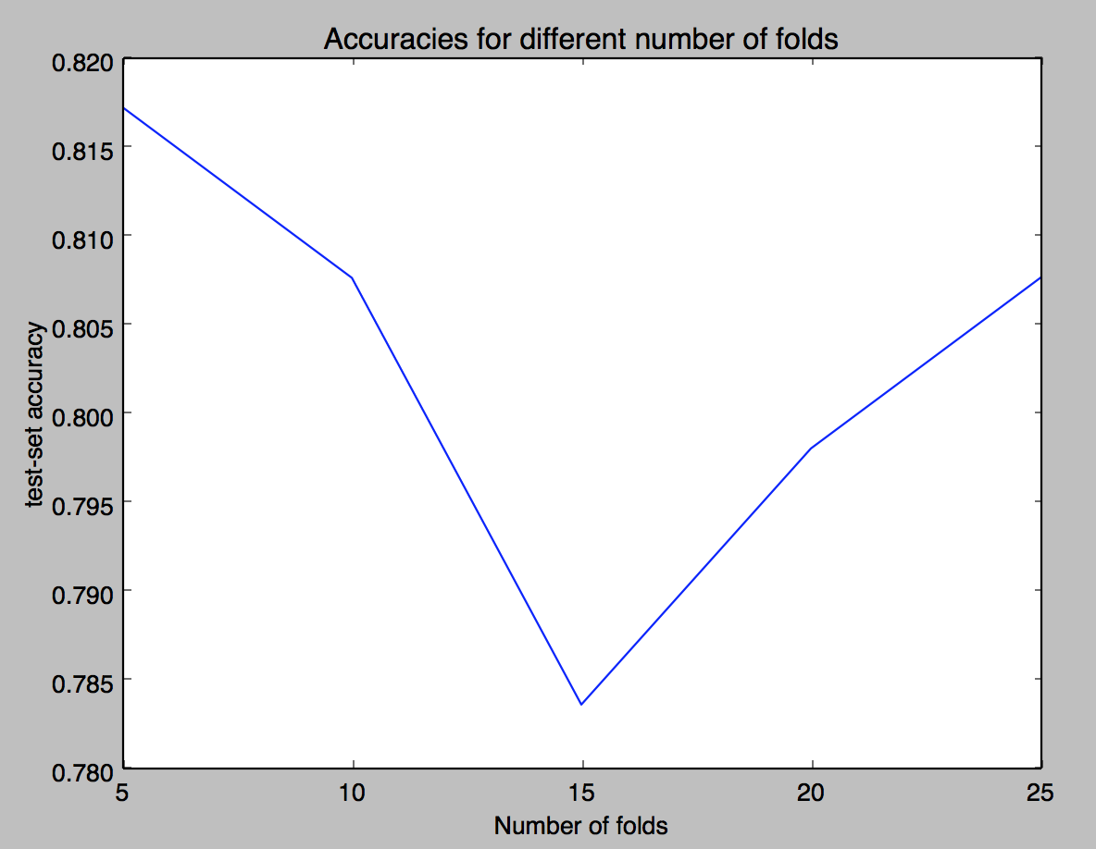

figure 1 is the cross-validation accuracy of the neural network given different numbers of folds. 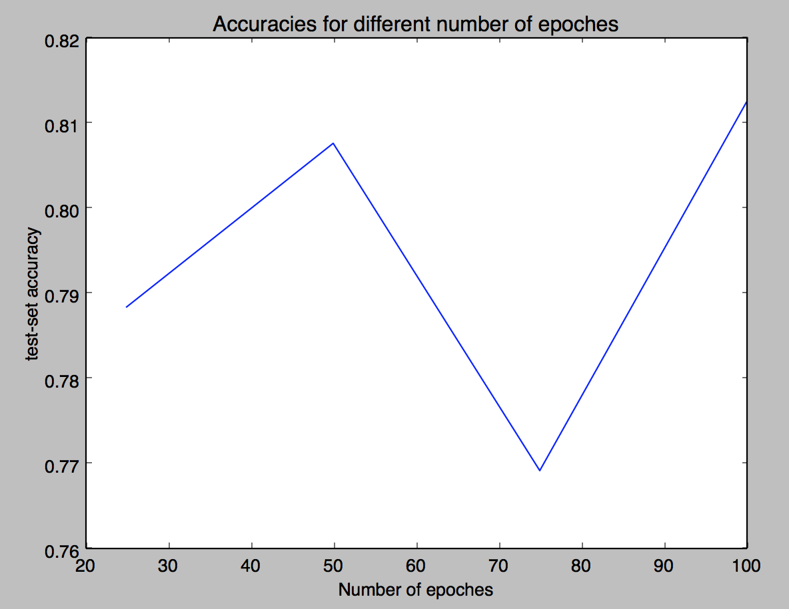

figure 2 is the plot of accuracy against the number of epoches.

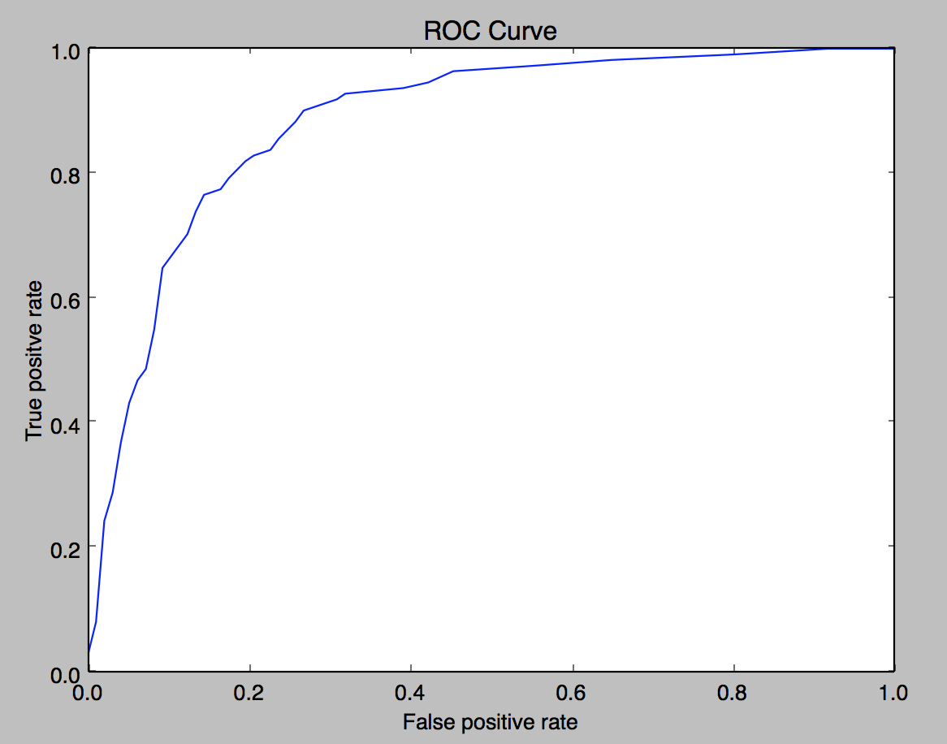

figure 3 is the roc curve of the model