**Project P5 – Project Description**

Nick Forquer, William Greer, Gerard Puhalla, Trevor Rambacher

As stated in the project update, the group has implemented an app that gives the user the option to send a file via WiFi-direct or Bluetooth connection. Files from the users download documents can be used for transferring on both the WiFi-direct and Bluetooth connections. The app sets up a connection between two devises utilizing the selected communication format. Once this connection has been established, both devises begin performing the Diffie-Hellman algorithm by creating public keys that they send to one another and private keys that they use to generate the secret shared key. After both sides have calculated the secret shared key, they can send encrypted messages across the connection. When they receive a message, they know it came from the other party and can easily decrypt it to read the message. Aside from establishing the connection between phones and sending messages between the phones, the two connection types use the same code to perform Diffie-Hellman and encrypt/decrypt the messages.

The app was tested after being downloaded onto the phones of two group members. One phone was set up as the receiver and the other phone was set up as the sender. During this initial test, we did find a bug in sender, the sender was not looking for a receiver properly we also had to set up permissions due to one of the phones having above android 6, but the receiver seemed to work properly. We then ran into the problem that the phones would properly generate the shared keys but weren’t receiving the other phones key properly.

The team did not omit anything from project that was mentioned in the original project description and added the challenge of sending files via Wifi-direct to make the project more complicated for four people to work on.

Screenshots of what our application looks like and a demo have been included below with descriptions, some images may look different due to coming from screenshots of an emulator opposed to from a phone.

**Bluetooth Screenshots:**

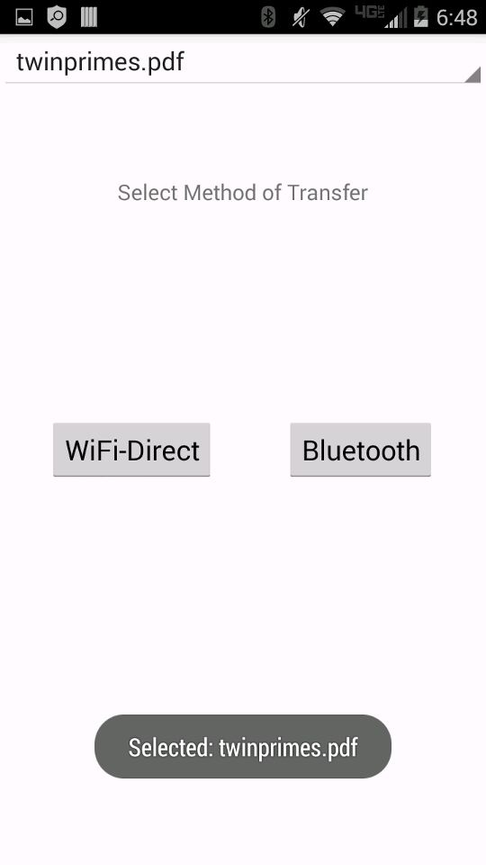

Choice page for wifi-direct or Bluetooth connection with the file “twinprimes.pdf” selected.

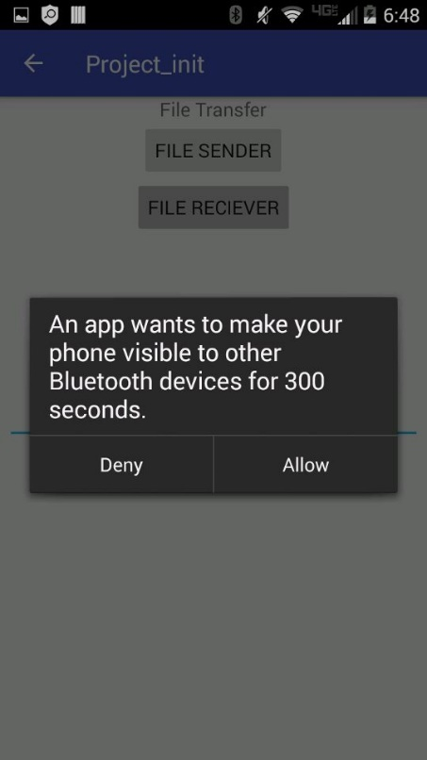

App asking permission to use Bluetooth and user selecting if they are the sender or receiver of the file.

**WIFI Screenshots**

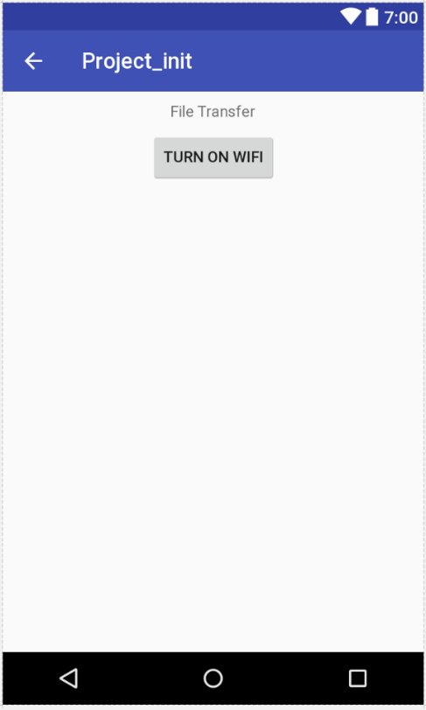

Ensuring user has wifi turned on for wifi-direct transfer.

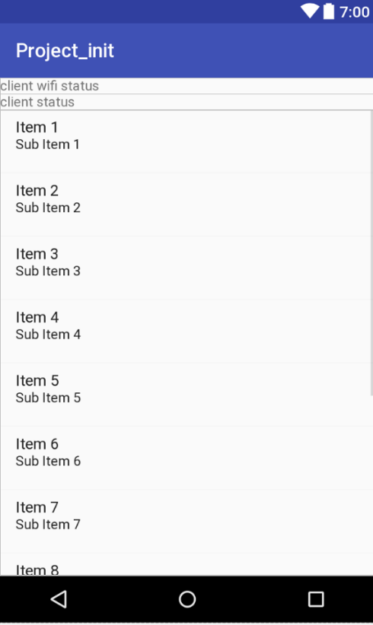

Sample file to that can be sent via connections

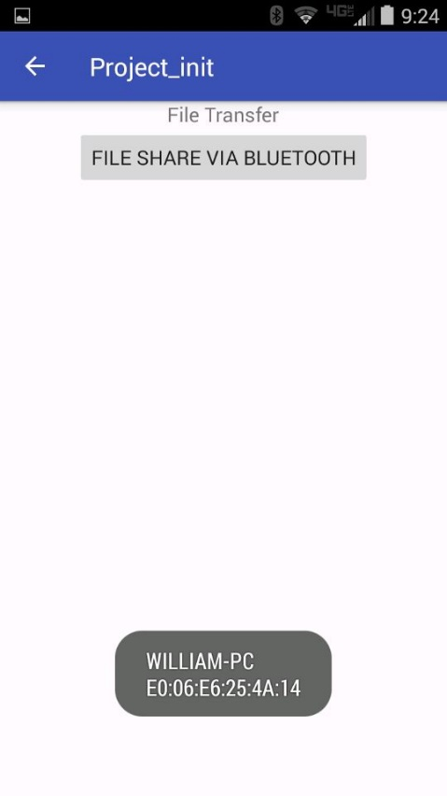

Showing completed connection via Bluetooth