**Project P5 - Project Update**

Nick Forquer, William Greer, Gerard Puhalla, Trevor Rambacher

The group has implemented an app that gives the user the option to send a file via Wifi-direct or Bluetooth connection. We have a file set up that will be our test document for transferring on both the wifi-direct and Bluetooth connections. At the current point in time we are able to make the connections between devices with the respective manners but are unable to send the document. In order to send the file, we just need a little more trouble shooting. Once we are able to send the file in an unsecure manner, we will then work on increasing the security of the transfer. This will involve the generation and sharing of keys, calculating a shared key with Diffie-Hellman, encryption of the file with this shared key, sending the encrypted file and having the receiver properly decrypt the file. The roles of the project will stay the same at the current moment with Nick Forquer as Base Application Lead, William Greer as Key Sharing Lead, Gerard Puhalla as Wifi-Direct Lead, and Trevor Rambacher as Bluetooth Lead. Screenshots of what our application looks like have been included below with descriptions.

**Screenshots:**

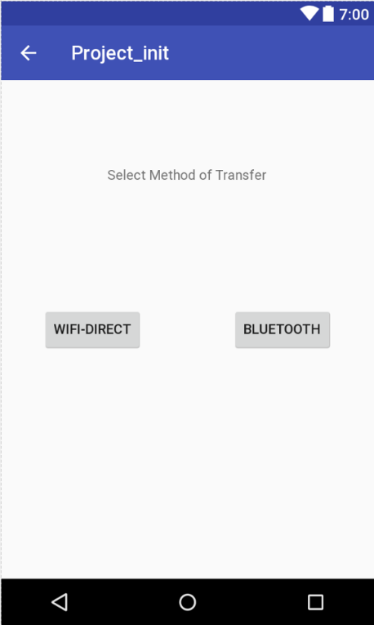

Choice page for wifi-direct or Bluetooth connection.

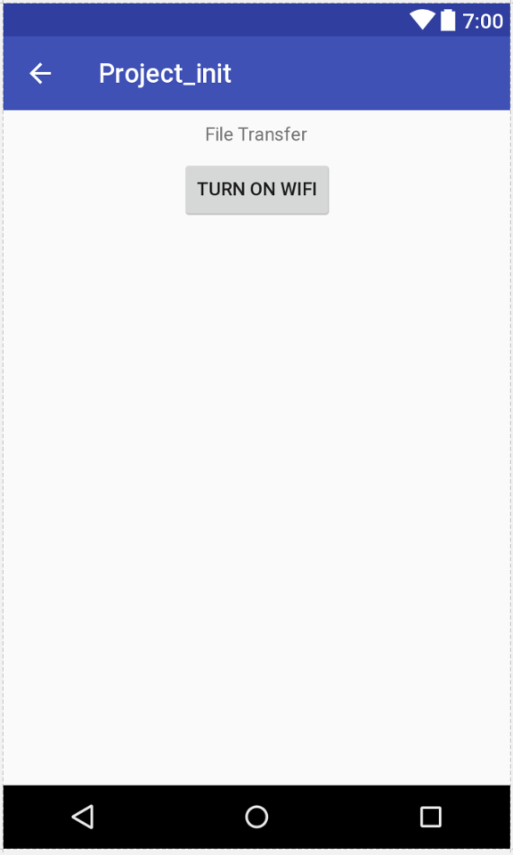

Ensuring user has wifi turned on for wifi-direct transfer.

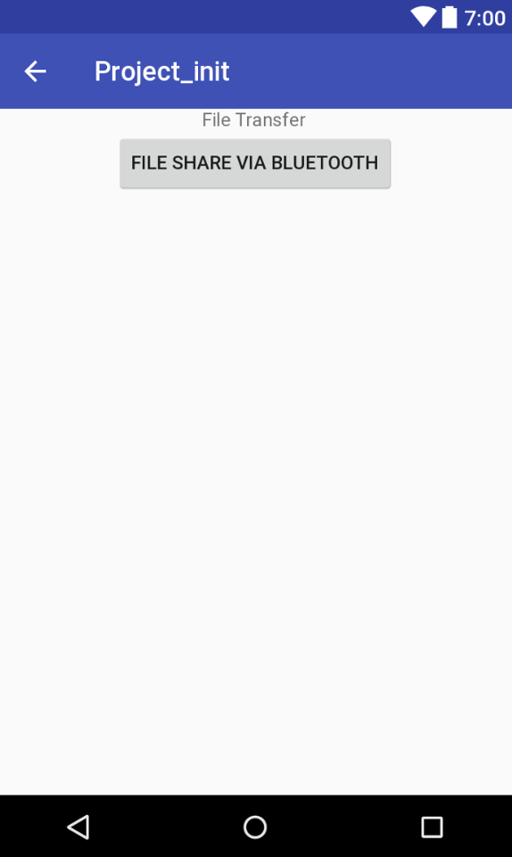

Page to start file transfer with Bluetooth

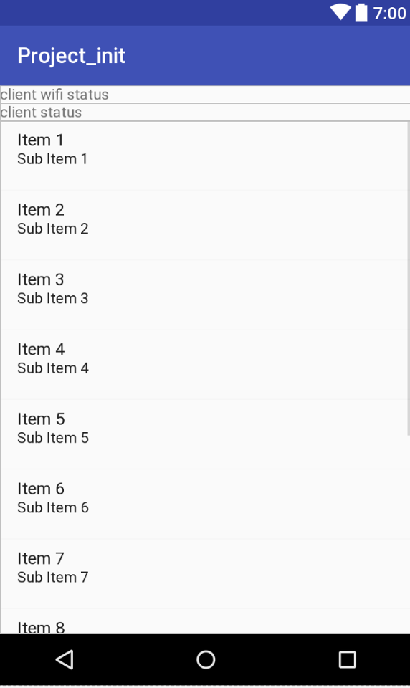

Sample file to be sent via connections

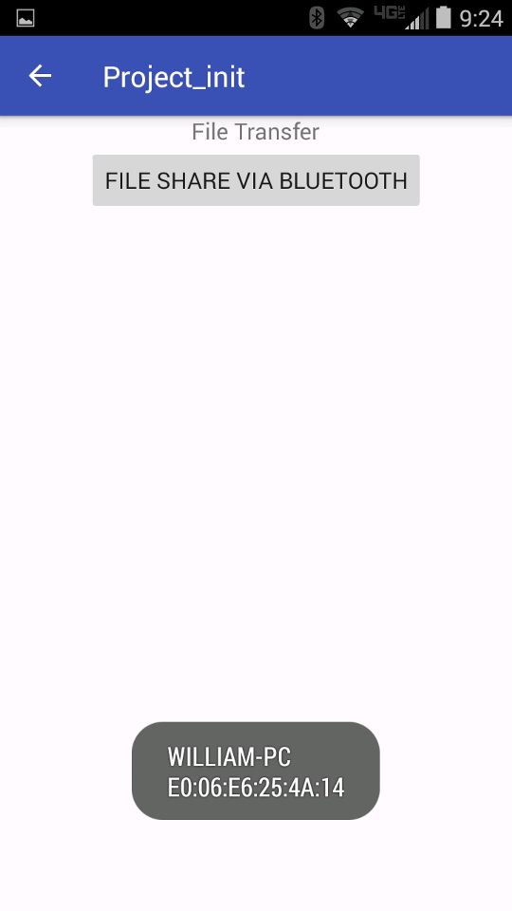

Showing completed connection via Bluetooth