Our Products and Services

IT strategy development

* Top-down, business-driven and aligned IT vision, objectives and plans;
* Infrastructure refresh;
* Improvements in IT’s ‘ways of working’

Business-IT transformation

* Cloud;
* Device mobility;
* Business Intelligence;
* DevOps

Automation & self-service

* uDo

Managed services

* Commoditised services around desktop engineering and packaging

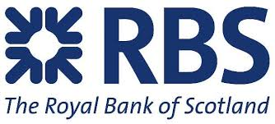

Some of our Clients

