RedPixie is an outcome based company and always focus on results for our customers. This is central to the RedPixie culture. RedPixie will apply the appropriate level of skills at any point on any given project to achieve our customers desired outcomes. Our proposals are always structured commercially around delivering success. This includes RedPixie sharing some of the commercial risk.

RedPixie Solution Framework

RedPixie operate a solution framework depicted below. This framework is adjusted and tuned as needed for a given engagement to support the process of reaching the desired goals of our customers.

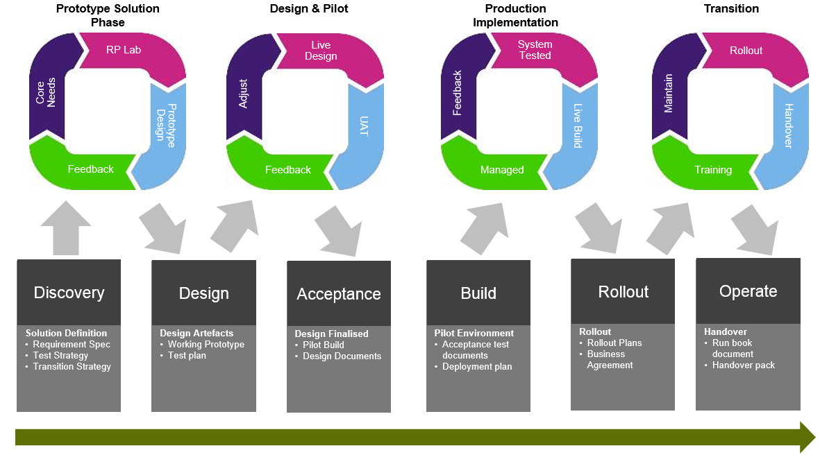

This proposal covers the initial discovery and high level design steps.

RedPixie Governance Framework

In large engagements RedPixie operate a robust governance structure, depicted below. RedPixie would utilise aspects of this framework as needed to ensure that good governance rigour is applied in reaching this engagements goals.

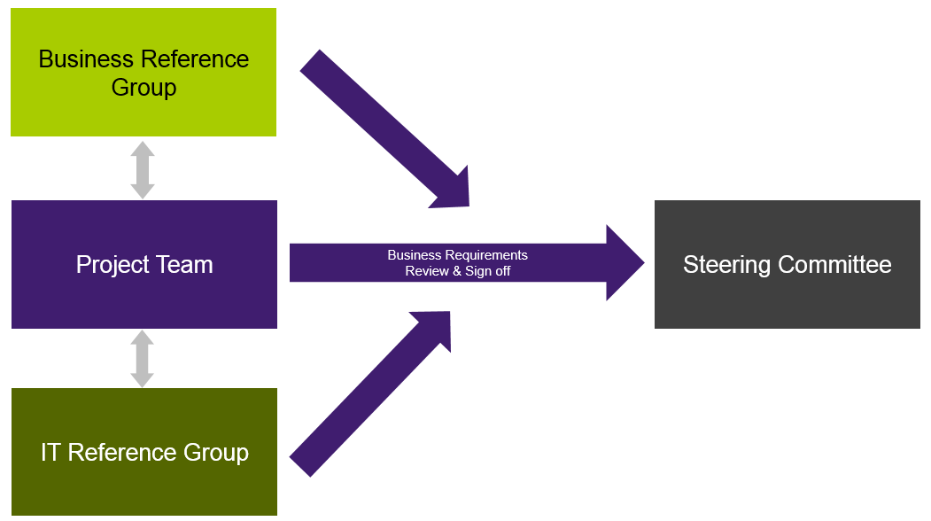

Example Overall Project Timeline

An example project timeline is show below with elapsed time to hit a set target date. This will be finalised at the start of the engagement. The timeline shows multiple example phases to hit an end of October date to transition all existing users. This proposal and quote covers the first phase only.

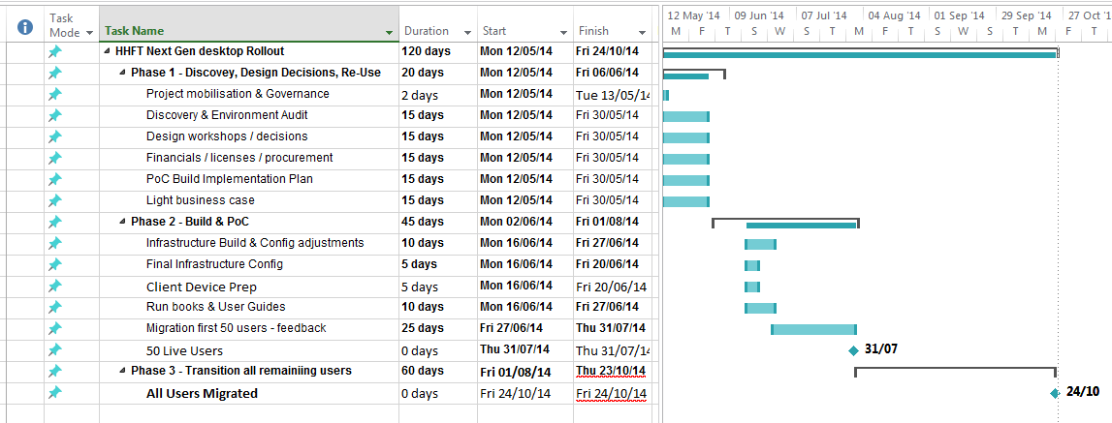

Engagement Deliverables

This engagement has the following deliverables:

* Multiple facilitated discovery and design workshops and capture key outputs.
* A decision document that captures re-use and design decisions from the workshops
* A High Level Design (HLD) Document that covers the UK VDI Service Tier
* An implementation plan that covers key build and transition steps along with a proposed schedule of transition activities
* A business case presentation (slide deck) that:
  + Identifies business outcomes and benefits
  + Highlights re-use opportunities and leverage of existing capital spend

<<Client_Company>> Dependencies

The following dependencies exist

* Sharing any relevant “end state” design documents that are available as inputs
* Providing RedPixie staff with access to appropriate RBCCM staff during the engagement (e.g. Wintel and Desktop teams)
* Providing RedPixie staff with building passes and user accounts
* Sharing license and vendor support information with RedPixie
* RBCCM technical stakeholders to participate workshops and meetings
* Provide access to staff who can represent the business requirements
* Identify constraints that exist (e.g. budget, schedule)

Proposed Team

RedPixie will provide sufficient resources and ensure it leverages its whole brain approach with the proposed team able to leverage additional resources within the company.

The following resources will be engaged.

* Project Management
* EUC Engineer
* Infrastructure engineer

Assumptions

The following assumptions have been made:

* Amulet client devices will be replaced in the final solution and RBCCM will identify replacements and secure budget accordingly. Where there is opportunity to re-purpose PC’s as thin clients then appropriate resources/software/budget would be secured for this work

Mobility and Availability of resources

RedPixie are able to start the project as within 1 week or the customer awarding the engagement.