LIBRARY MANAGEMENT SYSTEM

GROUP NO 5

MEMBERS

1. GREESHMA CT
2. SREEKESH A
3. ARCHANA D
4. DEVANANDA D
5. SAJIL S
6. ABHISHEK KRISHNA

1. Introduction
1.1 Purpose
The purpose of this document is to provide a detailed overview of the Library Management System. It will cover the functional and non-functional requirements to ensure a robust integration between the Python UI and MySQL database.

1.2 Scope
This system will automate the manual process of keeping track of books, members, and
issue/return transactions. It includes:
● Adding/Removing Books.
● Registering Members.
● Calculating Fines for overdue returns.
● Real-time inventory tracking.

2. System Architecture

The system follows a Two-Tier Architecture:
1. Client Tier (Frontend): Python (Tkinter) GUI for user interaction.
2. Database Tier (Backend): MySQL Server for persistent data storage.

FR1 Admin Login

Definition: Secure gateway for librarians to access administrative functions.
How it works: Admin enters username and password, which are validated against the Admin table in MySQL. Successful login grants access to the Admin Dashboard.
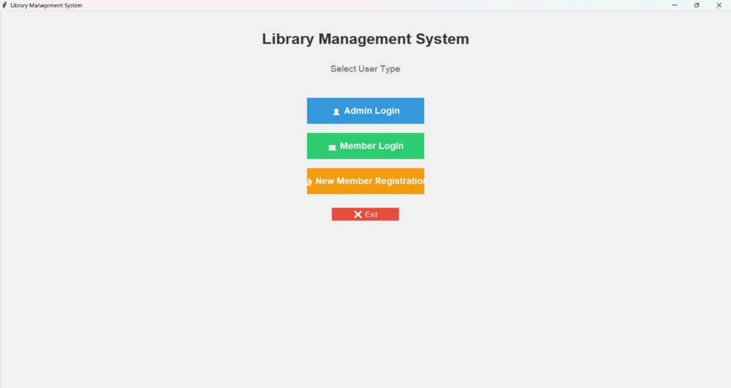

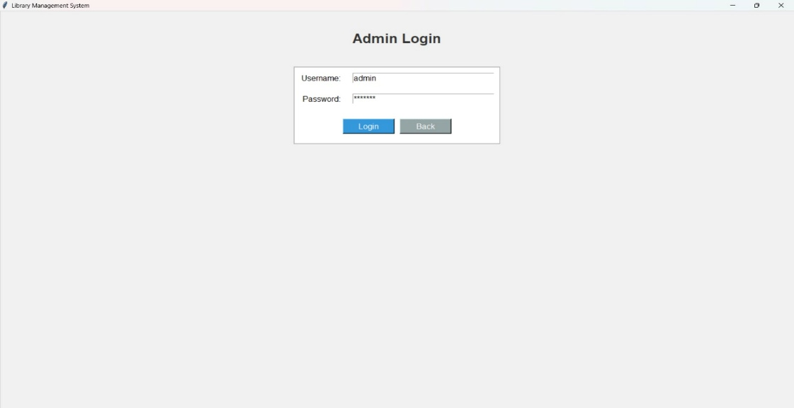

FR2 Book Management
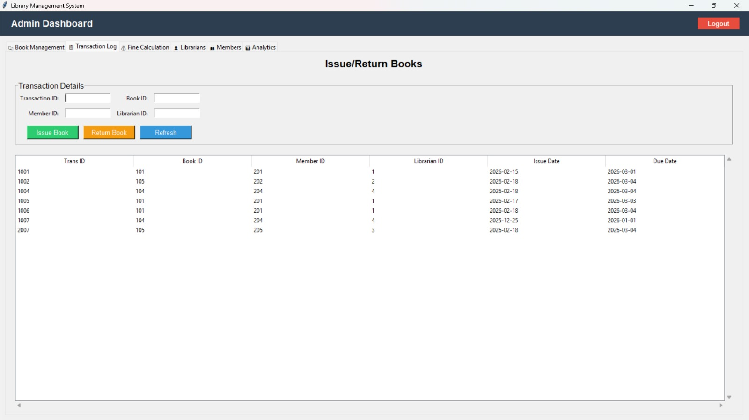
Definition: Central interface for managing the library's book inventory.
How it works: Provides CRUD operations (Create, Read, Update, Delete) on the Books table. Admin can add new books, update existing ones, delete records, and view all books in a treeview with search functionality.

FR3 Transaction Log
Definition: Interface for handling book issuance and returns.
How it works: Admin enters transaction details (Transaction ID, Book ID, Member ID, Librarian ID). The system automatically sets the issue date to current date and due date to +14 days, storing the record in the Transactions table.

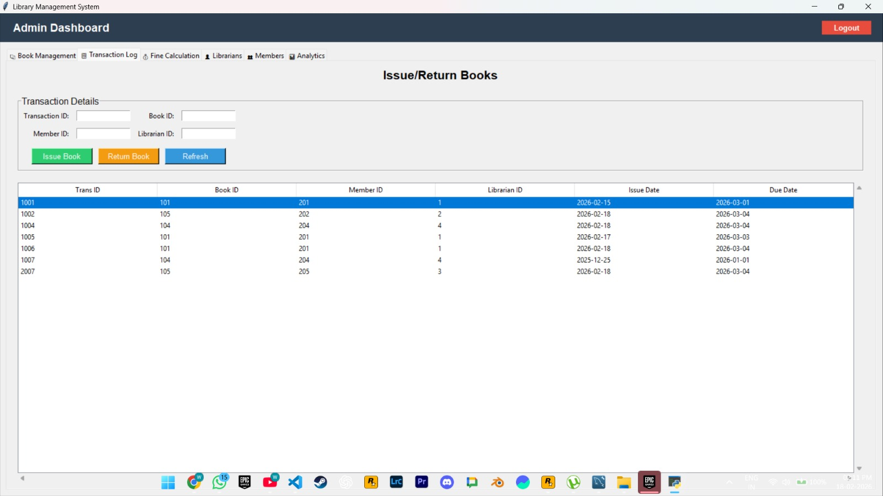

FR3 Fine Calculations
Definition: Tool for calculating penalties on overdue books.
How it works: Compares current date with due dates in the Transactions table, calculates days overdue, and applies a fine of ₹10 per day. Results are displayed in a table with total fine amount.

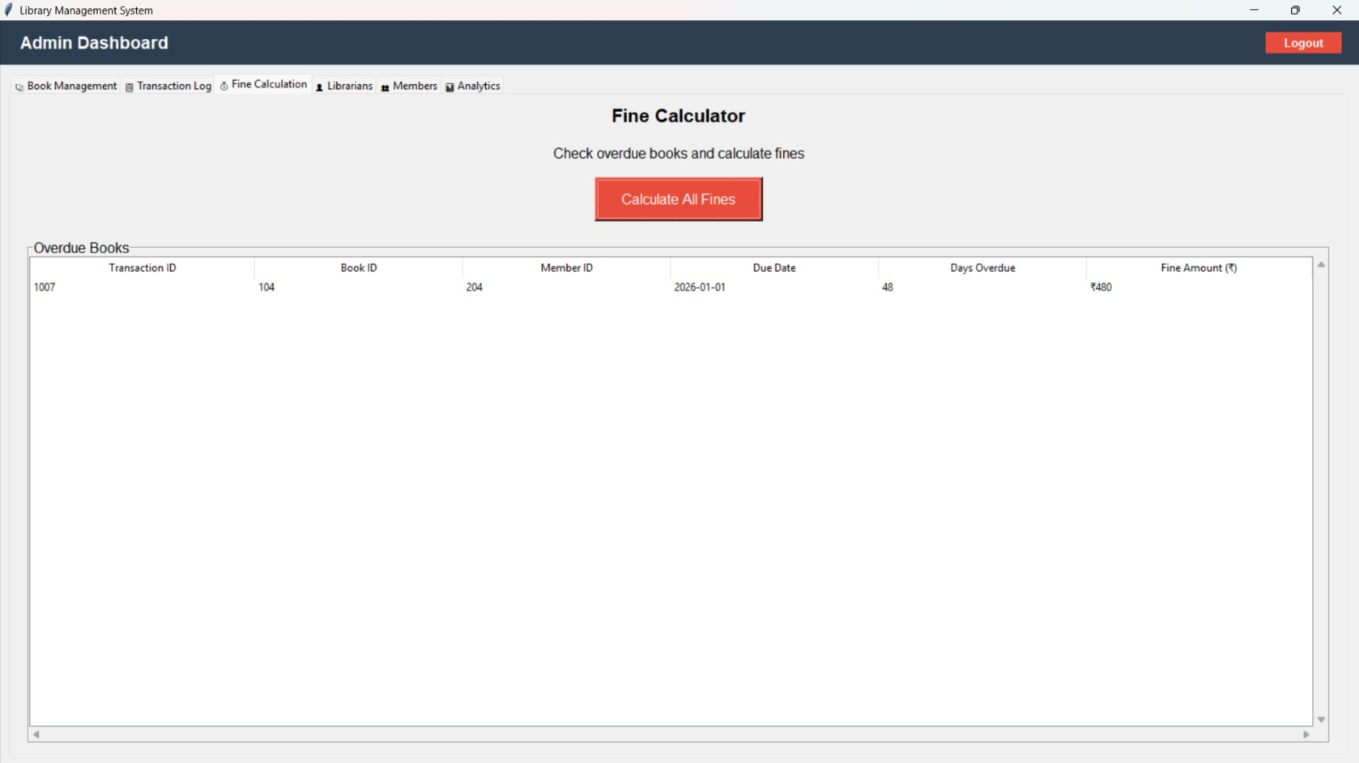

FR4 Search Facility
Definition: A dynamic filtering tool that allows users to quickly locate specific books from the library's inventory based on various criteria.

How it works: As the user types into the search field, the system continuously queries the database in real-time, filtering the displayed book records based on title or author matches, and instantly updates the results table without requiring a page refresh.

4. Database Design (Backend)
4.1 ER Diagram Components
ER DIAGRAM SUBMITTED.

5. Non-Functional Requirements
These describe the quality of the system (related to Module 4).
● Integrity: Use of Foreign Keys in MySQL to ensure Referential Integrity.
● Durability: Using db.commit() in Python to ensure transactions are saved.
● Security: Prevention of SQL Injection by using parameterized queries.
● Usability: Simple Tkinter forms that require no technical knowledge to operate.

