R SIMULATION: COMPARING SRSWR AND SRSWOR

# 7.0 R Simulation: Comparing SRSWR and SRSWOR
# 7.1 Generating the Hypothetical Population
set.seed(123)
N <- 10000
# Generate hypothetical GPA data (skewed towards higher values, mean ~3.1, sd ~0.5)
population_data <- data.frame(
StudentID = 1:N,
GPA = rbeta(N, shape1 = 8, shape2 = 2) * 4 # Scale Beta(8,2) to 0-4 range
)
# Check population parameters
pop_mean <- mean(population_data$GPA)
pop_sd <- sd(population_data$GPA)
cat("Population Mean GPA:", round(pop_mean, 3), "\n")
## Population Mean GPA: 3.198
cat("Population Std Dev GPA:", round(pop_sd, 3), "\n")
## Population Std Dev GPA: 0.484
# 7.2 Applying SRSWOR and SRSWR
n <- 100
num_sim <- 1000
# Vectors to store results
sample_means_wor <- numeric(num_sim)
sample_means_wr <- numeric(num_sim)
# Simulation loop
for (i in 1:num_sim) {
# SRS without replacement
sample_wor <- sample(population_data$GPA, size = n, replace = FALSE)
sample_means_wor[i] <- mean(sample_wor)
# SRS with replacement
sample_wr <- sample(population_data$GPA, size = n, replace = TRUE)
sample_means_wr[i] <- mean(sample_wr)
}
# 7.3 Comparing the Results
# Create a data frame for plotting
results_df <- data.frame(
Method = rep(c("SRSWOR", "SRSWR"), each = num_sim),
SampleMean = c(sample_means_wor, sample_means_wr)
)
# Load ggplot2 for visualization
library(ggplot2)
## Warning: package 'ggplot2' was built under R version 4.3.3
# Plot the distributions
ggplot(results_df, aes(x = SampleMean, fill = Method)) +
geom_density(alpha = 0.5) +
geom_vline(xintercept = pop_mean, linetype = "dashed", color = "red") +
labs(title = "Comparison of Sampling Distributions: SRSWOR vs SRSWR",
subtitle = paste("Population Mean (Red Line) =", round(pop_mean, 3)),
x = "Sample Mean GPA",
y = "Density") +
theme_minimal()
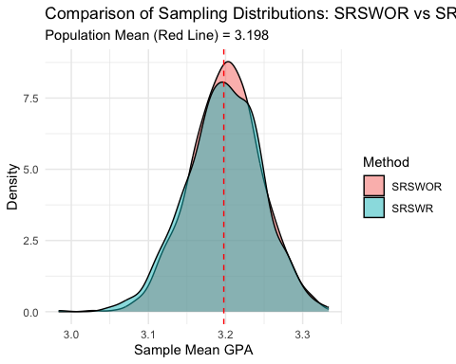
# Calculate and print the mean and variance of the sample means
cat("--- Simulation Results (Based on 1000 samples of n=100) ---\n")
## --- Simulation Results (Based on 1000 samples of n=100) ---
cat("SRSWOR - Mean of Sample Means:", round(mean(sample_means_wor), 3), "\n")
## SRSWOR - Mean of Sample Means: 3.2
cat("SRSWOR - Variance of Sample Means:", round(var(sample_means_wor), 5), "\n")
## SRSWOR - Variance of Sample Means: 0.0021
cat("SRSWR - Mean of Sample Means:", round(mean(sample_means_wr), 3), "\n")
## SRSWR - Mean of Sample Means: 3.197
cat("SRSWR - Variance of Sample Means:", round(var(sample_means_wr), 5), "\n")
## SRSWR - Variance of Sample Means: 0.00237
# Theoretical variance for comparison
theoretical_var_wor <- (pop_sd^2 / n) * ((N - n) / (N - 1))
theoretical_var_wr <- (pop_sd^2 / n)
cat("\n--- Theoretical Variance ---\n")
##
## --- Theoretical Variance ---
cat("Theoretical SRSWOR Variance (with FPC):", round(theoretical_var_wor, 5), "\n")
## Theoretical SRSWOR Variance (with FPC): 0.00232
cat("Theoretical SRSWR Variance:", round(theoretical_var_wr, 5), "\n")
## Theoretical SRSWR Variance: 0.00235
# Additional comparison: Standard Error
cat("\n--- Standard Error Comparison ---\n")
##
## --- Standard Error Comparison ---
cat("SRSWOR - SE from simulation:", round(sd(sample_means_wor), 5), "\n")
## SRSWOR - SE from simulation: 0.04578
cat("SRSWOR - Theoretical SE:", round(sqrt(theoretical_var_wor), 5), "\n")
## SRSWOR - Theoretical SE: 0.0482
cat("SRSWR - SE from simulation:", round(sd(sample_means_wr), 5), "\n")
## SRSWR - SE from simulation: 0.04871
cat("SRSWR - Theoretical SE:", round(sqrt(theoretical_var_wr), 5), "\n")
## SRSWR - Theoretical SE: 0.04844

