Clothes&stuff
Official document
Future plan- dresses- for launch
Other aspects:
1.delivery
2.packaging
3.budget breakdown:
1L:
5k raw cloth
Jan 2 - first Chickpet run
Red cloth (1m)- 400
Yellow cloth(1 1/2M)- 300
Red top stitching – 600
Yellow top stitching-450
Accessories-3028
4.Shoot ideas:
-vegetable market
-panipuri
-auto
-smoking
-chai tapri
-flower market
-railway station
-construction site
-if we can find a handpump bonus
-fishmarket
-grocery store shopping
-riding bike
-dj
Skateboarding
Hotel room shoot
ADITI HOUSE
Golf
Tennis
Parking Lot
Clubbing
Clubbin otw cab
Cricketer Bf
Thar Shoot
Aryaman- Appartment Shoot
Time line
Jan end goals:
G
-website
-instagram advertisements
-15 reels
-influencer outreach
-marketing
-labels and tags
V
-setup flip kart amazon myntra
-find a reliable manufacturer
Feb end goals:

Initial launch: Tops
1. 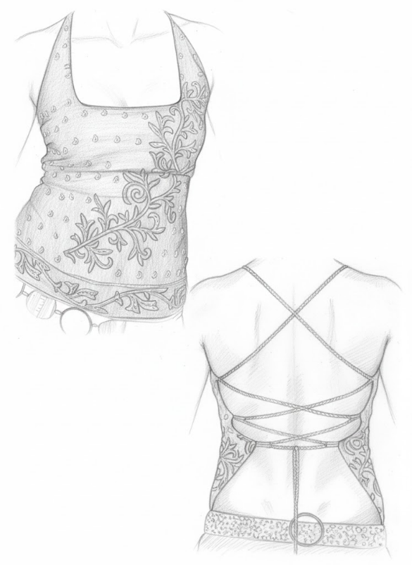
Square neck
Red fabric
2. 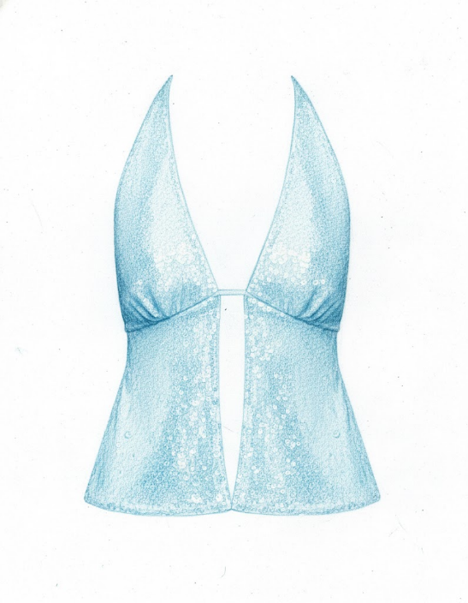
Ibiza
Ocean blue

3.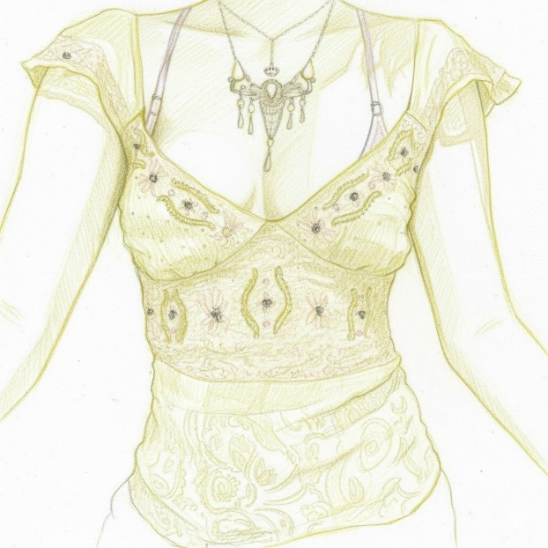
Yellow
With sleeves
4. 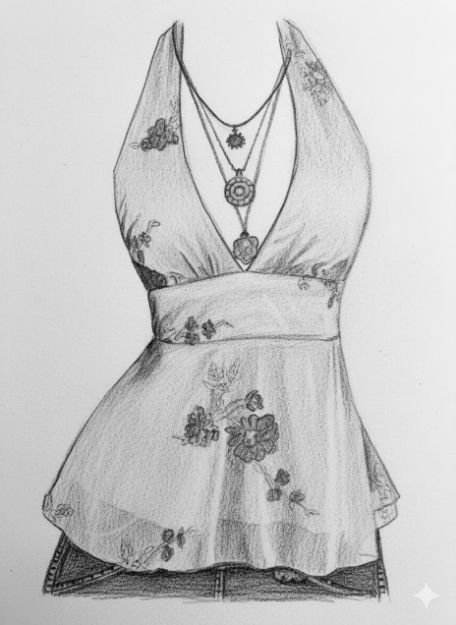
Black
Plain fabric

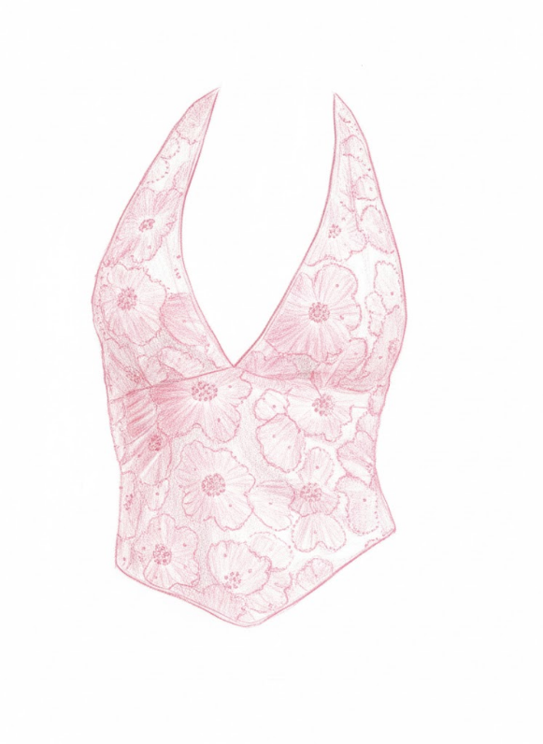

5.pink
Plain cloth

