**CDA Test Automation:**

Automated user acceptance test is implemented with the Robot framework, that makes use of Selenium Library to interact with Web elements. This is a keyword driven framework built on python libraries.

This test is named as **CDA_Testsuite** and it is integrated with Jenkins for Continuous testing.

Setup:

1.Install robotframework-SeleniumLibrary in the host machine.

2.Add the Robotframework plugin to the Jenkins.

3.Code is kept in the git repository. (https://github.com/greeshmabits/cda_test.git)

4.Chrome browser and Chromedriver should be present in the host machine.

5.Python should be installed in the host machine.

**Testcases**

There are 4 testcases automated. They are:

1.Verify the title of the ChemometricsDataAnalyzer application homepage.

2.Verify the login for admin .

3.Verify the login for general user.

4.Verify the analyze data feature gives the analysis report.

**Automation folder structure** is as follows:

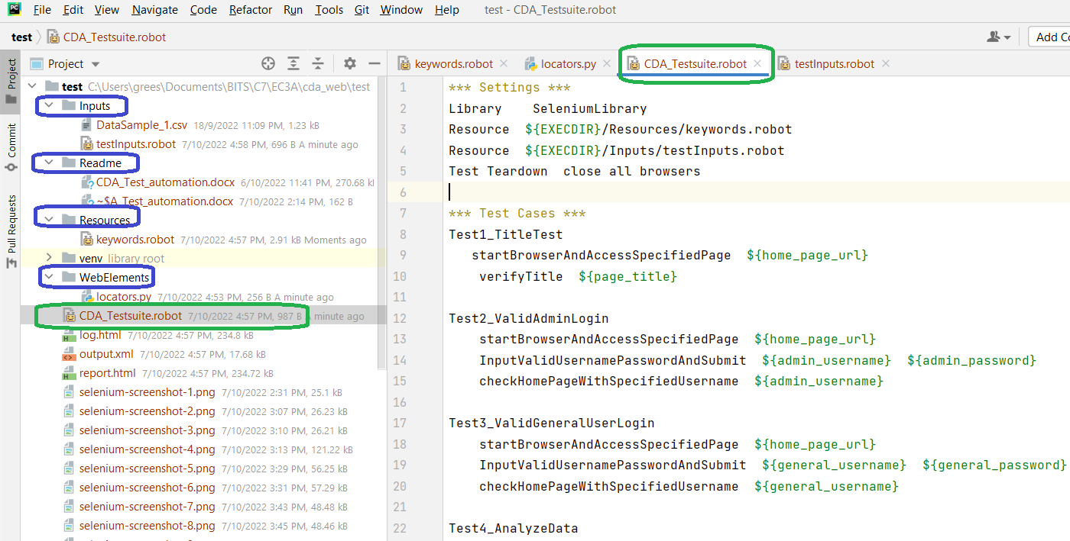

**Input**: All the test inputs are stored in this folder

**Readme**: user guide on CDA_Automation test suite.

**Resources**: All the keywords are defined inside this folder

**WebElements**: All the Web element locators or accessors are inside this folder.

**CDA_Testsuite.robot** : This file has all the testcases

.**Test** **result** : log.html,output.xml,report.html and screenshot in jpeg for failure scenarios.

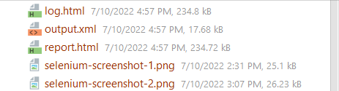

**Test suite**

Test suite is named as **CDA_Testsuite.robot** and it has all the four testcases.

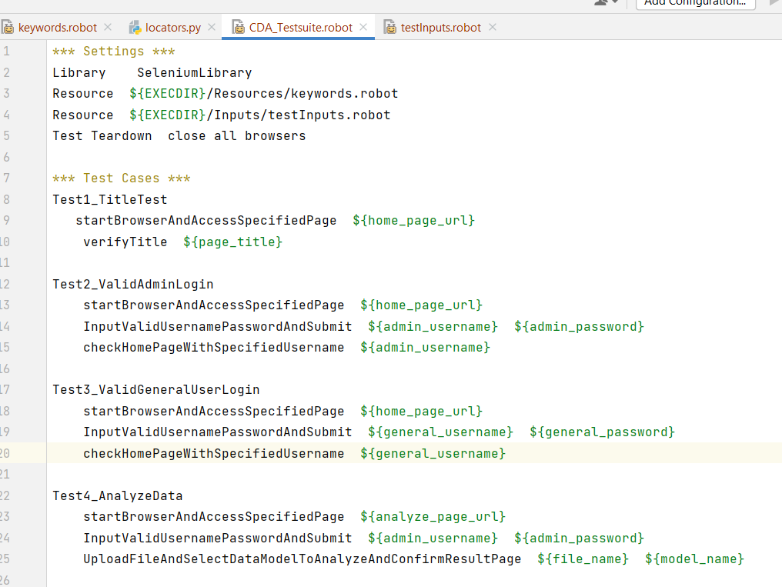

**Command to execute the test suite**

robot CDA_Testsuite.robot

**Jenkins Job Configuration**

The job is named as cda-test and the description also entered. The other details are as follows:

1.Source code management

Git->Repository URL> https://github.com/greeshmabits/cda_test.git

Credentials>input repository accessible credentials

Branch to build> */master

2.Build

Execute shell>Command > robot CDA_Testsuite.robot

3.Post-build Actions

Publish Robot Framework test results > Advanced>

Name of archive directory > robot-plugin

Output xml name > output.xml

Report html name > report.html

Log html name > log.html

**Test result**

Test result will be available after execution as report.html, output.xml and log.html

These results can be pulled to Jenkins using the robot framework plugin.

Jenkins display result as follows:

