ServiceNow-Based Employee Laptop Request Application
Project manual/implementation guide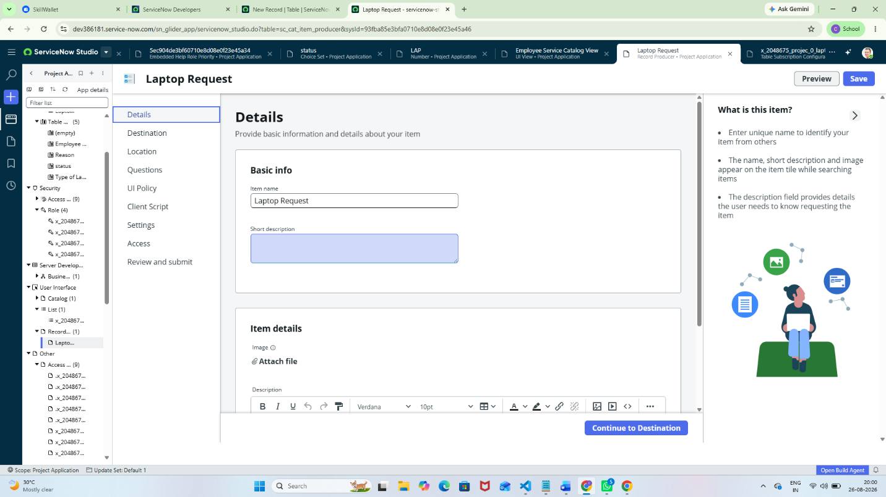
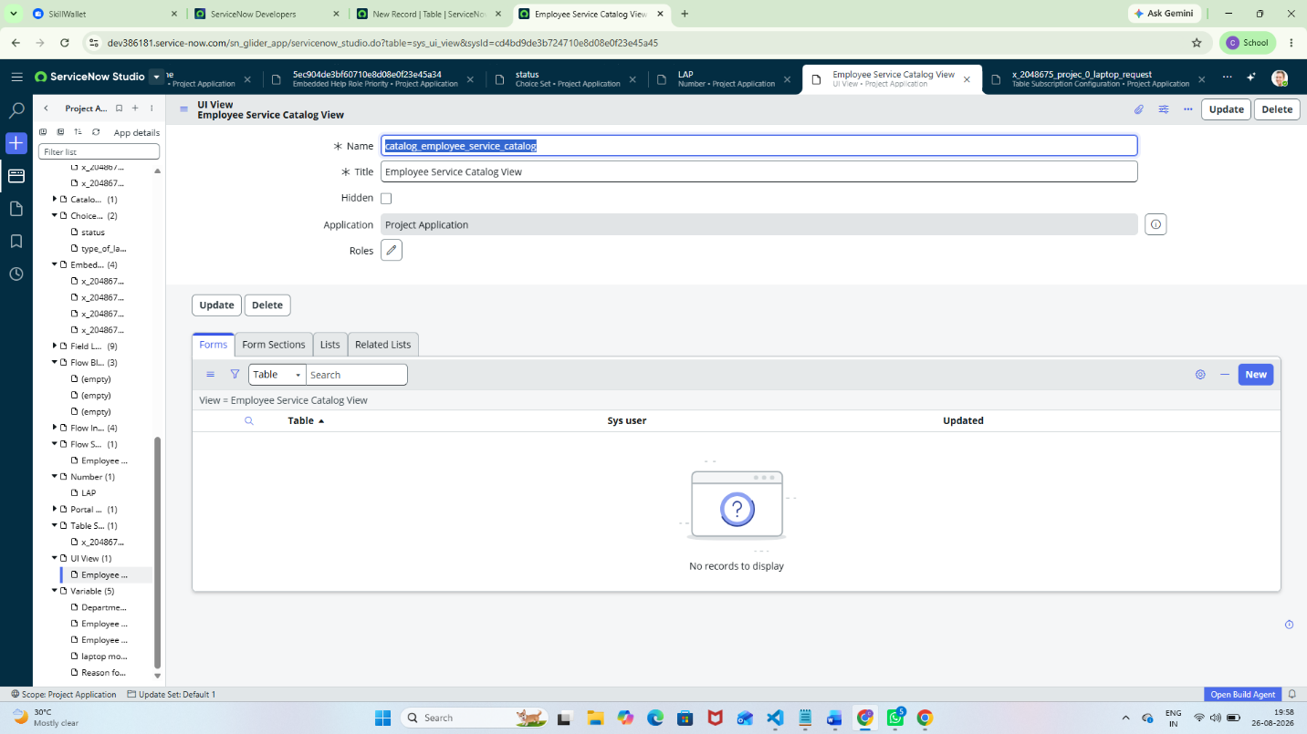
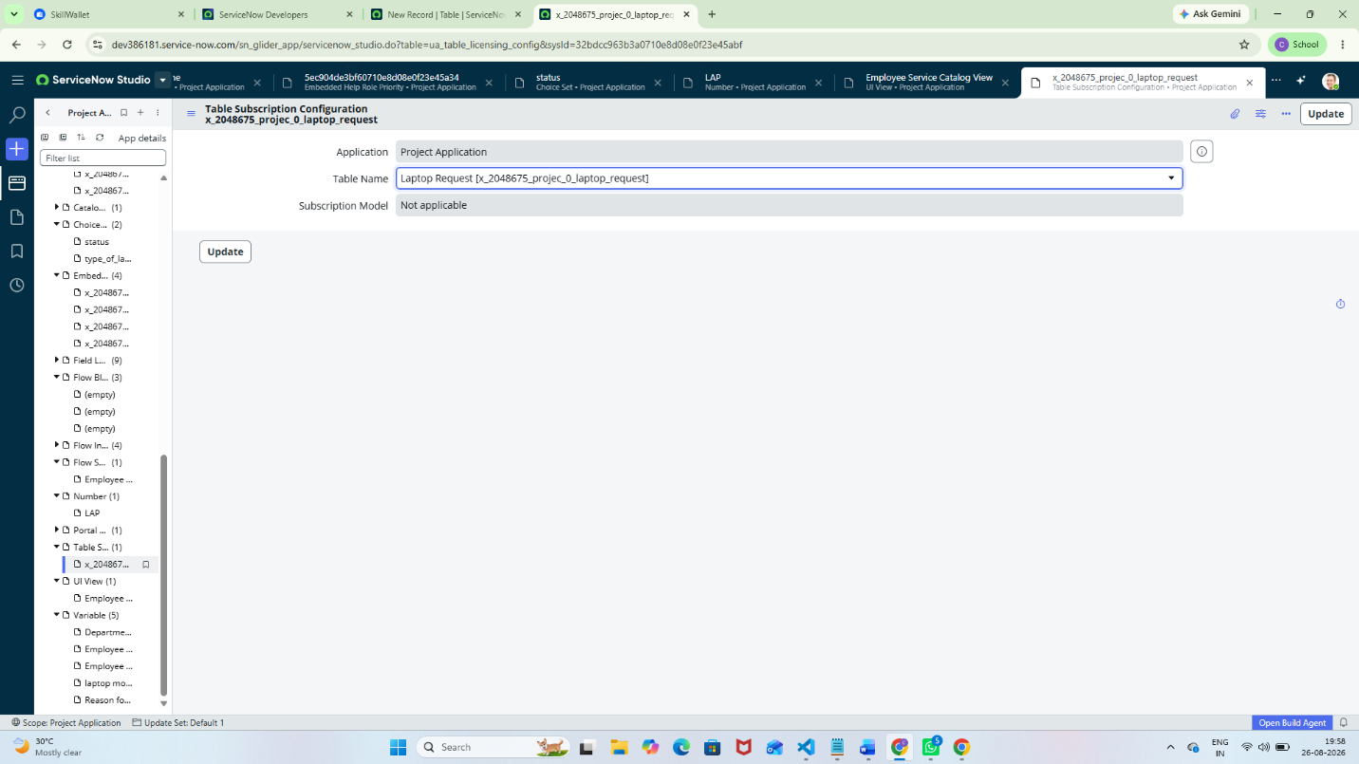
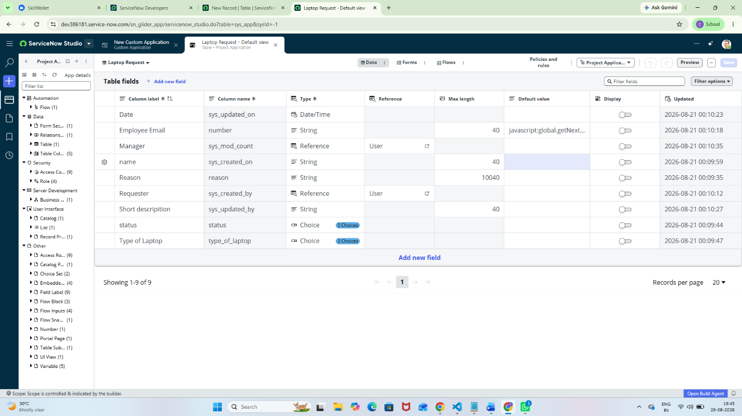
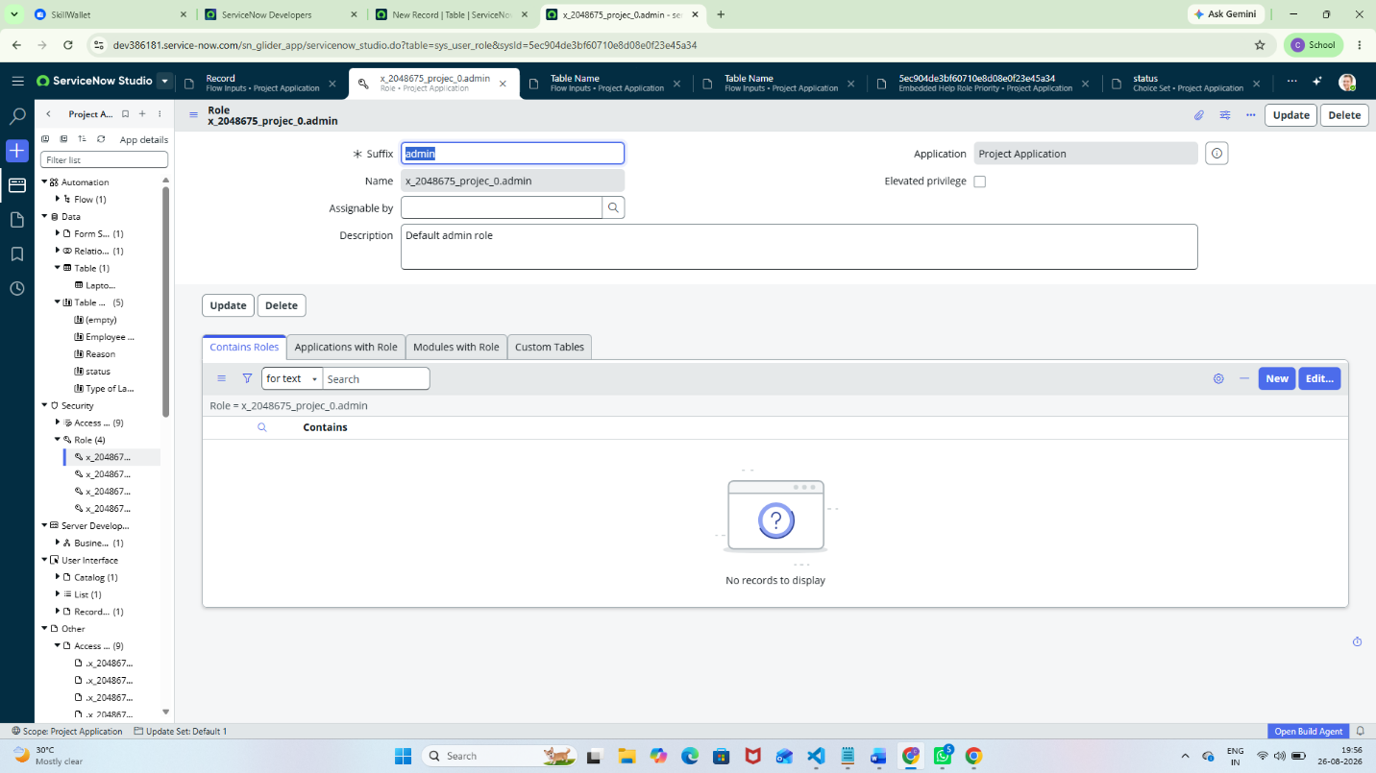

1.Project Overview
- This project is used to request laptops through ServiceNow.
- Employees can submit a laptop request using a Service Catalog.
- The request contains details like laptop type, specifications, and reason.
- The request is sent for manager approval.
- After approval, the IT team processes and fulfills the request.
- Employees can track the status of their requests.
- It reduces manual work and paperwork and makes the process faster and organized.

2.Business Objectives
- Automate the laptop request process.
- Reduce manual work for employees and IT teams.
- Make the request and approval process faster and easier.
- Provide tracking and visibility of laptop requests.
- Reduce errors in request processing.
- Improve employee satisfaction through a simple self-service portal.
- Help IT teams manage laptop requests efficiently

3. Functional Scope
- Employees can submit laptop requests through the ServiceNow Service Catalog.
- Employees can enter laptop requirements and request details.
- The system sends requests for manager approval.
- Managers can approve or reject requests.
- IT team can view, process, and fulfill approved requests.
- Employees can track the request status.
- The system sends notifications about request updates.
- All requests are stored and managed in ServiceNow.

4. User Roles
- Employee – Submits a laptop request and tracks its status.
- Manager/Approver – Reviews and approves or rejects the request.
- IT Support Team – Processes approved requests and arranges laptop fulfillment.
- ServiceNow Administrator – Manages users, roles, catalog items, workflows, and system configuration.
5. ServiceNow Table Design
Table | Purpose

Laptop Request Table | Stores employee laptop request details.

Employee/User Table | Stores employee information such as name, department, and email.

Approval Table | Stores approval details such as approver, approval status, and comments.

Laptop Inventory Table | Stores available laptop details such as model, specific availability.

6. Create the Laptop Request Table
- Open the ServiceNow application/table configuration area.
- Create a new table.
- Set the label to Laptop Request.
- Allow ServiceNow to generate the technical table name.
- Associate the table with Employee Laptop Request Management.
- Save the table and verify the Columns/Table Columns section

7. Create Fields for the Laptop Request Table
- Create Employee Department as String.
- Create Assigned To as a Reference to User.
- Create Requested Date as Date/Time.
- Create Laptop Type as Choice.
- Create Requested For as a Reference to User.
- Create Priority as Choice.
- Create Status as Choice.
- Create Laptop Specifications as String / Multi-line Text.
- Create Reason for Request as String / Multi-line Text.
- Do not duplicate standard system fields such as Created, Created By, Updated, and Updated By.

8.Choice Values
- Laptop Type examples: Standard Laptop, High-Performance Laptop, Developer Laptop, Business Laptop.
- Priority examples: 1-Critical, 2-High, 3-Moderate, 4-Low.
- Status examples: New, Awaiting Approval, Approved, Rejected, In Progress, Completed, Closed.
- Use the exact values required by the project instructions if they differ from these examples.

9.Application Menu and Module
- Create a module under Employee Laptop Request Management.
- Use a clear title such as Laptop Requests.
- Configure the module to open the Laptop Request table/list.
- Save the module and verify that it appears in the Application Navigator.
- If the Link Type screen uses different labels in your ServiceNow release, choose the available table/list option that opens Laptop Request record
10.Form and List Configuration
- Arrange the form fields in a logical order: Number, Requested For, Department, Laptop Type, Requested Date, Priority, Assigned To, Status.
- Make important fields such as Requested For, Department, Laptop Type, and Requested Date mandatory where appropriate.
- Configure the list to display: Number, Requested For, Department, Laptop Type, Priority, Assigned To, Status, and Requested Date.
- Test sorting and filtering of laptop request records.

11. Flow / Automation
- Recommended lifecycle: Laptop Request Created → Validation → Assignment → Manager Approval → Approved or Rejected → In Progress → Completed → Closed.
- Use Flow Designer or the workflow tool available in your ServiceNow instance.
- Automatically update the request status at important stages.
- Send a notification to the employee/requester when the request is approved, rejected, or completed.

12. Approval Process
- Identify laptop requests that require manager approval.
- Create an approval action in the Flow Designer.
- Send the approval request to the employee's designated manager.
- Assign approved requests to the appropriate IT Support team for fulfillment.
- Wait for the approval result before proceeding with laptop fulfillment.
- If approved, move the request to In Progress and assign it to the IT Support team.
- If rejected, stop the fulfillment process and notify the requester.
- Update the request status to Approved or Rejected accordingly

13 Notifications
- Request Created – Confirmation notification to the employee/requester.
- Approval Requested – Notification to the manager/approver.
- Request Approved – Notification to the requester and IT Support team.
- Request Rejected – Notification to the requester with the rejection status.
- Request In Progress – Notification to the requester that IT is processing the request.
- Request Completed – Completion notification to the requester.
- Request Closed – Final notification to the requester when the request is closed.

14. Security
- Use appropriate roles for employees/requesters, IT fulfillers, managers/approvers, and administrators.
- Restrict ServiceNow configuration and administration to authorized users.
- Use Access Control Rules (ACLs) where required to protect laptop request data.
- Allow employees to view only their own requests where applicable.
- Allow IT Support to access and update requests assigned to them.
- Never store passwords, tokens, API keys, or confidential information in GitHub.

15. Testing Plan
- Create a valid laptop request and verify that a request number is generated.
- Test mandatory field validation for required laptop request details.
- Test assignment and routing to the appropriate IT Support team.
- Test the manager approval and rejection process.
- Test status changes from New → Awaiting Approval → Approved → In Progress → Completed → Closed.
- Test notifications for request creation, approval, rejection, and completion.
- Test list filtering and form display for laptop requests.
- Test role-based access for employees, managers, IT Support, and administrators.
- Capture screenshots as evidence for each major testing step.
16. GitHub Submission
- Create a GitHub repository for the Employee Laptop Request Application.
- Add the recommended files:
  - README.md
  - Project Manual PDF
  - Screenshots folder
  - Project documentation
- Do not upload passwords, credentials, API keys, tokens, or confidential data.
- Copy the GitHub repository URL after uploading the project.
- In SkillWallet, select Add GitHub Link.
- Paste the GitHub repository URL and submit it.

17.Demonstration Script
- Open Employee Laptop Request Management.
- Open the Laptop Requests module.
- Create a new laptop request.
- Show the configured fields and choice values.
- Save the request and show the generated Request Number.
- Show the assignment and current status.
- Demonstrate the manager approval/rejection process.
- Move the request through In Progress → Completed → Closed.
- Show the request list and filtering options.
- Show the configured automation/Flow Designer.
- Show the GitHub repository containing the project documentation and screenshots.

18.Final Deliverables
- Working ServiceNow Employee Laptop Request Application.
- Laptop Request table with required fields.
- Laptop Requests application module.
- Configured request form and list view.
- Flow Designer automation for the request lifecycle.
- Approval and notification configuration.
- Testing evidence and screenshots.
- GitHub repository with project documentation.
- Project manual and final demonstration.

19.Screenshot Checklist
- Laptop Request table record
- Table Columns/Fields
- Choice Values – Laptop Type, Priority, Status
- Application Module – Laptop Requests
- Laptop Request Form
- Laptop Request List
- Flow Designer / Automation
- Approval Configuration
- Notification Configuration
- Successful Test Record with Request Number
- GitHub Repository with project files and screenshots

20.Important Submission Note
- This is a manual/implementation guide for the Employee Laptop Request Application.
- Before final submission, replace any example values with the exact values configured in your own ServiceNow Developer Instance.
- Add your own ServiceNow screenshots as evidence of implementation and testing.
- Make sure the GitHub repository contains only non-sensitive project materials.
- Do not upload passwords, credentials, API keys, tokens, or confidential information.
- Verify that all project configurations and screenshots match your actual Employee Laptop Request Application.

