Common Network Security Threats
GREESHMA LAKSHMI KUKKATALA

Cyber Security

Research Report on Common Network Security Threats

1. Introduction
In today’s rapidly evolving digital world, network security has become a critical aspect of information technology. With the increasing use of the internet for communication, banking, education, business operations, and social interactions, vast amounts of sensitive data are transmitted and stored across networks every day. This makes networks a prime target for cybercriminals who aim to steal, manipulate, or destroy valuable information.
Network security refers to the policies, practices, and technologies used to protect computer networks and data from unauthorized access, misuse, modification, or disruption. It includes both hardware and software solutions such as firewalls, encryption, antivirus programs, and intrusion detection systems. A secure network ensures the confidentiality, integrity, and availability of data, which are essential for maintaining trust and smooth functioning of systems.
As technology continues to grow, cyber threats are becoming more advanced, frequent, and difficult to detect. Attackers use various methods such as malware, phishing, denial-of-service attacks, and hacking techniques to exploit vulnerabilities in networks. These threats can lead to serious consequences like data breaches, financial losses, identity theft, and damage to an organization’s reputation.
Moreover, the rise of cloud computing, mobile devices, and the Internet of Things (IoT) has expanded the attack surface, making network security even more challenging. Both organizations and individuals must stay informed about common network security threats and adopt effective preventive measures to protect their systems.
Therefore, understanding network security threats is essential not only for IT professionals but also for general users. Awareness, proper security practices, and timely updates play a key role in reducing risks and ensuring a safe digital environment.

2. What is a Network Security Threat?

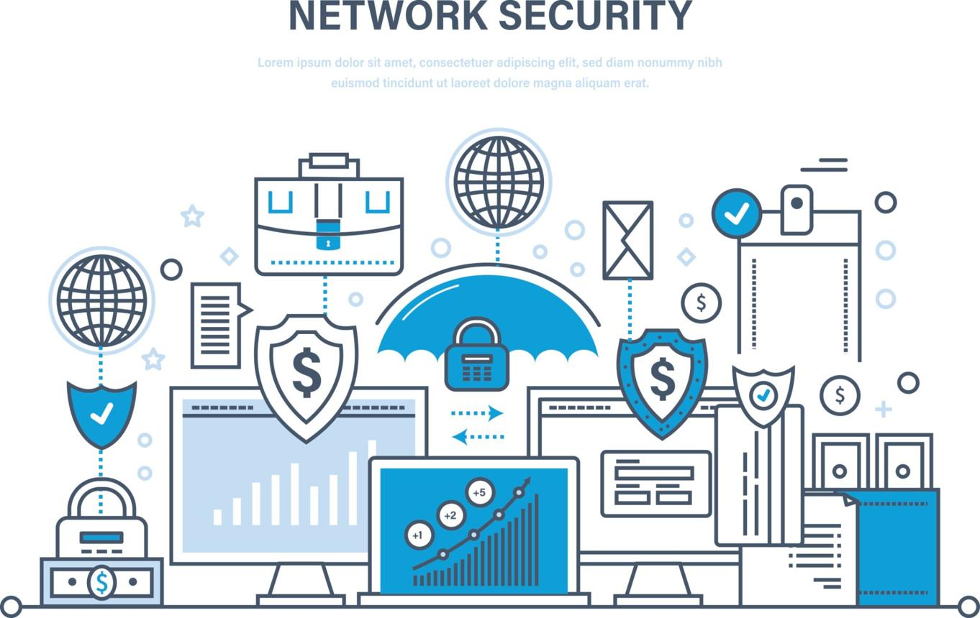
A network security threat is any activity, event, or action that has the potential to damage, disrupt, or gain unauthorized access to a computer network and its data. These threats aim to compromise the safety of information by affecting its confidentiality, integrity, or availability. In simple terms, a network security threat is anything that can harm a network or the data stored within it.
Network security threats can originate from various sources. External threats are usually carried out by hackers or cybercriminals who attempt to break into systems to steal sensitive information such as passwords, financial details, or personal data. On the other hand, internal threats come from individuals within an organization, such as employees or users, who may intentionally or unintentionally misuse their access privileges.
These threats can take many forms, including malicious software (malware), phishing attacks, denial-of-service attacks, and unauthorized access. Some threats are designed to spy on user activities, while others aim to damage systems or make services unavailable. With the increasing use of the internet, cloud computing, and connected devices, the number and complexity of network security threats are continuously growing.
Understanding what network security threats are and how they operate is the first step in protecting systems and data. By identifying potential threats early and applying proper security measures, organizations and individuals can reduce risks and ensure a safer digital environment.
Here is an expanded and detailed version of your section:
3. Types of Common Network Security Threats
Network security threats come in many forms, each targeting different weaknesses in a system. Understanding these threats helps in protecting networks effectively.
1. Malware (Malicious Software)
Malware is any software intentionally designed to harm a computer system, network, or user. It can enter a system through email attachments, unsafe downloads, or infected websites.
Common types of malware include:
- Viruses: Attach to files and spread when the file is opened
- Worms: Spread automatically across networks without user action
- Trojans: Disguise as legitimate software to trick users
Malware can steal sensitive data, damage files, slow down system performance, or even give attackers full control over a system.
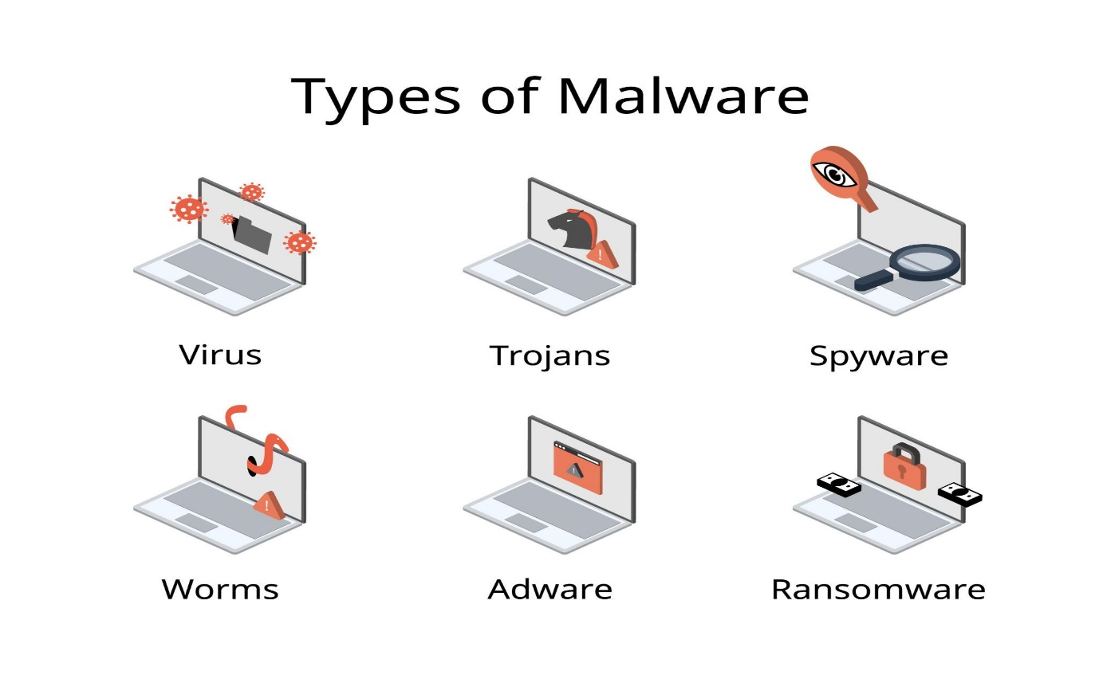

2. Phishing Attacks
Phishing is a type of social engineering attack where attackers trick users into revealing confidential information such as passwords, OTPs, or bank details.
Attackers usually send fake emails, messages, or links that appear to come from trusted organizations like banks or social media platforms. When users click these links, they are redirected to fake websites.
Common phishing methods:
- Email phishing
- SMS phishing (smishing)
- Fake websites
Phishing can lead to identity theft and financial loss.


3. Denial of Service (DoS) Attacks
A Denial of Service (DoS) attack occurs when attackers flood a network, server, or website with excessive traffic, making it unavailable to legitimate users.
A more advanced version is Distributed Denial of Service (DDoS), where multiple systems attack a single target simultaneously.
Effects of DoS attacks:
- Website crashes
- Slow performance
- Service interruption
These attacks are often used to disrupt business operations.

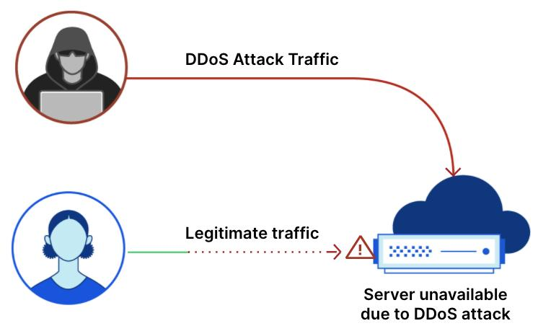

4. Man-in-the-Middle (MITM) Attack
In a Man-in-the-Middle attack, the attacker secretly intercepts communication between two parties without their knowledge.
For example, when a user connects to an unsecured public Wi-Fi network, attackers can capture the data being transmitted.
Risks include:
- Data theft
- Unauthorized transactions
- Message manipulation
This type of attack mainly targets sensitive information like login credentials.

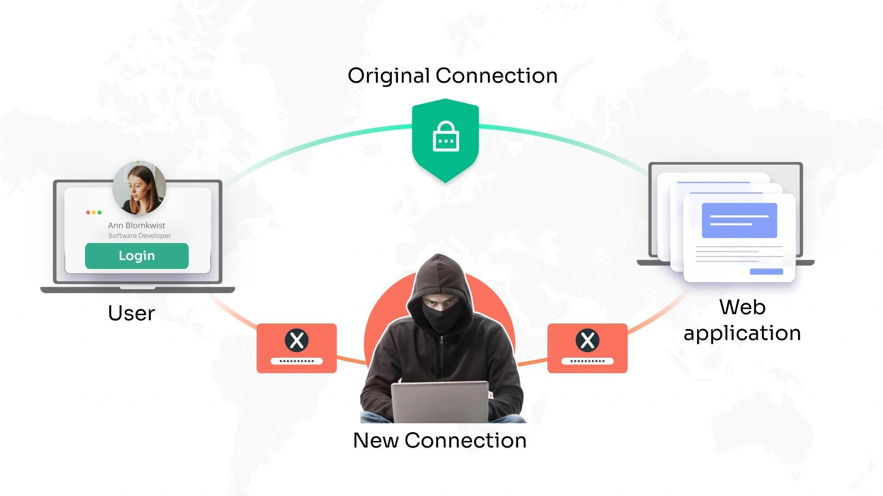

5. Password Attacks
Password attacks are attempts to gain unauthorized access by cracking user passwords.
Common techniques include:
- Brute Force Attack: Trying all possible combinations
- Dictionary Attack: Using a list of common passwords
- Credential Stuffing: Using leaked passwords from other sites
Weak or reused passwords make systems highly vulnerable.

6. Insider Threats
Insider threats originate from people within an organization, such as employees, contractors, or partners.
These threats may be:
- Intentional: Data theft or sabotage
- Unintentional: Mistakes like sharing sensitive data or clicking malicious links
Insider threats are dangerous because these users already have access to the system.

4. Effects of Network Security Threats
Network security threats can have serious and wide-ranging impacts on individuals, organizations, and even governments. These effects not only cause immediate damage but can also create long-term problems if not handled properly.
1. Loss of Important Data
One of the most common effects of network security threats is the loss of valuable data. Hackers can delete, corrupt, or steal important files such as personal records, business information, and confidential documents. In some cases, data may be permanently lost, which can disrupt operations and decision-making.
2. Financial Loss
Cyberattacks can lead to significant financial damage. Organizations may lose money due to stolen banking information, fraud, or ransom demands (as seen in ransomware attacks). Additionally, companies may need to spend large amounts on repairing systems, improving security, and compensating affected users.
3. Damage to Reputation
When a security breach occurs, customers and users may lose trust in the organization. A damaged reputation can reduce customer confidence, affect business growth, and lead to loss of clients. It may take a long time for an organization to rebuild its image after a cyberattack.
4. System Downtime
Some attacks, such as Denial of Service (DoS), can make systems or websites unavailable for a period of time. This downtime interrupts normal operations, delays services, and affects productivity. For businesses, even a short downtime can result in major losses.
5. Privacy Violations
Network security threats often result in the exposure of personal and sensitive information such as passwords, contact details, and financial data. This can lead to identity theft, misuse of personal information, and legal issues. Privacy violations can affect both individuals and organizations.
6. Legal and Compliance Issues
Organizations that fail to protect user data may face legal consequences. They may have to pay fines or face lawsuits for not following data protection laws and regulations. This adds to both financial and reputational damage.
7. Loss of Productivity
When systems are attacked or infected, employees may not be able to work efficiently. Time is wasted in fixing issues, recovering data, and restoring systems, which reduces overall productivity.

5. Prevention Measures
To protect networks from security threats, it is important to follow proper safety practices and use effective security tools. Prevention is always better than dealing with the damage caused by cyberattacks. The following measures help in maintaining a secure network environment:
1. Use Strong Passwords
Creating strong and unique passwords is the first step in securing any system. A strong password should include a mix of uppercase letters, lowercase letters, numbers, and special characters. Avoid using common words, names, or birthdays. It is also important to change passwords regularly and not reuse the same password across multiple accounts.
2. Install Antivirus and Anti-malware Software
Antivirus software helps detect and remove harmful programs like viruses, worms, and trojans. Keeping antivirus software updated ensures protection against the latest threats. Regular system scans can identify and eliminate hidden malware.
3. Update Systems Regularly
Software updates and security patches fix vulnerabilities in operating systems and applications. Hackers often exploit outdated systems, so it is important to enable automatic updates and install patches as soon as they are available.
4. Use Firewalls
A firewall acts as a barrier between a trusted network and untrusted external networks. It monitors incoming and outgoing traffic and blocks suspicious activity. Both hardware and software firewalls are essential for strong network security.
5. Avoid Clicking Unknown Links
Users should be careful when opening emails, messages, or links from unknown or suspicious sources. These links may contain malware or lead to phishing websites. Always verify the source before clicking.
6. Educate Users About Security
Human error is one of the biggest causes of security breaches. Providing training and awareness programs helps users understand common threats like phishing and password attacks. Educated users can identify risks and respond appropriately.
7. Use Data Encryption
Encryption converts data into a secure format that cannot be easily read by unauthorized users. It protects sensitive information during transmission over networks, especially in online transactions and communications.
8. Enable Two-Factor Authentication (2FA)
Two-factor authentication adds an extra layer of security by requiring users to provide two forms of verification, such as a password and a one-time code sent to their mobile device. This reduces the risk of unauthorized access.
9. Backup Important Data
Regular data backups help recover information in case of data loss due to cyberattacks or system failures. Backups should be stored securely, either offline or in a trusted cloud service.
10. Monitor Network Activity
Continuous monitoring of network traffic helps detect unusual activities early. Using intrusion detection systems (IDS) or intrusion prevention systems (IPS) can help identify and stop attacks before they cause damage.
6. Conclusion
In today’s digital age, network security has become more important than ever due to the rapid growth of technology and internet usage. As individuals and organizations rely heavily on digital systems for communication, storage, and transactions, the risk of cyber threats continues to increase. Network security threats such as malware, phishing, denial-of-service attacks, and unauthorized access can cause serious damage, including data loss, financial loss, and privacy violations.
Understanding the different types of network security threats and their potential impacts is essential for building a secure environment. These threats are becoming more advanced and sophisticated, making it necessary to adopt strong and updated security practices. Simple measures like using strong passwords, updating software regularly, and being cautious while using the internet can make a significant difference in preventing attacks.
Moreover, organizations must invest in advanced security tools, regular monitoring, and employee training to minimize risks. Awareness among users plays a key role, as human error is often the weakest point in security systems. By combining technology, proper policies, and user education, it is possible to create a strong defense against cyber threats.
In conclusion, network security is not just a technical requirement but a shared responsibility. Continuous learning, vigilance, and proactive prevention strategies are essential to stay safe in the ever-changing cyber world. By taking the right precautions, we can protect our data, systems, and digital lives effectively.
7. References (Links Only)
- https://www.cisco.com/c/en/us/products/security/common-cyberattacks.html
- https://www.kaspersky.com/resource-center/threats
- https://www.ibm.com/topics/cybersecurity
- https://www.fortinet.com/resources/cyberglossary
- https://www.cynet.com/security-foundations/cybersecurity/
- https://cyberswork.org/resources/cyber-security-web-resources/
- https://globalcybersecuritynetwork.com/resources/
8.Github
https://github.com/greeshmalakshmikukkatala-afk/Common-Network-Security-Threats.git

