Deploy a folder into the git hub

Steps required to deploy a folder into the git hub

To push the folder into the git hub we need to use commands

Requirements needed:-

1. Must have git hub account
2. We have to install git software to the system

Steps needed to deploy a folder into git hub:-

1. Create a new repository in the git hub of choosing public and add a readme. File

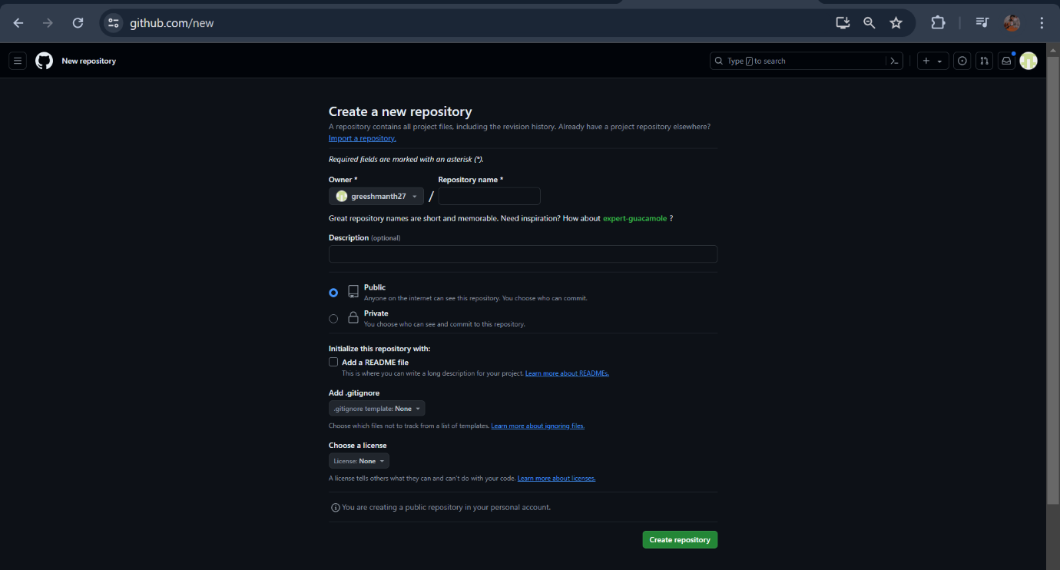

1. We have to create one folder in the local repository

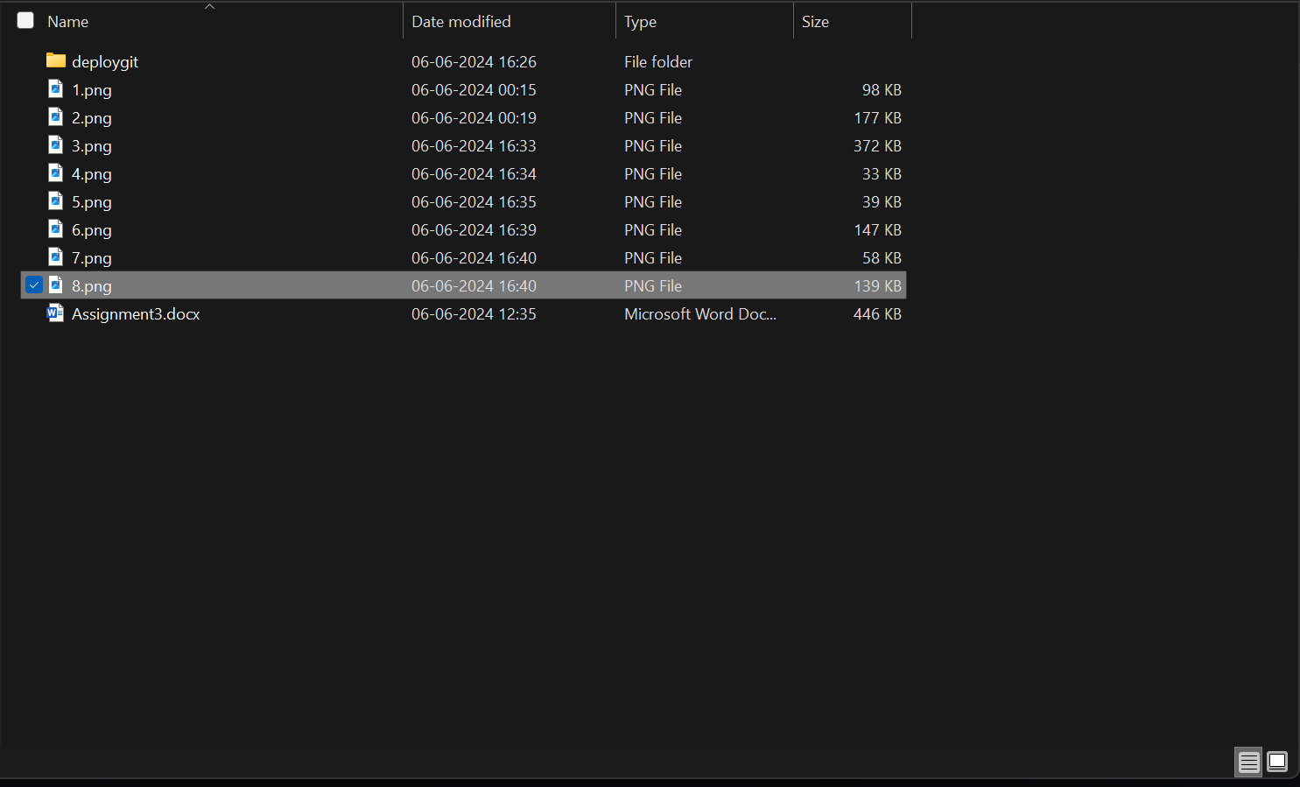

3. right click on that folder and select open git bash here

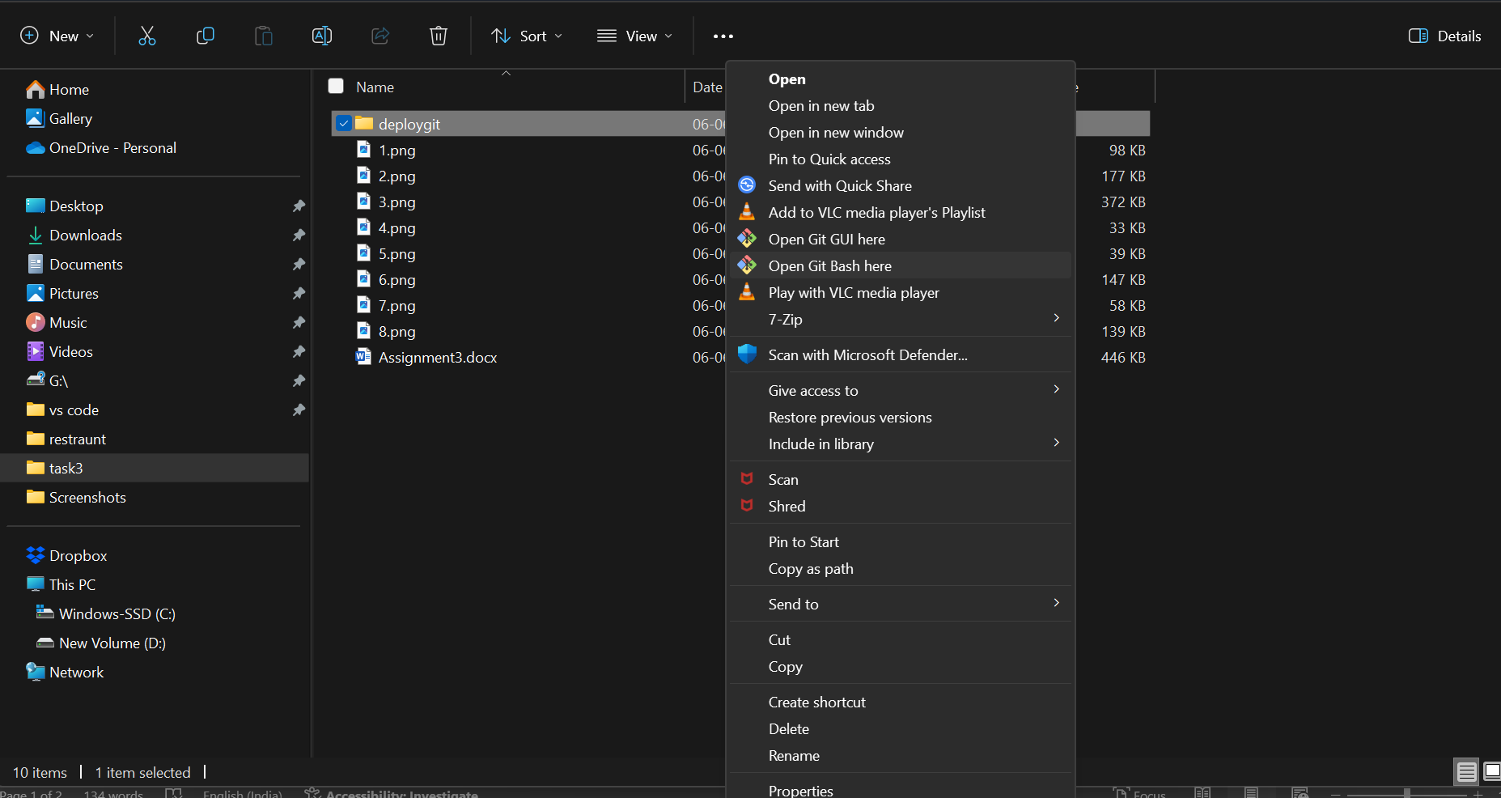

4.then git command line opens

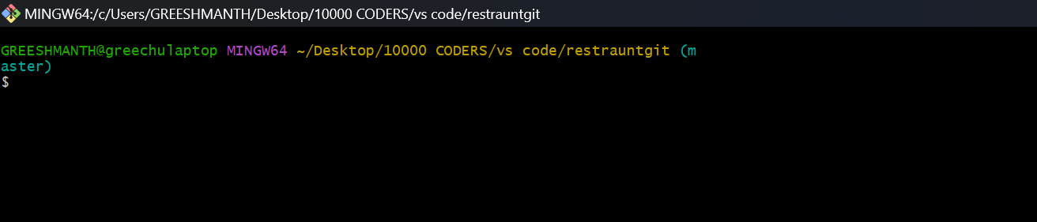

5. after that we have to push & deploy a folder to git hub using git commands

git init :-To initialize a repository, Git creates a hidden directory called .git. That directory stores all of the objects and refs that Git uses and creates as a part of your project's history. This hidden .git directory is what separates a regular directory from a Git repository.

git clone :- The git clone command is used to create a copy of a specific repository or branch within a repository. Ex: git clone “ git hub account url “

ls:- it is windows command used to display the foledrs or files in the current directory

cd:- change directory it is used to change one dir to another dir ex: cd dirname

git add :- git command it is used to add the files to the git account via main/master branch

git commit:- git commit creates a commit, which is like a snapshot of your repository. These commits are snapshots of your entire repository at specific times. Ex:- git commit -m “msg” .

git push:- git push uploads all local branch commits to the corresponding remote branch.

6. after opening git bash console we have to perform some commands

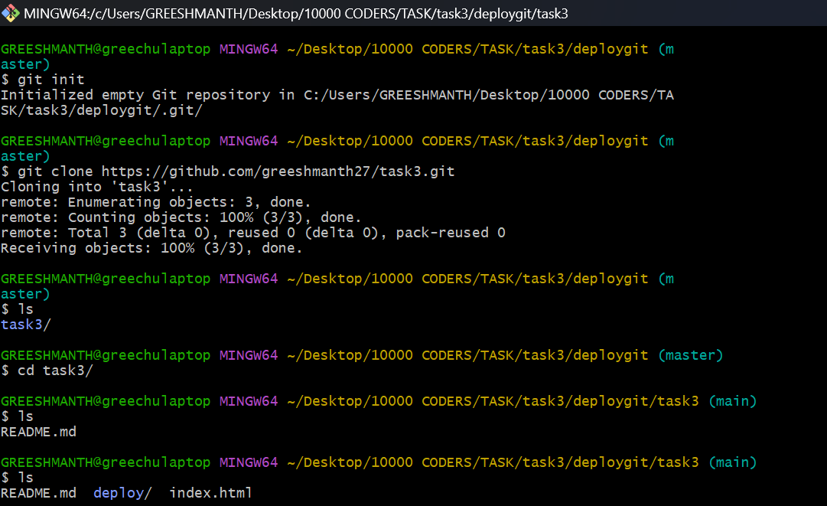

7. After that we have to open the folder and copy the folder path and type “cmd”

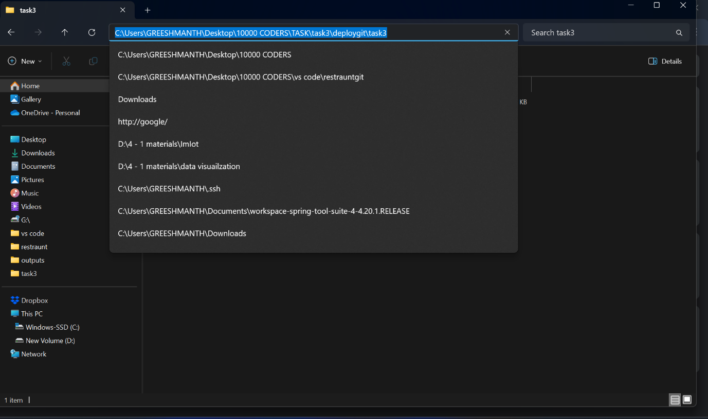

8. in terminal we have to type code . it will help to open the vs code

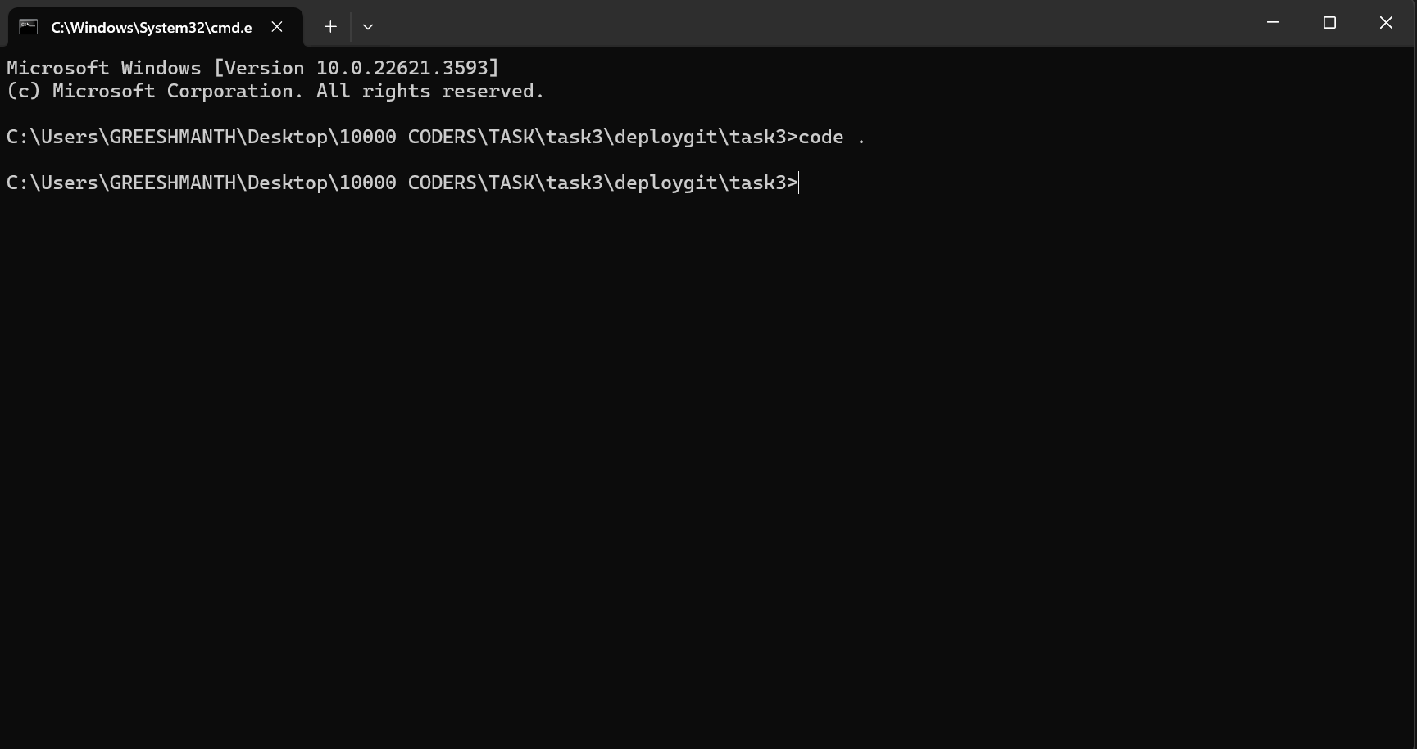

9. this shows the git bash console

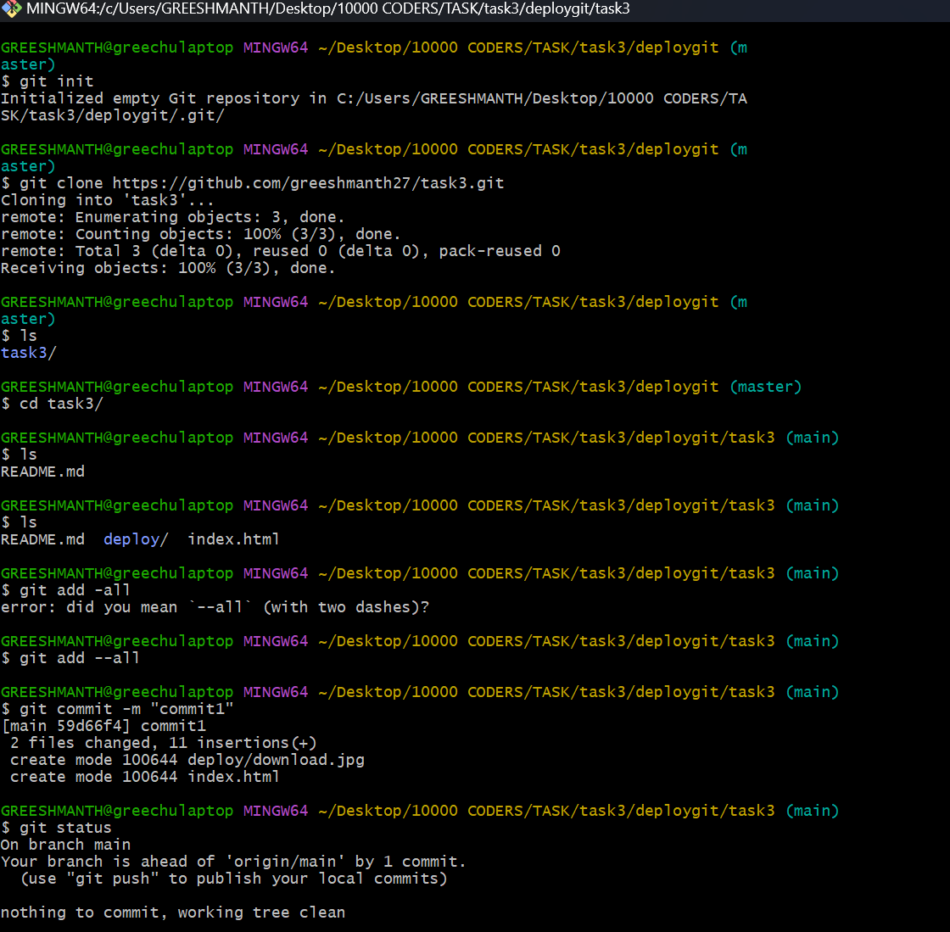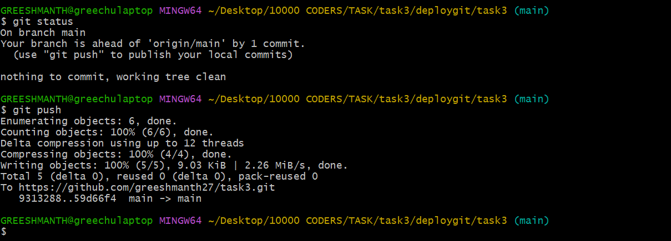

10. after that we have to open git hub account and refresh the page

