**AWS INSTANCE CREATION**

STEP-1 :- CREATE AN ACCOUNT IN THE AWS WEBSITE

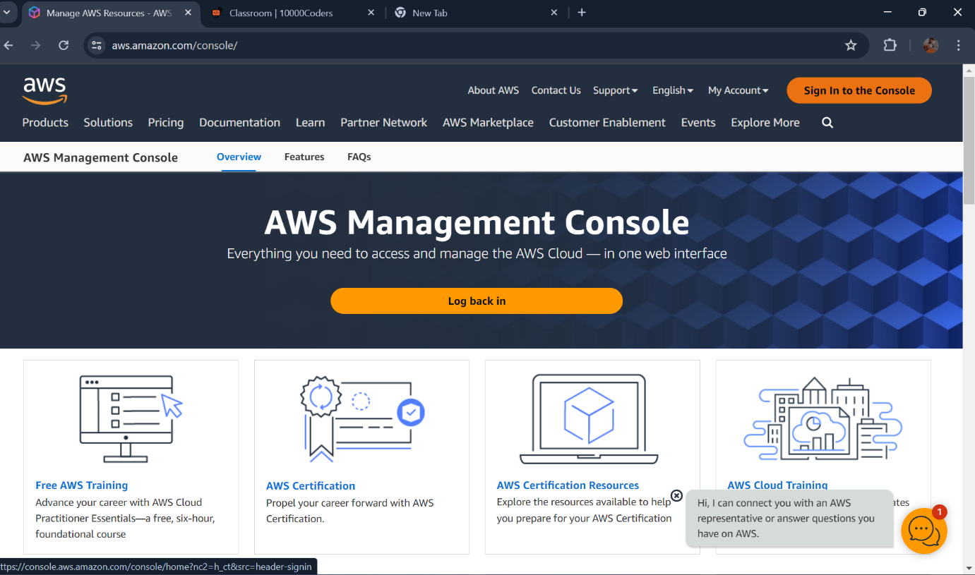

STEP -02 :- LOGIN WITH ROOT USER CREDENTIALS AS ROOT USER

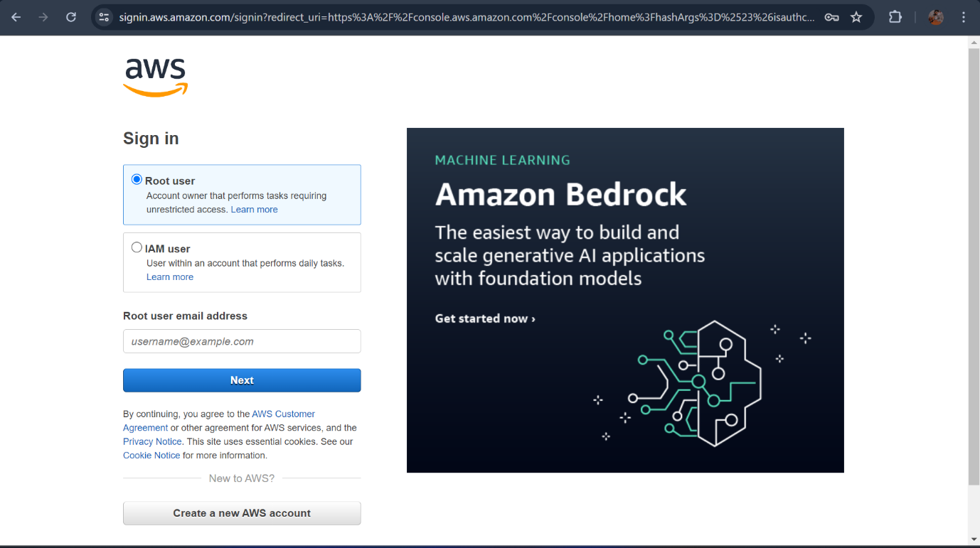

STEP-03 :- CLICK ON EC2 TO CREATE AN INSTANCE.

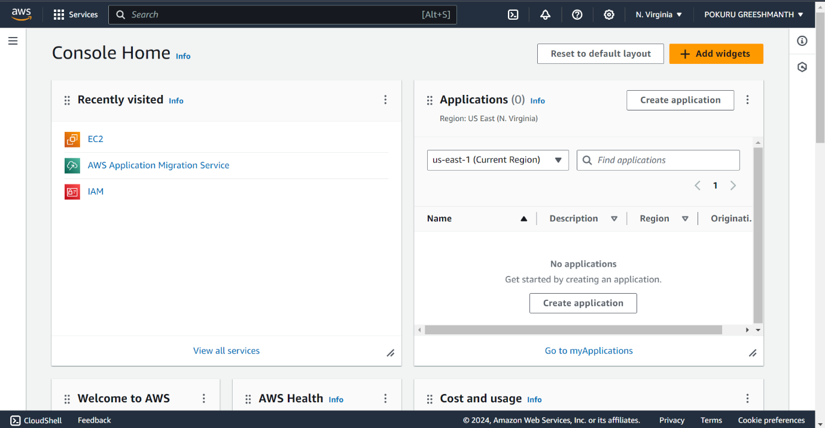

STEP -4 :- CLICK ON LAUNCH INSTANCE AND FILL DETAILS. 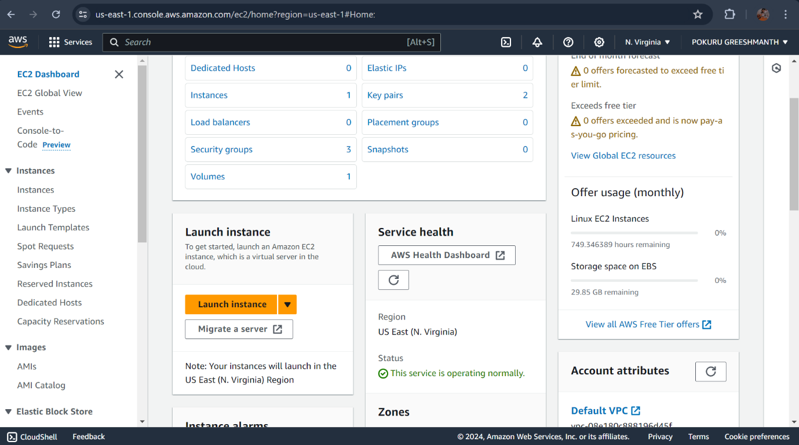

STEP -5:- FILL THE DETAILS GIVE THE NAME OF THE SERVER

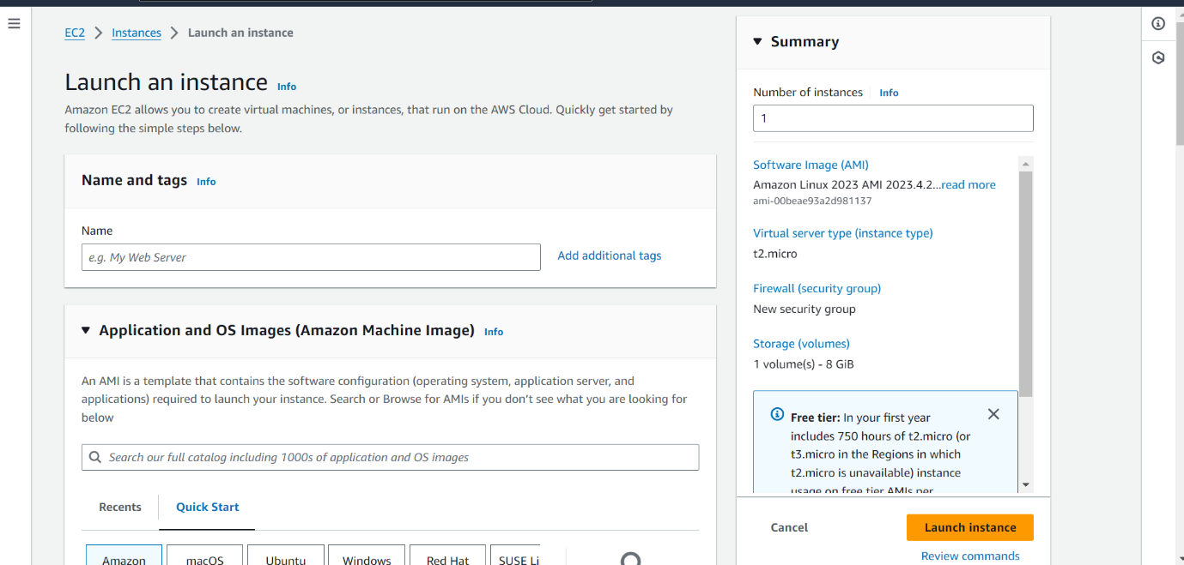

STEP – 06:- SELECT UBUNTU SERVER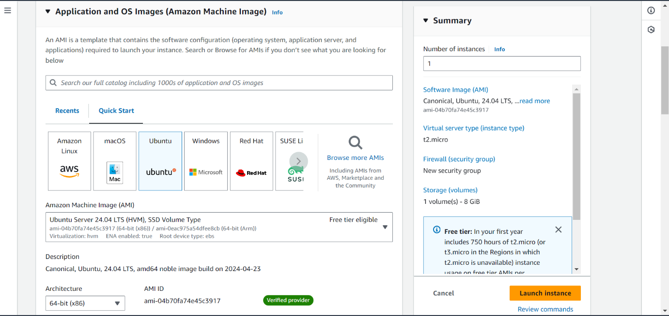

STEP -07:- SELECT INSTANCE TYPE AND KEY PAIR

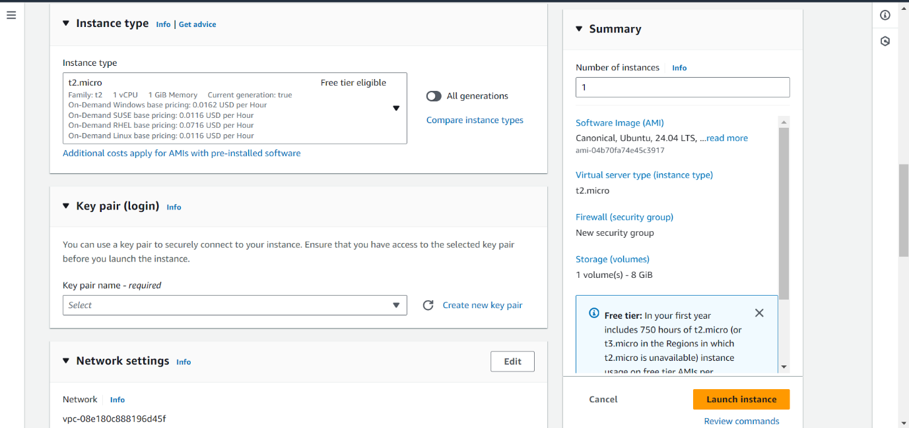

STEP -08 :- SELECT NETWORK SETTINGS 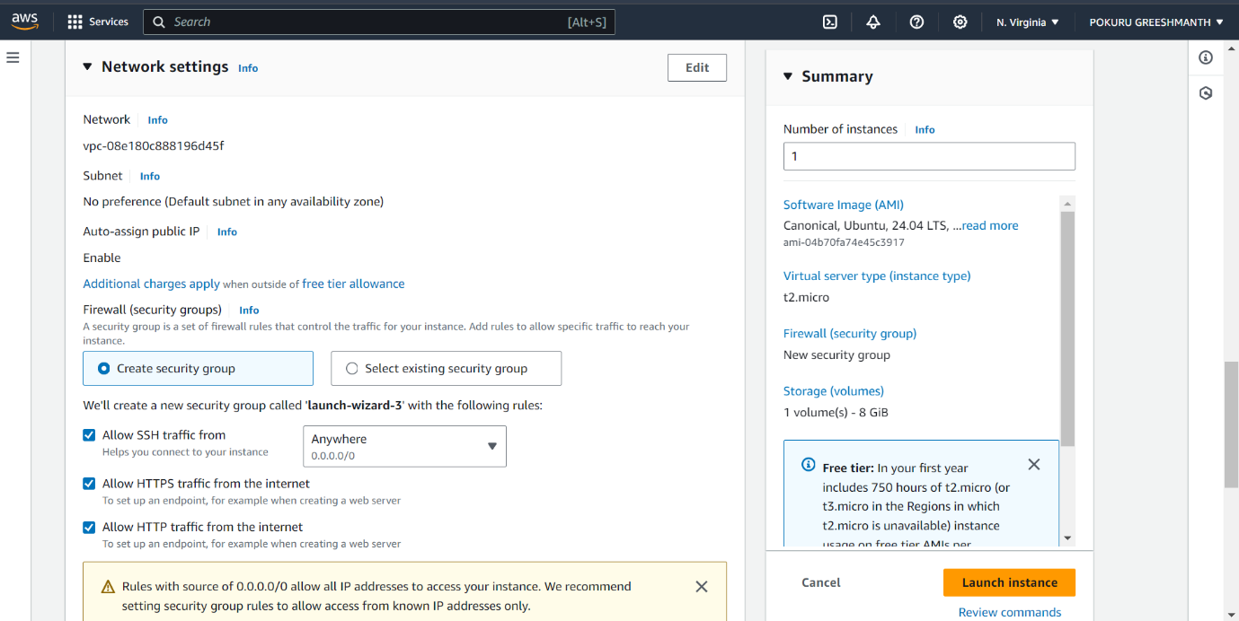

SELECT AND CONFIGURE SETTINGS AND CLICK ON LAUNCH INSTANCE.

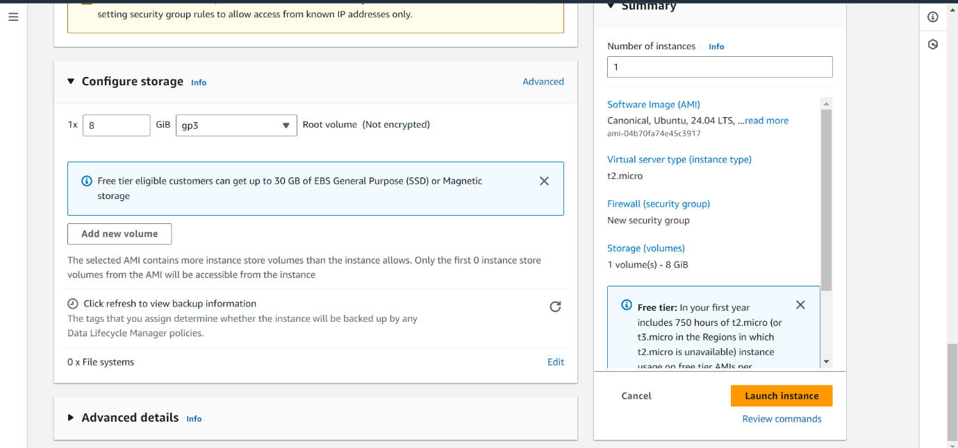

FINNALLY OUR SERVER CREATED AND READY TO USE.

