**HID** : {{card_number }}

NAME : {{name}}

GENDER/: {{gender}} DOB : {{dob}}

Any Insurance : {{insurance}}

WhatsApp Mobile :_{{number }}

Address: {{ address }}

{{photo}}

**DR.RADHIKA MULTISPECIALITY HOSPITAL**

**& FERTILITY CENTER**

**(A 100 BEDDED HOSPITAL)**

**FREE HEALTH CARD**

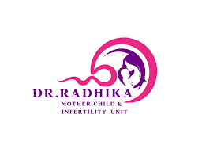

**BENEFITS FOR HEALTH CARD HOLDERS**

* **For all specialties only service charge of Rs. 100/- and for first visit only OP charges Rs. 300/- remaining OP consultations are free.**
* **Upto 10% Discount On LAB & INVESTIGATION.**
* **Upto 5% discount on all admissions.**
* **Upto 5% Discount On PHARMACY Bills.**
* **Free Medical Tele Consultation - 9392174489**
* **FREE Enrolment For All Health Camps.**
* **Upto 5% discount on all Surgeries And Procedures.**

**\*\* Timings : 9AM – 2PM \*\***

**\*\* SPECIALITIES \*\***

* **Gynaecology & Obstetrics Fertility Paediatrics**
* **General Medicine Orthopaedic Dermatology**
* **General Surgery ENT Dental Surgery**

**Appointments :9392174477 / 9392174488**

**Note: Allotment of OP with this free Health card, completely based on Doctors Availability**

**Address: OppRythu Bazaar Out Gate, Gopalapatnam, Visakhapatnam,**

[**www.drradhikahospitals.com**](http://www.drradhikahospitals.com)

**Dr.RadhikaMultiSpeciality Hospitals**  **drradhikahospitals**

 **Dr.RadhikaMultispeciality Hospitals**