Making a Blog wit rails

Saved in C:\web-projects\learn_rails\workspace\first_rails_project\first_rails_project\blogger

1. I initiated a repo on github and wrote an initial read.me file
2. Ran rails new blogger- this command creates a basic rails app which I can personalise
3. All commands are now run from the bin directory
4. Rails server- this command (in a new terminal) will run a server from my machine allowing me to open my rails app with my browser to see the welcome to rails page at local host 3000.

**Setting up the Article Model**

1. The blog will contain articles so I need to create a model which will be able to interact with the articles in the database. To do this I use rails generate model Article. This command will create all the files I need to interact with the articles in the database.

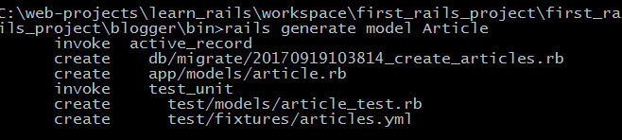

The db migrate (first line) is a database migration. It has a time stamp. A migration is able to alter our database for us. Each migration creates a new version of the database, altering tables, columns or entries. This migration will be able to create the articles table in the database.

app/models/article.rb- this ruby file will contain the code for the model

The last two files are associated with testing

**The Article Migration**

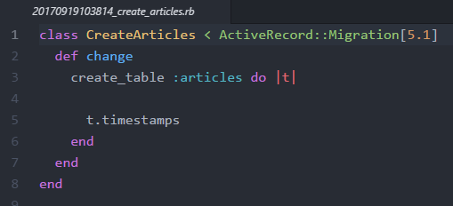

This is the current file for the migration. It is named with a timestamp which allows the migrations to be kept in chronological order. It has only one method-change. Within the change method create_table has been called automatically. This is a method which will create a table! The generator has passes the create_table method the symbol :article as a parameter. This will create a table called Articles. There is then a block which assigns the variable t to the table which is created.

,t is important because we call methods on t to create the columns in the articles table. We will need a column called title and a column named body to hold the data from our articles. The title will be defined as a string and the body is defined as text. “Text” is data type which the rails adapters can change to whatever type our database will understand without us having to worry about it. This could be varchar or text depending on the database used(postgres/sqlite).

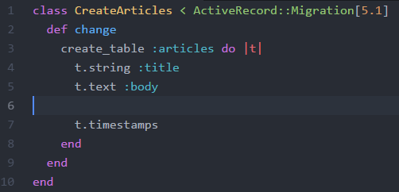

We edit the change method to include t.string :title and t.text :body. This will create our columns with the correct titles and data types. Rails also automatically makes two columns using t.timestamps. These columns are titled “created_at“ and “updated_at”. These record the times that articles are uploaded and when they are subsequently updated. Rails will do the recording for us.

We are now ready to run the migration (to create our table in the database). We do this with the command, rake rb:migrate. Rake is used to carry out maintainance functions and testing. The command says, “look in your functions for databases and run the migrate function”. The migrate action will then find all the migrations in db/migrations folder. It then looks at a table in the database which says which migrations haven’t been run. It will then run the migrations which haven’t been run yet.

In our case CreateArticles was run and made a table named articles.

**WORKING WITH A MODEL IN THE CONSOLE-Side step 😉**

If we want to we can access all parts of our app with the command line. If we run rails console it initiates an IRB. This means we don’t need to go through a web interface to update our app eg create articles. We can then type Article.new to create an empty article. It shows that we have the headings title, body and two timestamp headings

**LOOKING AT THE MODEL**

The code for the model is kept in app/models/article.rb. Currently this file is pretty empty with no attributes defined. Rails is really clever in that it already knows that an article should have a title and a body. It does this using a technique called reflection. Rails looks at the database, sees the column headings and assumes that these headings should be the attributes in the model. There will also be an attribute called id. Rails gives each entry a unique id so that we can refer to it if needed.

To make a new article in the console we type the below line by line

a = Article.new

a.title =”sample title”

a.body = “sample text in the body”

a.save

This input will create our first article and save it! As well as filling in the title and body, rails will fill in the id and timestamps for me. The id was 1. I can view the article using Article.all

**SETTING UP A ROUTER**

Out of the MVC architecture we have made the model. Now we need to create the view and the controller. When a browser speaks to a rails app the first thing rails does is go to the router. The router is able to decided what the request is trying to do and what it needs. It figures it out using the address it is requesting and other http parameter such as Get or Put. We find the router file in confige/routes.rb. This file is pretty empty until I start building routes.

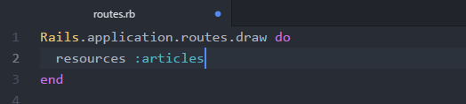

We edit the file to something like the above. I added resources :articles. What this block is doing is telling the router to expect requests which follow RESTful principles What this means is that when I get a request like “localhost3000/articles/” the router will understand that I want a list of articles. I don’t have to specifically tell it(?) Also it would know that “localhost3000/articles/new/” means I want to write a new article.

Line two, although simple will create all the typical routes I will need(in accordance with rails’ restfull principles). I can view them by doing rake routes and I get the below. If I delete line two my routes disappear!

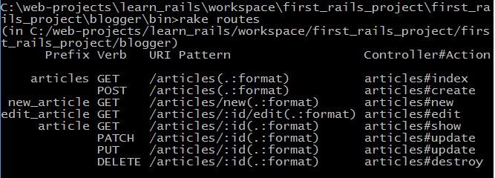

Let’s look at the first row. Articles is the first prefix in the list. The router will provide two methods using “articles”, the articles_path and article_url. The _path version is relative while the _url version uses a full url. The path version is always preferred.

The second column says “get”, this is the verb for the HTTP route. Web borwsers typically send requests with the verbs get or post.

The third column- *I don’t understand it* but the part in brackets is optional. The uri pattern in the example will match articles/, articles, and articles.json.

The fourth column shows where the route will map to in the application. In our example the route will map to the index method of the Articlescontroller class.

Now we have our router knows how to handle requests about articles we need a place to send the requests-the controller

(So the router has several routes to the controller. Which route it takes will depend on what the browser has asked.)

**Making a controller**

To generate a controller for the Articles we use rails generate controller articles. This make several files for us seen below.

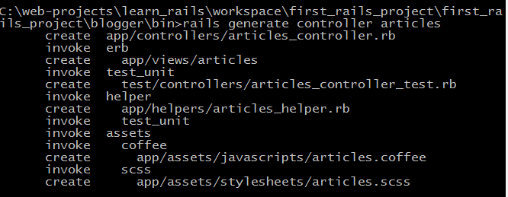

At the moment the first to creations are important. The first is the articles_controller file (the actual controller) and the second is an empty directory called views/articles. This directory will hold the templates for my controllers view.

The first route we want to specify is for an index page. This should show an index of all of our articles. The index page will show when a user requests <http://localhost:3000/articles/>.

Rails uses restfull principles to assume that the above is true. When the router sees <http://localhost:3000/articles/> it knows to use the index action within the articles controller. We haven’t made this yet so if we go to the address we get the following error.

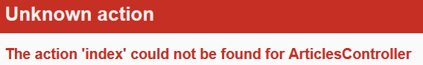

This proves that rails is working on restfull principles because I haven’t told it to look for the index action( it just knows!). So we add the index action to the articles controller

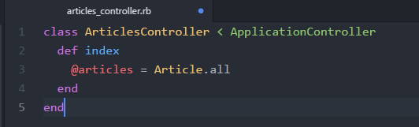

We have defined the action (method) “index”. The action has an instance variable called “@articles” and its value is all the articles. If “@articles” was not an instance variable it would only exist within the index method. Our rails app needs to be able to access the variable outside of this action. Rails need to use @articles in the view so it has to be an instance variable, so that it has a larger scope (not a local scope)

If we refresh our address we get a new error

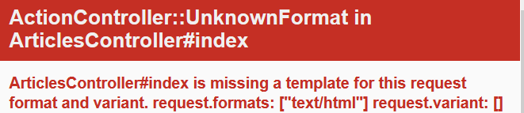

This is telling us that the app is looking for a view template in the right place but couldn’t find one called index.html.erb. So rails automatically knows that our index action should have a corresponding index view template in the view folder!

CREATING A VIEW

In our empty views/articles directory I have named a file “index.html.erb”. The .html is usefull because it makes it clear that this template is for geneating html. Rails assumes that localhost3000/articles/ will be looking for a html page. I f we later create a file names index.xml.erb it will not show it for the articles request.

Within the file I have added the code below. It is a mixture of html and erb tags.

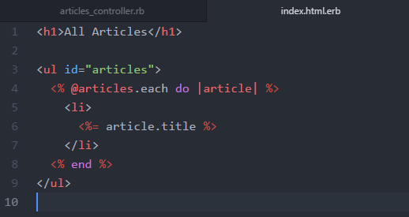

ERB is a templating language which allows usto put Ruby into our html template. An ERB clause starts with <% or <%= and ends with %>. If the clause starts with <% the result of the ruby code will be processed but not shown. If the clause starts with <%= the ruby code will be output in the place of the clause. This this syntax creates a header then an un ordered list. The list has an id of articles. Before the first item in the list we call a block on the instance variable @articles (remember this from the index action) This instance variable holds all our articles. The block iterates through the list assigning the variable article to each article. We then have our html tag for the list item. Below is an ERB clause which requests that the template shows the titles of the articles in our database. We then end the list and end the ERB block and the html un ordered list. As a result of this local3000/articles now shows the below in the browser!

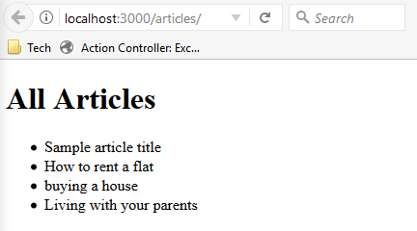

CREATING LINKS



Above is the list of routes which are available to my articles. We can use the routes helper to create links in our app. If I want to see one article I need to use the 5th route. The address for this would look like localhost300/article/id- Note that the article is singular and it needs the id of the article. In order to use this I will have to make a show action in my articles controller and then create a view for the show action 😊

In order to generate a url like “ /article/id” I need to use the route helper article_path(id). For example article_path(1) will generate the url string “/article/1”. We place the route helper within our html on the page that we want the link to appear on.

SIDE NOTE- Here we are using article_path- This will generate a realative path to a file within our application eg app/articles/views/sample_article If I used article_url it would generate a web address instead eg localhost3000/articles/sample_article. The path is preferred.

On our index view page we might want to make the title of each article a link to the full article. We can do this by amending the existing title ERB to this.

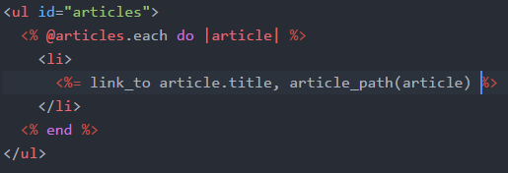

We have changed <%= article.title %> to <%= link_to article.title, article_path(article) %>

The first part is the link_to helper. This tells ruby that the text that follows should be displayed and made into a link. In this case the article’s title will be displayed as a link. The next part is the route helper. This helper will generate the address of the page we want to visit upon clicking the article title. It generates html like the below.

<a href=”/articles/1”>First Sample Article</a>

Now I want to make a link at the bottom of the page which will take me to the page where I make new articles. To do this I have added the below to the index template.

<%= link_to "Create a New Article", new_article_path %>

It is similar to the other link but the path I used is different. It uses the new article route which in turn uses the article#new action (which I haven’t made yet).

Lets not forget that so far my page is very boring. It looks terrible. We will want to be able to style this link with css later. To do this the link will need a HTML attribute/class. To add the attribute to the link we add it to the end of the link in the style of a ruby hash as below. We will now be able to style the link later on.

<% link_to “Create a New Article”, new_article_path, class: ‘article_title’ %>

THE SHOW ACTION

In order for our article links to work we will need to define the show action in the Articles_controller and then create a view to see them.

We can define the show action under the index method as below.

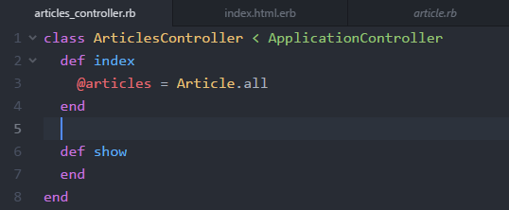

Remember that actions are just the name for methods which exist within a controller. So the articles_controller’s actions are its methods.

Now if we click the first article title our error message changes to “missing template”.

SIDE NOTE

*When we click the first article, the URL is* <http://localhost:3000/articles/1> *. This URL was generated using the article_path(article) route. It found the id of the article in the database and added it to the end of the URL. When we click the article we want to be able to see the title and body of the article. We are able to use the number at the end of the URL to search through the database if we use params.*

*Params is a method within the controller which will return a hash of the requested parameters/value. We often call the params method the params hash (even though it’s a method which return a hash!) Within the hash we can access the article ID. We add the below to the show action.*

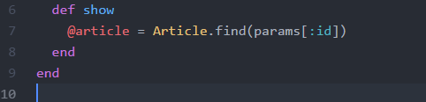

*This creates a new instance variable @article (singular). Show will now look at the class Article and find the id parameter and return is as the value of a hash.*

In order for the show action to show the article we need to create a view. The view is called show.html.erb and contains the code below.

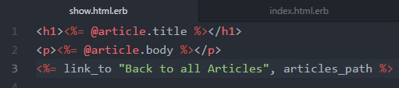

The code uses the instance variable I made in the show action under the articles controllers class. The page will display the articles title and the articles text. It also has a link at the bottom of the page which takes you back to the list of articles.

**At this point, the tutorial has told me to download a css stylesheet to make my app more funky. I have C/P the css into app/assets/stylesheets/blogger.css. Rails know how to find the stylesheet automatically.

CREATING A FORM

So far I have added articles to my app using the console and command line. Most users wont want this so I need to make a form to accept article entries and that can save them to the database.

In order to create a new article we need to look at our routes.



We will be using new_article and the controller/ method for this needs to be defined and a view created. I already have a link to my new view on the index page. I made it earlier using new_article_path. This path generates the URL <http://localhost:3000/articles/new>.

I have defined the method in the controller and created a view with the heading “create a new article”. The file name for the view is new.html.erb. The file name is important to rails. New matches the name of the controller. HTML tells rails to output the file as HTML to the user and erb is the language the file is written in.

We also now need to add a form to the new page.

