Project Proposal
Greg Pologruto
2026-02-16

Detecting Digital Payment Fraud
The title of my project is Detecting Digital Payment Fraud. This will be a classification problem. Classifying digital payments as either fraudulent or not.

Research Goals
- Compare how well different classification models can detect fraud.
- Discover which variables are most significant for detecting fraud.
- Interpret results from the different classification models.

Data Source:
Kaggle

Data Description
There are 7,500 rows. There are 15 columns. The dependent variable is fraud_label and this is the variable I will predict. There are some categorical variables like transaction_type and payment_mode that I can use in the model. There are also many quantitative variables, such as account_age_days, ip_risk_score, previous_failed_attempts, that can also be used to predict fraud_label.
## Rows: 7,500
## Columns: 15
## $ transaction_id <chr> "T1", "T2", "T3", "T4", "T5", "T6", "T7", "T8…
## $ user_id <chr> "U3756", "U7899", "U1765", "U8850", "U9049", …
## $ transaction_amount <dbl> 18758.28, 47538.18, 36613.10, 29952.99, 7843.…
## $ transaction_type <fct> Transfer, Payment, Payment, Payment, Payment,…
## $ payment_mode <fct> UPI, Wallet, Card, Wallet, UPI, NetBanking, U…
## $ device_type <fct> Web, iOS, Android, iOS, Web, Web, Android, We…
## $ device_location <chr> "Hyderabad", "Hyderabad", "Chennai", "Chennai…
## $ account_age_days <dbl> 895, 918, 1506, 800, 301, 1992, 1285, 1621, 1…
## $ transaction_hour <dbl> 14, 21, 8, 1, 4, 20, 22, 4, 11, 9, 3, 11, 14,…
## $ previous_failed_attempts <dbl> 1, 0, 4, 3, 1, 3, 4, 4, 0, 3, 4, 2, 4, 4, 3, …
## $ avg_transaction_amount <dbl> 25535.84, 3955.85, 22727.71, 18095.89, 9317.4…
## $ is_international <dbl> 0, 0, 0, 0, 1, 0, 0, 0, 0, 0, 0, 0, 0, 0, 0, …
## $ ip_risk_score <dbl> 0.718, 0.525, 0.985, 0.797, 0.468, 0.583, 0.0…
## $ login_attempts_last_24h <dbl> 4, 9, 9, 2, 1, 3, 8, 4, 5, 5, 2, 1, 8, 5, 2, …
## $ fraud_label <fct> 0, 0, 0, 0, 0, 0, 1, 0, 0, 0, 0, 0, 0, 0, 0, …

Discuss Variables
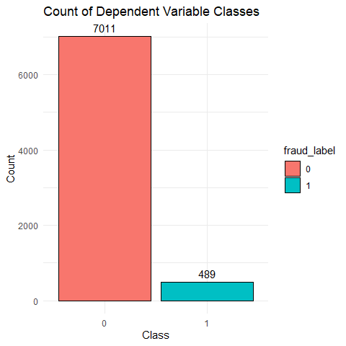
This barchart shows us that there are 7011 transactions that are not fraudulent and 489 transactions that are. (0=no fraud, 1=fraud)
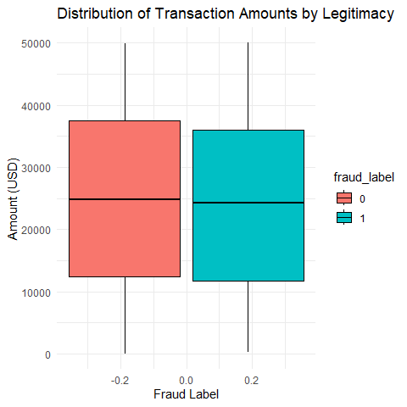
Boxplot of transaction_amount sorted by fraud_label. The distributions look nearly identical, however this variable could still be useful in the classification models.
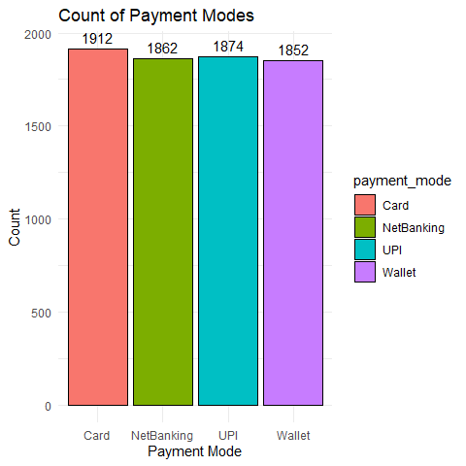
Bar chart of payment_mode. This shows that there are 4 types of payments in this dataset and there is about an equal amount of each.
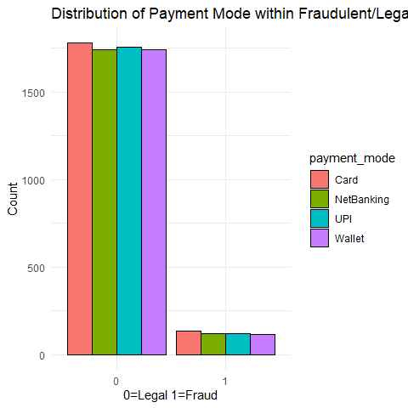
This is a barchart of the amount of fraudulent/nonfradulent transactions filled by payment type (1=Fraudulent). It seems that the payment type is evenly distributed in both fraudulent and legal transactions.

