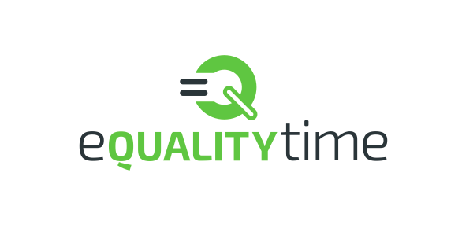

*eQuality Time, 68 Truro Gardens, Luton, LU3 2AP*

Device Description for

The Open Voice Factory

Version 0.8

|  |  |
| --- | --- |
| Reference | 1002 |
| Author | Joseph Reddington |
| Contributors | Greg Smart |
| Approver | Joseph Reddington (Product Owner) |

This is a controlled document and is listed in the master register of eQuality Time documents, available on request from eQuality Time’s trustees. It is also on the sub-register of documents relevant to the Open Voice Factory, which is publicly available at <https://github.com/eQualityTime/MHRA-Technical-File/blob/master/OVF%20controlled%20documents.csv>

Table of Contents

General Description and intended population 3

Intended Use 3

Hardware and software requirements 3

Desktop/Laptop 4

Mobile 4

Server 4

Principles of operation 4

Risk Class 4

Novel Features 5

Accessories and other Products 5

Configurations and Variants 5

Functional Elements 5

User Stories 5

People 6

The Open Voice Format Architecture 7

Upload Architecture: 8

Physical/Deployment 8

Logical 8

Process 9

Display Architecture 9

Logical 10

Process 10

Examples 10

# General Description and intended population

The Open Voice Factory aids allows people to communicate. Open Voice Factory aids exist as webpages or within apps that mimic the webpage operation – and when icons on those pages are touched they speak particular utterances aloud. For example: pressing a picture of a toilet might say “I want to go to the toilet now”.

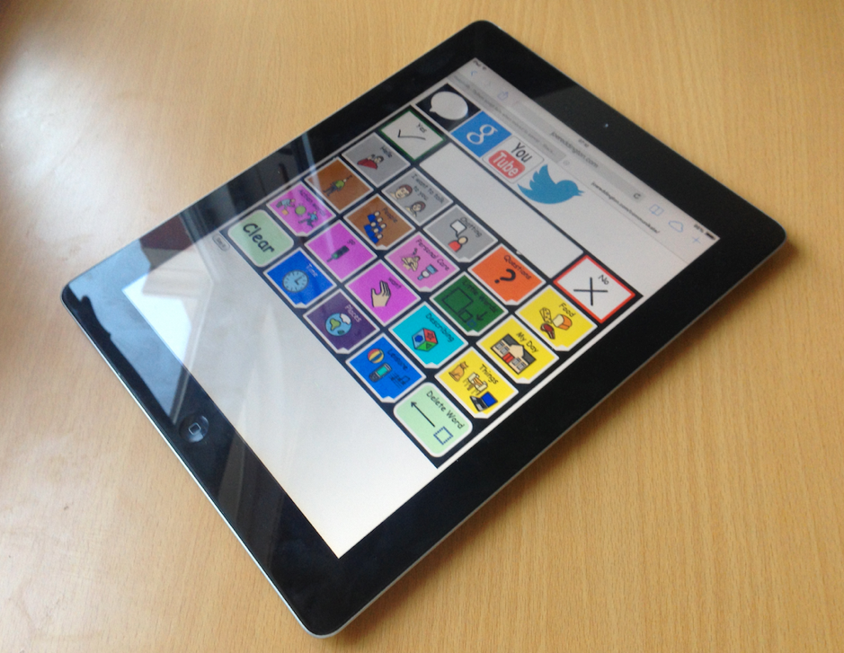

Figure 1: An Open Voice Factory Aid, running on an iPad

The intended patient population is any person with a cognitive or physical issue that reduces the capacity for understandable speech. Examples include: traumatic brain injury, downs syndrome, autism, and cri-du-chat syndrome.

# Intended Use

The Open Voice Factory replaces or supports verbal speech in members of the intended patient population.

## Hardware and software requirements

The following describes the minimum specification device on which OVF is approved to run. Higher specification devices would also be acceptable.

### Desktop/Laptop

* Supported operating system:
  + (OSX) macOS version 10.13 (High Sierra) or above
  + (Windows) Windows 10
* 1 GHz or faster processor
* 1 GB or more of RAM
* 800 x 600 display
* Steady Internet connection of at least 10Mbps and supported web browser, one of:
  + Firefox 62 – without any extensions or modifications
  + Chrome 69 – without any extensions or modifications

### Mobile

* iOS 12 on an official Apple Device

### Server

The Open Voice Factory requires the use of an online server. We have tested on a Virtual Private Server with 64Gb memory running Linux Version: 3.14.52-vs2.3.6.15-1 and consider that to be the minimum running requirements along with an minimum uptime of 99%.

# Principles of operation

## Risk Class

Factors to consider in assessing the risk class of The Open Voice Factory:

* Duration of use is for periods of up to several hours continuous use per day.
* The device is not in contact with the human body
* It is not a reusable surgical device
* It is not an implantable device
* It is an active therapeutic device
* It does not perform a measuring function
* It is not a procedure pack

The following rules apply[1]

Rule 1 – Non-invasive device

Therefore the devices is Class 1.

Note that Rule 9 does not apply because, although the device is an Active Therapeutic Device, it does not administer or exchange energy.

## Novel Features

The Open Voice Factory has been developed as an Open Source software application; that is software whose source code anyone can inspect and modify. Although anyone can modify the source code, modifications are only accepted into the official product in accordance with the eQuality Time development policy which ensures compliance with the Essential Requirements for CE marking.

## Accessories and other Products

The Open Voice Factory is software which runs via a web browser. This can be run on any suitable device (such as a laptop, tablet or smartphone). The device operating the browser in which The Open Voice Factory runs is not considered a medical device.

The Open Voice Factory is delivered by eQuality Time from cloud based virtual computers which they have procured. This environment is not considered a medical device.

The Open Voice Factory can however be downloaded and operated by anyone, however in this configuration the product cannot be considered certified and this is made clear in the associated information provided to potential users.

## Configurations and Variants

A single version of The Open Voice Factory will be made available as a Medical Device. Updates to this version will be made periodically in line with eQuality Learning’s policies which ensure continued compliance with the Essential Requirements.

## Functional Elements

### User Stories

We use [User Stories](https://en.wikipedia.org/wiki/User_story) to show the high level requirements.

* As a user I want to create a board in PowerPoint which can be compiled into an AAC board so that I can use the board to assist with my communication.
* Note that one person may create a board for some other person to use. Also ‘create’ here also means edit.
* As a user I want to upload a PowerPoint file to the system so that it can be compiled
* As a user, if I upload a PowerPoint file to the system for compilation and that file does not conform to the correct conventions I want to receive a meaningful response so that I can fix it
* As a user I want to display a previously compiled board so that I can use it to assist with my communication
* As a user I want to display a board saved in Open Board Format so that I can display board created by other applications or means
* As a user, if I attempt to display a previously prepared board that does not comply with Open Board Format I want to see a meaningful message so that I can fix it
* As a user I want to select a cell on a board so that the action associated with that cell takes place
* As a user I want to initiate scanning of each cell on the board so that I can indicate when the cell I want is selected
* As a user I want the words I have selected to be spoken so that I can communicate with other people
* As a user I want the system to run from a browser so that I can use the system on a large range of different devices
* As a product owner I want us to produce software for the most common sizes of interface (5x5 and 4x4) so we help the most people. Size information from [this publication](http://aclweb.org/anthology/W14-1901)

### People

Everything in the Open Voice Factory should be for the benefit of one of these people. Some of whom are real and have shared their data, some are famous and we are using publicly available data, and some are fictional, but reflect a need we are aware of. If you add a feature to the Open Voice Factory, you should be able to defend it as "But Rob will like this". Note: [CK12](http://communikate.equalitytime.co.uk/) and CK20 are open pagesets that can be run by OVF and other similar devices.

#### Richard

Richard is in his mid-30s and has developmental difficulties. He has no speech, and limited cognitive ability (no reading and limited working memory. His vision and hearing are fine.

Richard will typically produce outputs of 1-3 symbols (occasionally four) that are presented without tense or indeed much context. Examples might be <dad, sonic, screwdriver>. This turns out NOT to be a Doctor Who reference. Conversations with Richard require a lot of scaffolding:

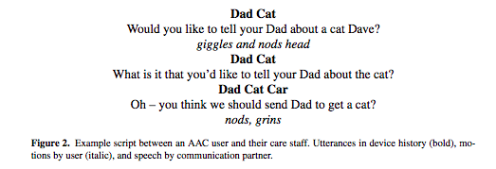

(From [this book chapter](http://joereddington.com/wp-content/uploads/2013/10/STAL9781614992950-0059_AC.pdf) which is particularly interesting on the topic of user privacy).

Richard has physical issues, but they do NOT interfere with his use of the device. If Richard is given access to the editing functions of the device then he typically will accidentally delete something important and get frustrated.

#### Rob

Rob is a 35 year old who has Down syndrome and Autism. He has no literacy skills and is only able recognised 3 letters. ROB. He uses symbols/pictures and photographs in order to generate sentences up to 3 key words in length. He didn’t have access to an electronic communication aid until he was 18. Prior to that he used mime gestures and Makaton sign language to get his message across. This was frustrating and often his attempts to communicate were misinterpreted as challenging behaviour. He lives in the here and now has very little concept of time. For example when Easter is over he continually talks about Halloween as he knows this is the next party to happen. Then quickly moved on to talk about Christmas after Halloween. He uses CK20 and is able to make requests and comments and make most of his daily needs known to his care staff and family.

#### Larry

Larry is a 21 year old man who has cerebral palsy. He uses a manual wheelchair which he is able to self propel. He has a tablet computer attached to his wheelchair CIA a mount and accesses CK12 via a key guard. The key guard enables him to acutely press the buttons he wants and helps him avoid miss hits. He’s accessing CK12 through Grid 3, a specialist piece of software which enables him also to have environmental control so he can access his tv turn his lights on/off, open and close his curtains and front door. He can also access social media and YouTube through CK12 on the Grid3. His independence has massively increased in just 1 year of use.

#### Jenny

Jenny was a typically developing 16 year old who was expected to gain high GCSE results sh was planning on studying English literature and history at A level and hoped to go on to university. During a family meal to celibate her 16th birthday she suffered an allergic reaction and went into anaphylactic shock. She suffered a cardiac arrest and stopped breathing. Drs work hard to stabilise her but as a result she suffered a massive brain injury and is now ventilated tube fed and relent on 24hour care. She can’t talk, sit, stand or walk. She now communicates through CK20 accessed through eye gaze

#### Lee

Lee is a professional standup comedy artist who doesn't speak. He uses a device to quickly trigger pre-programmed lines. He accesses his device by the touchscreen easily. He is fully literate and users the programming function extensively. Response speed and editor effectiveness are important to lee's use case.

#### Stephen

Stephen has ALS, and accesses his speech device by [switch access scanning](https://en.wikipedia.org/wiki/Switch_access_scanning). He is quite bright. He also uses his device to trigger pre-programmed lines and it is important to him that both programming and accessing the memory can be done with the minimum amount of scanning.

## The Open Voice Format Architecture

The Open Voice Factory’s architecture is effectively that of a compiler – with a python ‘front end’ that accepts a PowerPoint file and created an intermediate form, and a JavaScript back-end that reads the intermediate form and presents it to the user as a speech aid.

The python front end relies heavily on the open source library python-pptx, which we paid some code bounties to improve. The intermediate form that is created is (now) the Open Board Format, an (JSON-based) open source effort to improve speech aid compatibility that we are supporting. Our JavaScript is currently undergoing a large rewrite but is currently very low tech. Speech synthesis is provide by Google for the online version.

The system is broken into two main components, one to convert pptx to obf, and the other to display obf and deliver the board functionality.

The architecture of the components is represented here by UML models. It adopts the principles of [4+1](https://en.wikipedia.org/wiki/4%2B1_architectural_view_model), although currently no Development view is provided as this is contained in the Physical and Logical.

## **Upload Architecture:**

### Physical/Deployment

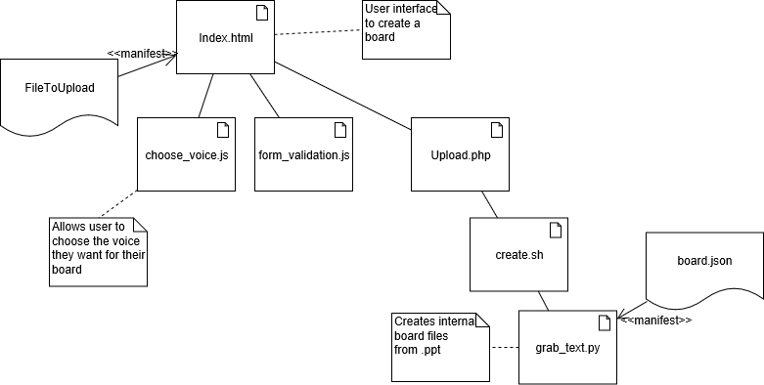

* upload.php accepts the uploaded pptx file and saves it before passing it to create.sh.
* create.sh creates a hashed location to store the generated files and populates it with the files needed to display the data (see Display Architecture), it then activates grab_text.py
* grab_text.py uses the python-pptx library to read the pptx file and extract the relevant data before creating the json files for the display architecture to read.

### Logical

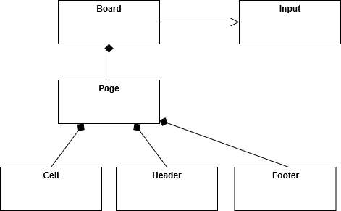

Boards consist of Pages. Pages consist of Cells, a Header and a Footer. This is common for Upload and Display. For Upload, the Board creates an Input (the board in file format). For Display, the Board accepts that same input.

### Process

When a user uploads a file, upload.php accepts the uploaded pptx file and saves it to the server before passing it to create.sh, which manages the rest of the process.

First, create.sh creates a hashed location to store the generated files and populates it with the files needed to display the data (see Display Architecture), it then activates grab_text.py, which uses the python-pptx library to read the pptx file and extract the relevant data before creating the json files for the display architecture to read.

## ****Display Architecture****

#### Physical/Deployment

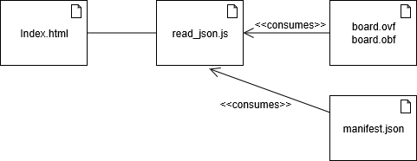

* Index.html provides a means to initiate the application in the browser.
* read_json.js contains the javascript files which form the application
* manifest.json defines which files the application should load to define the board which should be displayed.

### Logical

See Upload

### Process

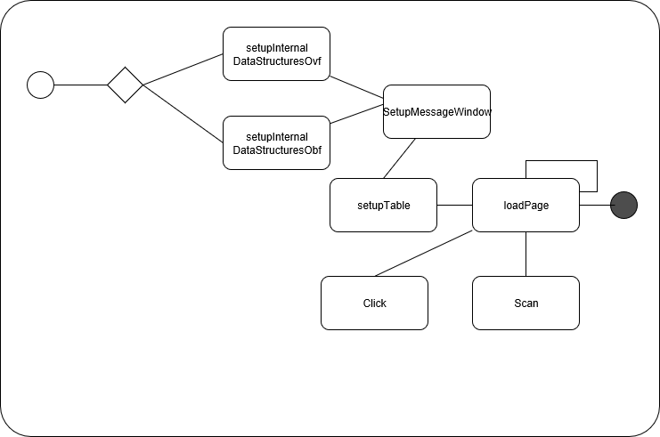

When the application runs, the board data is read into internal memory through the relevant setupInternalDataStructures function (for Open Board Format or the historical Open Voice Format).

For each page, the application then defines the page, setups up the content for the page and then displays it. Users can either click a cell or switch on scanning to select cells. Cell contents is copied into the message window from where it can be verbalised.

# Examples

The top page of CK12 running in a browser:

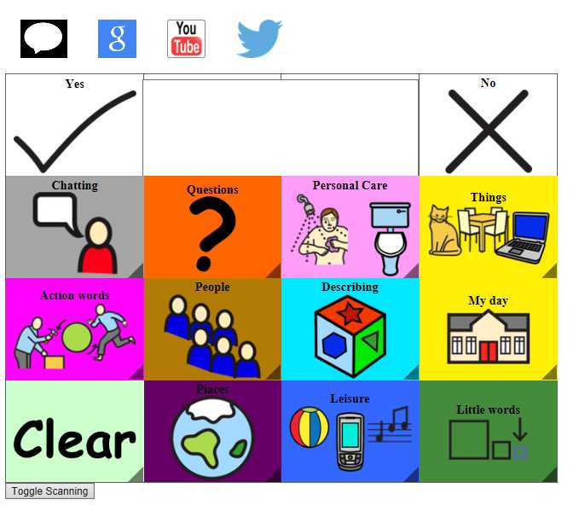

1. Annex IX MEDDEV 93-42-amended