**#01) Send message from dotnet to Java/Springboot/camunda**

C:\UserAppsCamunda\camundaSpringbootWorkspace\camunda-get-started-spring-boot\dotnetclient\GregPracticeDotnetAPI

Run “dotnet run”

https://localhost:5001/api/message2

{

"firstName": "Greg8899",

"lastName": "Qiu1",

"personalAddess": {

"streetNo": "8889",

"streetName": "Bay Street"

}

}

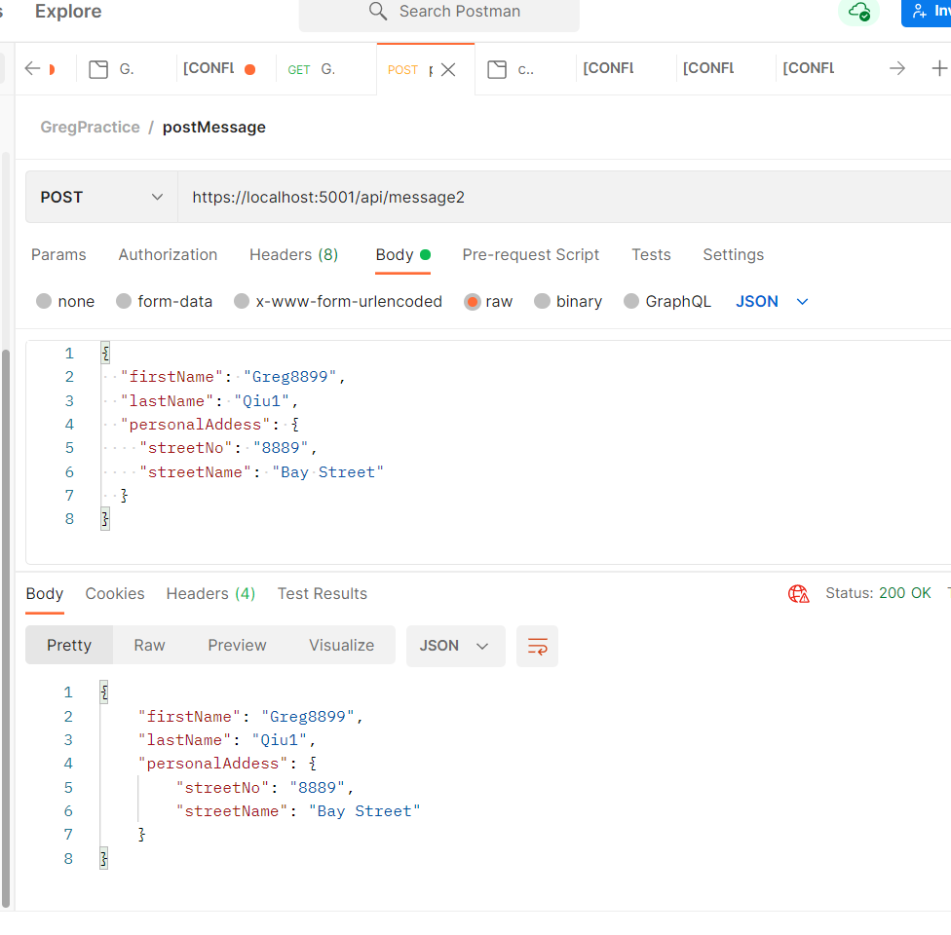

Java side Receive:

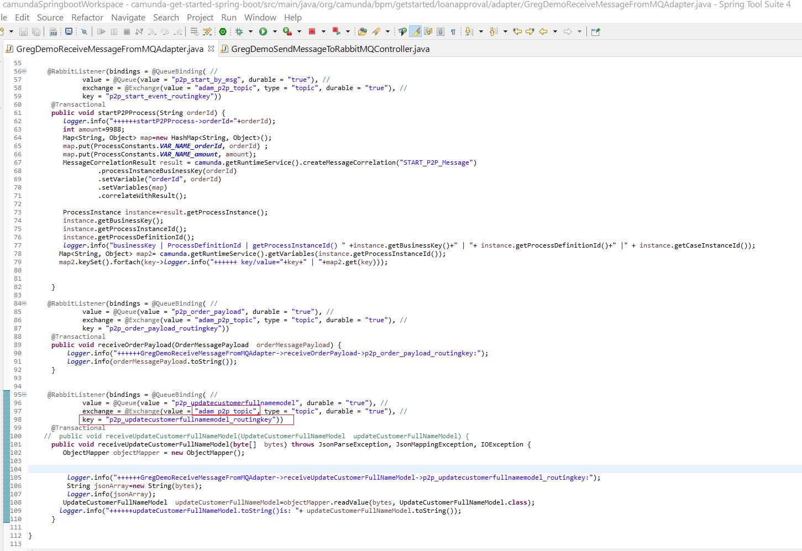

**#02) Send message from Java/Springboot/camunda to dotnet**

HTTP method: POST

URL: <http://localhost:9080/rabbitmq/payload2>

payload

{

     "orderId": "2888991",

     "amount": 1001,

      "exchange": "adam_p2p_topic",

      "routingKey": "p2p_order_dotnet_payload_routingkey"

}

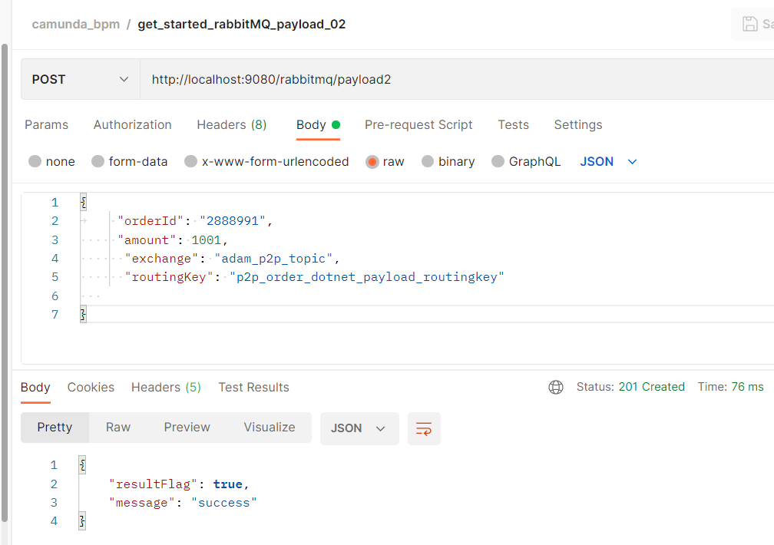

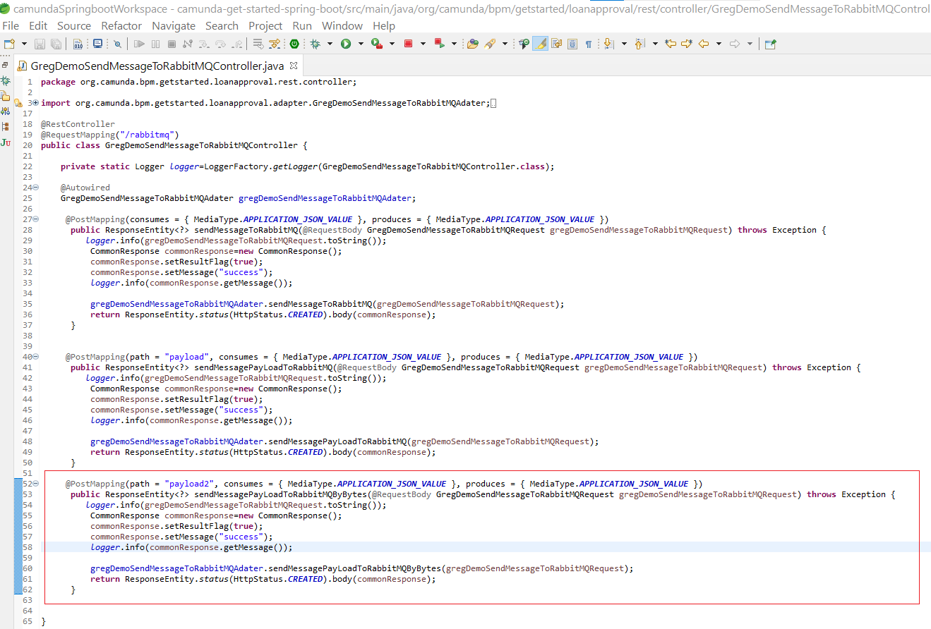

Receive in dotnet side

