**Configure environment for the microservice:**

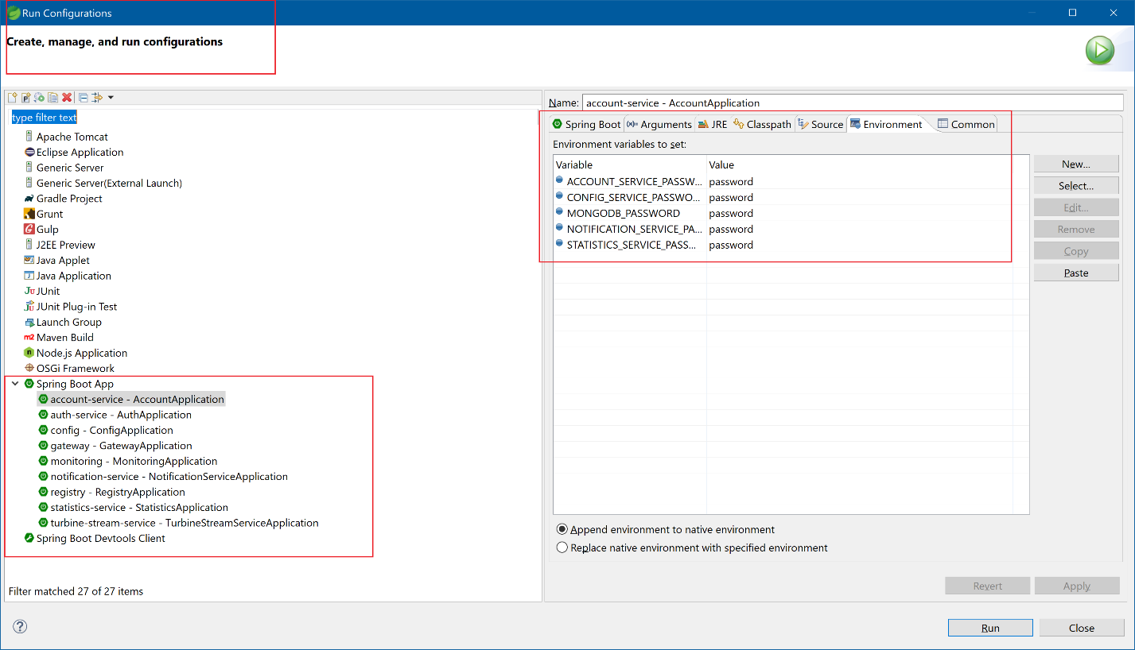

**# Configure hosts file C:\Windows\System32\drivers\etc like below:**

127.0.0.1 localhost

127.0.0.1 config

127.0.0.1 auth-service

127.0.0.1 auth-mongodb

127.0.0.1 registry

127.0.0.1 account-mongodb

127.0.0.1 account-service

127.0.0.1 rabbitmq

127.0.0.1 notification-mongodb

127.0.0.1 statistics-mongodb

#02) modify configuration files

config/src/main/resources/shared/account-service.yml

config/src/main/resources/shared/auth-service.yml

config/src/main/resources/shared/monitoring.yml

config/src/main/resources/shared/notification-service.yml

config/src/main/resources/shared/statistics-service.yml

config/src/main/resources/shared/turbine-stream-service.yml

gregqiu@XPS8900 MINGW64 /c/UserAppsFour/sqshqPiggymetricsWorkspace/piggymetrics (GREGQIU_BR_2020AUG17)

$ git status

On branch GREGQIU_BR_2020AUG17

Changes not staged for commit:

(use "git add <file>..." to update what will be committed)

(use "git checkout -- <file>..." to discard changes in working directory)

modified: config/src/main/resources/shared/account-service.yml

modified: config/src/main/resources/shared/auth-service.yml

modified: config/src/main/resources/shared/monitoring.yml

modified: config/src/main/resources/shared/notification-service.yml

modified: config/src/main/resources/shared/statistics-service.yml

modified: config/src/main/resources/shared/turbine-stream-service.yml

Untracked files:

(use "git add <file>..." to include in what will be committed)

GregQiu_readMe.txt

GregQiu_readMe_piggymetrics.docx

gregqiu_test_hosts-2020Aug17

~$egQiu_readMe_piggymetrics.docx

no changes added to commit (use "git add" and/or "git commit -a")

gregqiu@XPS8900 MINGW64 /c/UserAppsFour/sqshqPiggymetricsWorkspace/piggymetrics (GREGQIU_BR_2020AUG17)

git diff config/src/main/resources/shared/account-service.yml

git diff config/src/main/resources/shared/auth-service.yml

git diff config/src/main/resources/shared/monitoring.yml

git diff config/src/main/resources/shared/notification-service.yml

git diff config/src/main/resources/shared/statistics-service.yml

git diff config/src/main/resources/shared/turbine-stream-service.yml

$ git diff config/src/main/resources/shared/account-service.yml

**diff --git a/config/src/main/resources/shared/account-service.yml b/config/src/main/resources/shared/account-service.yml**

**index 209425d..d51b342 100644**

**--- a/config/src/main/resources/shared/account-service.yml**

**+++ b/config/src/main/resources/shared/account-service.yml**

@@ -11,8 +11,8 @@ spring:

data:

mongodb:

host: account-mongodb

- username: user

- password: ${MONGODB_PASSWORD}

+ # username: user

+ # password: ${MONGODB_PASSWORD}

database: piggymetrics

port: 27017

gregqiu@XPS8900 MINGW64 /c/UserAppsFour/sqshqPiggymetricsWorkspace/piggymetrics (GREGQIU_BR_2020AUG17)

$

gregqiu@XPS8900 MINGW64 /c/UserAppsFour/sqshqPiggymetricsWorkspace/piggymetrics (GREGQIU_BR_2020AUG17)

$ git diff config/src/main/resources/shared/auth-service.yml

**diff --git a/config/src/main/resources/shared/auth-service.yml b/config/src/main/resources/shared/auth-service.yml**

**index 137c067..54f0c43 100644**

**--- a/config/src/main/resources/shared/auth-service.yml**

**+++ b/config/src/main/resources/shared/auth-service.yml**

@@ -2,8 +2,8 @@ spring:

data:

mongodb:

host: auth-mongodb

- username: user

- password: ${MONGODB_PASSWORD}

+ # username: user

+ # password: ${MONGODB_PASSWORD}

database: piggymetrics

port: 27017

gregqiu@XPS8900 MINGW64 /c/UserAppsFour/sqshqPiggymetricsWorkspace/piggymetrics (GREGQIU_BR_2020AUG17)

$ git diff config/src/main/resources/shared/monitoring.yml

**diff --git a/config/src/main/resources/shared/monitoring.yml b/config/src/main/resources/shared/monitoring.yml**

**index e69de29..47fbb02 100644**

**--- a/config/src/main/resources/shared/monitoring.yml**

**+++ b/config/src/main/resources/shared/monitoring.yml**

@@ -0,0 +1,2 @@

+server:

+ port: 8080

\ No newline at end of file

gregqiu@XPS8900 MINGW64 /c/UserAppsFour/sqshqPiggymetricsWorkspace/piggymetrics (GREGQIU_BR_2020AUG17)

$ git diff config/src/main/resources/shared/notification-service.yml

**diff --git a/config/src/main/resources/shared/notification-service.yml b/config/src/main/resources/shared/notification-service.yml**

**index 4ab5302..4f90003 100644**

**--- a/config/src/main/resources/shared/notification-service.yml**

**+++ b/config/src/main/resources/shared/notification-service.yml**

@@ -29,8 +29,8 @@ spring:

data:

mongodb:

host: notification-mongodb

- username: user

- password: ${MONGODB_PASSWORD}

+# username: user

+# password: ${MONGODB_PASSWORD}

database: piggymetrics

port: 27017

mail:

gregqiu@XPS8900 MINGW64 /c/UserAppsFour/sqshqPiggymetricsWorkspace/piggymetrics (GREGQIU_BR_2020AUG17)

$ git diff config/src/main/resources/shared/statistics-service.yml

**diff --git a/config/src/main/resources/shared/statistics-service.yml b/config/src/main/resources/shared/statistics-service.yml**

**index a460f90..9f4e42b 100644**

**--- a/config/src/main/resources/shared/statistics-service.yml**

**+++ b/config/src/main/resources/shared/statistics-service.yml**

@@ -12,8 +12,8 @@ spring:

mongodb:

host: statistics-mongodb

username: user

- password: ${MONGODB_PASSWORD}

- database: piggymetrics

+# password: ${MONGODB_PASSWORD}

+# database: piggymetrics

port: 27017

server:

gregqiu@XPS8900 MINGW64 /c/UserAppsFour/sqshqPiggymetricsWorkspace/piggymetrics (GREGQIU_BR_2020AUG17)

$ git diff config/src/main/resources/shared/turbine-stream-service.yml

**diff --git a/config/src/main/resources/shared/turbine-stream-service.yml b/config/src/main/resources/shared/turbine-stream-service.yml**

**index e69de29..2b99161 100644**

**--- a/config/src/main/resources/shared/turbine-stream-service.yml**

**+++ b/config/src/main/resources/shared/turbine-stream-service.yml**

@@ -0,0 +1,2 @@

+server:

+ port: 8989

\ No newline at end of file

gregqiu@XPS8900 MINGW64 /c/UserAppsFour/sqshqPiggymetricsWorkspace/piggymetrics (GREGQIU_BR_2020AUG17)

$

#)

http://localhost:4000/

http://localhost:8989/hystrix-dashboard

#) hystrix dashboard

http://localhost:8080/hystrix

#turbine stream

http://localhost:8989/turbine/turbine.stream

