Spring REST Controller

Just the REST basics (no Service Layer)

Illustrates the minimal Spring REST Annotations – a complete class would incorporate a @Service Layer.



Simple POJO that conveys a FAUX DAO – hence the informative-only TransientMarker Interface.



Lifecycle | The post cURL call

The post ßash script

POSTs (convey) a payload/message to the @RestController annotated handler method, via a cURL call that accepts a single (incoming) value as a script variable (for conditionalization).

It can be invoked via 3 CLI commands:

1. . post the_message
2. source post the_message
3. post the_message (w/ a ßash provision, next page)

CONTINUES

Add these ßash functions to the canonical ~/.bashrc file (then source the ~/.bashrc file).

This (global, meaning all Terminals) provision eliminates the need to issue either the 'source' CLI command, or the '.' CLI command.

The operand being post, and its formal argument being the_message

The 3 CLI commands:

1. . post the_message
2. source post the_message
3. post the_message



Lifecycle | The get cURL call

The get ßash script

GET (the default HTTP method) acquires a payload/message from the @RestController annotated handler method, via a cURL call that accepts a single (incoming) value as a script variable (for conditionalization).

It can be invoked via 3 CLI commands:

1. . get the_message
2. source get the_message
3. get the_message (w/ a ßash provision, next page)

CONTINUES

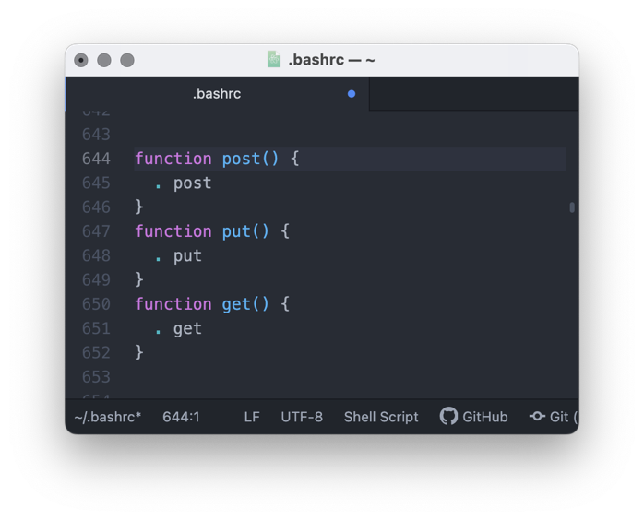

Add these ßash functions to the canonical ~/.bashrc file (then source the ~/.bashrc file).

This (global, meaning all Terminals) provision eliminates the need to issue either the 'source' CLI command, or the '.' CLI command.

The operand being get, and its formal argument being the_message

The 3 CLI commands:

1. . get the_message
2. source get the_message
3. get the_message



Lifecycle (Efficient Teardown) | The kbyport Function

Like any/all ßash functions, the kbyport() function is globally-available.

It can be called at the command line, anywhere.

It can be invoked within any ßash script, anywhere.

Add the above ßash function to the canonical ~/.bashrc file (then source the ~/.bashrc file).

