1. Download the compressed folder app.zip
2. Extract this folder *Right Click -> Extract All.*

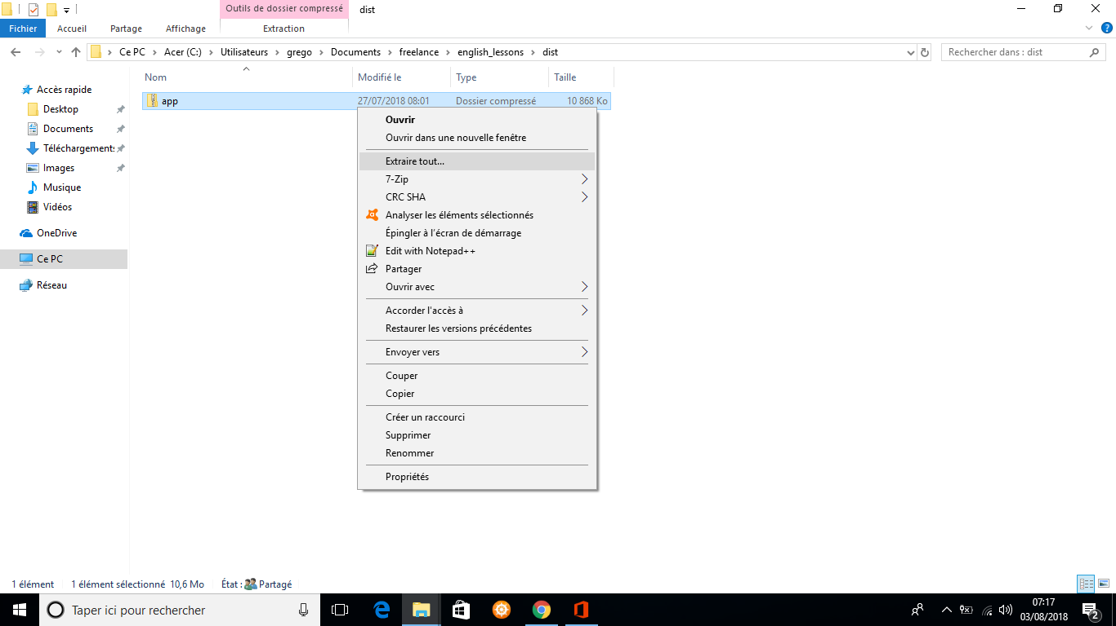

1. You should now have a folder “app”. Open it.

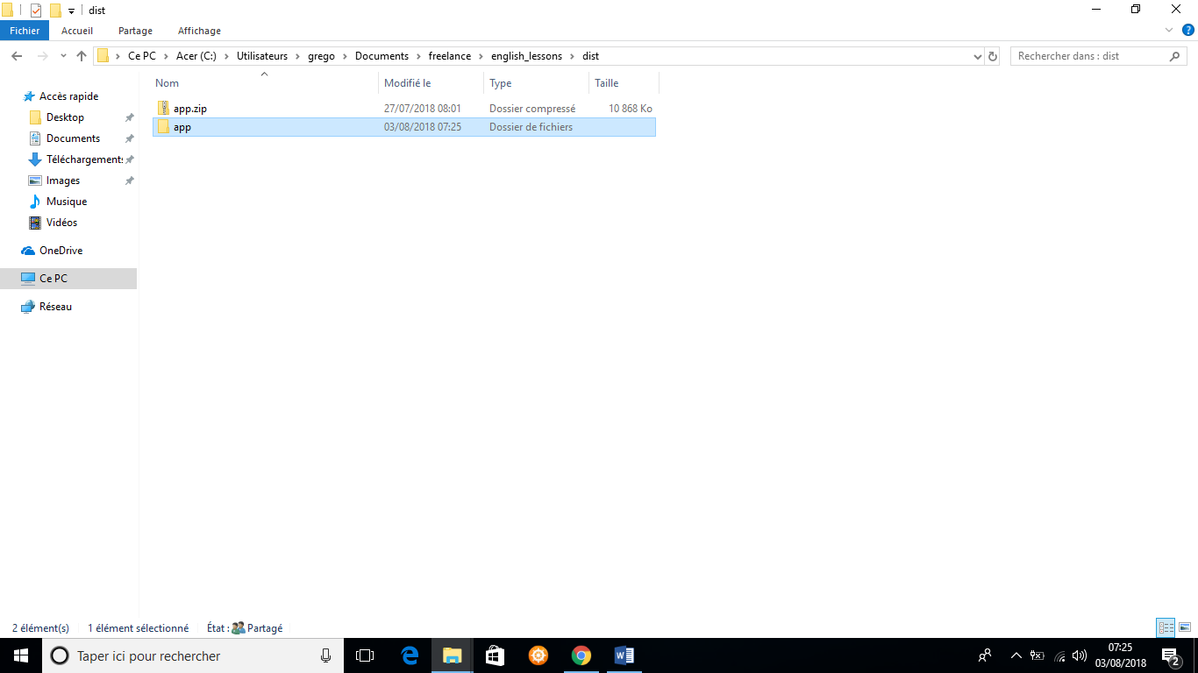

1. Run the file app (or app.exe) inside this folder. It is possible that Windows blocks your from running this app, in this case, click on *run anyway*. Once running, the following screen should appear.

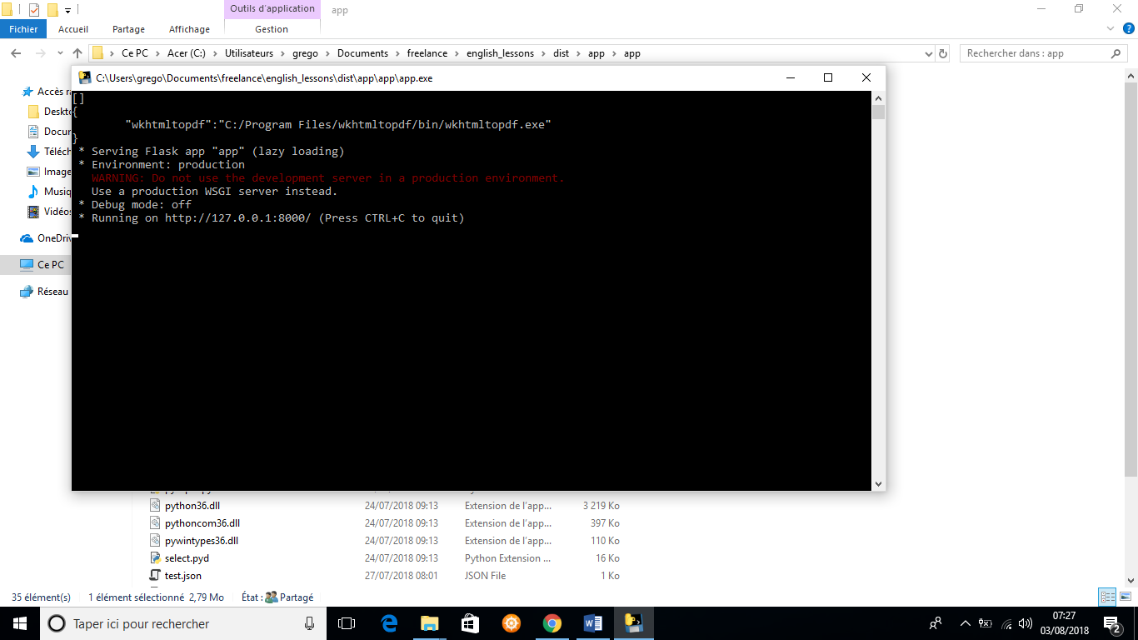

1. Now the app is running on your computer. To open the interface, go to a web browser (chrome, Firefox, internet explorer …) and go to <http://localhost:8000>. Click on the “*authorize”* button and connect with your google account.

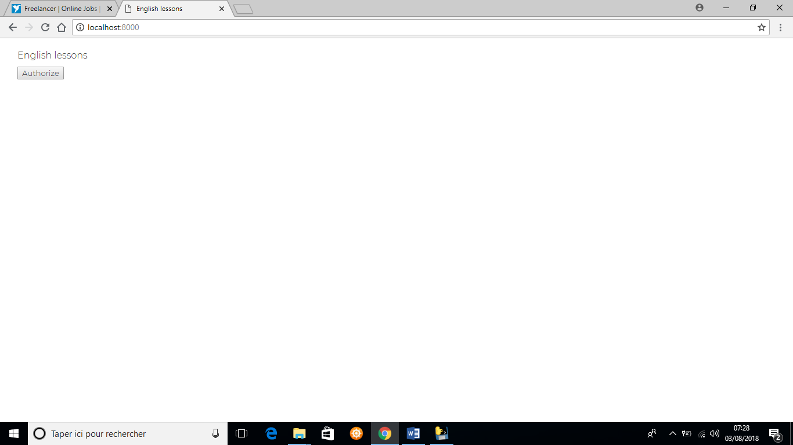

1. After being connected (or if you are already connected, after clicking on the *“Check for updated”* button) you should see a summary of your google sheets. You just have to click on “*Update Docs*” to generate the pdf files.
2. Into the app folder, go to *\app\static\docs*, you will find your pdf in the *pdf* folder. To import to drive, just drag and drop this *pdf* folder into drive.
3. If you want to add new lessons, update your spreadsheets and click on the “*Check for updates*” button. The app will find the modifications and you can do the same process starting from step **6**. After updating yous pdf files, drag and drop your *\pdf* folder at the same location into google drive. You will be ask if you want to update the documents, say yes. The PDF will be updated while keeping the same file links.

