Analyse incendie sous la passerelle - V1.1
Rapport automatique. Les hypotheses V1.1 doivent etre validees avant utilisation pour une justification.

Synthese des cas
Cas | Tmax intrados | Tmax suspente | Tmax cable
ISO834_F1_H10 | 1046.3 | 1045.6 | 1028.1
ISO834_F1_H12 | 1046.3 | 1045.6 | 1028.1
ISO834_F1_H15 | 1046.3 | 1045.6 | 1028.1
ISO834_F2_H10 | 1046.3 | 1045.6 | 1028.1
ISO834_F2_H12 | 1046.3 | 1045.6 | 1028.1
ISO834_F2_H15 | 1046.3 | 1045.6 | 1028.1
ISO834_F3_H10 | 1046.3 | 1045.6 | 846.7
ISO834_F3_H12 | 1046.3 | 1045.6 | 1028.1
ISO834_F3_H15 | 1046.3 | 1045.6 | 1028.1
CEREMA_EXT_F1_H10 | 680.0 | 680.0 | 658.8
CEREMA_EXT_F1_H12 | 680.0 | 680.0 | 658.8
CEREMA_EXT_F1_H15 | 680.0 | 680.0 | 658.8
CEREMA_EXT_F2_H10 | 680.0 | 680.0 | 658.8
CEREMA_EXT_F2_H12 | 680.0 | 680.0 | 658.8
CEREMA_EXT_F2_H15 | 680.0 | 680.0 | 658.8
CEREMA_EXT_F3_H10 | 680.0 | 680.0 | 580.5
CEREMA_EXT_F3_H12 | 680.0 | 680.0 | 658.8
CEREMA_EXT_F3_H15 | 680.0 | 680.0 | 658.8

Graphiques
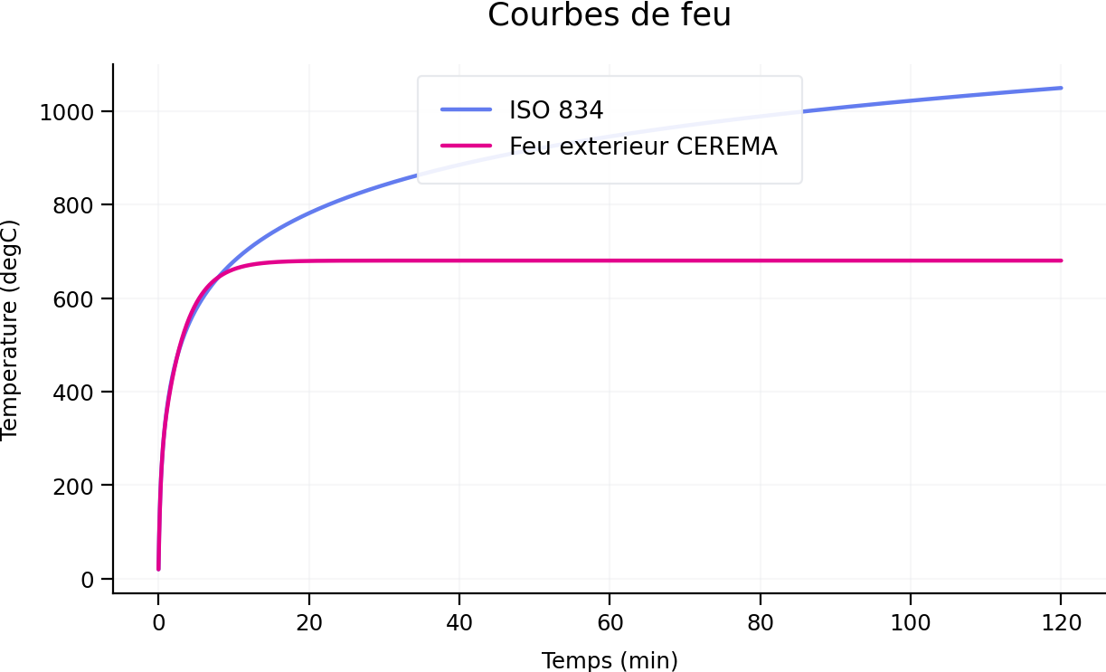
01_courbes_feu
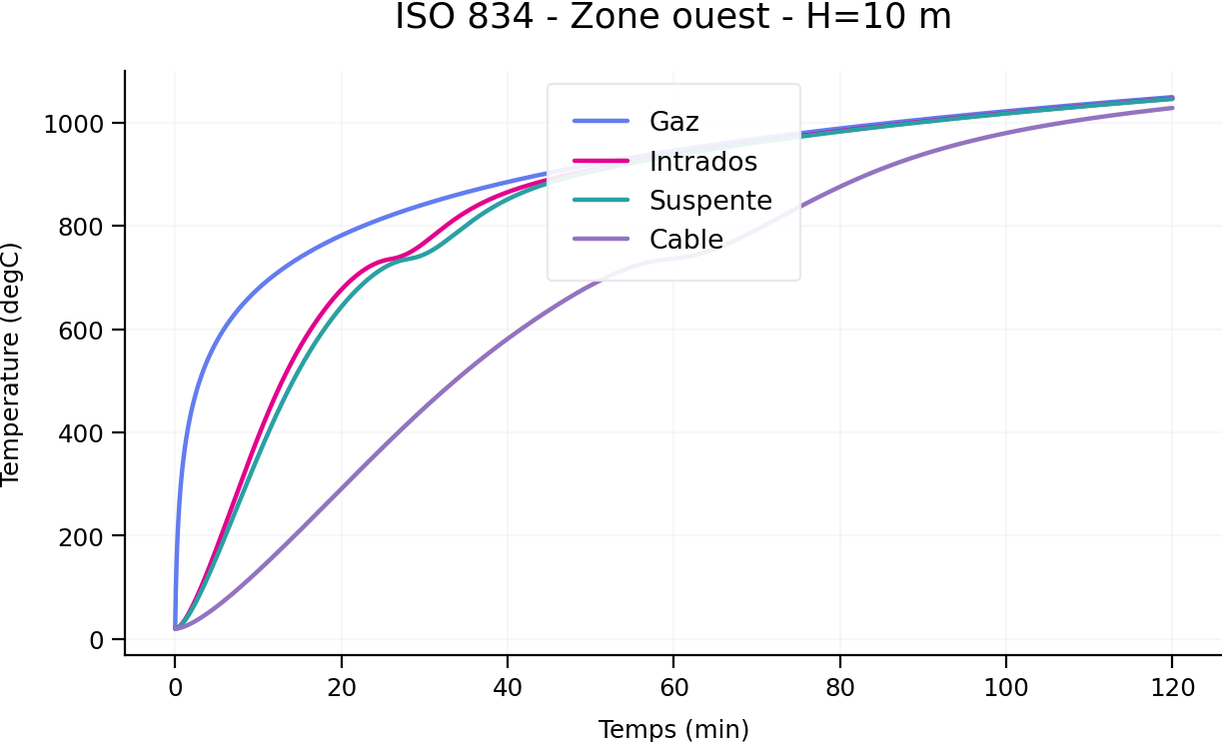
ISO834_F1_H10
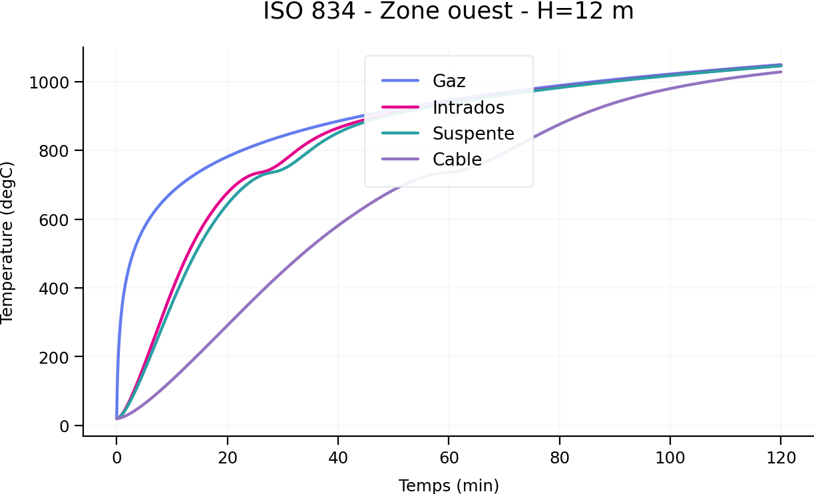
ISO834_F1_H12
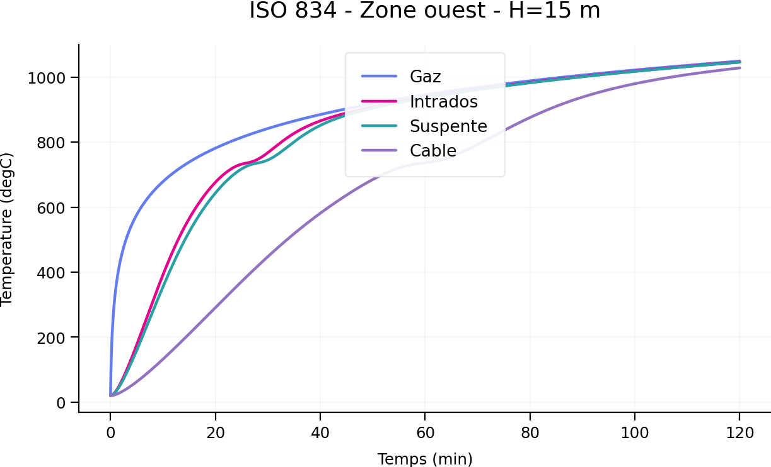
ISO834_F1_H15
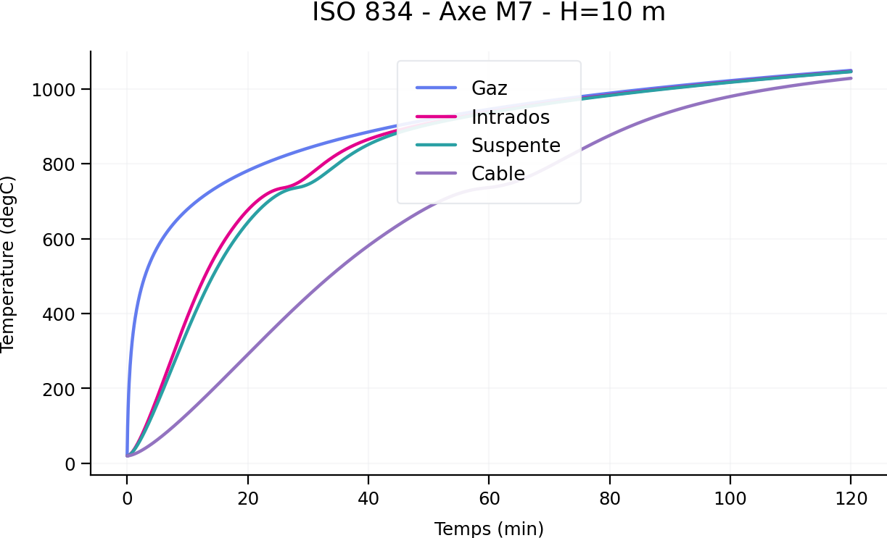
ISO834_F2_H10
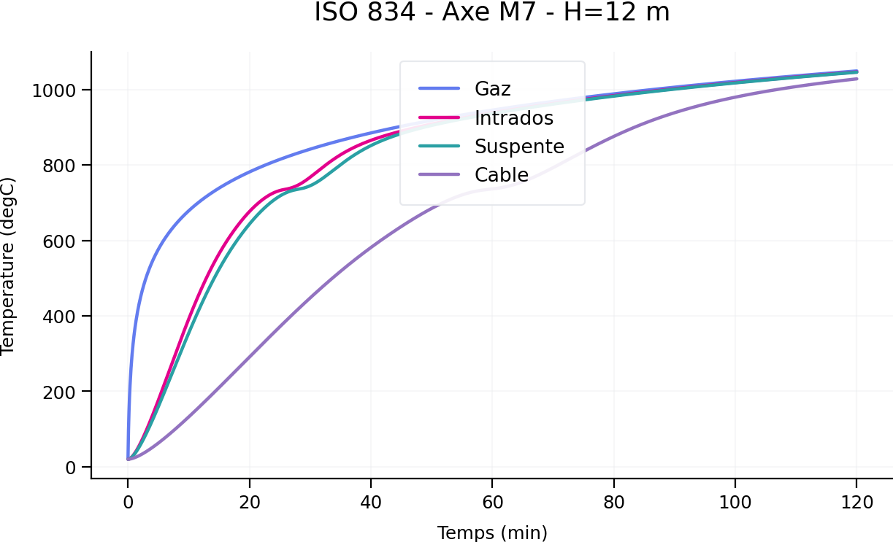
ISO834_F2_H12
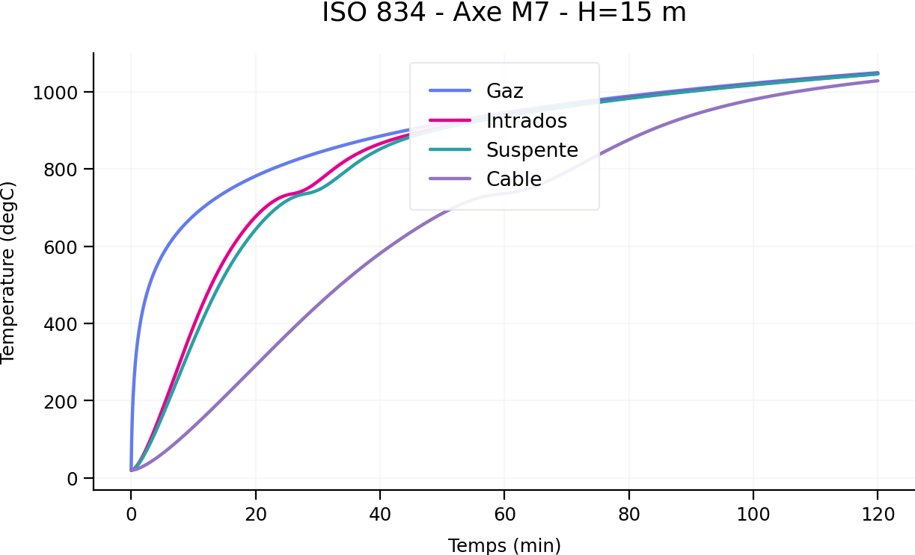
ISO834_F2_H15
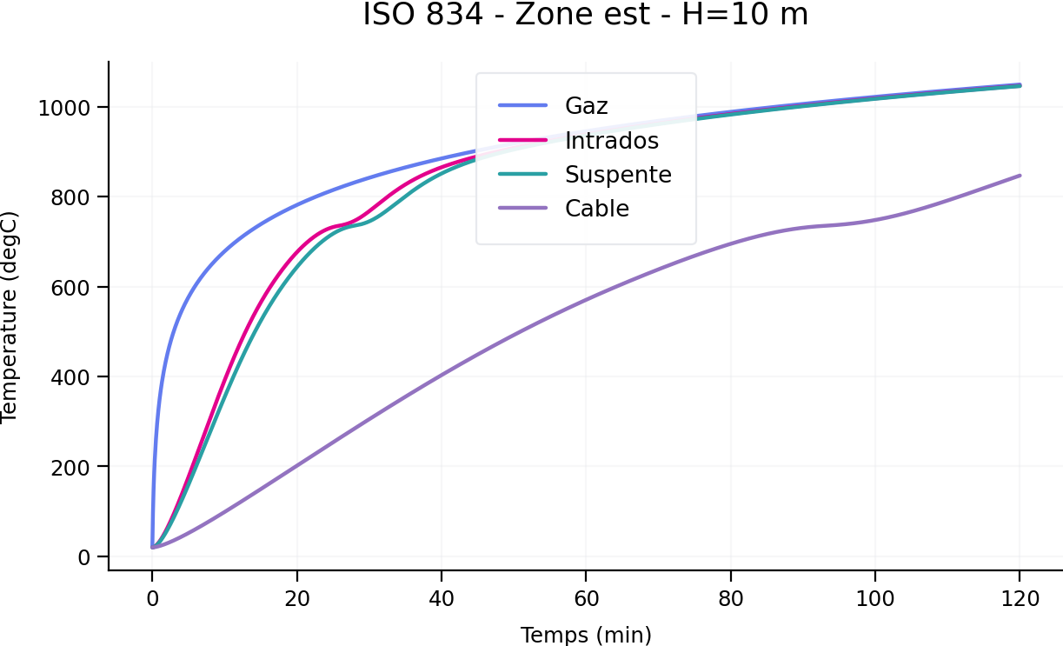
ISO834_F3_H10
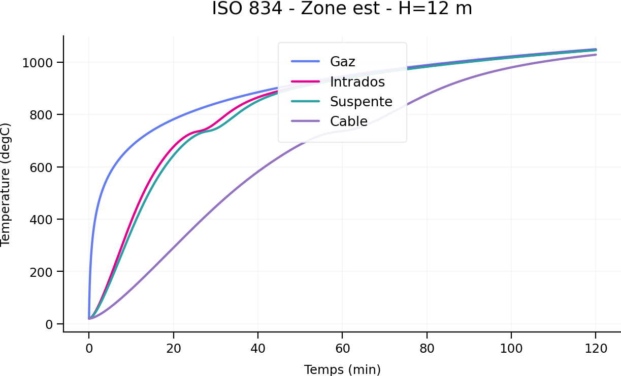
ISO834_F3_H12
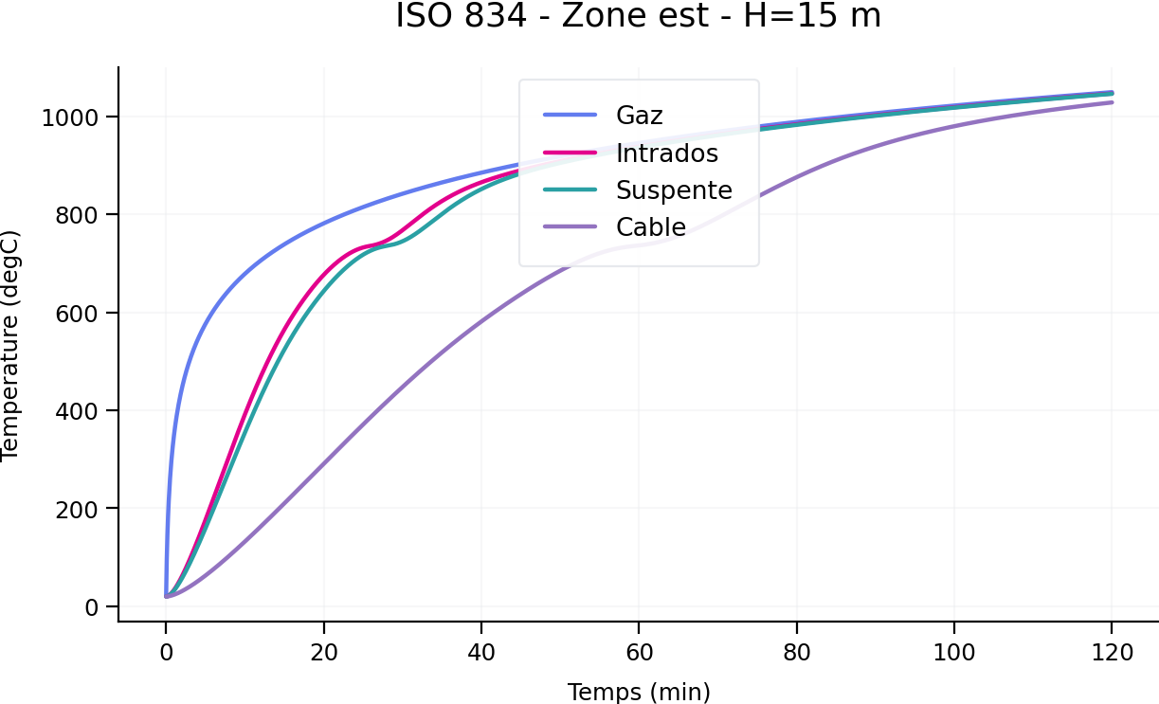
ISO834_F3_H15
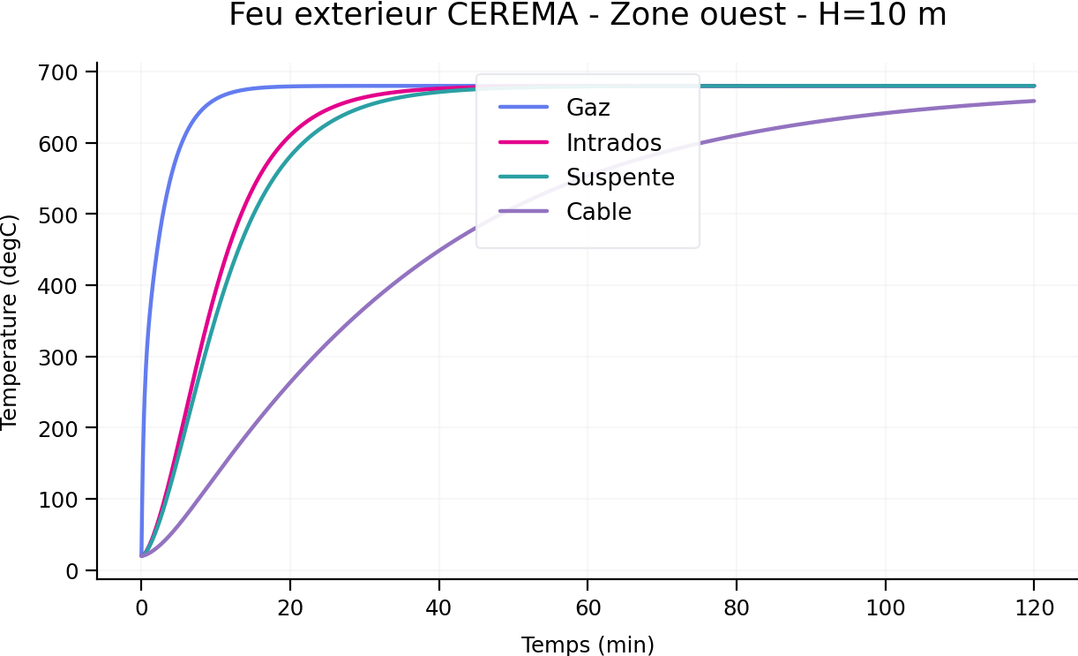
CEREMA_EXT_F1_H10
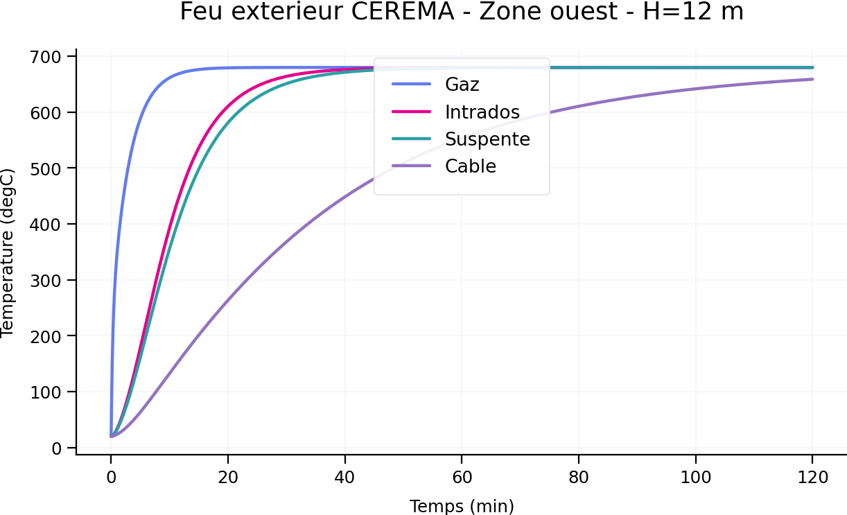
CEREMA_EXT_F1_H12
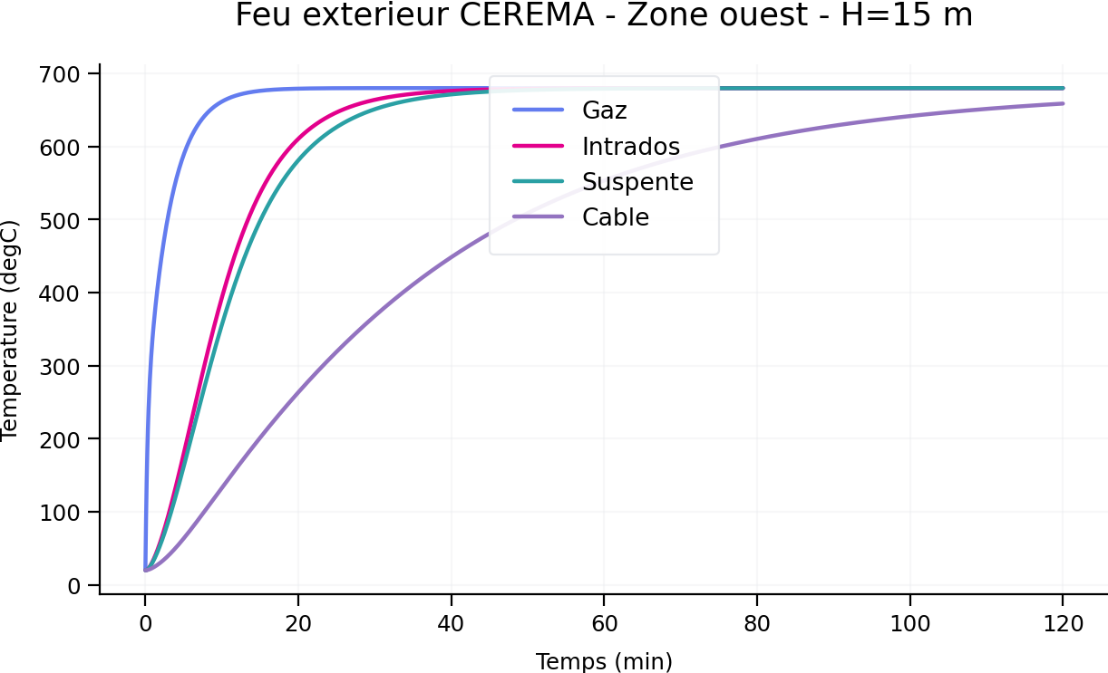
CEREMA_EXT_F1_H15
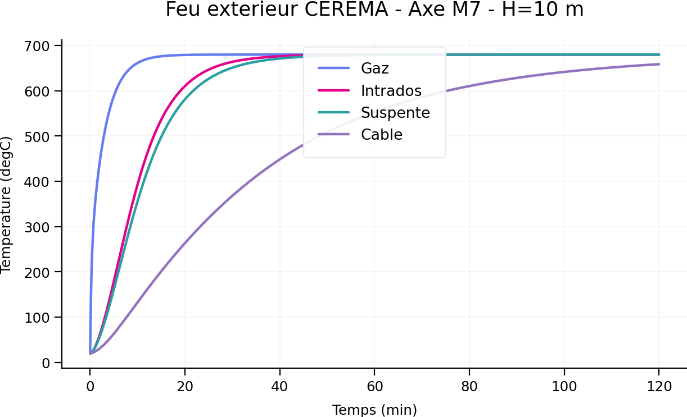
CEREMA_EXT_F2_H10
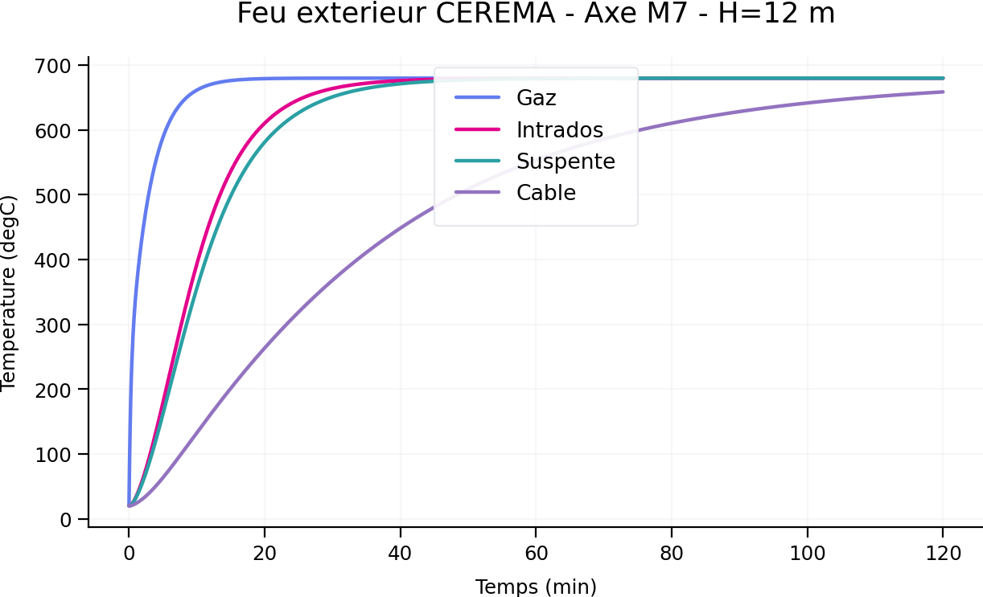
CEREMA_EXT_F2_H12
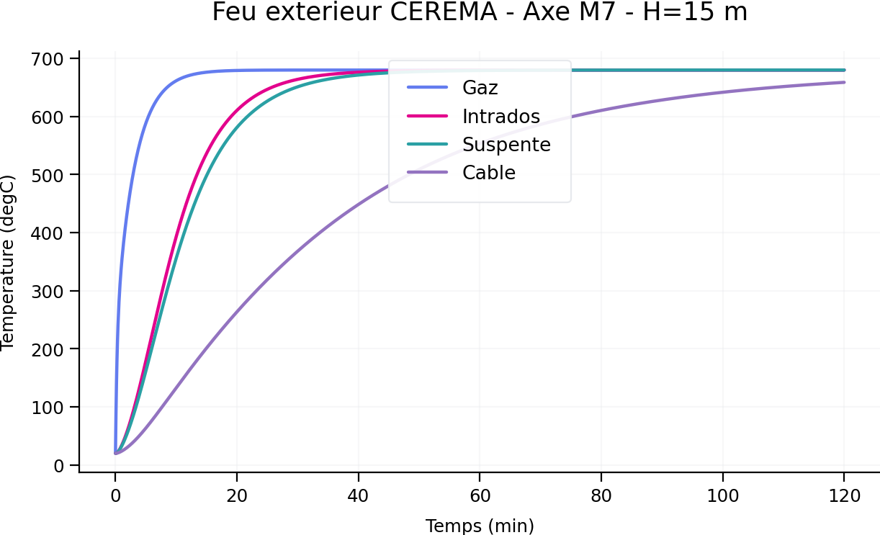
CEREMA_EXT_F2_H15
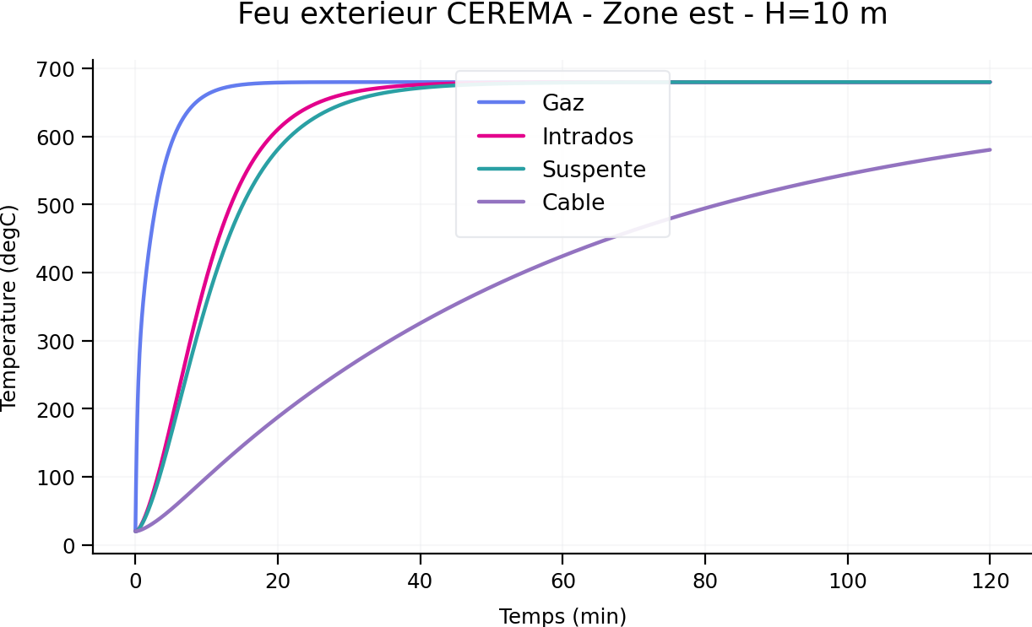
CEREMA_EXT_F3_H10
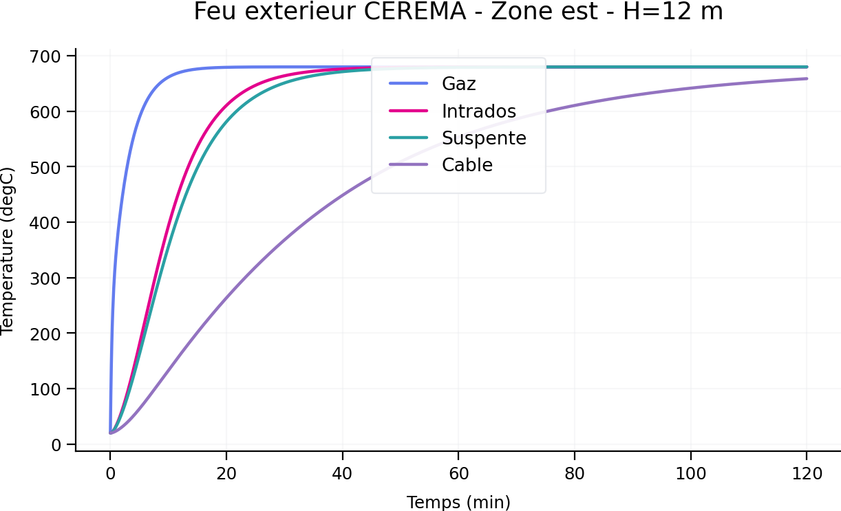
CEREMA_EXT_F3_H12
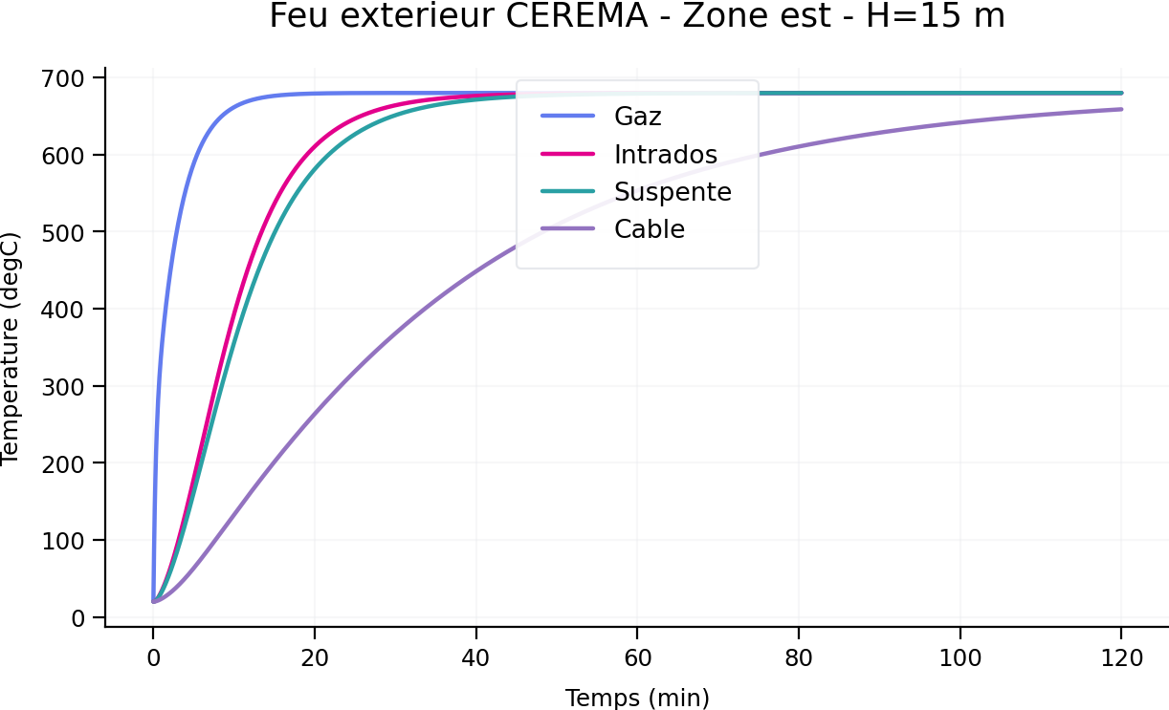
CEREMA_EXT_F3_H15

