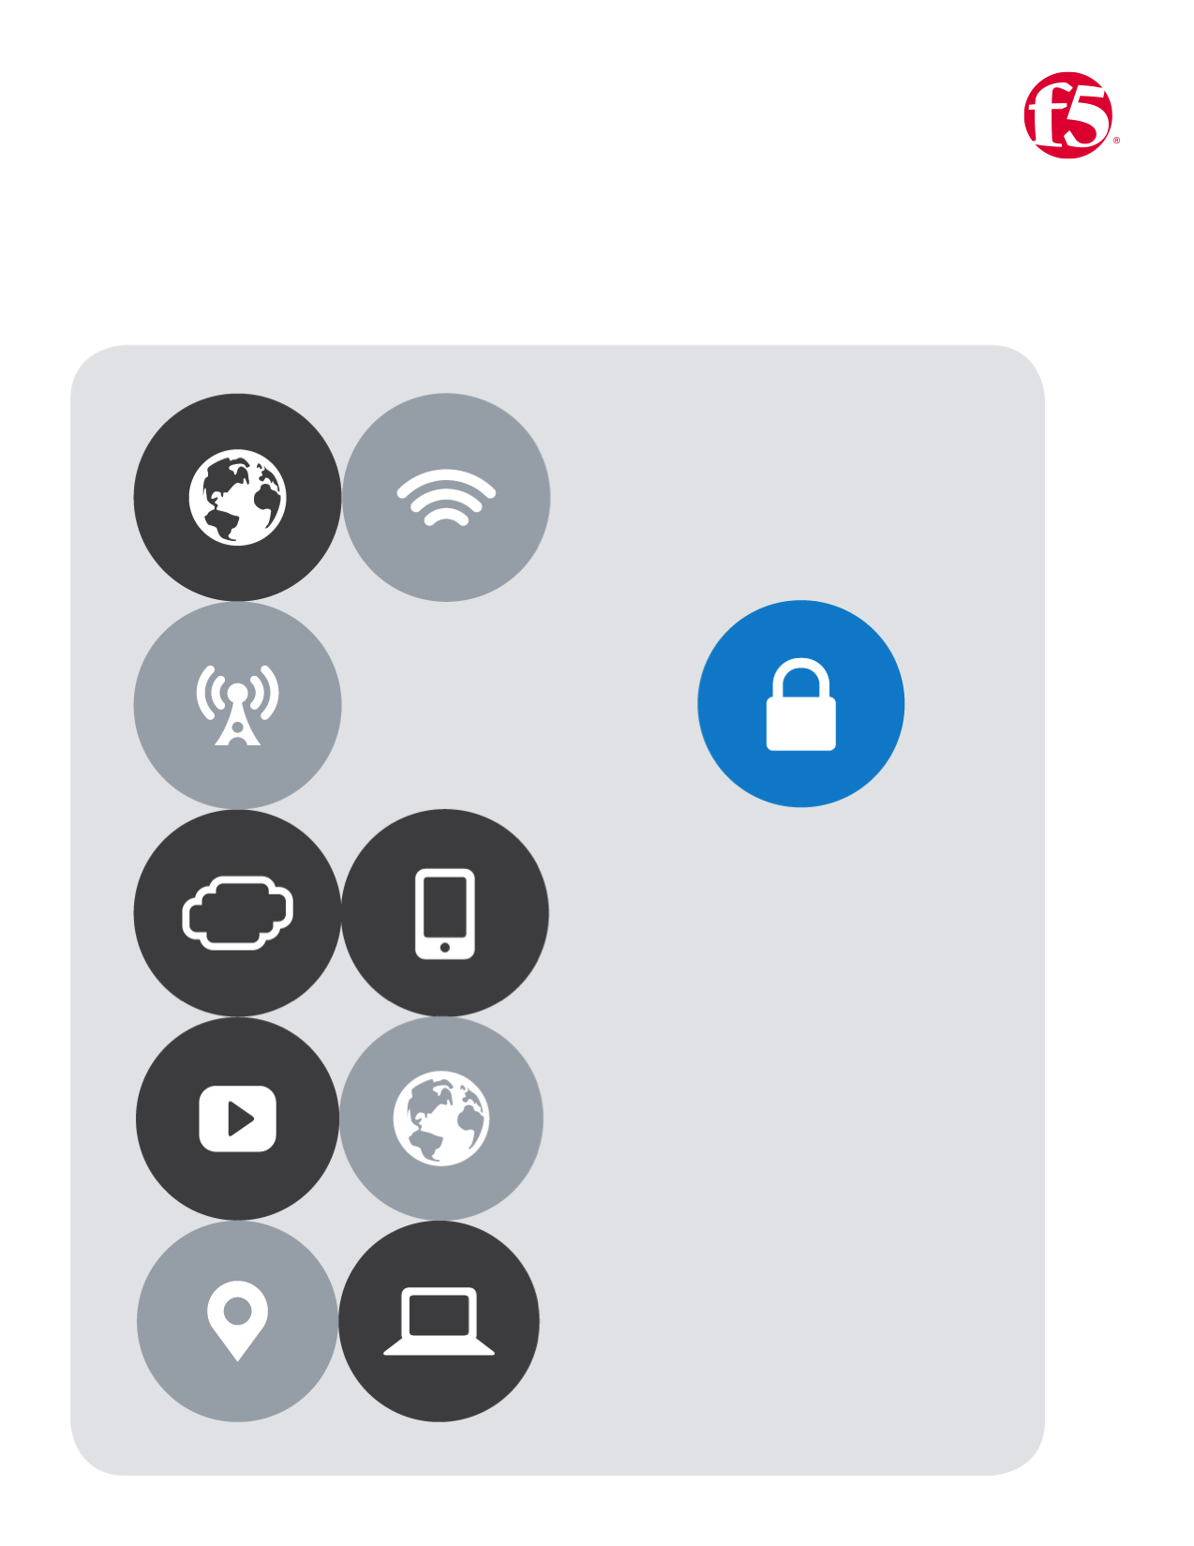

F5 | BD Tech Days

*Azure / AWS Lab Guide*

Table of Contents

[Azure lab guide 3](#_Toc473482745)

[Navigate to github: 3](#_Toc473482746)

[Navigate to the Azure Portal: 3](#_Toc473482747)

[Azure Terminology quick reference 4](#_Toc473482748)

[Lab One 7](#_Toc473482749)

[Deploy a web-app server from a template 7](#_Toc473482750)

[Lab Two 10](#_Toc473482752)

[Deploy a BIG-IP from the Azure Marketplace 10](#_Toc473482753)

[The Create Virtual Machine Blade will open and 5 tasks will need to be completed 11](#_Toc473482754)

[Lab Three 12](#_Toc473482755)

[a. New Parameters 13](#_Toc473482756)

[b. New Variables 13](#_Toc473482757)

[Modified Resources: 14](#_Toc473482758)

[1. Virtual Network 14](#_Toc473482759)

[2. Web VM 15](#_Toc473482760)

[3. Web VM Network Interface 16](#_Toc473482761)

[4. Web VM Extension 16](#_Toc473482762)

[New Resources: 17](#_Toc473482763)

[5. BIG IP Availability Set 17](#_Toc473482764)

[6. Azure Load Balancer, (ALB) 18](#_Toc473482765)

[7. Inbound NAT Rule 19](#_Toc473482766)

[8. Inbound NAT Rule 20](#_Toc473482767)

[9. BIG-IP Network Interfaces 21](#_Toc473482768)

[10. BIG-IP VM’s 22](#_Toc473482769)

[Lab Four 23](#_Toc473482770)

[Deploy a web-app server from a template 23](#_Toc473482771)

[AWS Lab Guide 26](#_Toc473482772)

[Navigate to github: 26](#_Toc473482773)

[Navigate to the F5 Webtop 26](#_Toc473482774)

[AWS Terminology quick refference 27](#_Toc473482775)

[Create a Key Pair 27](#_Toc473482776)

[Lab Five 30](#_Toc473482777)

[Deploy a web-app server from a template 30](#_Toc473482778)

[Lab Six 32](#_Toc473482779)

[Deploy a BIG-IP from the AWS Marketplace 32](#_Toc473482780)

[Lab Seven 34](#_Toc473482781)

[a. New Meta Data 35](#_Toc473482782)

[b. New Parameters 36](#_Toc473482783)

[c. New Output 37](#_Toc473482784)

[d. New Resources 38](#_Toc473482785)

[e. New BIG-IP instance 39](#_Toc473482786)

[Lab Eight 40](#_Toc473482787)

[Deploy a web-app server from a template 40](#_Toc473482788)

# Azure lab guide

## *Navigate to github:*<https://github.com/gregcoward/azuretraining>

1. Notice the section highlighted below. Here you will find the templates that relate to this lab

|  |
| --- |
|  |
|  |

## *Navigate to the Azure Portal:* [HTTPS://PORTAL.AZURE.COM/](https://portal.azure.com/)

Note: You will be assigned an **alphabet letter** which will correspond your user account. Substitute your alphabet letter with the **first** letter of the **username**

1. Username**:** **auser@f5cloudtry@onmicrosoft.com** **|** Password**:** **F5labnet**

|  |
| --- |
|  |
|  |

## *Azure Terminology quick reference*

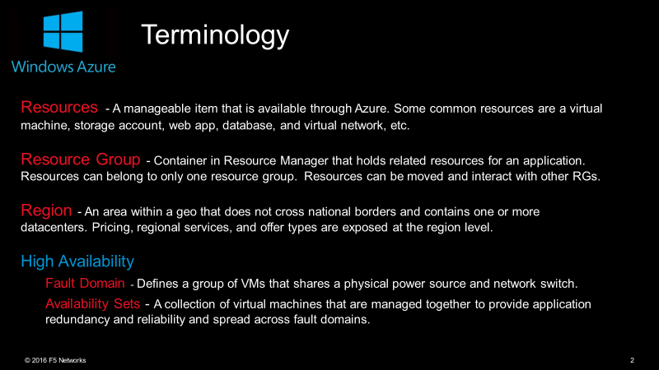

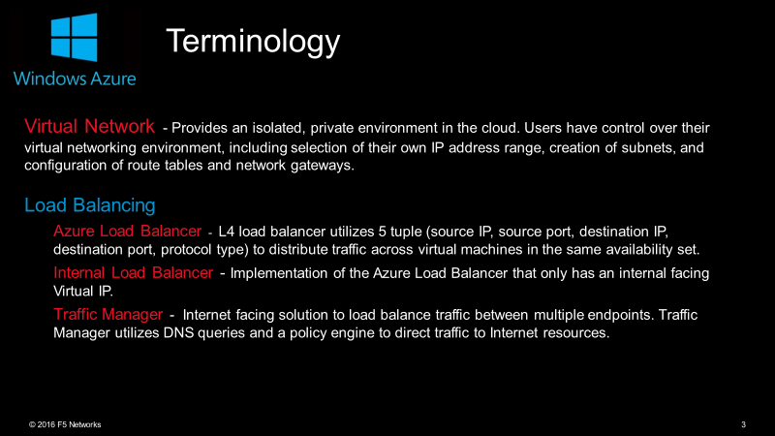

|  |  |
| --- | --- |
|  | |
|  | Expand / Collapse the left bar |
|  | Provides access to the **marketplace** and all **Azure offerings** |
|  | All deployed Resources in this subscription |
|  | All Resource Groups created in this subscription |
|  | Microsoft Azure (PaaS) offering. Create web and mobile apps for any platform or device |
|  | database-as-a-service in the cloud built on the Microsoft SQL Server engine |
|  | DocumentDB is a schema-less, SSD-backed database that stores JSON documents and exposes a REST API |
|  | Customized Windows and Linux VMs with complete control of the OS Providing what's known *as* Infrastructure as a Service (IaaS) |
|  | Public and Internal facing load balancing objects |
|  | Provides a unique namespace to store and access Storage your data objects |
|  | A logical isolation of the Azure cloud dedicated to your subscription |
|  | A multi-tenant cloud based directory and identity management service |

|  |  |
| --- | --- |
|  | Metrics and logs made available within the portal and via APIs to gain more visibility into the state and performance of your resources |
|  | Scan your Azure applications, and get actionable recommendations based on your configuration and usage patterns. |
|  | View of the security state of all of your Azure resources. At a glance, verify that the appropriate security controls are in place and configured correctly. And quickly identify any resources that require attention. |
|  | information shown here pertains to subscriptions you’ve created. To view the spend for any other subscription or resource you’re associated with, go to the blade for that subscription or resource |
|  | a range of support options for customers from developers starting their journey in the cloud to organizations deploying business-critical, strategic applications on Microsoft Azure |

# Lab One

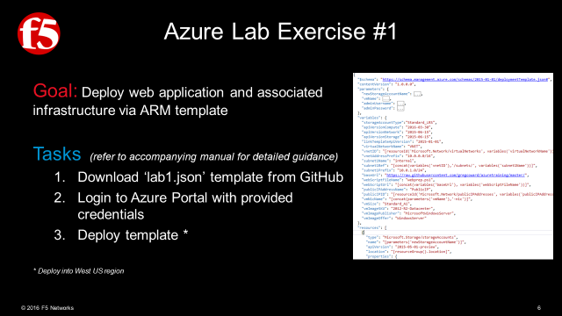

## *Deploy a web-app server from a template*

1. On the **github** page that you opened previously find the template labeled **|** double click **lab1.json** template
2. Once it opens notice the menu bar at the top of the template **|** click the **Raw** button
3. A new browser page will **|** Select all and copy the **Raw** content

|  |  |
| --- | --- |
|  | |
|  | |
|  |  |
|  |  |

### Return to the Azure Portal **|** Click **New** from the left menu bar

1. In the search the marketplace field **|** Type **Template Deploymnet**
2. The Marketplace filter will open will open and you will see the image below **|** Click **Template Deployment**
3. A new pane opens **|** Click the **Create** button
4. A new pane opens **|** Click **edit**
5. In the Edit Template Pane **|** Paste the content from the **ARM Template** that you copied previously
6. If you template looks like the screenshot **|** click **Save** near the bottom of the template.

|  |  |  |  |
| --- | --- | --- | --- |
|  | |  | |
|  | |  | |
|  |  | | |
|  |  | | |
|  | | |  |
|  | | |  |

1. You should now see the custom deployment pane **|** Fill in the required fields as indicated in the screen shot below **|** Check the box to agree to the **terms and conditions |** Check the **Pin to dashboard** checkbox **|** then click **Purchase**
2. You will then be returned to the **dashboard** where you can monitor your deployment **|** More details are available by double clicking the image seen in the screen shot below

|  |  |
| --- | --- |
|  |  |
|  |  |

# Lab Two

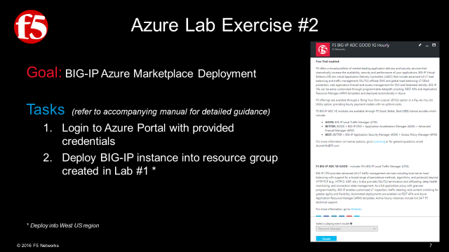

## *Deploy a BIG-IP from the Azure Marketplace*

1. Return to the Azure Portal **|** Click  **New** from the left menu bar
   1. In the search the marketplace field **|** Type **f5**
   2. Take a moment to review the F5 marketplace offerings **|** Then select **Good 1G Hourly**
   3. A new blade will open, review the information **|** Click **Create**

|  |  |
| --- | --- |
|  |  |
|  |  |
|  |
|  |

### The **Create Virtual Machine Blade** will open and 5 tasks will need to be completed

Required fields will be indicated by the following icon 

1. **Basics** (configure basic settings) **|** Then click **OK**
2. **Size** (choose virtual machine size) **|** Select **View all** on the top right **|** Then select **A2M\_V2** as your size **|** Then Click **Select**
3. **Settings** (configure optional features) **|** you will want to use the previously created **Storage Account** and **VNET |** for the **Network Security Group** select **|** Then Click **OK**
4. Review the **Summary** **|** Click **OK**
5. Review the **Offer Details** **|** Click **Purchase**

|  |  |
| --- | --- |
|  |  |
|  |  |
|  |  |
|  |  |
|  |
|  |

# Lab Three

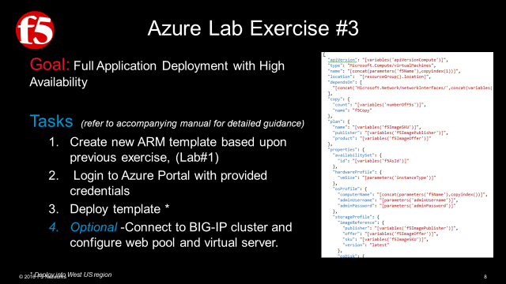

|  |  |  |  |
| --- | --- | --- | --- |
|  | Modified Parameters | | |
|  | Modified Variables | | |
| Original Template | |  | Modifications to Original Template |
| *Storage Account* | |  | *No Change* |
| *Virtual Network* | |  | *Modified for* **2 Subnets** |
| *Virtual Machine* **(Webserver)** | |  | **2** *Virtual Machine* **(Webserver)** - **copy** |
| *Network Interface* **(Webserver)** | |  | **2** *Network Interface* **(Webserver)** – **copy** |
| *Extension Script* | |  | **2** *Extension Script* – **copy** |
| Net-New Adds to Original Template | | | |
|  | |  | *Availability set* **(BIG-IP)** |
|  | *Azure Load Balancer* |
|  | *Inbound MGMT NAT Rule* |
|  | *Inbound SSH NAT Rule* |
|  | *Network Interfaces* **(BIG-IP)** |
|  | *Virtual Machines* **(BIG-IP)** |

### **New Parameters**

|  |
| --- |
|  |
| **Add in additional parameters to specify BIG-IP instance name and instance size.** |
|  |

### **New Variables**

|  |
| --- |
|  |
| **Add the following additional variables to the end of the variables section.** |
| 'numberOfVms": 2  "subnet2Name": "external" ,  "subnet2Ref" :  " [concat (variables( 'vnetID'), ' / subnets/' ,  variables ( ' subnet2Name ' " ,  "subnet2Prefix" :  "1ø.ø.2.ø/24",  "f51mageSKLl" :  "f5-bigip-virtuaI-edition-Ig- best- hourly"  "f51magePubIisher": "f 5-networks" ,  "f51mageOffer": "f5-big-ip-hourIy" ,  "numberOfF5s": 2,  "f5NicName": " '-nic  "f5AvaiIabiIitySetName": " [concat (parameters( 'f5Name ' ) , ' -avset'))  "f5AsId": "Cresourceld( 'Microsoft .Network/availabilitysets ' , variables('f5AvaiIabiIitySetName')))",  "f5Load8aIancerName": " 'f5Name ' ) , '-alb '  "f5LbId": "Cresourceld( 'Microsoft .Network/Ioad8aIancers ' , variables('f5Load8aIancerName')))",  "frontEndIPConfigID" :  " [concat (variables( 'f5LbID ) , ' /frontendIPConfigurations/Ioad8aIancerFrontEnd ' " |

## **Modified Resources:**

### Virtual Network

|  |
| --- |
|  |
| **Modify the existing virtual network resource to include a second subnet, (‘external’). The BIG-IPs will be deployed into this new subnet.** |
| 'apiVersion" .  "type" •  "Microsoft . Network/ virtualNetworks " ,  name' :  " [variables( 'virtualNetworkName ' " ,  "location": " location) " ,  properties": {  "addressSpace": {  "addressprefixes" :  " (variables ( 'vnetAddr  "subnets":  Modified to add  additional subnet  name" • " " ,  properties": {  "addressprefix": " "  name' : " [variables('subnet2Name'))",  properties": {  "addressprefix": " " |

### Web VM

|  |
| --- |
|  |
| **Modify the existing virtual machine resource to allow for creation of multiple copies of the web server** |
| 'apiVersion" .  "2ø15-ø5-ø1-preview",  "type" •  "Microsoft . Compute / virtualmachines " ,  name' : " 'vmName ' ) , copylndex(l)))",  "location": " Cresourcefiroup() . location)'  Modified to deploy multiple copies  name' : "vmCopy",  "copy": {  'count":  " [variables ( ' numberOfVms ' "  "dependsOn": C  'Cconcat( 'Microsoft.Storage/storageAccounts/', parameters(' newStorageAccountName  'Cconcat( 'Microsoft.Network/networkInterfaces/', variables( 'wnNicName'), copylndex(l)))"  properties": {  "hardwareprofile": {  "vmSize": " "  "osprofile": {  ' computerName" :  " 'vmName ' ) , copylndex(l))) " ,  'adminl_lsername": " [parameters( admindsername  " admin Password'  " [parameters( ' adminpassword ' "  "storageprofile": {  "imageReference": {  'publisher": " " ,  "offer" :  " [variables( 'vmImageOffer ' " ,  • " [variables( 'wnImageSKLl'  'version": "latest"  "osDisk" :  ": "osdisk",  name  "vhd":  url"  " [concat( ' http://',  parameters ( ' newStorageAccountName' ) , ' . blob. core. windows . net/vhds/ '  'osdisk' , copylndex(l), ' .vhd "  'caching'  "ReadWrite " ,  'createOption " : "Fromlmage"  "networkprofile": {  " networklnterfaces " :  ' Cresourceld ( ' Microsoft. Network/ networklnterfaces ' ,  concat(variables ( ' vmNicName ' ) , copylndex(l) " |

### Web VM Network Interface

|  |
| --- |
|  |
| **Modify existing network interface resource to allow for creation of multiple copies. Additionally, remove the public IP association. The public IP will be assigned to the new ALB object in a later step.** |
| 'apiVersion" .  "2ø15-ø5-ø1-preview",  "type" •  "Microsoft . Network/ networklnterfaces " ,  name' : " (variables( 'vmNicName ' ) , copylndex(l))) " ,  "location": " Cresourcefiroup() . location]'  name' : "vmCopy"  "copy": {  'count":  " [variables ( ' numberOfVms ' "  "dependsOn": C  " [concat ( 'Microsoft . Network/ publicl  ' [concat( 'Microsoft.Network/virtua  properties": {  " ipConfigurations" :  name' :  'ipconfigl" ,  properties": {  Modified to deploy multiple  copies and removal of  Public IP association  • clPAddressName' "  rkName ' ) "  'privatelPAIIocationmethod": "Dynamic" ,  "subnet": {  • " (variables('subnetIRef'))" |

### Web VM Extension

|  |
| --- |
|  |
| **Modify existing custom script extension resource to allow for creation of multiple copies.** |
| "type" •  "Microsoft. Compute/virtualmachines / extensions " ,  name' : 'vmName ' '/iisScript'))",  " [variables( ' apiVersionCompute'  "location": " CresourceGroup() . location]'  "copy": {  name' : "vmCopy"  'count": " numberOfVms "  parameters ( ' vmName ' ) ,  Modified to deploy multiple copies  copylndex(l))) "  "dependsOn": C  ' [concat( 'Microsoft. Compute/virtualmachines/ ' ,  'publisher" :  "Microsoft. Compute" ,  "type" •  "CustomScriptExtension " ,  "typeHandIerVersion": '  " settings "  "filel_lris": C  " (variables ( ' webScriptLlrI ' "  ' commandToExecute" :  " [concat( ' powershell  -ExecutionPoIicy Unrestricted  -file  variables ( ' webScriptF ileName ' " |

## **New Resources:**

### BIG IP Availability Set

|  |
| --- |
|  |
| **Create an availability set. The BIG-IP cluster will be assigned to the set providing fault tolerance. Create an availability set. The BIG-IP cluster will be assigned to the set providing fault tolerance.** |
| 'apiVersion" .  • "2ø15-ø6-15",  "tags "  "displayName"• "AvailabilitySet"  "location": " CresourceGroup() . location) " ,  name' : " [variables( 'f5AvaiIabiIitySetName ,  "type" :  "Mic rosoft. Compute/ ava i la bilitySets " |

### Azure Load Balancer, (ALB)

|  |
| --- |
|  |
| **Create a new ALB resource for load balancing inbound connections across the BIG-IP cluster** |
| " [variables ( ' " ,  "type" •  "Microsoft. Network/ loadaalancers " ,  "dependsOn": C  " [concat( 'Microsoft.Network/pubIicIPAddresses/ ' ,  "location": " CresourceGroup() . location) " ,  variables ( ' publiclPAddressName ' "  name' :  " (variables( 'f5Load8aIancerName ' " ,  properties": {  "frontendIPConfigurations " :  name' : "Cconcat('IoadaaIancerFrontEnd'))",  properties": {  'publiclPAddress": {  • " publiclpld  "backendAddressPooIs": C  name  ": "loadaaIanceraackEnd"  "loadaaIancingRuIes": L  "Name" :  "APPI-HTTP",  properties": {  "frontendIPConfiguration": {  ' [concat(resourceld ( 'Microsoft.Network/IoadaaIancers ' ,  "backendAddressPooI": {  " [concat(resourceld ( 'Microsoft.Network/IoadaaIancers ' ,  'probe": {  ' [concat(resourceld ( 'Microsoft.Network/IoadaaIancers ' ,  ' protocol" :  "Tcp",  "frontendport" .  "backendport" .  " idleTimeoutInminutes " :  "loadDistribution " :  "SourceIP"  "probes":  properties": {  rotocol" :  "Tcp",  'port" •  'intetwaIInSeconds" :  "numberOfProbes": 2  variables ( ' f5LoadaaIancerName ' ) ) ,  variables ( ' f5LoadaaIancerName ' ) ) ,  variables ( ' f5LoadaaIancerName ' ) ) ,  ' /frontendIpConfigurations/IoadaaIancerFrontEnd ' "  ' / backendAddressPooIs/IoadaaIanceraackEnd ' "  ' / probes/ IbprobeHTTP ' ) ) "  name" •  " [concat( ' IbprobeHTTP'))" |

### Inbound NAT Rule

|  |
| --- |
|  |
| **Create an inbound NAT rule for GUI management access to the BIG-IPs** |
| 'apiVersion" .  • "2ø15-ø6-15",  "tags "  "displayName"  "InboundNATRu1es6U1"  "Microsoft .Network/Ioad8aIancers/inboundNatRuIes" ,  name' :  " [concat (variables( 'f5Load8aIancerName ' ) , '/guimgt' ,  "location": " CresourceGroup() . location) " ,  "copy": {  name' : "f5Copy",  'count":  " (variables( ' numberOfF5s ' "  copylndex(l))) "  "dependsOn": C  " [concat( 'Microsoft.Network/IoadaaIancers/ ' ,  "frontendIPConfiguration": {  variables ( ' f5LoadaaIancerName ' "  • " 'frontEndIPConfigID' "  ' protocol" :  "tcp" ,  "frontendport": " CcopyIndex(8443)) " ,  "backendport" .  "enableFIoatingIP": false |

### Inbound NAT Rule

|  |
| --- |
|  |
| **Create an inbound NAT rule for SSH management access to the BIG-IPs.** |
| 'apiVersion" .  • "2ø15-ø6-15",  "tags "  "displayName" :  "InboundNATRuIesSSH"  "Microsoft.Network/Ioad8aIancers/inboundNatRuIes" ,  name' :  " [concat (variables( 'f5Load8aIancerName ' ) , '/sshmgt' ,  "location" :  " CresourceGroup() . location) " ,  "copy": {  name' :  "f5Copy"  'count":  " [variables( ' numberOfF5s ' "  copylndex(l))) "  "dependsOn": C  " Cconcat( 'Microsoft.Network/IoadaaIancers/ ' ,  "frontendIPConfiguration": {  ' protocol" :  "tcp" ,  "frontendport": " CcopyIndex(8ß22)) " ,  "backendport" :  "enableFIoatingIP": false  variables ( ' f5LoadaaIancerName ' " |

### BIG-IP Network Interfaces

|  |
| --- |
|  |
| **Create a new network interface resource for each of the BIG-IP cluster nodes.** |
| 'apiVersion" .  • "2ø15-ø5-ø1-preview",  "type" •  "Microsoft . Network/ networklnterfaces " ,  name' : " (variables( 'f5NicName ' ) , copylndex(l))) " ,  "location": " . location) " ,  "copy": {  name' : "f5Copy"  'count":  " (variables( ' numberOfF5s ' "  "dependsOn": C  '[concat( 'Microsoft.Network/virtuaINetworks/', variables('virtuaINetworkName')))",  " [concat (variables( 'f5LbId ' ) , ' / inboundNatRuIes/guimgt ' , copylndex(l) ) ) " ,  " [concat (variables( 'f5LbId ' ) , ' /inboundNatRuIes/ sshmgt ' , copylndex(l) "  properties": {  " ipConfigurations " :  name" •  'ipconfigl" ,  properties": {  'privatelPAIIocationmethod": "Dynamic" ,  "subnet": {  " (variables ( ' subnet2Ref' "  "loadaaIancer3ackendAddressPooIs": C  " [concat(variables ( 'f5LbId ' )  "loadaaIancerInboundNatRuIes": C  " Cconcat(variables ( 'f5LbId ' )  " [concat(variables ( 'f5LbId ' )  ' /backendAddressPooIs/ ' ,  ' loadaaIanceraackEnd ' "  ' / inboundNatRuIes/' , 'sshmgt' , copylndex(l))) "  ' / inboundNatRuIes/' , 'guimgt' , copylndex(l))) " |

### BIG-IP VM’s

|  |
| --- |
|  |
| " [variables ( ' " ,  "type" •  "Microsoft . Compute / virtualNachines " ,  name' : 'f5Name ' ) , copyindex(l)))",  "location " :  " CresourceGroup() . location) '  "dependsOn": C  ' [con cat( ' Microsoft. Network/ networklnterfaces/ ' , concat(variables ( ' f5NicName ' ) , copylndex(l)))) "  "copy": {  'count": " numberOfF5s " ,  name" • "f5Copy"  'plan": {  name' : " (variables('f51mageSKLl'))",  'publisher": " (variables( 'f51magePubIisher')) " ,  'product":  " (variables( 'f51mageOffer ' "  properties": {  "availabilitySet": {  " • d" • " (variables('f5AsId'))"  "hardwareprofile": {  "vmSize" :  " [parameters ( ' instanceType ' "  "osprofile": {  ' computerName" :  " [concat (parameters ( 'f5Name ' ) , copyindex())) " ,  'adminl_lsername": " Cparameters( admindsername  "adminpassword"• " [parameters( ' adminpassword ' "  "storageprofile": {  "imageReference": {  'publisher" :  " [variables ( 'f51magePubIisher' " ,  "offer" :  " [variables( 'f51mageOffer ' " ,  • " [variables( 'f51mageSKLl'  'version": "latest"  "osDisk" :  name' : "Cconcat('osdisk' , parameters('f5Name'), copyindex(l)))",  "vhd":  url"  " [concat( ' http:// ' , parameters ( ' newStorageAccountName' ) , ' . blob. core. windows . net/ ' , parameters ( ' newStorageAccountName ) ,  ' ' /f5Disk' , copyindex(l), ' . vhd ' ) ) "  'caching": "ReadWrite",  'createOption " : "Fromlmage"  "networkprofile": {  " networklnterfaces " :  ' Cresourceld ( ' Microsoft. Network/ networklnterfaces ' , concat(variables ( ' f5NicName ' ) , copyindex(l)))) "  "diagnosticsprofile": {  "bootDiagnostics": {  'enabled": true,  "storagel_lri": " [concat('http://',  parameters( ' newstorageAccountName' ) , ' . blob. core. windows . net' " |

# Lab Four

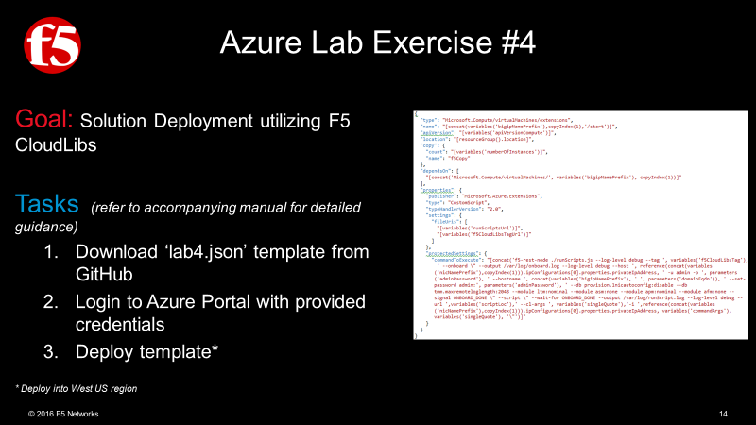

## **Deploy a web-app server from a template**

1. On the **github** page that you opened previously find the template labeled **|** double click **lab4.json** template
2. Once it opens notice the menu bar at the top of the template **|** click the **Raw** button
3. A new browser page will **|** Select all and copy the **Raw** content

|  |  |
| --- | --- |
|  |  |
|  |  |
|  | |
|  | |

1. Return to the Azure Portal **|** Click  **New** from the left menu bar
2. In the search the marketplace field **|** Type **Template Deploymnet**
3. The Marketplace filter will open will open and you will see the image below **|** Click **Template Deployment**
4. A new pane opens **|** Click the Create button
5. A new pane opens **|** Click edit
6. In the Edit Template Pane **|** Paste the content from the ARM template that you copied previously
7. If you template looks like the screenshot **|** click Save near the bottom of the template.

|  |  |  |  |
| --- | --- | --- | --- |
|  | |  | |
|  | |  | |
|  |  | | |
|  |  | | |
|  | | |  |
|  | | |  |

1. You should now see the custom deployment pane **|** Fill in the required fields as indicated in the screen shot below **|** Check the box to agree to the **terms and conditions |** Check the **Pin to dashboard** checkbox **|** then click **Purchase**
2. You will then be returned to the **dashboard** where you can monitor your deployment **|** More details are available by double clicking the image seen in the screen shot below

|  |  |
| --- | --- |
|  |  |
|  |  |

# AWS Lab Guide

## *Navigate to github:* https://github.com/gregcoward/awstraining

1. Notice the section highlighted below. Here you will find the templates that relate to this lab

|  |
| --- |
|  |
|  |

## ***Navigate to the F5 Webtop*** HTTPS://FEDERATE.F5.COM

1. Click on the **AWS Management Console** Icon as depicted below
2. The image below shows an authenticated user

|  |
| --- |
|  |
|  |
|  |
|  |

1. On the **Services Bar** switch the **Datacenter** to **Oregon** as depicted in the image below if not already selected

|  |
| --- |
|  |
| C:\Users\merrick\AppData\Local\Temp\SNAGHTML64cf8d6.PNG |

## Create a Key Pair

1. From **AWS Services** under All services **|** Find **EC2** and click it
2. In the EC2 Dashboard Under the Network & Security heading **|** Click **Key Pairs**
3. At the top of the page **|** Click the button labeled **Create Key Pair**

|  |  |
| --- | --- |
|  |  |
|  |  |
|  |
|  |

1. Provide a Name **|** Click **Create**
2. At the bottom of your browser you should see a pop-up **|** click the carrot and choose **Save As** from the drop down
3. Select a secure local location **|** Then click **Save**

|  |
| --- |
|  |
|  |
|  |
|  |
|  |
|  |

## AWS Terminology quick refference

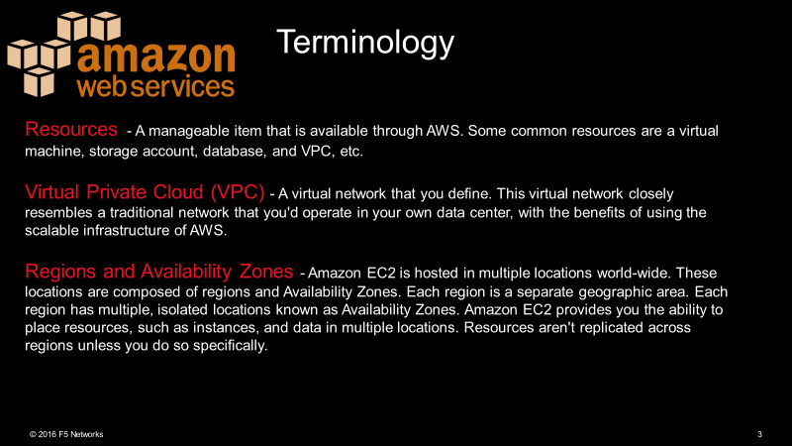

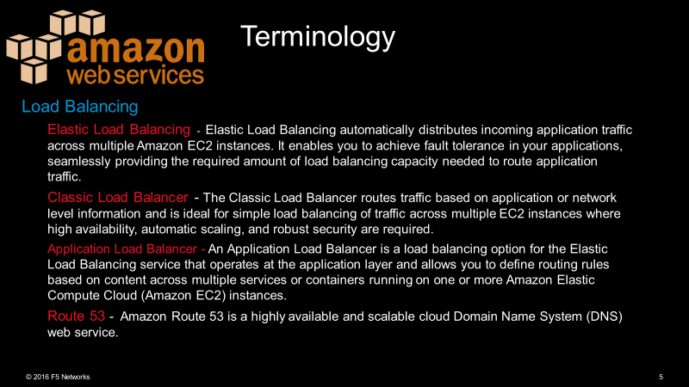

# Lab Five

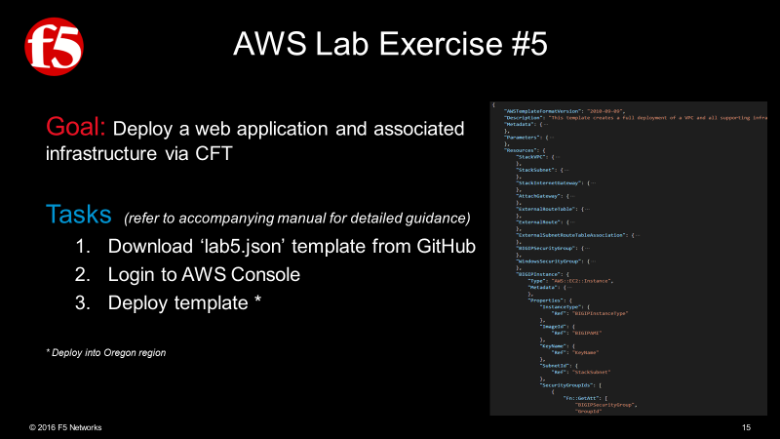

## *Deploy a web-app server from a template*

1. Return to the AWS Portal
2. Expand the **All services** by clicking the carrot as dipicted below
3. Under the **Management Tools** section **|** Click **CloudFormation**
4. A new page opens **|** Click the **Create Stack** button
5. On the new page **|**Click the radio button next to **Specify an Amazon S3 Template URL |** Paste the following URL **substituting** the \* for the correct lab Number https://s3-us-west-2.amazonaws.com/f5awstraining2017/lab\*.cf.json**|** then Click **Next**

|  |  |  |
| --- | --- | --- |
|  | |  |
|  | |  |
|  |  | |
|  |  | |

1. You should now see the **Specify Details** **|** Fill in the required fields as indicated in the screen shot below
2. If you selected **Oregon** as your **Datacenter** as indicated above **|** If not already present Paste the following **ami** into the **WindowsAMI** field as depicted below **ami-bdb618dd**
3. On the **Options** page **|** click **Next**
4. On the **Review** page double check your details **|** Then click **Next**

|  |  |
| --- | --- |
|  | |
|  | |
|  | |
|  | |
|  |  |
|  |  |

# Lab Six

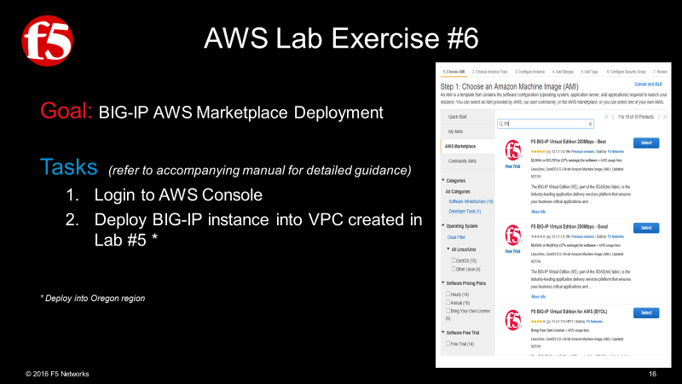

## *Deploy a BIG-IP from the AWS Marketplace*

1. Return to the **AWS Services** page
   1. On the far-right hand side **|** Click **EC2 Launch Wizard** link as depicted below
   2. In the Quick Start Menu **|** Click **AWS Marketplace Products** field **|** Then type **F5** in the **Search AWS Marketplace Products** Field
   3. Take a moment to review the marketplace offerings **|** Then select **Good 1G Hourly**
   4. A new window will open, review the information **|** Click **Continue**
   5. On the next page review the Instance type **|** Then Click the button labeled **Review and Launch**

|  |  |  |  |  |
| --- | --- | --- | --- | --- |
|  | | |  |  |
|  | | |  |  |
|  | |  | | |
|  |  | | | |

* 1. A window will appear **Boot from General Purpose (SSB)** **|** Click the Radio button labeled **Continue with Magnetic as the boot volume for this instance |** then click **Next**
  2. Review your instance details **|** Then click **Launch** as depicted below
  3. A new window will appear **|** Select **Choose an existing Key** pair from the Dropdown list **|** then select the **key pair** that you created earlier | be sure to check the I acknowledge checkbox

|  |  |
| --- | --- |
|  |  |
|  |  |
|  |
|  |

# Lab Seven

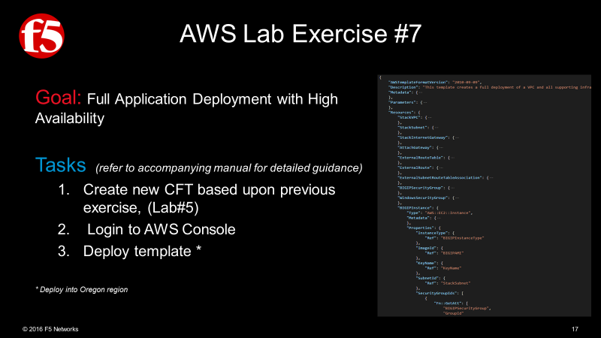

|  |  |
| --- | --- |
|  | New Meta Data |
|  | New Parameters |
|  | New Output |
|  | New Resources |
|  | New BIG-IP instance |

## **New Meta Data**

|  |
| --- |
|  |
| **Add the following fields** |
| "Metadata": {  "AWS : : CloudFormation :  : Interface": {  " Pa rameterGroups "  "Label" :  "default": "Basics"  "Parameters "  "WindowsName" ,  " BIGIPName " ,  " KeyName" ,  " adminUsername" ,  " adminPassword"  "Label" :  "default": "Size"  "Parameters "  "Windows InstanceType" ,  " BIGIPInstanceType"  "Label" :  "default" :  "Settings "  "Parameters "  "WindowsAMI " ,  "ParameterLabe1s": { } |

## **New Parameters**

|  |
| --- |
|  |
| **Add the new Parameters** |
| Machine generated alternative text: "Parameters": {  "KeyName": {  " admi nUsername" :  "adminPassword": {  "WindowsName": {  "BIGIPName": {  "Description": "The name of the BIG-IP. "  "Type" • "String"  Win owsInstanceType  "WindowsAMI": {  "BIGIPInstanceType": {  "Description" :  "EC2 instance type'  "Type" • "String" ,  "Default" :  "m3 . xlarge" ,  "AllowedVa1ues" : [  "m3. xlarge",  "m3.2x1arge" ,  "cl .medium" ,  "cl .xlarge",  "cc1.4x1arge" ,  "cc2. 8x1arge" ,  " cg1.4x1arge"  "ConstraintDescription": "Choose one of these. "  BIGIPAMI :  "Description •  ". "F5 BIG-IP AMI to install from. "  "Type" • "String" ,  "Default": "ami-8633efe6",  "AllowedVa1ues" : [  'ami -8633efe6",  'ami-øb7ae11c" |

## **New Output**

|  |
| --- |
|  |
| **Add the New Output** |
| Machine generated alternative text: "Outputs": {  "ServerURL": {  "BIGIPURL": {  "Description •  ". "The BIG-IP MGMT URL. "  "Value": {  "Fn: : Join":  "https : // " ,  "Fn: :GetAtt": [  "BIGIP1nstance" ,  "PublicDnsName"  " :8443/" |

## **New Resources**

|  |
| --- |
|  |
| **Add the New Output** |
| Machine generated alternative text: "BIGIPSecurityGroup" •  "Type" • "AWS : : EC2: : SecurityGroup"  "Properties": {  "GroupDescription •  "Vpcld": {  "Ref": "Stackvpc"  "SecurityGroupIngress": C  "IpProtoc01 " :  " FromPort" :  "Toport" :  "Cidrlp" •  . "e.e.e.e,'ø"  "IpProtoc01 " :  "tcp",  " FromPort  "8443",  "Toport" :  "Cidrlp •  ". "e.e.e.e,'ø"  "IpProtoc01 " :  "tcp",  " FromPort" :  "Toport" •  . "443",  "Cidrlp •  ". "e.e.e.e,'ø"  "IpProtoc01 " :  "tcp",  " FromPort" :  "Toport" :  "Cidrlp •  ". "e.e.e.e,'ø"  ". "Enable HTTP and RDP",  "tcp", |

## **New BIG-IP instance**

|  |
| --- |
|  |
| **Add a BIG-IP instance** |
| "BIGIP1nstance": {  "Type"  : Instance " ,  "metadata": { •  "Properties": {  "InstanceType"•  { "Ref":  "BIGIPInstanceType"  "Imageld": { "Ref"  • "BIGIPN41"  "KeyName": { "Ref" • "KeyName"  "Subnetld": { "Ref" • "StackSubnet"  "SecurityGroupIds":  " Fn: :GetAtt": [ "BIGIPSecurityGroup", "Groupld"  "UserData": {  "CreationP01icy |

# Lab Eight

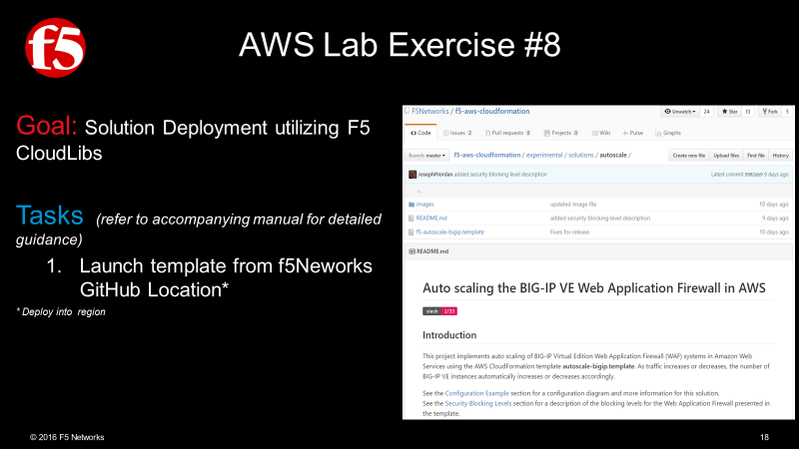

## *Deploy a web-app server from a template*

1. Return to the AWS Portal
2. Expand the **All services** by clicking the carrot as dipicted below
3. Under the **Management Tools** section **|** Click **CloudFormation**
4. A new page opens **|** Click the **Create Stack** button
5. On the new page **|** Download template from **GitHub** <https://github.com/F5Networks/f5-aws-cloudformation/tree/master/experimental/solutions/autoscale>**|** then Click **Next**

|  |  |  |
| --- | --- | --- |
|  | |  |
|  | |  |
|  |  | |
|  |  | |

1. You should now see the **Specify Details** **|** Fill in the required fields as indicated in the screen shot below
2. On the **Options** page **|** click **Next**
3. On the **Review** page double check your details **|** Then click **Next**

|  |  |
| --- | --- |
|  | |
|  | |
|  |  |
|  |  |