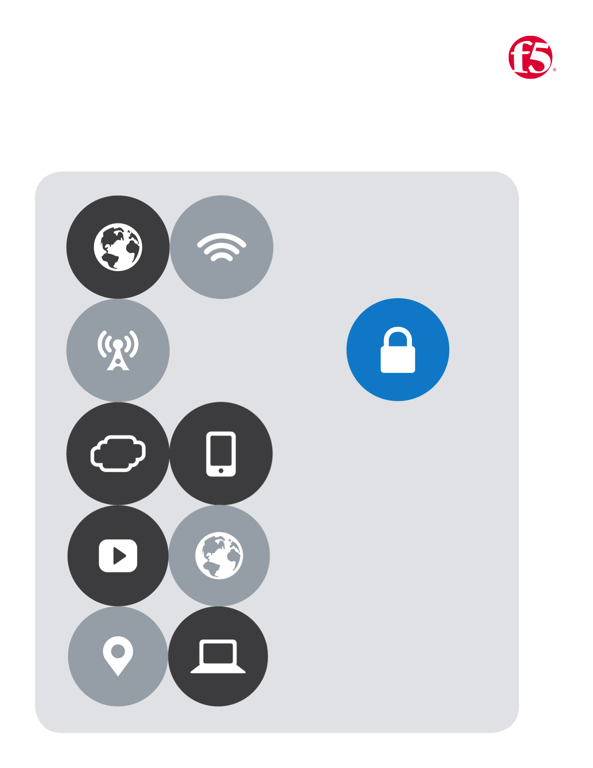

F5| AWS Lab

Cloud Apps BD

No.7

Table of Contents

Lab Eight 2

Deploy a web-app server from a template 2

# Lab Eight

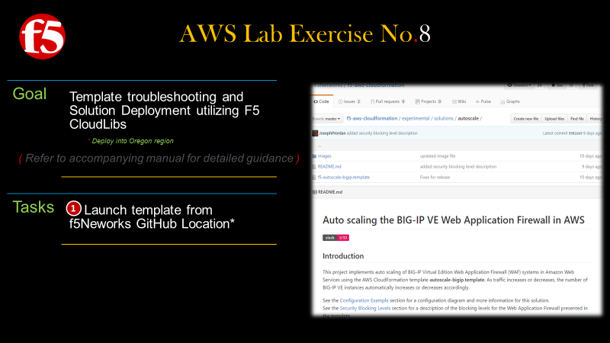

## *Deploy a web-app server from a template*

1. Return to the AWS Portal
2. Expand the **All services** by clicking the carrot as dipicted below
3. Under the **Management Tools** section **|** Click **CloudFormation**
4. A new page opens **|** Click the **Create Stack** button
5. On the new page **|** Download template from **GitHub** <https://github.com/F5Networks/f5-aws-cloudformation/tree/master/experimental/solutions/autoscale>**|** then Click **Next**

|  |  |  |
| --- | --- | --- |
|  | |  |
|  | |  |
|  |  | |
|  |  | |

1. You should now see the **Specify Details** **|** Fill in the required fields as indicated in the screen shot below
2. On the **Options** page **|** click **Next**
3. On the **Review** page double check your details **|** Then click **Next**

|  |  |
| --- | --- |
|  | |
|  | |
|  |  |
|  |  |