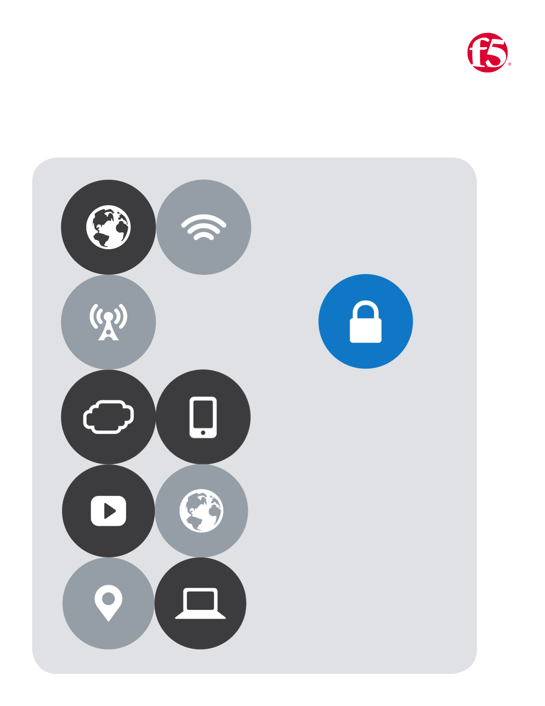

No.5

F5| AWS Lab

Cloud Apps BD

# AWS Lab Guide

## *Navigate to github:* <https://github.com/gregcoward/awstraining>

1. Notice the section highlighted below. Here you will find the templates that relate to this lab

|  |
| --- |
|  |
|  |

## ***Click the following link*** <https://250871914685.signin.aws.amazon.com/console>

1. Click the link above and enter the credentials that you where assigned
2. The image below shows an authenticated user

|  |
| --- |
|  |
|  |

1. On the **Services Bar** switch the **Datacenter** to **Oregon** as depicted in the image below if not already selected

|  |
| --- |
|  |
| C:\Users\merrick\AppData\Local\Temp\SNAGHTML64cf8d6.PNG |

## Create a Key Pair

1. From **AWS Services** under All services **|** Find **EC2** and click it
2. In the **EC2** Dashboard Under the Network & Security heading **|** Click **Key Pairs**
3. At the top of the page **|** Click the button labeled **Create Key Pair**

|  |  |
| --- | --- |
|  |  |
|  |  |
|  |
|  |

1. Provide a Name **|** Click **Create**
2. At the bottom of your browser you should see a pop-up **|** click the carrot and choose **Save As** from the drop down
3. Select a secure local location **|** Then click **Save**

|  |
| --- |
|  |
|  |
|  |
|  |
|  |
|  |

## AWS Terminology quick refference

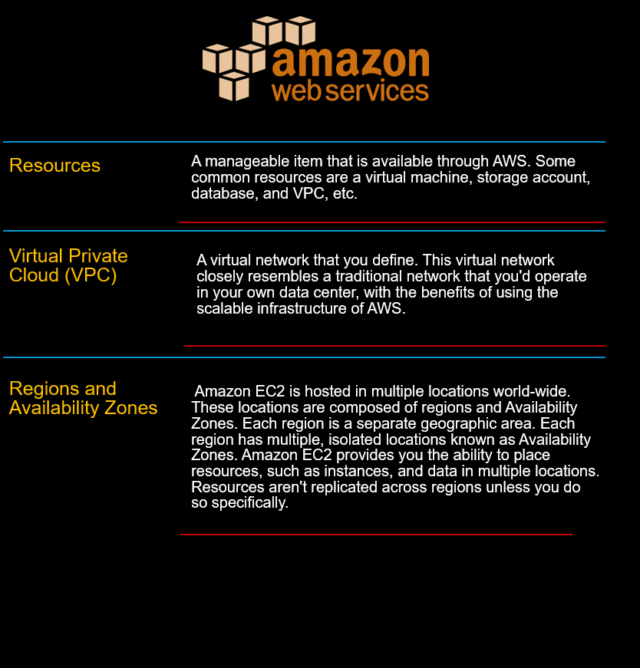

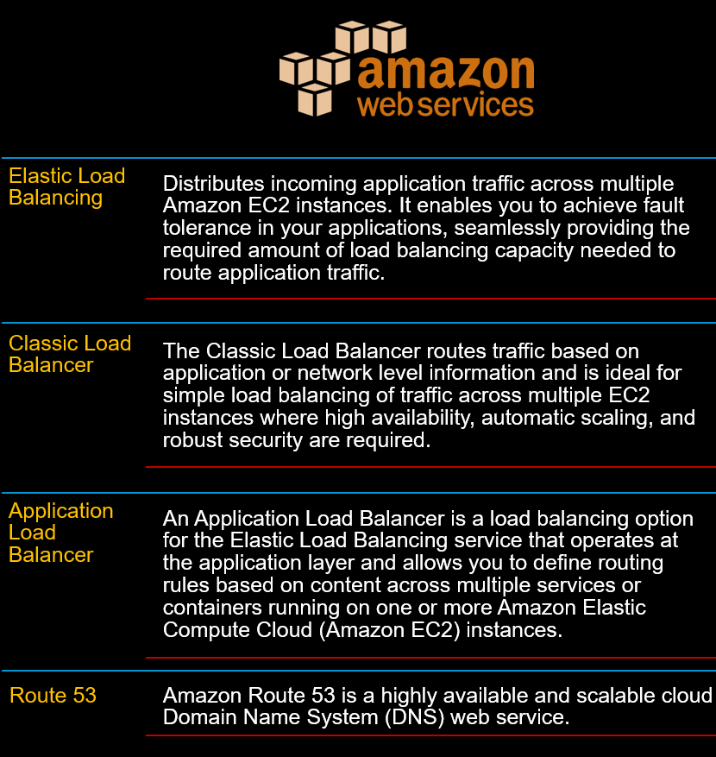

# Lab Five

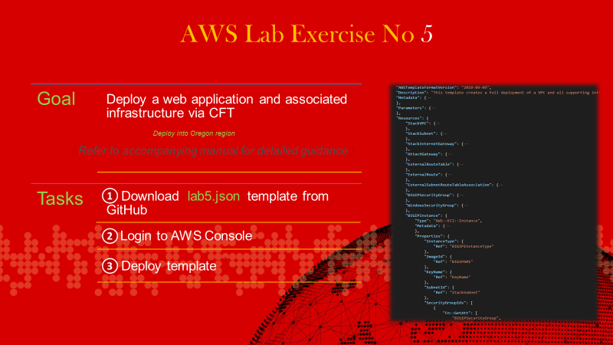

## *Deploy a web-app server from a template*

1. Return to the AWS Portal
2. Expand the **All services** by clicking the carrot as dipicted below
3. Under the **Management Tools** section **|** Click **CloudFormation**
4. A new page opens **|** Click the **Create Stack** button
5. On the new page **|**Click the radio button next to **Specify an Amazon S3 Template URL |** Paste the following URL **substituting** the * for the correct lab Number https://s3-us-west-2.amazonaws.com/f5awstraining2017/lab*.cf.json**|** then Click **Next**

|  |  |  |
| --- | --- | --- |
|  | |  |
|  | |  |
|  |  | |
|  |  | |

1. You should now see the **Specify Details** **|** Fill in the required fields as indicated in the screen shot below
2. If you selected **Oregon** as your **Datacenter** as indicated above **|** If not already present Paste the following **ami** into the **WindowsAMI** field as depicted below **ami-bdb618dd**
3. On the **Options** page **|** click **Next**
4. On the **Review** page double check your details **|** Then click **Next**

|  |  |
| --- | --- |
|  | |
|  | |
|  | |
|  | |
|  |  |
|  |  |