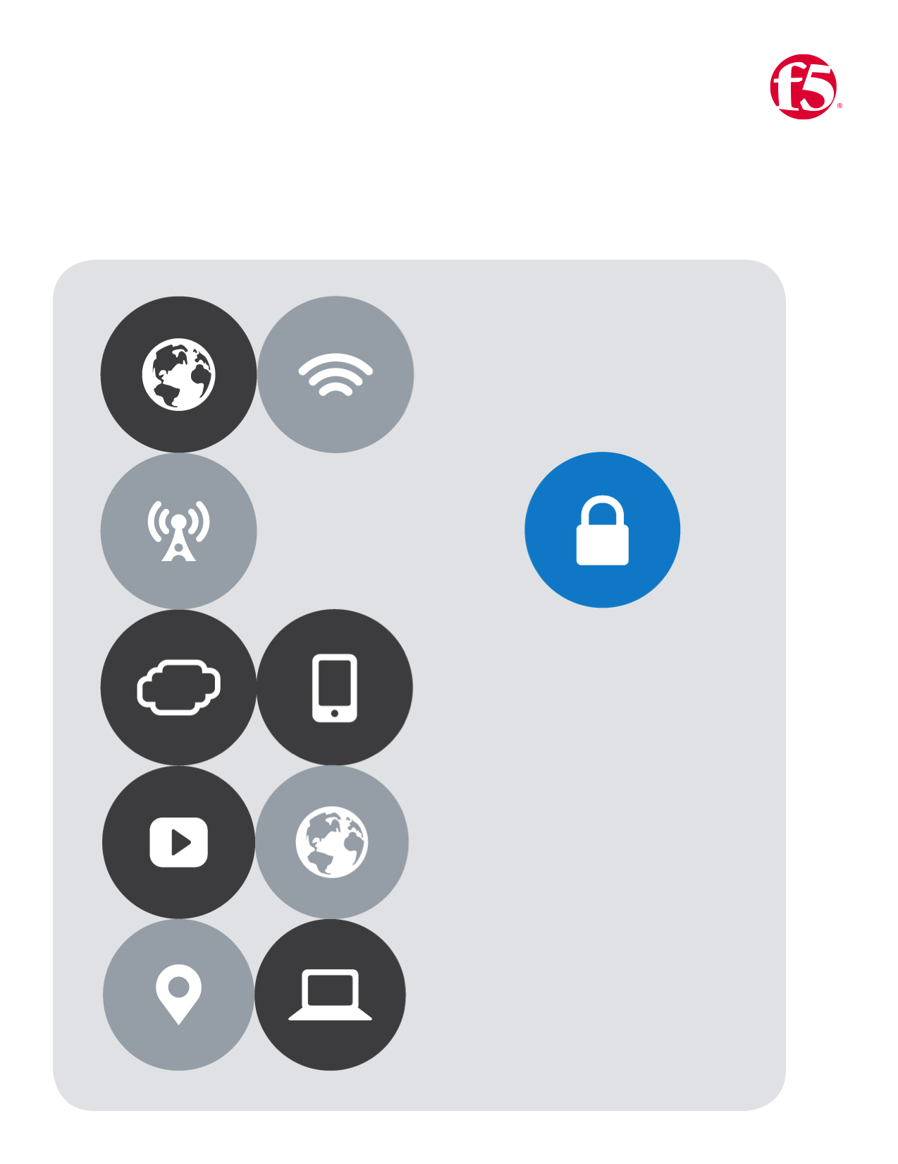

No.7

F5| AWS Lab

Cloud Apps BD

# Lab Seven

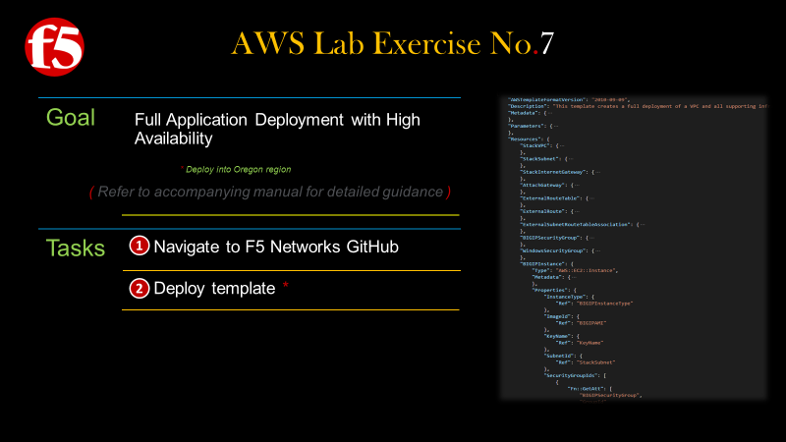

|  |  |
| --- | --- |
|  | New Meta Data |
|  | New Parameters |
|  | New Output |
|  | New Resources |
|  | New BIG-IP instance |

## **New Meta Data**

|  |
| --- |
|  |
| **Add the following fields** |
| "Metadata": {  "AWS : : CloudFormation :  : Interface": {  " Pa rameterGroups "  "Label" :  "default": "Basics"  "Parameters "  "WindowsName" ,  " BIGIPName " ,  " KeyName" ,  " adminUsername" ,  " adminPassword"  "Label" :  "default": "Size"  "Parameters "  "Windows InstanceType" ,  " BIGIPInstanceType"  "Label" :  "default" :  "Settings "  "Parameters "  "WindowsAMI " ,  "ParameterLabe1s": { } |

## **New Parameters**

|  |
| --- |
|  |
| **Add the new Parameters** |
| Machine generated alternative text: "Parameters": {  "KeyName": {  " admi nUsername" :  "adminPassword": {  "WindowsName": {  "BIGIPName": {  "Description": "The name of the BIG-IP. "  "Type" • "String"  Win owsInstanceType  "WindowsAMI": {  "BIGIPInstanceType": {  "Description" :  "EC2 instance type'  "Type" • "String" ,  "Default" :  "m3 . xlarge" ,  "AllowedVa1ues" : [  "m3. xlarge",  "m3.2x1arge" ,  "cl .medium" ,  "cl .xlarge",  "cc1.4x1arge" ,  "cc2. 8x1arge" ,  " cg1.4x1arge"  "ConstraintDescription": "Choose one of these. "  BIGIPAMI :  "Description •  ". "F5 BIG-IP AMI to install from. "  "Type" • "String" ,  "Default": "ami-8633efe6",  "AllowedVa1ues" : [  'ami -8633efe6",  'ami-øb7ae11c" |

## **New Output**

|  |
| --- |
|  |
| **Add the New Output** |
| Machine generated alternative text: "Outputs": {  "ServerURL": {  "BIGIPURL": {  "Description •  ". "The BIG-IP MGMT URL. "  "Value": {  "Fn: : Join":  "https : // " ,  "Fn: :GetAtt": [  "BIGIP1nstance" ,  "PublicDnsName"  " :8443/" |

## **New Resources**

|  |
| --- |
|  |
| **Add the New Output** |
| Machine generated alternative text: "BIGIPSecurityGroup" •  "Type" • "AWS : : EC2: : SecurityGroup"  "Properties": {  "GroupDescription •  "Vpcld": {  "Ref": "Stackvpc"  "SecurityGroupIngress": C  "IpProtoc01 " :  " FromPort" :  "Toport" :  "Cidrlp" •  . "e.e.e.e,'ø"  "IpProtoc01 " :  "tcp",  " FromPort  "8443",  "Toport" :  "Cidrlp •  ". "e.e.e.e,'ø"  "IpProtoc01 " :  "tcp",  " FromPort" :  "Toport" •  . "443",  "Cidrlp •  ". "e.e.e.e,'ø"  "IpProtoc01 " :  "tcp",  " FromPort" :  "Toport" :  "Cidrlp •  ". "e.e.e.e,'ø"  ". "Enable HTTP and RDP",  "tcp", |

## **New BIG-IP instance**

|  |
| --- |
|  |
| **Add a BIG-IP instance** |
| "BIGIP1nstance": {  "Type"  : Instance " ,  "metadata": { •  "Properties": {  "InstanceType"•  { "Ref":  "BIGIPInstanceType"  "Imageld": { "Ref"  • "BIGIPN41"  "KeyName": { "Ref" • "KeyName"  "Subnetld": { "Ref" • "StackSubnet"  "SecurityGroupIds":  " Fn: :GetAtt": [ "BIGIPSecurityGroup", "Groupld"  "UserData": {  "CreationP01icy |