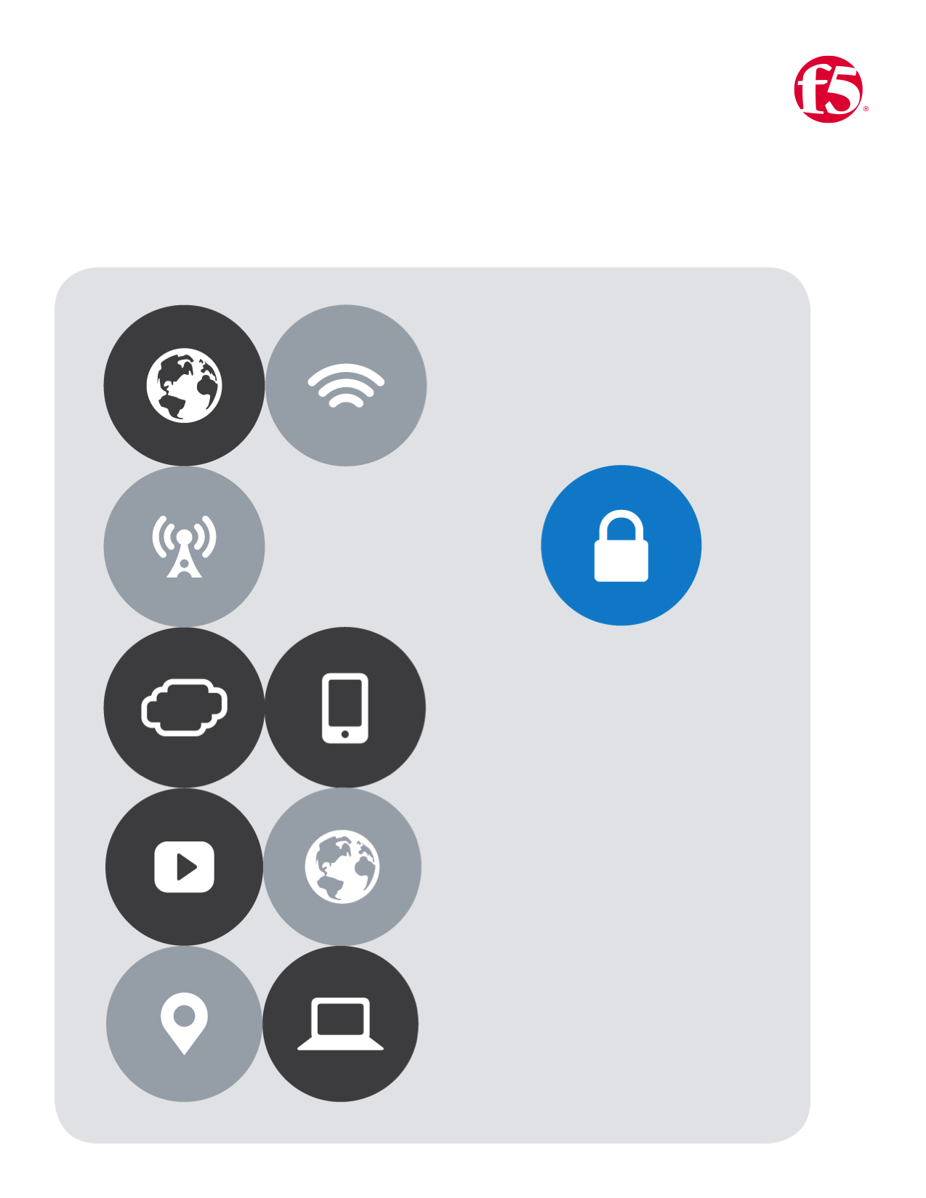

F5| AWS Lab

Cloud Apps BD

No.6

# Lab Six

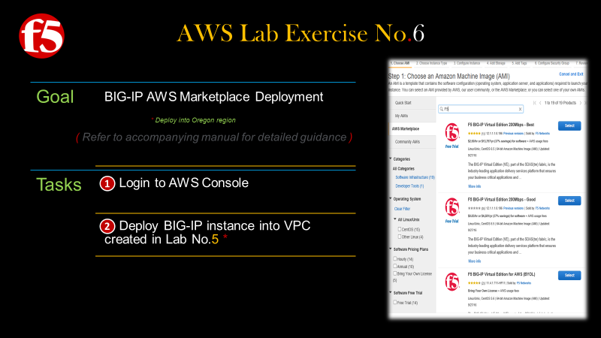

## *Deploy a BIG-IP from the AWS Marketplace*

1. Return to the **AWS Services** page
   1. On the far-right hand side **|** Click **EC2 Launch Wizard** link as depicted below
   2. In the Quick Start Menu **|** Click **AWS Marketplace Products** field **|** Then type **F5** in the **Search AWS Marketplace Products** Field
   3. Take a moment to review the marketplace offerings **|** Then select **Good 1G Hourly**
   4. A new window will open, review the information **|** Click **Continue**
   5. On the next page review the Instance type **|** Then Click the button labeled **Review and Launch**

|  |  |  |  |  |
| --- | --- | --- | --- | --- |
|  | | |  |  |
|  | | |  |  |
|  | |  | | |
|  |  | | | |

* 1. A window will appear **Boot from General Purpose (SSD)** **|** Click the Radio button labeled **Continue with Magnetic as the boot volume for this instance |** then click **Next**
  2. Review your instance details **|** Then click **Launch** as depicted below
  3. A new window will appear **|** Select **Choose an existing Key** pair from the Dropdown list **|** then select the **key pair** that you created earlier | be sure to check the I acknowledge checkbox

|  |  |
| --- | --- |
|  |  |
|  |  |
|  |
|  |