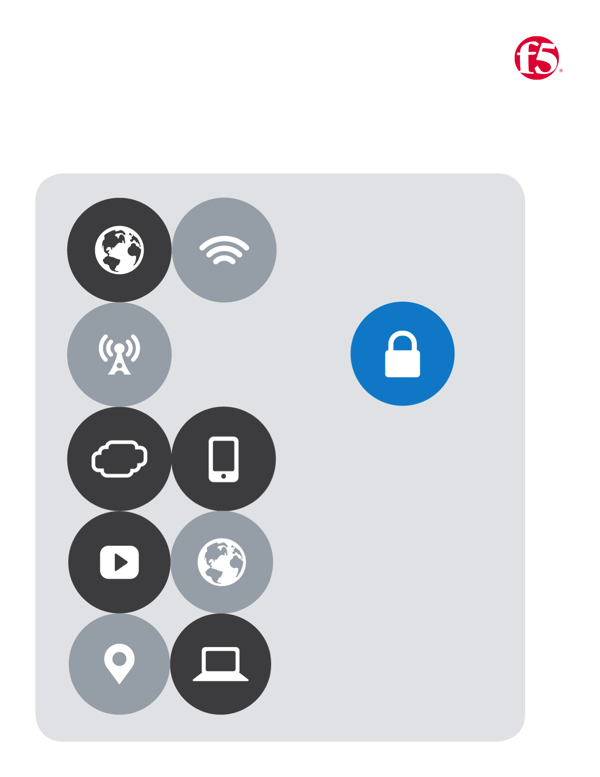

No.9

F5| Application Connector

BD Cloud Apps

Table of Contents

[Application Connector Configuration Part 1 3](#_Toc476762197)

[Navigate to Github | https://github.com/gregcoward/awstraining/ 3](#_Toc476762198)

[Login to Your Aws Console | https://federate.f5.com/my.policy 3](#_Toc476762199)

[Service Center Configuration 5](#_Toc476762200)

[Connect to Your Assigned BIG-IP Via SSH 5](#_Toc476762201)

[Login to the GUI and provision iRulesLX 6](#_Toc476762202)

[Upload the App Connector RPM 7](#_Toc476762203)

[Navigate To Github | https://github.com/gregcoward/awstraining 7](#_Toc476762204)

[Configure the Irulelx And Workspace for the Service Center Traffic 8](#_Toc476762205)

[Create a Virtual Server and Dummy Pool 9](#_Toc476762206)

[Configure the iAppLX Application to Always Be Running. 10](#_Toc476762207)

[Authorize the App Connector 11](#_Toc476762208)

[Authorize Application Connector 12](#_Toc476762209)

[Add Application Nodes to Service Center 13](#_Toc476762210)

# Application Connector Configuration Part 1

## Navigate to Github|<https://github.com/gregcoward/awstraining/>

1. Find the template that matches this **lab #** | Click to **Open**
2. Find the menu bar | Click the button marked **Raw**
3. Select all | Then **Copy**
4. Paste contents into a text editor | Save as **lab9.json**

## Login to Your Aws Console | <https://federate.f5.com/my.policy>

1. From the **webtop** | Select **AWS Management Console**
2. Under the **Management Tools** menu| select **CloudFormation**
3. Click the button  |Select the Radio button labeled **Upload a template to Amazon S3 |** browse to **lab9.cft.json |** Click 

|  |  |  |
| --- | --- | --- |
|  | Stack Name | **\*user- lab #** |  |
|  | appConnectorName | **ac-\*user** |
|  | appInstance1Name | *this value is hardcoded* |
|  | appInstance2Name | *this value is hardcoded* |
|  | KeyName | Select the key that you created in **Lab 5** from the dropdown |
|  | adminUsername | **\*user** |
|  | adminPassword | **F5labnet** |
|  | appConnectorType | Select an option from the **dropdown** |
|  | appConnectorAMI |Select an option from the **dropdown** |

1. Fill in the parameters on the Specify Details page**|** Click 
2. On the Options page | Click 
3. On the Review page | Click 
4. You will be returned to the **Cloud formation** page where you can monitor the **Status** of your deployment
5. If you click the **Stack Name** | **Stack Details** will display | Periodically **refresh** your bowser
6. The **Stack** should complete in **10-15** minutes | you will see the  message in the **Status c**olumn

|  |
| --- |
|  |
|  |
|  |
|  |
|  |
|  |

# Service Center Configuration

## Connect to Your Assigned BIG-IP Via SSH

1. You will have been assigned
   1. One **\*BIG-IP**
   2. Three public IP address’s
2. SSH to the BIG-IP CLI
   1. Login: **Root**
   2. Password: **F5labnet**
3. Type the following command | **touch /var/config/rest/iapps/enable**

|  |  |
| --- | --- |
|  | |
| C:\Users\merrick\AppData\Local\Temp\SNAGHTMLfea31f5.PNG | C:\Users\merrick\AppData\Local\Temp\SNAGHTMLfd27859.PNG |
|  |  |
| C:\Users\merrick\AppData\Local\Temp\SNAGHTMLfd48d8d.PNG | C:\Users\merrick\AppData\Local\Temp\SNAGHTMLfeae75a.PNG |

## Login to the GUI and provision iRulesLX

1. Use the first public IP address that you were assigned to access the **GUI** of your **BIG-IP**
2. Navigate to | **System** | **Resource Provisioning**
3. Nominally Provision **iRules Language Extensions (iRulesLX)**

|  |  |
| --- | --- |
|  |  |
| C:\Users\merrick\AppData\Local\Temp\SNAGHTMLfebef25.PNG |  |
|  | |
|  | |

## Upload the App Connector RPM

### Navigate To Github | <https://github.com/gregcoward/awstraining>

1. Find and click | **app-connector-0.0.1-53.noarch.rpm**
2. Click |  and save on your local system
3. Navigate back to your **BIG-IP** | Click **iApps** | **Package Management LX** | click **Import** | Browse to the Location where the **RPM** was saved in the previous step |Click **Upload**

It is anticipated that this package will be downloadable from downloads.f5.com or will come on all iSeries boxes pre-installed

|  |  |
| --- | --- |
|  |  |
|  |  |
|  | |
| Note: You may receive the following error message | |
|  | |
| if so please click Package Management LX ensure that it installed successful | |
|  | |

## Configure the Irulelx And Workspace for the Service Center Traffic

1. Click on **Local Traffic** | **iRules** | **LX Workspaces**
2. Verify that the **application\_connector** workspace already exists from the installation of the RPM package
3. Click | **LX Plugins** tab
4. Click | **Create** button and use the **Exact** name **application\_connector\_plugin**, Use drop down for **From Workspace** choosing **application\_connector** | finally Click the **finished** button

|  |  |
| --- | --- |
|  |  |
|  |  |
|  |  |
|  |  |

### Create a Virtual Server and Dummy Pool

1. On the **BIG-IP** navigate to | **Local Traffic** | **Virtual Servers** | Click **Create** | Use the table below for guidance

|  |  |  |  |  |
| --- | --- | --- | --- | --- |
|  | Name | ac\_vip | | |
| *Provide a unique value for the VIP used to communicate with Service Center* | | | |
|  | Destination Address | 2nd Public address assigned to your lab | | |
| *Type in a VIP address that the App Connector will be able to reach over the Internet* | | | |
|  | Service Port | 443 | | |
| *Select a port, in the case of a single NIC BIG-IP make sure it is not the mgmt port or port 443, so that it does not interfere with regular VIP's* | | | |
|  | SSL Profile | clientssl-insecure-complatible | | |
| *Add a Client SSL profile like clientssl-insecure-compatible "for now"* | | | |
|  | Default Pool | Click the Plus | | |
| *The settings in the pool do not need to exist and the information below is an example of values you can use* | | | |
|  | Name | dummy\_pool | | |
| Health Monitor | none | | |
| Node Name | dummy\_node | | |
| address | 192.168.1.115 | Click | |
| Service Port | 80 | HTTP | Click |
|  | **Virtual Server List** | Click C:\Users\merrick\AppData\Local\Temp\SNAGHTML1072ff71.PNG | | | |

## Configure the iAppLX Application to Always Be Running.

1. Click on iApps | Application Services | Applications LX | Click 
2. You only need to click the drop down and select the app-connector iApp.
   1. The Service Center will load
   2. You will be prompted for credentials
   3. Use the same credentials you used to login to the BIG-IP to login to the Service Center.
3. Click 
   1. **User Name** is pre-populated
   2. **Common partition** is pre-populated
   3. **App Name** field | Provide a value like **AppConServCent**
   4. Click the green button marked **Save**
4. Verify this by clicking on **iApps** | **Application Services** | **Applications LX** |Deploy the newly created service by selecting the **checkbox** | Then select 
   1. Note the **Green ball**  **Service Center** will remain running
5. Navigate back to **Application LX** | and select the application previously created
   1. Select **Config**
   2. Select the **Proxy Virtual Server** tab
   3. Check the **check box** next to the newly created **virtual server**
   4. Select the **Save** button
   5. Then select **Yes** to Confirm

|  |  |
| --- | --- |
|  |  |
|  |  |
|  |  |
|  |  |
|  | |
| C:\Users\merrick\AppData\Local\Temp\SNAGHTML1475952a.PNG | |

# Authorize the App Connector

1. Return to the **AWS** Console | Click **CloudFormation** | Select the checkbox next to the **Stack Name** that you had previously deployed | Click the tab near the bottom labeled **Outputs** | Click **App Connector URL** link to connect to the application connector.
2. Use the **username** and **password** when you initially deployed the CFT to login to the **Application Connector**

Note: If you are using Microsoft Edge you may not see the credential prompt. Switch to another browser like Chrome

1. In the **Service Center Connections** Section | Click on the  button
   1. Name | **lab#bigip**
   2. IP/FQDN | Provide the **Virtual Server** IP address
   3. Port | **443**
   4. Click the connect icon C:\Users\merrick\AppData\Local\Temp\msohtmlclip1\02\clip_image001.png
2. Click **OK** on the dialog box saying the **App Connector** was added Successfully

|  |  |
| --- | --- |
|  | |
|  | |
|  |  |
|  |  |
|  | |
|  | |

# Authorize Application Connector

1. Login to the BIG-IP with the Service Center Running on it.
   1. Click **iApps** | **Application** **Services** | **Applications** **LX**
   2. Click your Service Center Application
   3. Login with the **BIG-IP** credentials provided.
   4. Click on the **Proxies** Tab
   5. Select the check mark next to the **Application Connector** that you added earlier.
   6. Click  | Successful authorization will turn the status ball from red to green.

|  |
| --- |
|  |
|  |

# Add Application Nodes to Service Center

1. You will need to return to your **AWS** Portal | log into the **Application Connector** | Use the **username** and **password** you entered in the **CFT**
   1. In the **Nodes** section | click the **Add** button | You will need to enter the information that is separated by double hashes ## as shown in the next step
   2. You can find the **application servers** information in the **Outputs** section of the **CloudFormation** **Stack**
   3. Enter Description | Then click  button appears near the end of the row
   4. Check the checkboxes next to the nodes | Click  to activate the nodes.
2. login into the **Service Center** | **Local Traffic** | **Nodes |** Verify that the nodes are active by click on the nodes tab in the Service Center

|  |
| --- |
|  |
|  |
|  |
|  |
|  |
|  |

1. Both nodes have been added, and should be visible in **Local Traffic** | **Nodes**.
2. Add the nodes to | a **Pool** | and **Virtual Server**
3. Test your connection

|  |  |
| --- | --- |
|  |  |
|  |  |
|  | |
|  | |