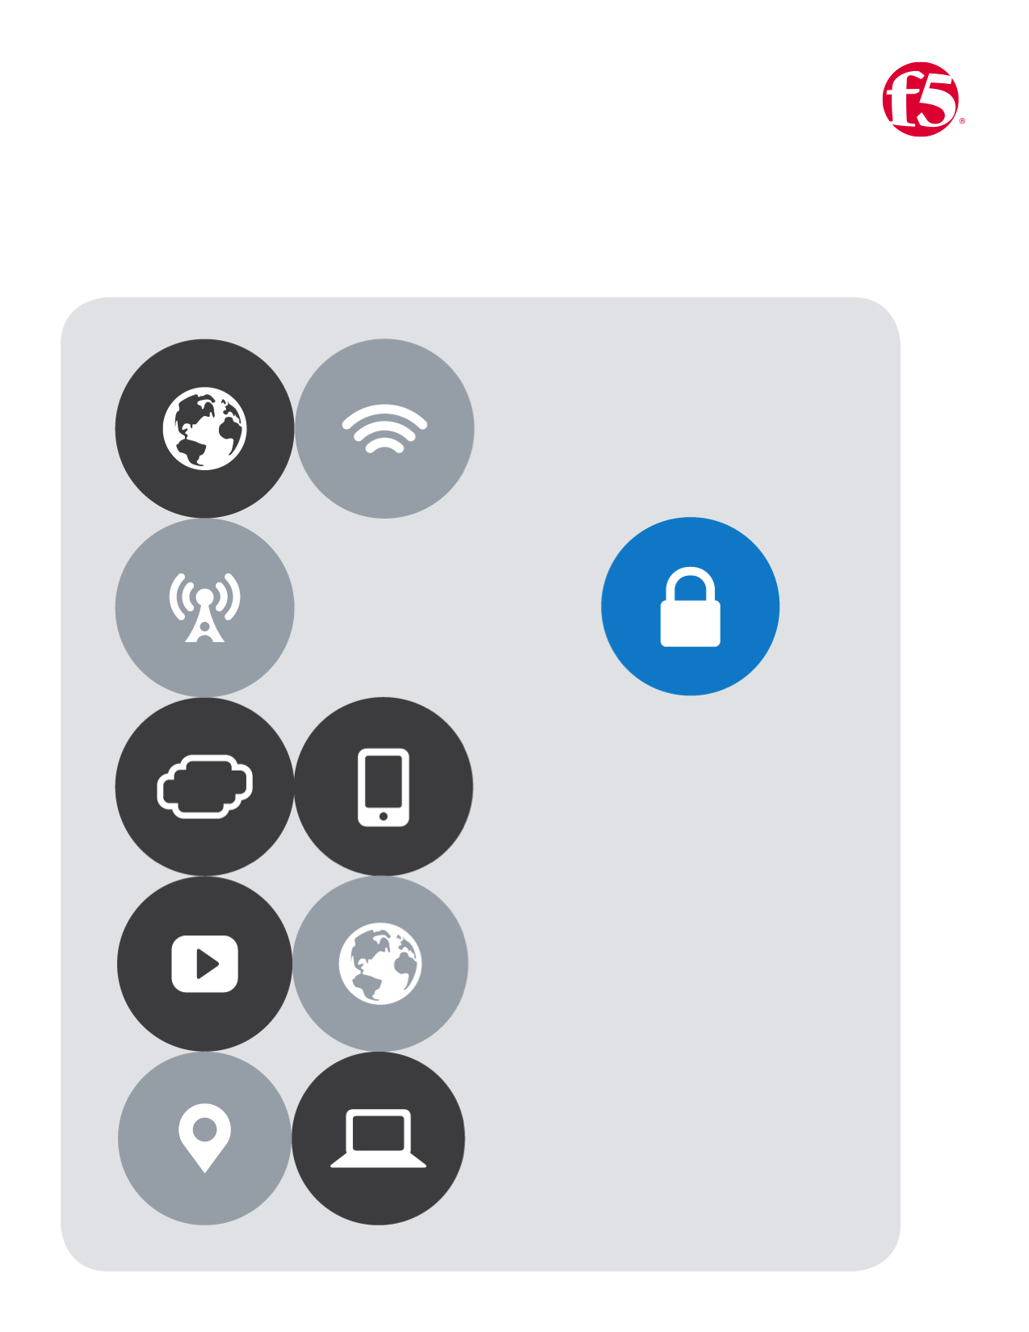

No.4

F5| Azure Lab

Cloud Apps BD

Table of Contents

Lab Four 2

Deploy a web-app server from a template 2

# Lab Four

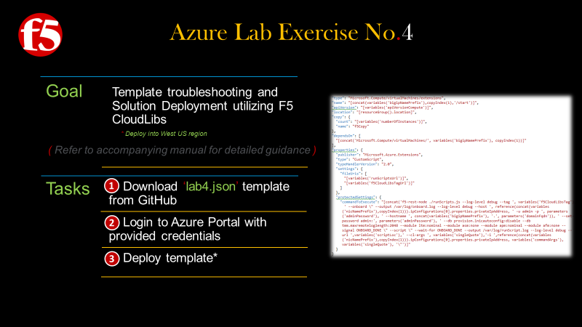

## **Deploy a web-app server from a template**

1. On the **github** page that you opened previously find the template labeled **|** double click **lab4.json** template
2. Once it opens notice the menu bar at the top of the template **|** click the **Raw** button
3. A new browser page will **|** Select all and copy the **Raw** content

|  |  |
| --- | --- |
|  |  |
|  |  |
|  | |
|  | |

1. Return to the Azure Portal **|** Click  **New** from the left menu bar
2. In the search the marketplace field **|** Type **Template Deploymnet**
3. The Marketplace filter will open will open and you will see the image below **|** Click **Template Deployment**
4. A new pane opens **|** Click the Create button
5. A new pane opens **|** Click edit
6. In the Edit Template Pane **|** Paste the content from the ARM template that you copied previously
7. If you template looks like the screenshot **|** click Save near the bottom of the template.

|  |  |  |  |
| --- | --- | --- | --- |
|  | |  | |
|  | |  | |
|  |  | | |
|  |  | | |
|  | | |  |
|  | | |  |

1. You should now see the custom deployment pane **|** Fill in the required fields as indicated in the screen shot below **|** Check the box to agree to the **terms and conditions |** Check the **Pin to dashboard** checkbox **|** then click **Purchase**
2. You will then be returned to the **dashboard** where you can monitor your deployment **|** More details are available by double clicking the image seen in the screen shot below

|  |  |
| --- | --- |
|  |  |
|  |  |