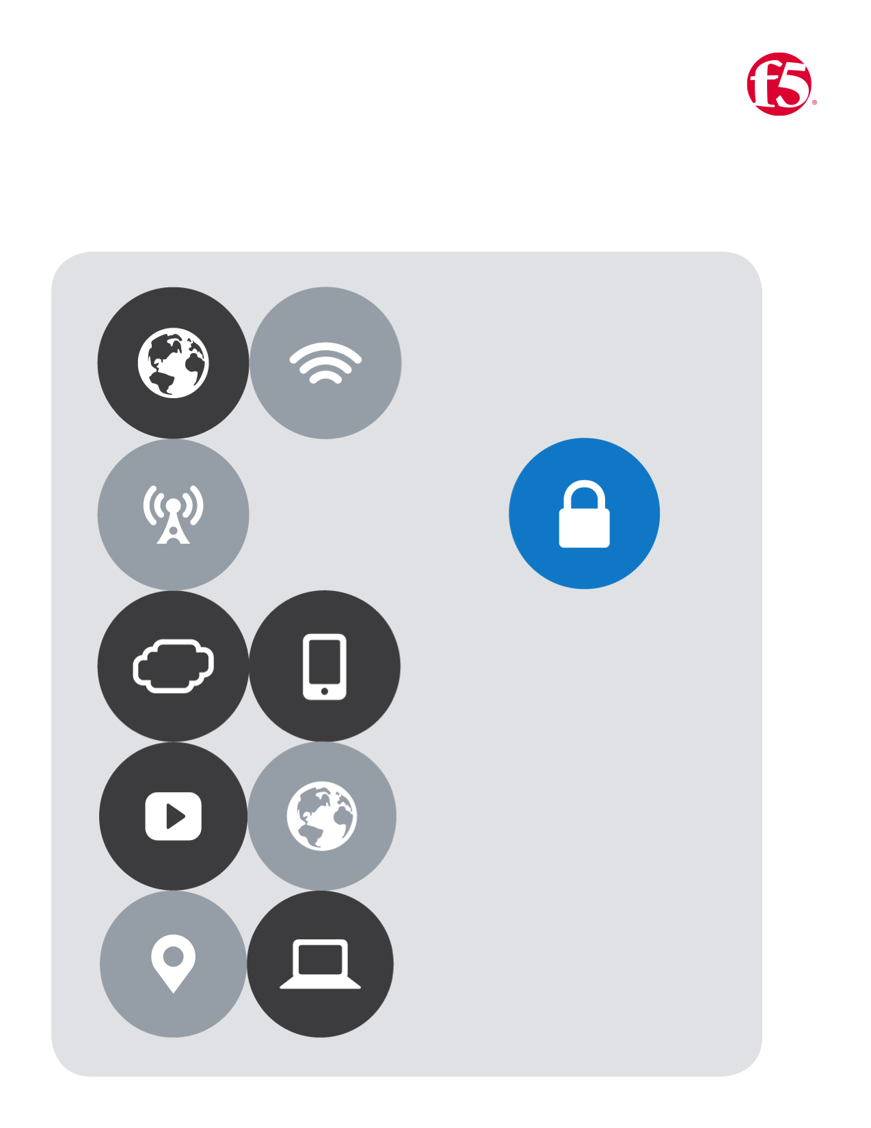

No.1

F5| Azure Lab

Cloud Apps BD

Table of Contents

Azure lab guide 3

Navigate to github:https://github.com/gregcoward/azuretraining 3

Navigate to the Azure Portal: HTTPS://PORTAL.AZURE.COM/ 3

Lab One 4

Deploy a web-app server from a template 4

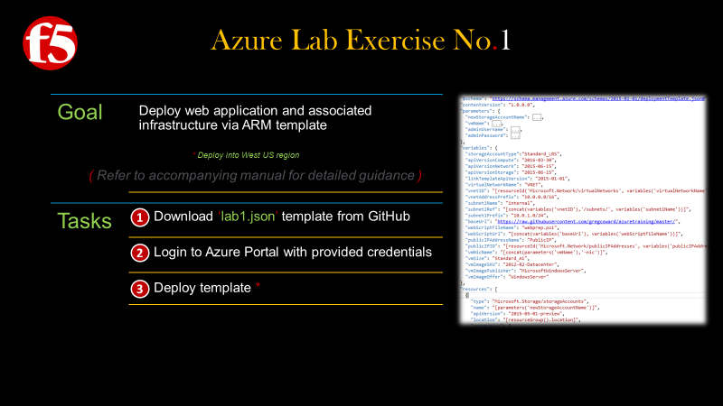

# Azure lab guide

## Navigate to github|<https://github.com/gregcoward/azuretraining>

1. Notice the section highlighted below. Here you will find the templates that relate to this lab

|  |
| --- |
|  |
|  |

## *Navigate to the Azure Portal:* [HTTPS://PORTAL.AZURE.COM/](https://portal.azure.com/)

Note: You will be assigned an **alphabet letter** which will correspond your user account. Substitute your alphabet letter with the **first** letter of the **username**

1. Username**:** **auser@f5cloudtry.onmicrosoft.com** **|** Password**:** **F5labnet**

|  |
| --- |
|  |
|  |

# Lab One

## *Deploy a web-app server from a template*

1. On the **github** page that you opened previously find the template labeled **|** double click **lab1.json** template
2. Once it opens notice the menu bar at the top of the template **|** click the **Raw** button
3. A new browser page will **|** Select all and copy the **Raw** content

|  |  |
| --- | --- |
|  | |
|  | |
|  |  |
|  |  |

### Return to the Azure Portal **|** Click **New** from the left menu bar

1. In the search the marketplace field **|** Type **Template Deploymnet**
2. The Marketplace filter will open will open and you will see the image below **|** Click **Template Deployment**
3. A new pane opens **|** Click the **Create** button
4. A new pane opens **|** Click **edit**
5. In the Edit Template Pane **|** Paste the content from the **ARM Template** that you copied previously
6. If you template looks like the screenshot **|** click **Save** near the bottom of the template.

|  |  |  |  |
| --- | --- | --- | --- |
|  | |  | |
|  | |  | |
|  |  | | |
|  |  | | |
|  | | |  |
|  | | |  |

1. You should now see the custom deployment pane **|** Fill in the required fields as indicated in the screen shot below **|** Check the box to agree to the **terms and conditions |** Check the **Pin to dashboard** checkbox **|** then click **Purchase**
2. You will then be returned to the **dashboard** where you can monitor your deployment **|** More details are available by double clicking the image seen in the screen shot below

|  |  |
| --- | --- |
|  |  |
|  |  |