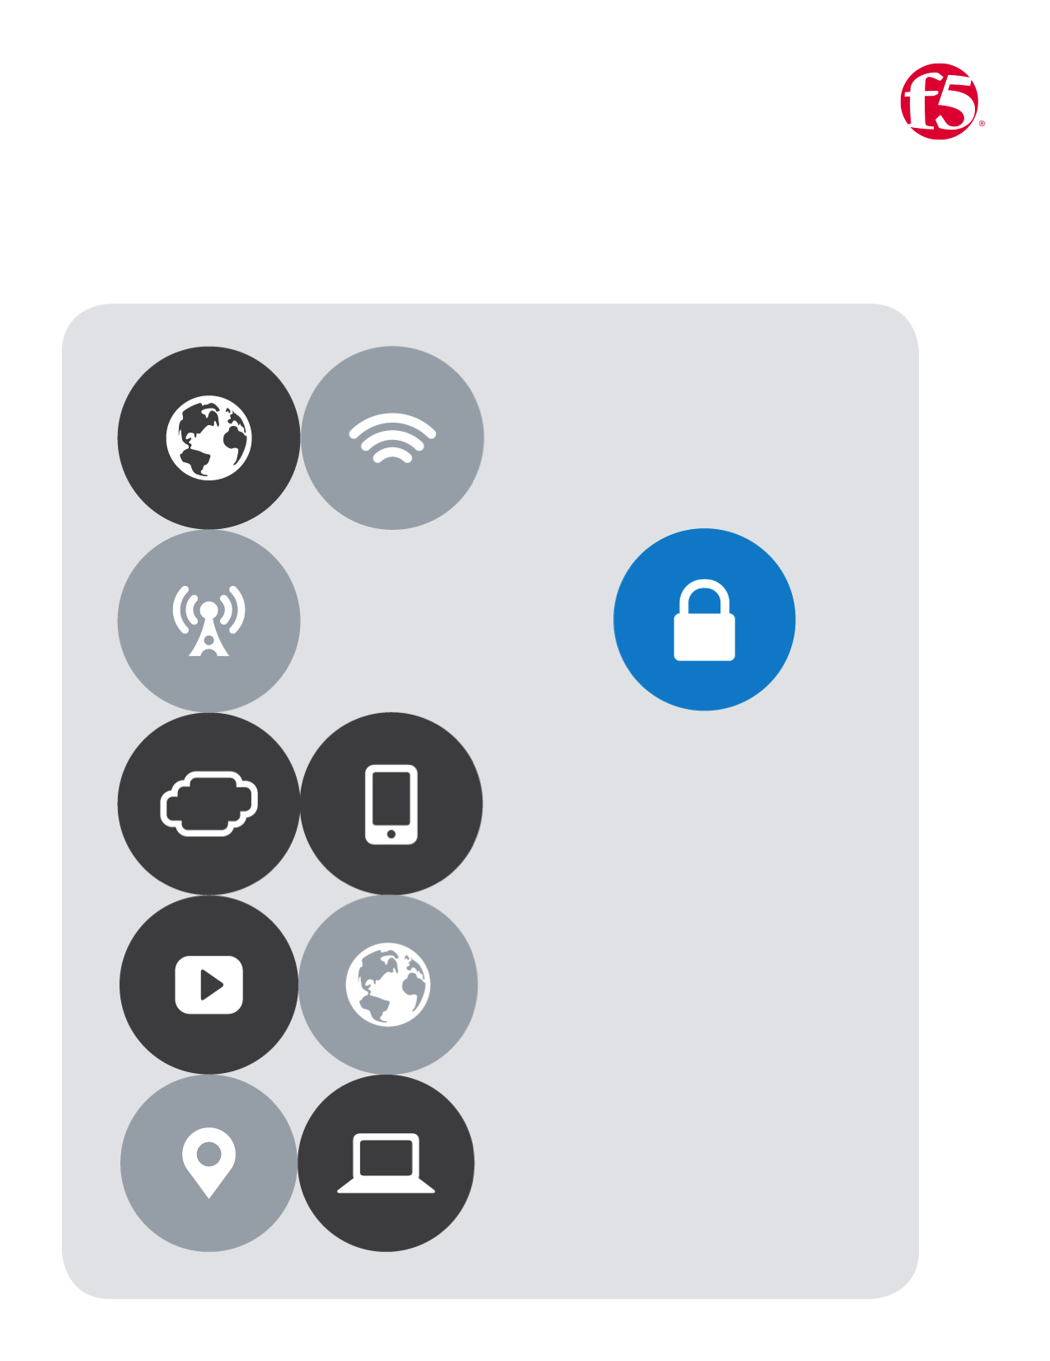

F5| Azure Lab

Cloud Apps BD

No.3

Table of Contents

[Lab Three 4](#_Toc475466432)

[a. New Parameters 5](#_Toc475466433)

[b. New Variables 5](#_Toc475466434)

[Modified Resources: 7](#_Toc475466435)

[1. Virtual Network 7](#_Toc475466436)

[2. Web VM 8](#_Toc475466437)

[3. Web VM Network Interface 9](#_Toc475466438)

[4. Web VM Extension 10](#_Toc475466439)

[New Resources: 11](#_Toc475466440)

[5. BIG IP Availability Set 11](#_Toc475466441)

[6. Azure Load Balancer, (ALB) 12](#_Toc475466442)

[7. Inbound NAT Rule 13](#_Toc475466443)

[8. Inbound NAT Rule 14](#_Toc475466444)

[9. BIG-IP Network Interfaces 15](#_Toc475466445)

[10. BIG-IP VM’s 16](#_Toc475466446)

# Lab Three

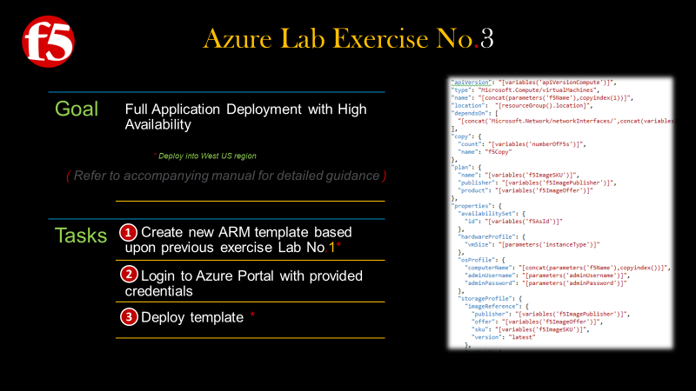

Snippets of code for this lab can be copied and pasted from the GitHub repository below.

1. Copy and paste the following URL’s into a browser | Then Select all | and paste into your editor

https://raw.githubusercontent.com/gregcoward/azuretraining/master/lab3adds.json

https://raw.githubusercontent.com/gregcoward/azuretraining/master/lab3mods.json

https://raw.githubusercontent.com/gregcoward/azuretraining/master/lab3paramsvars.json

Note: The code below is for reference

|  |  |  |  |
| --- | --- | --- | --- |
|  | Modified Parameters | | |
|  | Modified Variables | | |
| Original Template | |  | Modifications to Original Template |
| *Storage Account* | |  | *No Change* |
| *Virtual Network* | |  | *Modified for* **2 Subnets** |
| *Virtual Machine* **(Webserver)** | |  | **2** *Virtual Machine* **(Webserver)** - **copy** |
| *Network Interface* **(Webserver)** | |  | **2** *Network Interface* **(Webserver)** – **copy** |
| *Extension Script* | |  | **2** *Extension Script* – **copy** |
| Net-New Adds to Original Template | | | |
|  | |  | *Availability set* **(BIG-IP)** |
|  | *Azure Load Balancer* |
|  | *Inbound MGMT NAT Rule* |
|  | *Inbound SSH NAT Rule* |
|  | *Network Interfaces* **(BIG-IP)** |
|  | *Virtual Machines* **(BIG-IP)** |

### **New Parameters**

|  |
| --- |
|  |
| **Add in additional parameters to specify BIG-IP instance name and instance size.** |
|  |

### **New Variables**

|  |
| --- |
|  |
| **Add the following additional variables to the end of the variables section.** |
| 'numberOfVms": 2  "subnet2Name": "external" ,  "subnet2Ref" :  " [concat (variables( 'vnetID'), ' / subnets/' ,  variables ( ' subnet2Name ' " ,  "subnet2Prefix" :  "1ø.ø.2.ø/24",  "f51mageSKLl" :  "f5-bigip-virtuaI-edition-Ig- best- hourly"  "f51magePubIisher": "f 5-networks" ,  "f51mageOffer": "f5-big-ip-hourIy" ,  "numberOfF5s": 2,  "f5NicName": " '-nic  "f5AvaiIabiIitySetName": " [concat (parameters( 'f5Name ' ) , ' -avset'))  "f5AsId": "Cresourceld( 'Microsoft .Network/availabilitysets ' , variables('f5AvaiIabiIitySetName')))",  "f5Load8aIancerName": " 'f5Name ' ) , '-alb '  "f5LbId": "Cresourceld( 'Microsoft .Network/Ioad8aIancers ' , variables('f5Load8aIancerName')))",  "frontEndIPConfigID" :  " [concat (variables( 'f5LbID ) , ' /frontendIPConfigurations/Ioad8aIancerFrontEnd ' " |

## **Modified Resources:**

### Virtual Network

|  |
| --- |
|  |
| **Modify the existing virtual network resource to include a second subnet, (‘external’). The BIG-IPs will be deployed into this new subnet.** |
| 'apiVersion" .  "type" •  "Microsoft . Network/ virtualNetworks " ,  name' :  " [variables( 'virtualNetworkName ' " ,  "location": " location) " ,  properties": {  "addressSpace": {  "addressprefixes" :  " (variables ( 'vnetAddr  "subnets":  Modified to add  additional subnet  name" • " " ,  properties": {  "addressprefix": " "  name' : " [variables('subnet2Name'))",  properties": {  "addressprefix": " " |

### Web VM

|  |
| --- |
|  |
| **Modify the existing virtual machine resource to allow for creation of multiple copies of the web server** |
| 'apiVersion" .  "2ø15-ø5-ø1-preview",  "type" •  "Microsoft . Compute / virtualmachines " ,  name' : " 'vmName ' ) , copylndex(l)))",  "location": " Cresourcefiroup() . location)'  Modified to deploy multiple copies  name' : "vmCopy",  "copy": {  'count":  " [variables ( ' numberOfVms ' "  "dependsOn": C  'Cconcat( 'Microsoft.Storage/storageAccounts/', parameters(' newStorageAccountName  'Cconcat( 'Microsoft.Network/networkInterfaces/', variables( 'wnNicName'), copylndex(l)))"  properties": {  "hardwareprofile": {  "vmSize": " "  "osprofile": {  ' computerName" :  " 'vmName ' ) , copylndex(l))) " ,  'adminl_lsername": " [parameters( admindsername  " admin Password'  " [parameters( ' adminpassword ' "  "storageprofile": {  "imageReference": {  'publisher": " " ,  "offer" :  " [variables( 'vmImageOffer ' " ,  • " [variables( 'wnImageSKLl'  'version": "latest"  "osDisk" :  ": "osdisk",  name  "vhd":  url"  " [concat( ' http://',  parameters ( ' newStorageAccountName' ) , ' . blob. core. windows . net/vhds/ '  'osdisk' , copylndex(l), ' .vhd "  'caching'  "ReadWrite " ,  'createOption " : "Fromlmage"  "networkprofile": {  " networklnterfaces " :  ' Cresourceld ( ' Microsoft. Network/ networklnterfaces ' ,  concat(variables ( ' vmNicName ' ) , copylndex(l) " |

### Web VM Network Interface

|  |
| --- |
|  |
| **Modify existing network interface resource to allow for creation of multiple copies. Additionally, remove the public IP association. The public IP will be assigned to the new ALB object in a later step.** |
| 'apiVersion" .  "2ø15-ø5-ø1-preview",  "type" •  "Microsoft . Network/ networklnterfaces " ,  name' : " (variables( 'vmNicName ' ) , copylndex(l))) " ,  "location": " Cresourcefiroup() . location]'  name' : "vmCopy"  "copy": {  'count":  " [variables ( ' numberOfVms ' "  "dependsOn": C  " [concat ( 'Microsoft . Network/ publicl  ' [concat( 'Microsoft.Network/virtua  properties": {  " ipConfigurations" :  name' :  'ipconfigl" ,  properties": {  Modified to deploy multiple  copies and removal of  Public IP association  • clPAddressName' "  rkName ' ) "  'privatelPAIIocationmethod": "Dynamic" ,  "subnet": {  • " (variables('subnetIRef'))" |

### Web VM Extension

|  |
| --- |
|  |
| **Modify existing custom script extension resource to allow for creation of multiple copies.** |
| "type" •  "Microsoft. Compute/virtualmachines / extensions " ,  name' : 'vmName ' '/iisScript'))",  " [variables( ' apiVersionCompute'  "location": " CresourceGroup() . location]'  "copy": {  name' : "vmCopy"  'count": " numberOfVms "  parameters ( ' vmName ' ) ,  Modified to deploy multiple copies  copylndex(l))) "  "dependsOn": C  ' [concat( 'Microsoft. Compute/virtualmachines/ ' ,  'publisher" :  "Microsoft. Compute" ,  "type" •  "CustomScriptExtension " ,  "typeHandIerVersion": '  " settings "  "filel_lris": C  " (variables ( ' webScriptLlrI ' "  ' commandToExecute" :  " [concat( ' powershell  -ExecutionPoIicy Unrestricted  -file  variables ( ' webScriptF ileName ' " |

## **New Resources:**

### BIG IP Availability Set

|  |
| --- |
|  |
| **Create an availability set. The BIG-IP cluster will be assigned to the set providing fault tolerance. Create an availability set. The BIG-IP cluster will be assigned to the set providing fault tolerance.** |
| 'apiVersion" .  • "2ø15-ø6-15",  "tags "  "displayName"• "AvailabilitySet"  "location": " CresourceGroup() . location) " ,  name' : " [variables( 'f5AvaiIabiIitySetName ,  "type" :  "Mic rosoft. Compute/ ava i la bilitySets " |

### Azure Load Balancer, (ALB)

|  |
| --- |
|  |
| **Create a new ALB resource for load balancing inbound connections across the BIG-IP cluster** |
| " [variables ( ' " ,  "type" •  "Microsoft. Network/ loadaalancers " ,  "dependsOn": C  " [concat( 'Microsoft.Network/pubIicIPAddresses/ ' ,  "location": " CresourceGroup() . location) " ,  variables ( ' publiclPAddressName ' "  name' :  " (variables( 'f5Load8aIancerName ' " ,  properties": {  "frontendIPConfigurations " :  name' : "Cconcat('IoadaaIancerFrontEnd'))",  properties": {  'publiclPAddress": {  • " publiclpld  "backendAddressPooIs": C  name  ": "loadaaIanceraackEnd"  "loadaaIancingRuIes": L  "Name" :  "APPI-HTTP",  properties": {  "frontendIPConfiguration": {  ' [concat(resourceld ( 'Microsoft.Network/IoadaaIancers ' ,  "backendAddressPooI": {  " [concat(resourceld ( 'Microsoft.Network/IoadaaIancers ' ,  'probe": {  ' [concat(resourceld ( 'Microsoft.Network/IoadaaIancers ' ,  ' protocol" :  "Tcp",  "frontendport" .  "backendport" .  " idleTimeoutInminutes " :  "loadDistribution " :  "SourceIP"  "probes":  properties": {  rotocol" :  "Tcp",  'port" •  'intetwaIInSeconds" :  "numberOfProbes": 2  variables ( ' f5LoadaaIancerName ' ) ) ,  variables ( ' f5LoadaaIancerName ' ) ) ,  variables ( ' f5LoadaaIancerName ' ) ) ,  ' /frontendIpConfigurations/IoadaaIancerFrontEnd ' "  ' / backendAddressPooIs/IoadaaIanceraackEnd ' "  ' / probes/ IbprobeHTTP ' ) ) "  name" •  " [concat( ' IbprobeHTTP'))" |

### Inbound NAT Rule

|  |
| --- |
|  |
| **Create an inbound NAT rule for GUI management access to the BIG-IPs** |
| 'apiVersion" .  • "2ø15-ø6-15",  "tags "  "displayName"  "InboundNATRu1es6U1"  "Microsoft .Network/Ioad8aIancers/inboundNatRuIes" ,  name' :  " [concat (variables( 'f5Load8aIancerName ' ) , '/guimgt' ,  "location": " CresourceGroup() . location) " ,  "copy": {  name' : "f5Copy",  'count":  " (variables( ' numberOfF5s ' "  copylndex(l))) "  "dependsOn": C  " [concat( 'Microsoft.Network/IoadaaIancers/ ' ,  "frontendIPConfiguration": {  variables ( ' f5LoadaaIancerName ' "  • " 'frontEndIPConfigID' "  ' protocol" :  "tcp" ,  "frontendport": " CcopyIndex(8443)) " ,  "backendport" .  "enableFIoatingIP": false |

### Inbound NAT Rule

|  |
| --- |
|  |
| **Create an inbound NAT rule for SSH management access to the BIG-IPs.** |
| 'apiVersion" .  • "2ø15-ø6-15",  "tags "  "displayName" :  "InboundNATRuIesSSH"  "Microsoft.Network/Ioad8aIancers/inboundNatRuIes" ,  name' :  " [concat (variables( 'f5Load8aIancerName ' ) , '/sshmgt' ,  "location" :  " CresourceGroup() . location) " ,  "copy": {  name' :  "f5Copy"  'count":  " [variables( ' numberOfF5s ' "  copylndex(l))) "  "dependsOn": C  " Cconcat( 'Microsoft.Network/IoadaaIancers/ ' ,  "frontendIPConfiguration": {  ' protocol" :  "tcp" ,  "frontendport": " CcopyIndex(8ß22)) " ,  "backendport" :  "enableFIoatingIP": false  variables ( ' f5LoadaaIancerName ' " |

### BIG-IP Network Interfaces

|  |
| --- |
|  |
| **Create a new network interface resource for each of the BIG-IP cluster nodes.** |
| 'apiVersion" .  • "2ø15-ø5-ø1-preview",  "type" •  "Microsoft . Network/ networklnterfaces " ,  name' : " (variables( 'f5NicName ' ) , copylndex(l))) " ,  "location": " . location) " ,  "copy": {  name' : "f5Copy"  'count":  " (variables( ' numberOfF5s ' "  "dependsOn": C  '[concat( 'Microsoft.Network/virtuaINetworks/', variables('virtuaINetworkName')))",  " [concat (variables( 'f5LbId ' ) , ' / inboundNatRuIes/guimgt ' , copylndex(l) ) ) " ,  " [concat (variables( 'f5LbId ' ) , ' /inboundNatRuIes/ sshmgt ' , copylndex(l) "  properties": {  " ipConfigurations " :  name" •  'ipconfigl" ,  properties": {  'privatelPAIIocationmethod": "Dynamic" ,  "subnet": {  " (variables ( ' subnet2Ref' "  "loadaaIancer3ackendAddressPooIs": C  " [concat(variables ( 'f5LbId ' )  "loadaaIancerInboundNatRuIes": C  " Cconcat(variables ( 'f5LbId ' )  " [concat(variables ( 'f5LbId ' )  ' /backendAddressPooIs/ ' ,  ' loadaaIanceraackEnd ' "  ' / inboundNatRuIes/' , 'sshmgt' , copylndex(l))) "  ' / inboundNatRuIes/' , 'guimgt' , copylndex(l))) " |

### BIG-IP VM’s

|  |
| --- |
|  |
| " [variables ( ' " ,  "type" •  "Microsoft . Compute / virtualNachines " ,  name' : 'f5Name ' ) , copyindex(l)))",  "location " :  " CresourceGroup() . location) '  "dependsOn": C  ' [con cat( ' Microsoft. Network/ networklnterfaces/ ' , concat(variables ( ' f5NicName ' ) , copylndex(l)))) "  "copy": {  'count": " numberOfF5s " ,  name" • "f5Copy"  'plan": {  name' : " (variables('f51mageSKLl'))",  'publisher": " (variables( 'f51magePubIisher')) " ,  'product":  " (variables( 'f51mageOffer ' "  properties": {  "availabilitySet": {  " • d" • " (variables('f5AsId'))"  "hardwareprofile": {  "vmSize" :  " [parameters ( ' instanceType ' "  "osprofile": {  ' computerName" :  " [concat (parameters ( 'f5Name ' ) , copyindex())) " ,  'adminl_lsername": " Cparameters( admindsername  "adminpassword"• " [parameters( ' adminpassword ' "  "storageprofile": {  "imageReference": {  'publisher" :  " [variables ( 'f51magePubIisher' " ,  "offer" :  " [variables( 'f51mageOffer ' " ,  • " [variables( 'f51mageSKLl'  'version": "latest"  "osDisk" :  name' : "Cconcat('osdisk' , parameters('f5Name'), copyindex(l)))",  "vhd":  url"  " [concat( ' http:// ' , parameters ( ' newStorageAccountName' ) , ' . blob. core. windows . net/ ' , parameters ( ' newStorageAccountName ) ,  ' ' /f5Disk' , copyindex(l), ' . vhd ' ) ) "  'caching": "ReadWrite",  'createOption " : "Fromlmage"  "networkprofile": {  " networklnterfaces " :  ' Cresourceld ( ' Microsoft. Network/ networklnterfaces ' , concat(variables ( ' f5NicName ' ) , copyindex(l)))) "  "diagnosticsprofile": {  "bootDiagnostics": {  'enabled": true,  "storagel_lri": " [concat('http://',  parameters( ' newstorageAccountName' ) , ' . blob. core. windows . net' " |