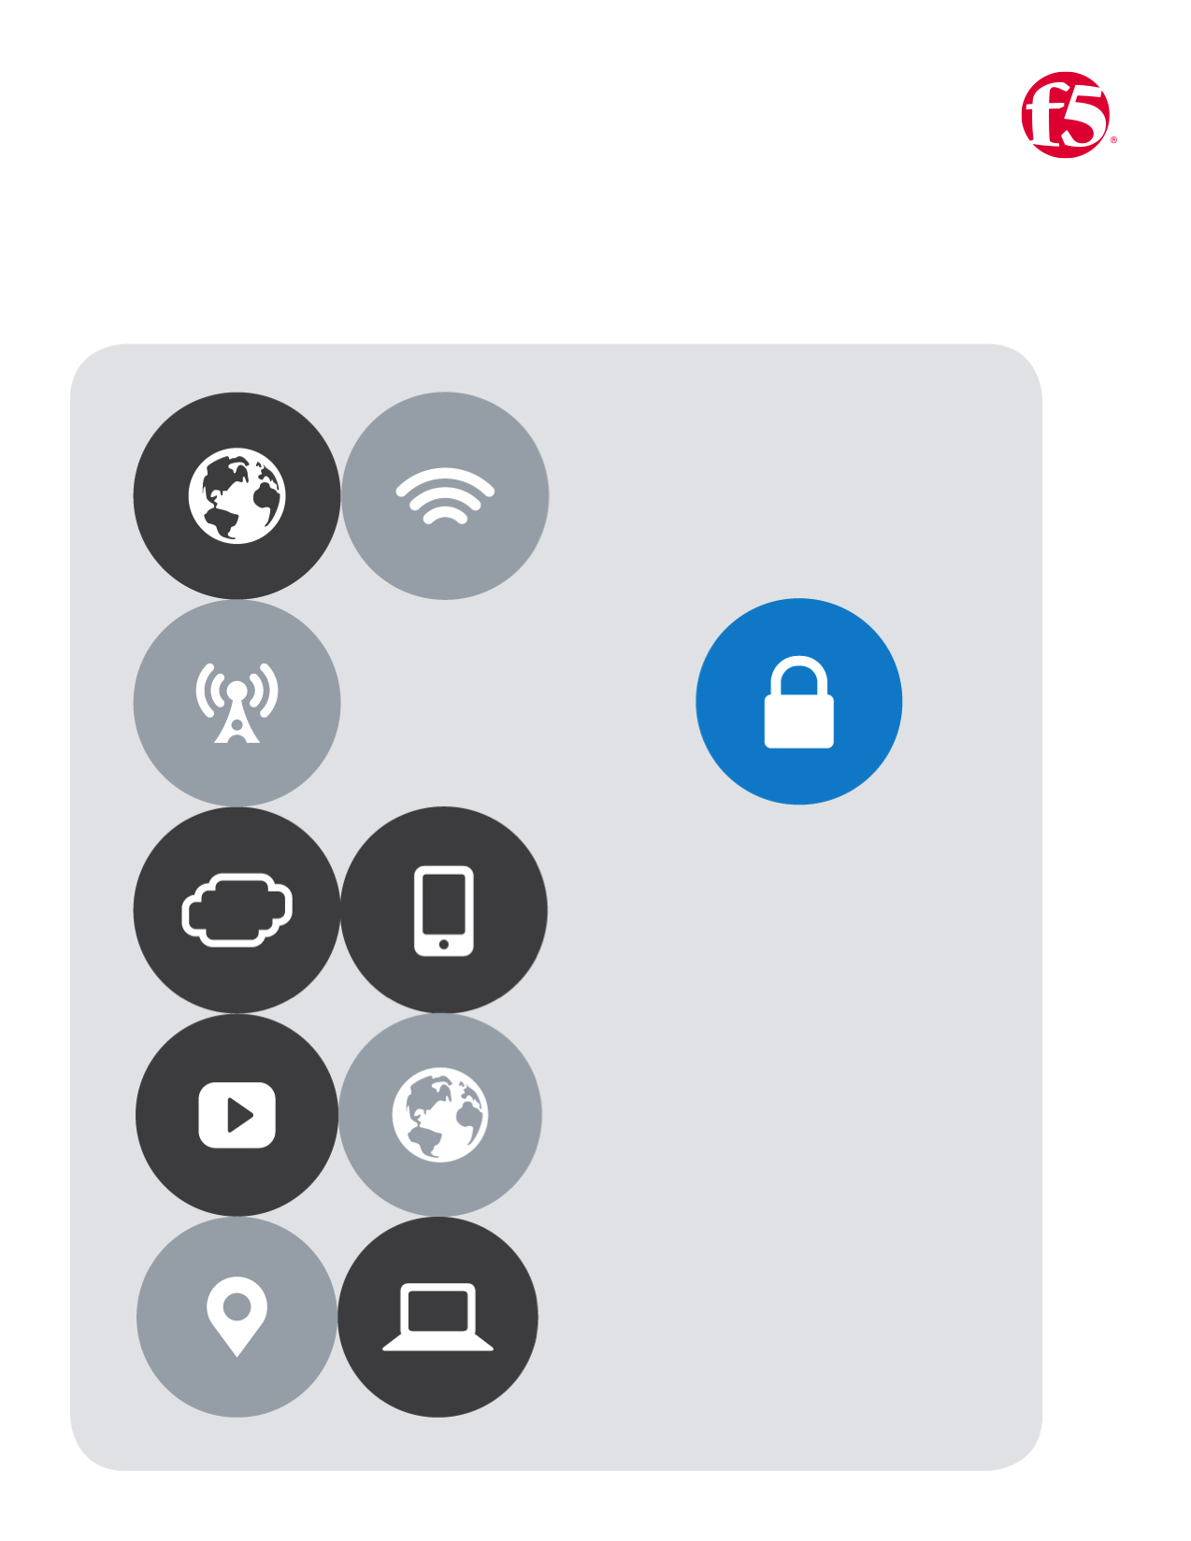

F5| Azure Lab

Cloud Apps BD

No.2

Table of Contents

Lab Two 4

Deploy a BIG-IP from the Azure Marketplace 4

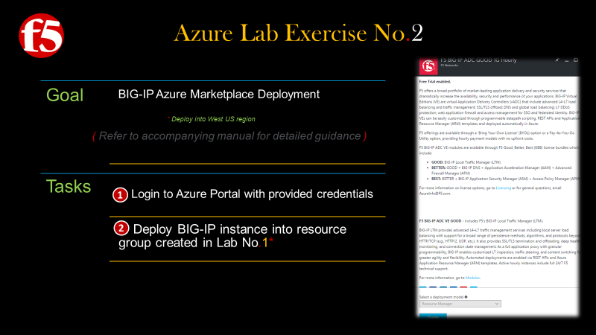

# Lab Two

## *Deploy a BIG-IP from the Azure Marketplace*

1. Return to the Azure Portal **|** Click  **New** from the left menu bar
   1. In the search the marketplace field **|** Type **f5**
   2. Take a moment to review the F5 marketplace offerings **|** Then select **Good 1G Hourly**
   3. A new blade will open, review the information **|** Click **Create**

|  |  |
| --- | --- |
|  |  |
|  |  |
|  |
|  |

### The **Create Virtual Machine Blade** will open and 5 tasks will need to be completed

Required fields will be indicated by the following icon 

1. **Basics** (configure basic settings) **|** Then click **OK**
2. **Size** (choose virtual machine size) **|** Select **View all** on the top right **|** Then select **A2M_V2** as your size **|** Then Click **Select**
3. **Settings** (configure optional features) **|** you will want to use the previously created **Storage Account** and **VNET |** for the **Network Security Group** select **|** Then Click **OK**
4. Review the **Summary** **|** Click **OK**
5. Review the **Offer Details** **|** Click **Purchase**

|  |  |
| --- | --- |
|  |  |
|  |  |
|  |  |
|  |  |
|  |
|  |