### Feature Selection

Feature selection is important when building a machine learning model for several reasons:

* It helps control overfitting by reducing the variance of the model
* Fewer features lead to a simpler model
* Simpler models are faster to train and easier to explain

For this problem, because of the choice to use tree based models (which inherently perform feature selection), the majority of the feature selection process was done from a logistical and business standpoint. Since we are trying to predict the overall trip time, we should only be using information that would be known to a taxi driver at the beginning of a trip. This means using no features associated with the dropoff portion of the trip, except for the dropoff location itself. In addition, no fare information can be used because knowing the cost of the ride requires knowledge of the overall trip time. This is what we are trying to predict, so using cost as a feature would be a form of target leakage. With that in mind, the following features were used:

* Pickup hour, day of the week, month
* Pickup time of day (early morning, afternoon, evening, etc.)
* Whether it is a weekend or a holiday (binary features)
* Pickup and dropoff location (ZIP codes and location clusters from kmeans algorithm)
* Traffic within the pickup and dropoff cluster (at pickup time)
* Whether it is rush hour (binary feature)
* Trip direction (N, NNE, NE, ENE, etc.)
* Current weather (is it raining?)

### Model Selection

Because of the nonlinear relationship between the various features and the trip time, it was decided that a tree based method would be the most appropriate. Linear regression models would not be able to capture the complex interactions between traffic, pickup location, time of day, weather, and the overall trip time. Tree based models, on the other hand, are extremely adept at modeling nonlinear behavior. The following tree based algorithms were considered:

* Simple regression tree (from ‘rpart’ package)
* Random forest (from ‘ranger’ package)
* Boosted regression tree (from ‘gbm’ package)
* Extreme gradient boosted tree (from ‘xgboost’ package)

For all models, the trip data was randomly split into a training set and a validation set (using a 70/30 split). The models were built on the training set and evaluated on the validation set.

The root mean squared error (RMSE) on the validation set for each model is summarized in the table on the following page. The RMSE is the standard deviation of the residuals, and is in the same units as the response variable (seconds, in this case). A lower RMSE means lower prediction error, and the random forest and xgboost regression trees performed best in this case. They will be considered for the final model selection, and the next step is to perform hyperparameter tuning to see if the performance can be improved.

|  |  |
| --- | --- |
| **Model** | **Validation RMSE (seconds)** |
| Regression Tree | 281 |
| Random Forest | 208 |
| Boosted Regression Tree | 364 |
| XGBoost Regression Tree | 209 |

### Hyperparameter Tuning

For each combination of parameters, 10 fold cross validation was used to evaluate the performance of the model, with the minimum RMSE taken over the 10 folds. To increase the tuning speed, 10% of the rides were chosen at random for the tuning models (approximately 150,000 rides).

For the random forest model, the parameters were the number of features to use for each tree, and the minimum number of observations allowed in a node. The combination that produced the lowest RMSE was: 3 features for each tree, and a minimum of 6 observations in a node. The model was relatively insensitive to the value of the parameters, perhaps because so many trees were grown (500). After tuning, the validation RMSE of the random forest model was still 208 seconds.

For the xgboost model, the parameters were the learning rate (the amount that the results of each tree are scaled by before being added to the current approximation) and the maximum tree depth. The combination that produced the lowest RMSE was: a learning rate of 0.2, and a max tree depth of 7 layers. The model was more slightly more sensitive to the value of the parameters compared to the random forest, and after tuning, the validation RMSE of the xgboost model dropped to 207 seconds.

Given that the results of the parameter tuning didn’t improve either model by a significant amount, the random forest model will be chosen for several reasons:

* Random forest models are easier to interpret.
* Random forest models grow many bagged trees, which reduces the variance of the model.
* Random forest models can be highly parallelized, since each tree is grown independently from every other tree. Boosted trees, on the other hand, are usually grown in series, since the error from the previous model is part of the input for the next model.

## Model Performance

The overall performance of the random forest model is summarized below:

* Number of trees: 500
* Number of features used: 16
* Validation RMSE: 208 seconds (~3.5 minutes)
* R2 value: 0.76

The residuals of the predicted trip times are shown below, along with a plot of the residual versus fitted values. Note that the residuals are normally distributed and centered about zero, and the residuals versus fitted plot shows some heteroscedasticity.

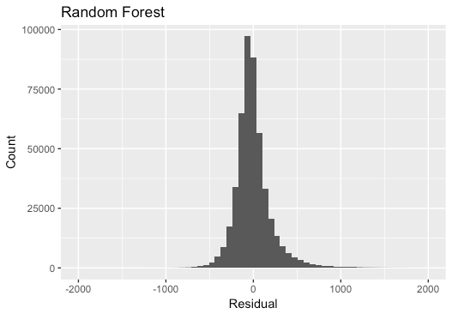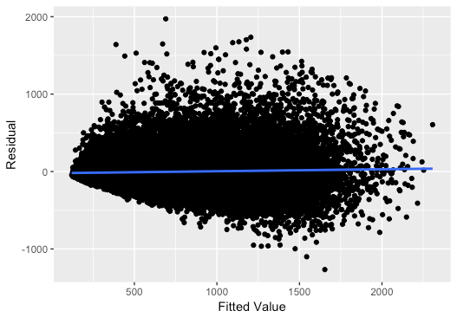

Given that the median trip time is 10 minutes, a RMSE of ~3.5 minutes is encouraging, but still a somewhat large error. The model is able to capture 76% of the variance in the trip time, which is significant considering the dependence of trip time on so many features. To put the RMSE value in context, consider a ‘crude’ model that predicts trip times with the following assumptions:

* Short trips (less than 1.5 miles) occur in the city with an average speed of 10 mph
* Medium trips (over 1.5 miles but less than 3 miles) are mostly in the city with an average speed of 15 mph
* Long trips (over 3 miles) occur on the highway with an average speed of 45 mph

The RMSE of this ‘crude’ model is just under 480 seconds, and serves as a sanity check that the random forest model is an improvement over a system that doesn’t require a model at all. However, as stated, the error is still somewhat large.

### Regression vs Classification

Upon evaluating the regression model, the results were encouraging, but predicting the trip time down to the second is a difficult task. Consider the most important features (obtained from the simple decision tree) that are listed below.

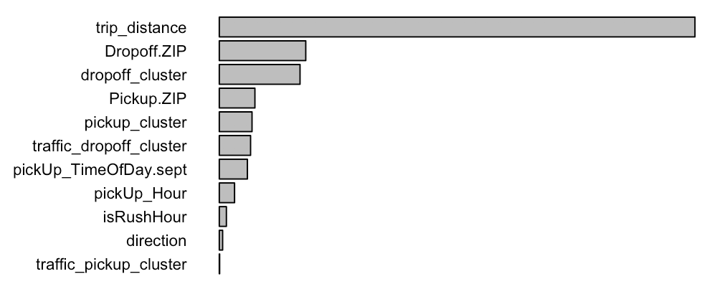

As expected, the trip distance is by far the strongest predictor of the trip time. With that in mind, the plot below shows trip time versus trip distance, colored by average speed. Note that although average speed generally increases with trip distance, most trips are on the slower end.

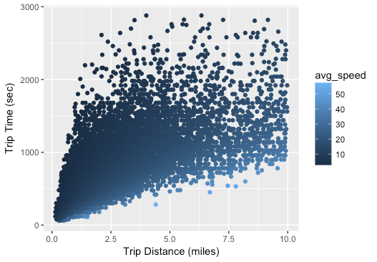

There is a moderately strong positive correlation between trip distance and trip time (the correlation coefficient is approximately 0.7). Some of the variance is due to local speed limits, but most of it is due to traffic. Keep in mind that this feature is (by far!) the strongest predictor of trip time, and there is still a great deal of noise. For a fixed trip distance, of say five miles, the trip time can vary from 500 seconds to nearly 3000 seconds!

In addition to the inherent difficulty presented by the large variance in trip times, predicting the trip time in seconds may not be that useful from a business standpoint. Rather, it may be more useful to be able to predict the length of a trip in a categorical sense. Without more accurate traffic based features to help explain more of the variance in the trip time and obtain more accurate predictions, the idea of converting the problem from a regression task to a simpler classification task was explored. Trips were binned into the following categories: Less than 10 minutes (52% of trips), 10-20 minutes (37% of trips), and over 20 minutes (11% of trips). A random forest classification model was built with the same features and parameters as the regression model. The validation set performance is summarized below:

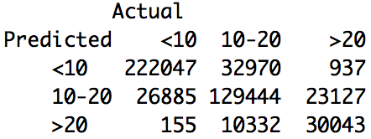

The overall accuracy for each predicted category is the number of correct predictions divided by the actual number of trips in that category:

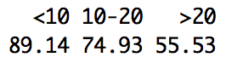

Given that just over 50% percent of trips are under 10 minutes, a prediction accuracy of nearly 90% is very encouraging. The next category covers 37% of trips, and the prediction accuracy was just under 75%. The prediction accuracy slipped a bit on the longest trip category, at just over 55%, but keep in mind only 11% of trips fit into this category. The model tends to underpredict longer trips, which once again is most likely due to not having accurate enough measures of the traffic along a given trip. Overall, these results are very encouraging, and suggest that a classification based approach be used over a regression model given the data available.