Normal Case:
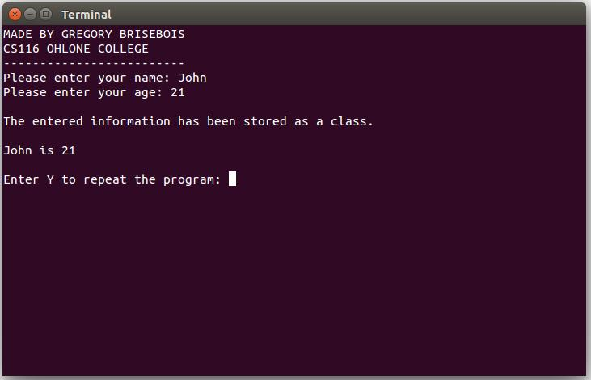

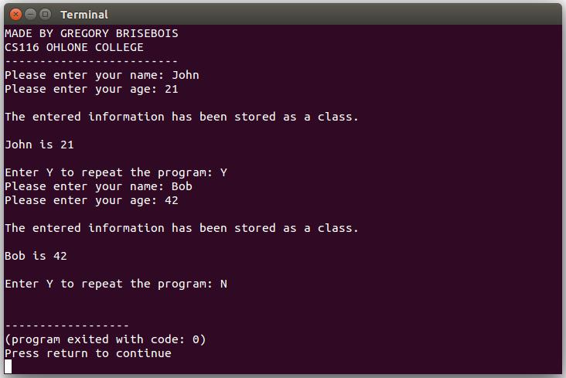
If the user enters Y the program will loop:

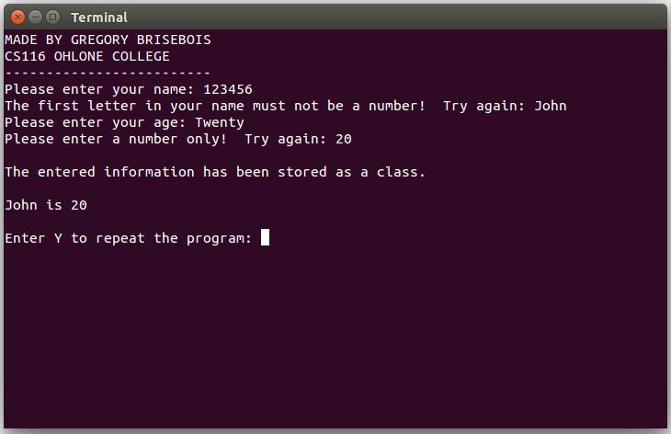
Handling bad input – if the user enters a number as the first letter of their name, or a word or character as their age, it will make them retry:

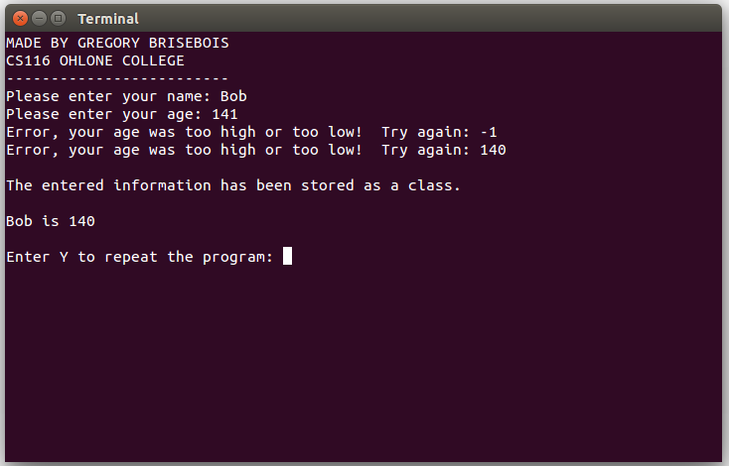
Age range – if the user enters an age outside the range of 0 to 140, they will need to try again:

