First test case.
The user also entered “Y” at the end so it will start over.
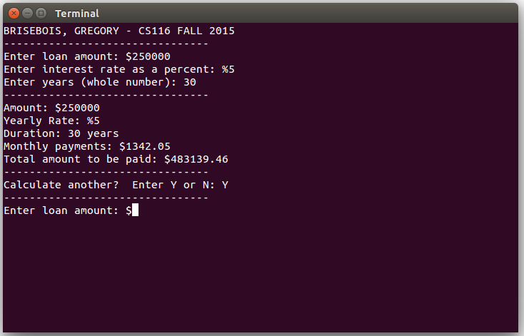
Second test case.
This time the user said “N” so the program quit.
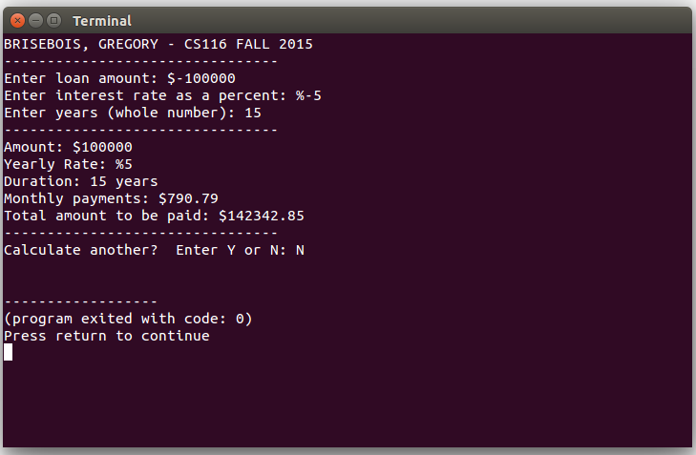
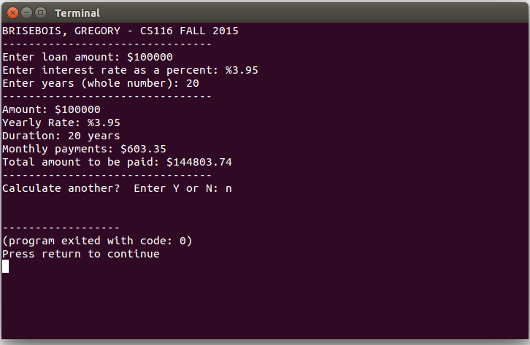
Third test case

Testing the inputs. If the user enters a letter the program will force them to re-enter a proper number.
