Gregory Brisebois, CS-116 Lab 4

- Overview
The user can enter wines, and parameters to display them
(Output is too big to capture in one terminal window)
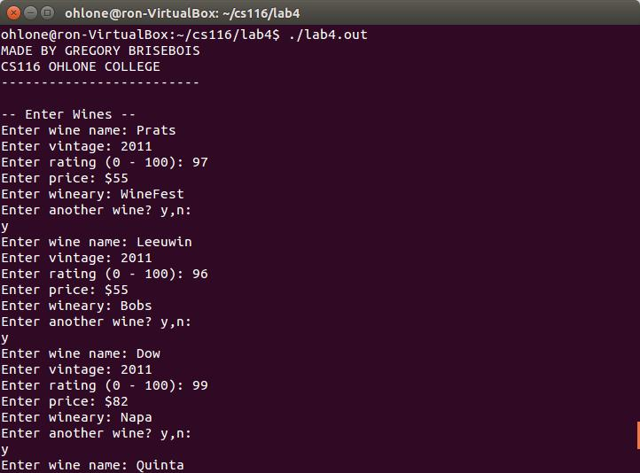
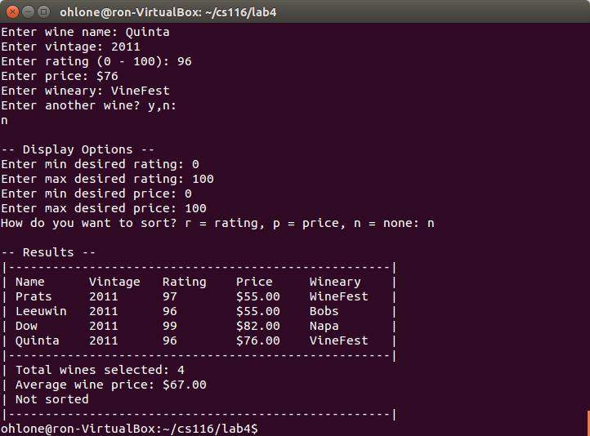
- Rating range & sort by price
Only show wines between 90 and 97 rating, and sort by price (low-hi)
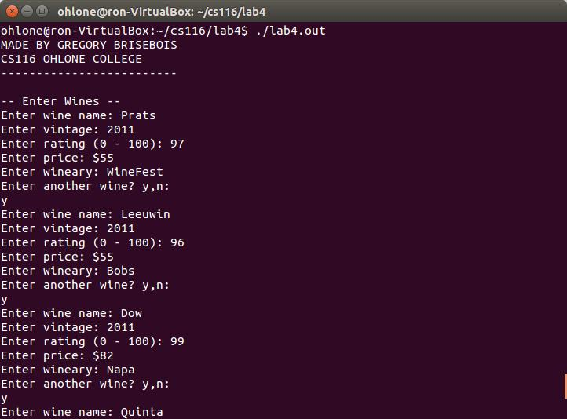
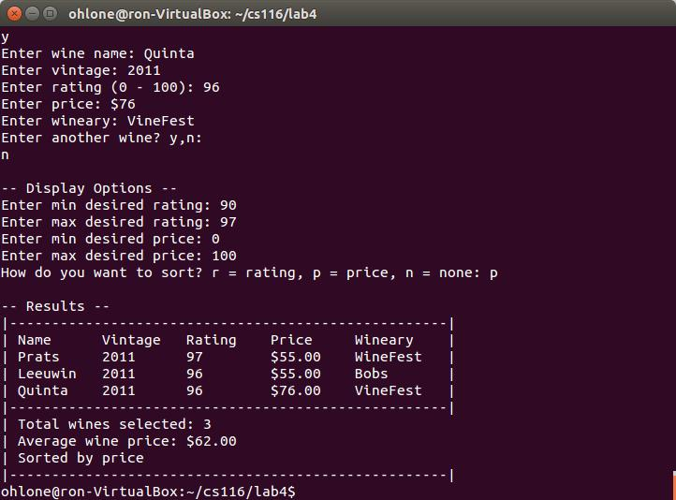
Only 3 wines end up being shown, even though 4 are entered
Since the user entered “p”, it is sorted by price
- Price range & sort by rating
The opposite of the last one: show only within a certain price and sort by rating.
Only 2 wines make the $50-60 cut, and they are in order of rating (high-low)

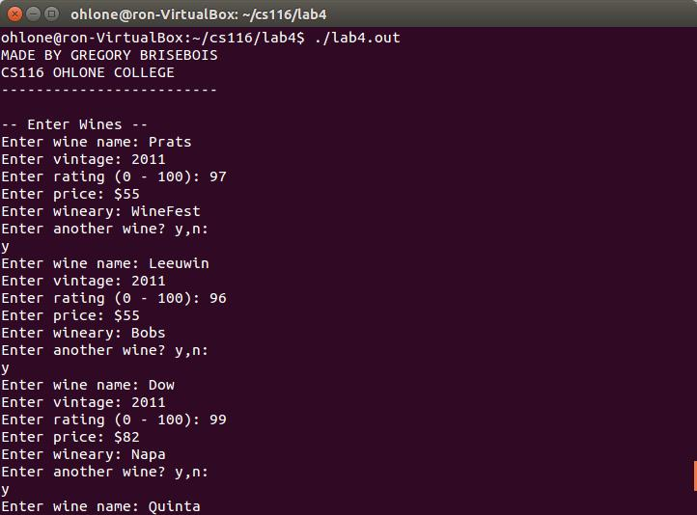
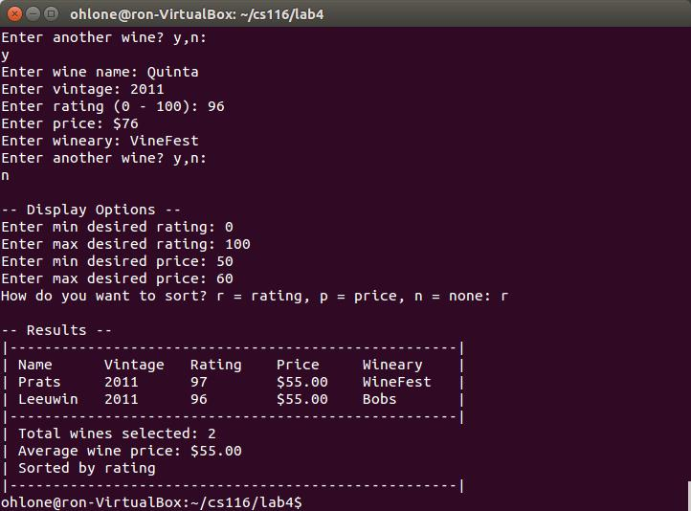
Source Code:

lab4.cpp (main)

#include <iostream>
#include <iomanip>
#include <string>
#include <vector>
#include <algorithm>

#include "wine.h"

using namespace std;

// Course requirement - prints my own name on the console
void printMyName()
{
cout << "MADE BY GREGORY BRISEBOIS" << endl;
cout << "CS116 OHLONE COLLEGE" << endl;
cout << "-------------------------" << endl;
}

// Prompts the user to enter 1 wine
// @return the created wine class
Wine getWineInput()
{
string newName = "";
int newVintage = 0;
int newRating = 0;
double newPrice = 0;
string newWineary = "";

cout << "Enter wine name: ";
cin >> newName;

cout << "Enter vintage: ";
cin >> newVintage;

cout << "Enter rating (0 - 100): ";
cin >> newRating;

cout << "Enter price: $";
cin >> newPrice;

cout << "Enter wineary: ";
cin >> newWineary;

Wine newWine(newName, newVintage, newRating, newPrice, newWineary);

return newWine;
}

// Sort functions used by the vector to sort itself
bool sortByPrice(Wine left, Wine right)
{
return left.getPrice() < right.getPrice();
}
bool sortByRating(Wine left, Wine right)
{
return left.getRating() > right.getRating();
}

// Prints a list of all wines, with the options to sort or display only those in a certain range
// @param wines - the vector of wines to display
// @param ratingMin - the minimum rating to include in the display
// @param ratingMax - max rating to include
// @param minPrice, maxPrice - min and max prices to include
void printAllWines(vector<Wine> wines, int ratingMin = 0, int ratingMax = 99, int priceMin = 0, int priceMax = 100, char sortId = 0)
{
// String that will tell the user how we sorted
string sortTypeDisplay = "Not sorted";

// Sort (or not) based on the input
switch(sortId)
{
case 'r':
sort(wines.begin(), wines.end(), sortByRating);
sortTypeDisplay = "Sorted by rating";
break;

case 'p':
sort(wines.begin(), wines.end(), sortByPrice);
sortTypeDisplay = "Sorted by price";
break;
}

// Variables that control the width of the output columns
int nameWidth = 10;
int vintageWidth = 10;
int ratingWidth = 10;
int priceWidth = 10;
int winearyWidth = 10;
int totalWidth = nameWidth + vintageWidth + ratingWidth + priceWidth + winearyWidth;

// Make a bar to use for the ends (formatting)
string bar = "|";
bar.append(totalWidth + 2, '-');
bar.append("|");

// Print column labels
cout << bar << endl;
cout << "| ";
cout << setw(nameWidth) << left << "Name"
<< setw(vintageWidth) << "Vintage"
<< setw(ratingWidth) << "Rating"
<< setw(priceWidth) << "Price"
<< setw(winearyWidth) << "Wineary"
<< " |" << endl;

// This will keep track of how many wines make the cut
int numSelectedWines = 0;

// These will keep track of selected prices
double totalPrice = 0;
double avgPrice = 0;

// Print the wine, if it makes the cut
for(int i = 0; i < wines.size(); i++)
{
// IF rating and price are within set bounds
if(wines[i].getRating() <= ratingMax && wines[i].getRating() >= ratingMin
&& wines[i].getPrice() <= priceMax && wines[i].getPrice() >= priceMin)
{
// Print out the row for the wine
cout << "| ";
cout << setw(nameWidth) << left << wines[i].getName()
<< setw(vintageWidth) << wines[i].getVintage()
<< setw(ratingWidth) << wines[i].getRating()
<< "$" << setw(priceWidth-1) << fixed << setprecision(2) << wines[i].getPrice() // We have to subtract width by 1 to make space for the dollar sign
<< setw(winearyWidth) << wines[i].getWineary()
<< " |" << endl;

// Update our selected wine statistics
numSelectedWines++;
totalPrice += wines[i].getPrice();
}
}

// Calculate the average price
avgPrice = totalPrice / numSelectedWines;

// Print summary of results after the chart
cout << bar << endl;
cout << "| " << "Total wines selected: " << numSelectedWines << endl;
cout << "| " << "Average wine price: $" << avgPrice << endl;
cout << "| " << sortTypeDisplay << endl;
cout << bar << endl;
}

int main()
{
printMyName();

cout << endl << "-- Enter Wines --" << endl;

// This is our main vector of wines
vector<Wine> wineVect;

// loop that allows user to enter new wines until breaking out by not entering 'y' at the prompt
bool doloop = false;
do
{
// Create the new wine
Wine myWine = getWineInput();

// Add it to the vector
wineVect.push_back(myWine);

// Ask if we want to enter another
cout << "Enter another wine? y,n: " << endl;
char cont;
cin >> cont;
doloop = (cont == 'y');
}
while (doloop);

// Now we want to know the range of price and rating that the user wants to display
int minRating = 0, maxRating = 100, minPrice = 0, maxPrice = 1000;
cout << endl << "-- Display Options --" << endl;
cout << "Enter min desired rating: "; cin >> minRating;
cout << "Enter max desired rating: "; cin >> maxRating;
cout << "Enter min desired price: "; cin >> minPrice;
cout << "Enter max desired price: "; cin >> maxPrice;

// Prompt for sort type
char sortId = 0; // r = rating, p = price, other = none
cout << "How do you want to sort? r = rating, p = price, n = none: ";
cin >> sortId;

cout << endl << "-- Results --" << endl;

// Display the wines
printAllWines(wineVect, minRating, maxRating, minPrice, maxPrice, sortId);
}

wine.cpp

#include <string>
#include "wine.h"

// Constructors

Wine::Wine()
{
name = "newwine";
vintage = 0;
rating = 0;
price = 0.00;
wineary = "newwineary";
}

Wine::Wine(std::string newWineName, int newVintage, int newRating, double newPrice, std::string newWineary)
{
name = newWineName;
vintage = newVintage;
rating = newRating;
price = newPrice;
wineary = newWineary;
}

// Mutators

// Change the name
void Wine::setName(std::string newName)
{
name = newName;
}

// Change the vintage
void Wine::setVintage(int newVintage)
{
vintage = newVintage;
}

// Change name, price, and rating all at once
void Wine::setInfo(std::string newName, double newPrice, int newRating)
{
name = newName;
price = newPrice;
rating = newRating;
}

// Accessors

// get the name
std::string Wine::getName()
{
return name;
}

// get the vintage
int Wine::getVintage()
{
return vintage;
}

// get the rating
int Wine::getRating()
{
return rating;
}

// get the price
double Wine::getPrice()
{
return price;
}

// get the wineary
std::string Wine::getWineary()
{
return wineary;
}

wine.h

#ifndef PERSON_H
#define PERSON_H

// Each wine has the following attributes:
// - Name
// - Vintage
// - Rating
// - Price
// - Wineary

class Wine
{
public:
Wine(double price, std::string name);
Wine(std::string newWineName, int newVintage, int newRating, double newPrice, std::string newWineary);
Wine();

// Mutators
void setName(std::string newName);
void setVintage(int newVintage);
void setInfo(std::string newName, double newPrice, int newRating);

// Accessors
std::string getName();
int getVintage();
int getRating();
double getPrice();
std::string getWineary();

private:
std::string name;
int vintage;
int rating;
double price;
std::string wineary;
};

#endif

