Lab 7 – MySQL Wine Database
Gregory Brisebois

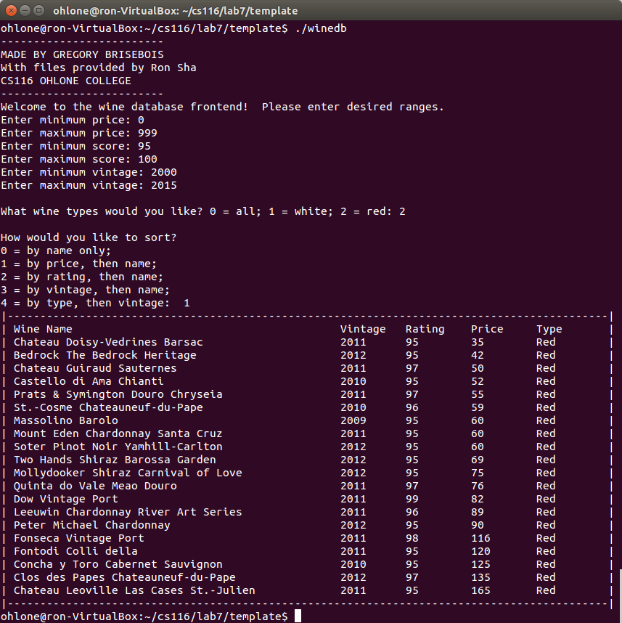
Test Case #1: All red wines, with a rating score between 95 and 100, sorted by price:

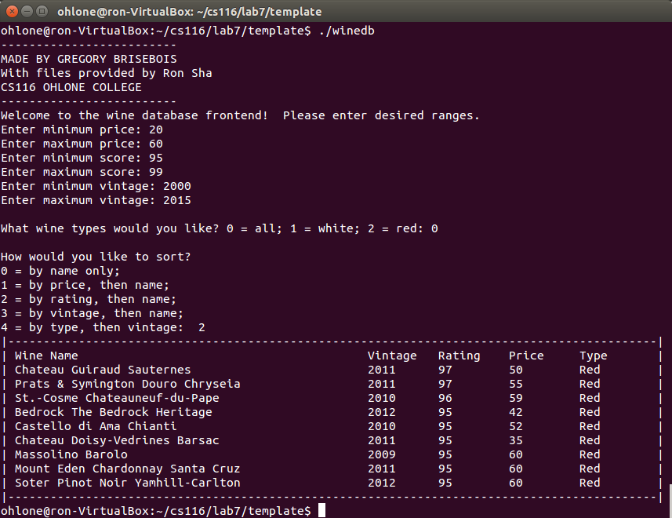
Test Case #2: All types, with a rating between 95 and 99, and a price between 20 and 60, sorted by rating:

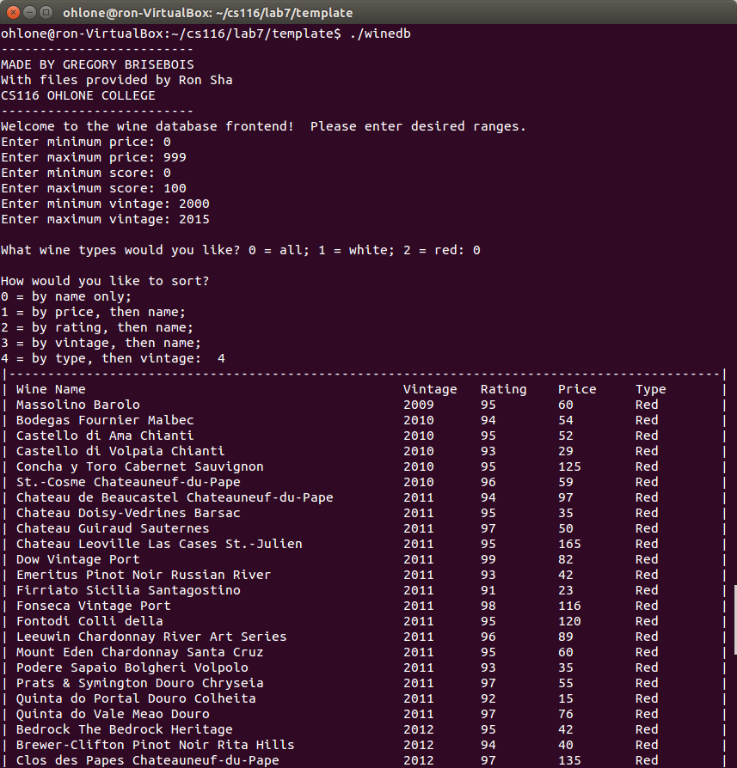
Test Case #3: All types, sorted by type and vintage (the list was too long to fit on one page, but on the next page you can see where the list goes from red to white):

Test Case #3 Continued:

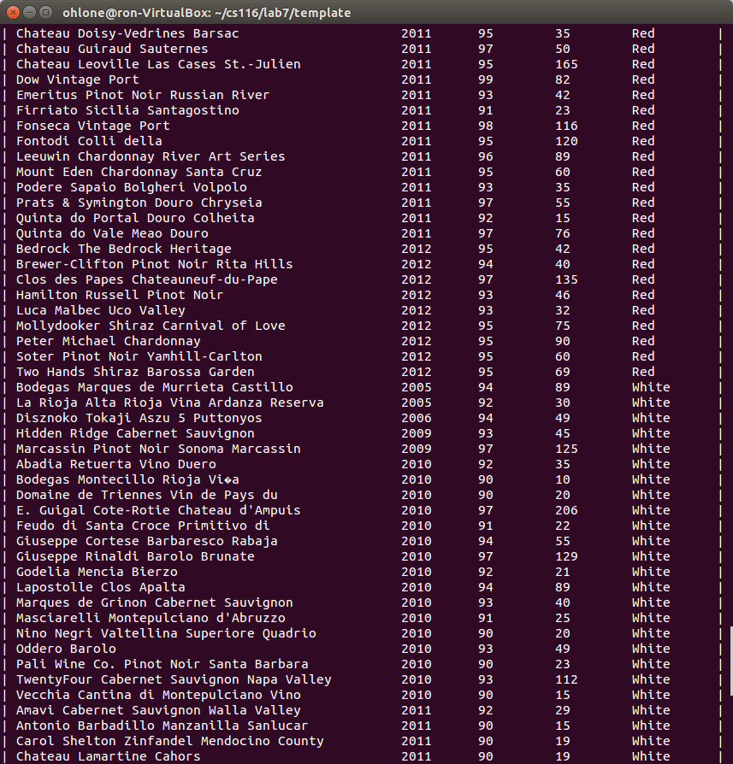

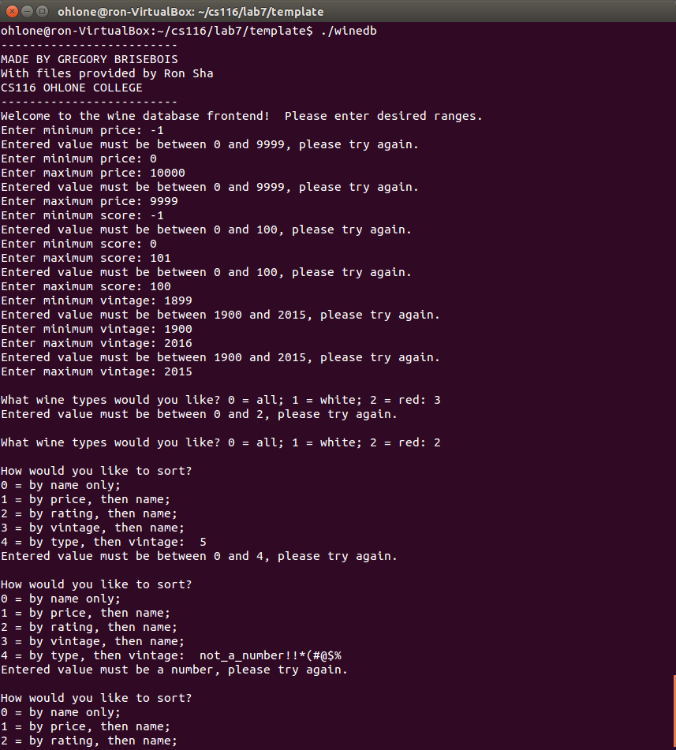
Test Case #4: Invalid inputs. For each data type, a number outside the bounds is entered, but the program rejects it. In the last example a non-numeric string is attempted.

Source Code

winedb.cpp

// Created by Gregory Brisebois with content from Ron Q. Sha

#include <mysql.h>
#include <stdio.h>
#include <stdlib.h>
#include <iostream>
#include <iomanip>
#include "dbconnect.h"
#include <string>
#include <cstring>
#include <sstream>

// We use a custom namespace to fix our to_string function
namespace patch
{
template < typename T > std::string to_string( const T& n )
{
std::ostringstream stm ;
stm << n ;
return stm.str() ;
}
}

using namespace patch;

// Course requirement - prints my own name on the console
void printMyName()
{
cout << "-------------------------" << endl;
cout << "MADE BY GREGORY BRISEBOIS" << endl;
cout << "With files provided by Ron Sha" << endl;
cout << "CS116 OHLONE COLLEGE" << endl;
cout << "-------------------------" << endl;
}

// Checks if a value is within two other values
// @return - true if it is
bool inRange(int value, int min, int max)
{
return value >= min && value <= max;
}

// Prompts the user for an input and rejects it if it is not valid
// @param promt - custom string to use for prompt
// @param min - min acceptable value
// @param max - max acceptable value
// @return - the inputted value
int getValidIntInput(string prompt = "Enter value: ", int min = 0, int max = 0)
{
// To hold the input
int input = -1;

// Used to track if the input is valid
bool inputOkay = true;

// Loop until the user gives us a good value
do
{
inputOkay = true;

cout << prompt;
cin >> input;

// Handle if input was non numeric
if(!cin)
{
cout << "Entered value must be a number, please try again." << endl;
inputOkay = false;
cin.clear();
cin.ignore(1000, '\n');
}

// Handle if input was out of range
else if(!inRange(input, min, max))
{
cout << "Entered value must be between " << min << " and " << max << ", please try again." << endl;
inputOkay = false;

}
}
while(!inputOkay);

return input;
}

// Returns the mySQL code from the user's entered int
// @param sortInt - user entered choice
// @return - string of SQL
string getSortFromInt(int sortInt)
{
switch(sortInt)
{
case 0:
return "order by winename";
break;

case 1:
return "order by price";
break;

case 2:
return "order by rating desc";
break;

case 3:
return "order by vintage";
break;

case 4:
return "order by wineType, vintage";
break;
}
}

// Returns the mySQL code from the user's entered int
// @param sortInt - user entered choice
// @return - string of SQL

string getTypeFromInt(int typeInt)
{
switch(typeInt)
{
case 0:
return "";
break;

case 1:
return " and wineType = 'White'";
break;

case 2:
return " and wineType = 'Red'";
break;
}
}

// Prompts the user for range and sort choices, and assembles a
// matching mySQL statement.
// @return - the SQL statement in string form.
string getSqlStatement()
{
cout << "Welcome to the wine database frontend! Please enter desired ranges." << endl;

int priceMin = getValidIntInput("Enter minimum price: ", 0, 9999);
int priceMax = getValidIntInput("Enter maximum price: ", priceMin, 9999);

int scoreMin = getValidIntInput("Enter minimum score: ", 0, 100);
int scoreMax = getValidIntInput("Enter maximum score: ", scoreMin, 100);

int yearMin = getValidIntInput("Enter minimum vintage: ", 1900, 2015);
int yearMax = getValidIntInput("Enter maximum vintage: ", yearMin, 2015);

string wineType = getTypeFromInt( getValidIntInput("\nWhat wine types would you like? 0 = all; 1 = white; 2 = red: ", 0, 2) );

string sortType = getSortFromInt( getValidIntInput("\nHow would you like to sort?\n0 = by name only;\n1 = by price, then name;\n2 = by rating, then name;\n3 = by vintage, then name;\n4 = by type, then vintage: ", 0, 4) );

string statement = "select * from wineInfo where price >= " + to_string(priceMin) + " and price <= " + to_string(priceMax) +
" and rating >= " + to_string(scoreMin) + " and rating <= " + to_string(scoreMax) +
" and vintage >= " + to_string(yearMin) + " and vintage <= " + to_string(yearMax) +
wineType + " " + sortType + ", winename;";

return statement;
}

int main()
{
printMyName(); // Course requirement

int wideColumn = 50; // column width for names
int shortColumn = 10; // column width for non-names

// Make a bar to use for the ends (formatting)
string bar = "|";
bar.append(shortColumn * 4 + wideColumn + 2, '-');
bar.append("|");

MYSQL *conn; // the connection
MYSQL_RES *res; // the results
MYSQL_ROW row; // the results row (line by line)

struct connection_details mysqlD;
mysqlD.server = (char *)"localhost"; // where the mysql database is
mysqlD.user = (char *)"root"; // the root user of mysql
mysqlD.password = (char *)"password"; // the password of the root user in mysql
mysqlD.database = (char *)"mysql"; // the databse to pick

// connect to the mysql database
conn = mysql_connection_setup(mysqlD);

// open our database
res = mysql_perform_query(conn, (char *)"use wine");

// Get the needed query in the form of a string
string statement = getSqlStatement();

// format our query string
string argString = statement;
char *myArg = new char[argString.length() + 1];
strcpy(myArg, argString.c_str());

// perform our query string
res = mysql_perform_query(conn, myArg);

delete [] myArg;

// Printing out the header
cout << bar << endl;
cout << "| " << setw(wideColumn)
<< left << "Wine Name"
<< setw(shortColumn)
<< "Vintage" << setw(shortColumn)
<< "Rating" << setw(shortColumn)
<< "Price" << setw(shortColumn)
<< "Type" << " |" << endl;

// Iterate through each row of data and print it
while ((row = mysql_fetch_row(res)) !=NULL)
{
cout << "| " << setw(wideColumn) << left << row[0] // coulumn (field) #1 - Wine Name
<< setw(shortColumn) << row[1] // field #2 - Vintage
<< setw(shortColumn) << row[2] // field #3 - Rating
<< setw(shortColumn) << row[3] // field #4 - Price
<< setw(shortColumn) << row[4] // field #5 - Wine type
<< " |" << endl;
}

// Close the bottom with another horizontal bar
cout << bar << endl;

/* clean up the database result set */
mysql_free_result(res);
/* clean up the database link */
mysql_close(conn);

return 0;
}

