Abstract:

Vision-language models (VLMs) have proven effective for a number of complex tasks involving images and text. In particular, these models can use language as a substrate for reasoning, allowing them to go beyond the constraints of prior computer vision approaches. For instance, a VLM can take an image of a geometry problem (prove that these two angles are congruent), describe the constraints of that problem in language (describe which lines are parallel and which intersect), and reason through to find a solution. In addition, a rising trend in VLMs is the use of visual “sketching”: manipulating the image to enable the VLM to reason over it more easily.

Our work involves fine-tuning a VLM to do reasoning about seismic images:
- Sweet lobe detection (not discussed here, was abandoned as a direction in early 2026 based on discussions between Exxon and UT)
- Two subtasks related to identifying the basement:
  - Total sediment thickness
  - Identifying the location of thickest or thinnest sediment

These images are generated from the underlying synthetic models that Qianqian Zhou and Michael Pyrcz’s team created.

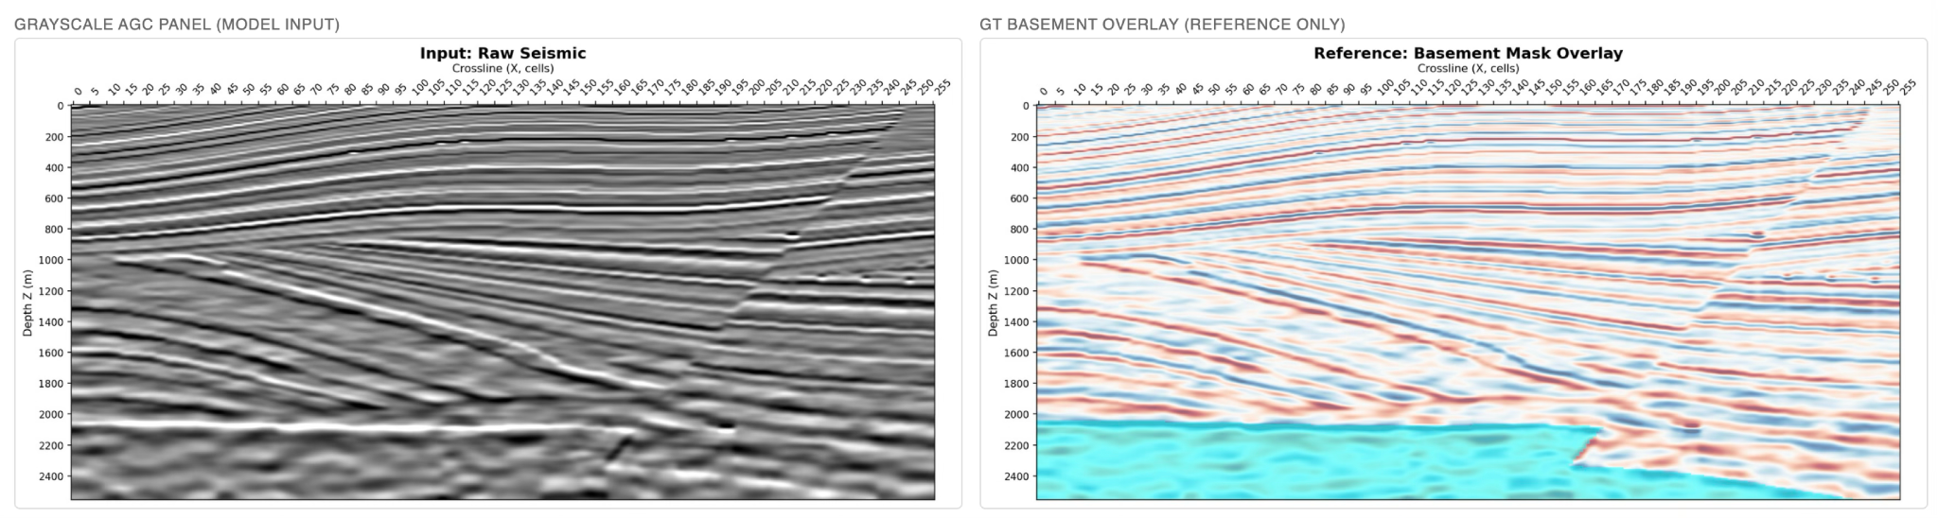

Approach:

We explored fine-tuning vision-language models (VLMs) with various kinds of supervised fine-tuning data to teach them to do intermediate reasoning.

Basic SFT approach: VLMs are models p(output | prompt, image). That is, they condition on a text prompt and an image, and place a probability distribution over output text, which is a series of tokens obtained by sampling next tokens.

We can prompt VLMs, including open-source models (Qwen series) and closed-source models (GPT series) to reason about seismic images. However, they often perform poorly out-of-the-box due to a lack of in-domain training.

As a result, we apply basic training via supervised fine-tuning (SFT). This is the most appropriate type of training for the data we have, where (1) we know the ground truth answer; (2) we have known intermediate reasoning, namely the location of the basement.

Our basic training data unit is an (image, question, answer) pair. Underlying this training data unit is a model: the model allows us to compute the ground truth answer to the question based on the true underlying basement mask. The system is trained to predict the answer given the image.

VLMs predict a reasoning chain, so their output actually takes the form

p(answer | prompt, image, reasoning) p(reasoning | prompt, image

The model is trained on both ground-truth reasoning traces as well as answers. The reasoning traces are imputed by

Reasoning traces:

…the wavelet centre at columns 130, 149 is 1970, 1940 m. At the queried column Inline (Y) = 130 it is 1970 m. Answer: 1970 m. → <answer>1970</answer>

…column 28 the shallowest (1650 m). The basement depths at columns 28, 199, 234 come out as 1650, 2390, 2350 m. Snapping column 28 to the 10-cell grid gives 30. → <answer>30</answer>

Experimental setup:

Train data: 200 models. Eval data: 30 models (disjoint)

Preprocessing:
- AGC gain-normalised seismic (reflector strength no longer decays with depth)
- 256 lateral × 256 depth cells
- Three colormaps per view (colored or grayscale)

SFT data: 12,078 (image, question) pairs over 200 SFT models

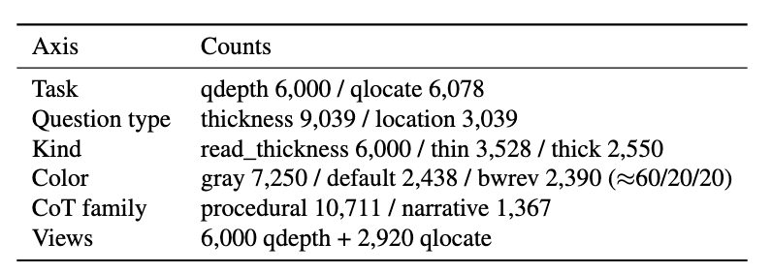

Results

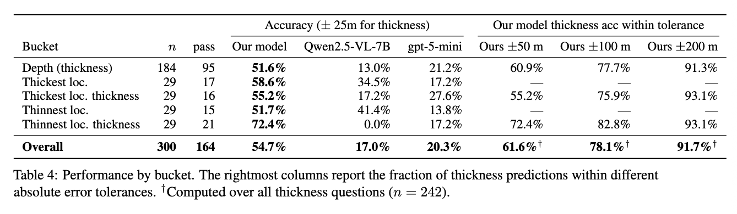

Examples
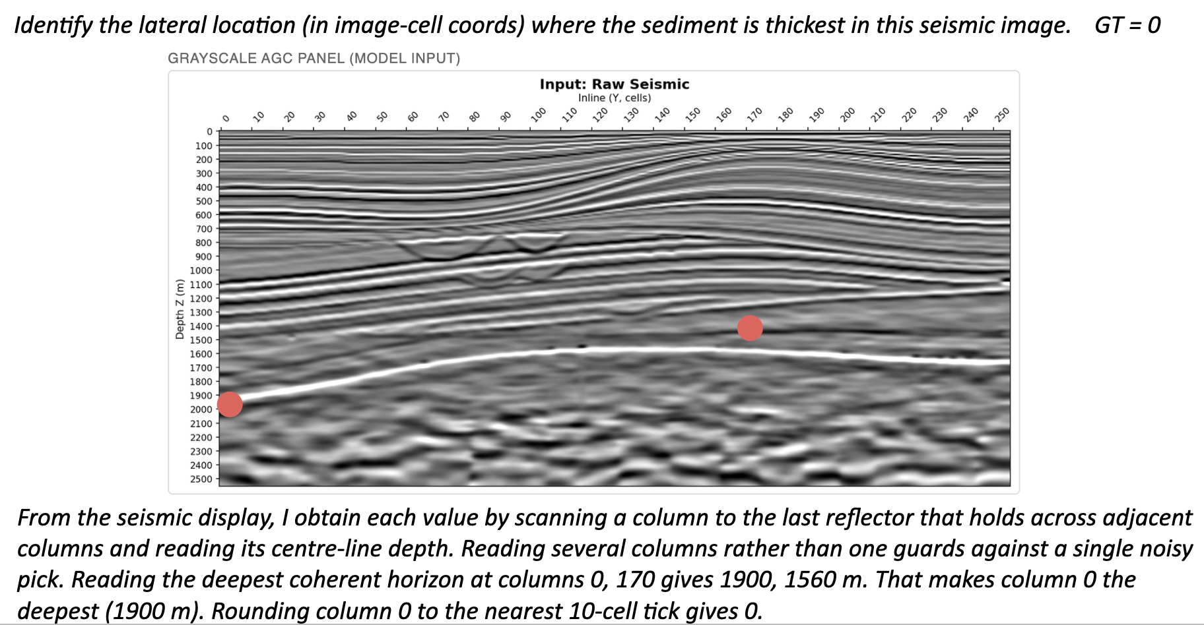

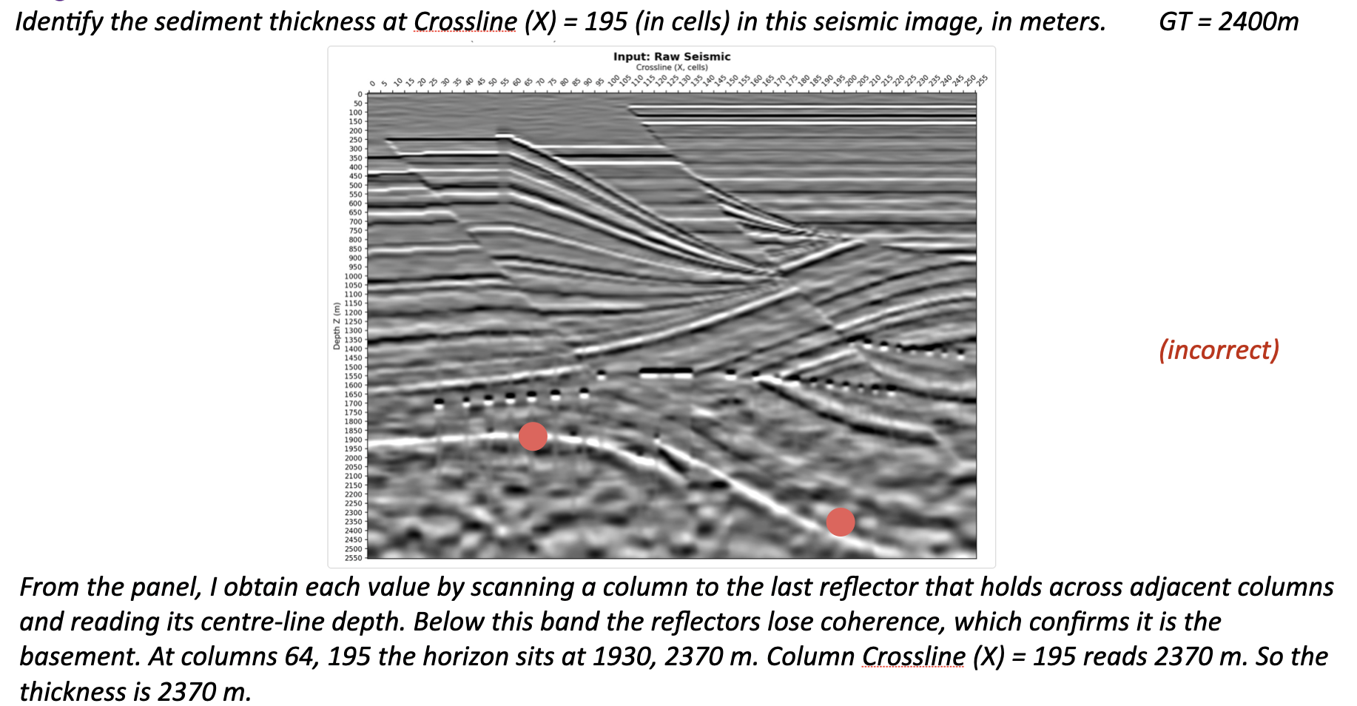

Intermediate reads are accurate. Across 875 per-column basement depths the model produces mid-trace, the median absolute error vs ground truth is 50 m (≈ half a 100 m z-tick); 72% land within 100 m, 87% within 200 m.

Perception accuracy predicts correctness
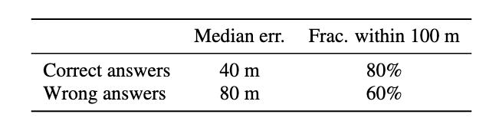
(Many errors are only barely outside the desired range.)

Generalization to new data

We tried on one unseen image sourced from a real seismic image. The axes were superimposed to match the training data.
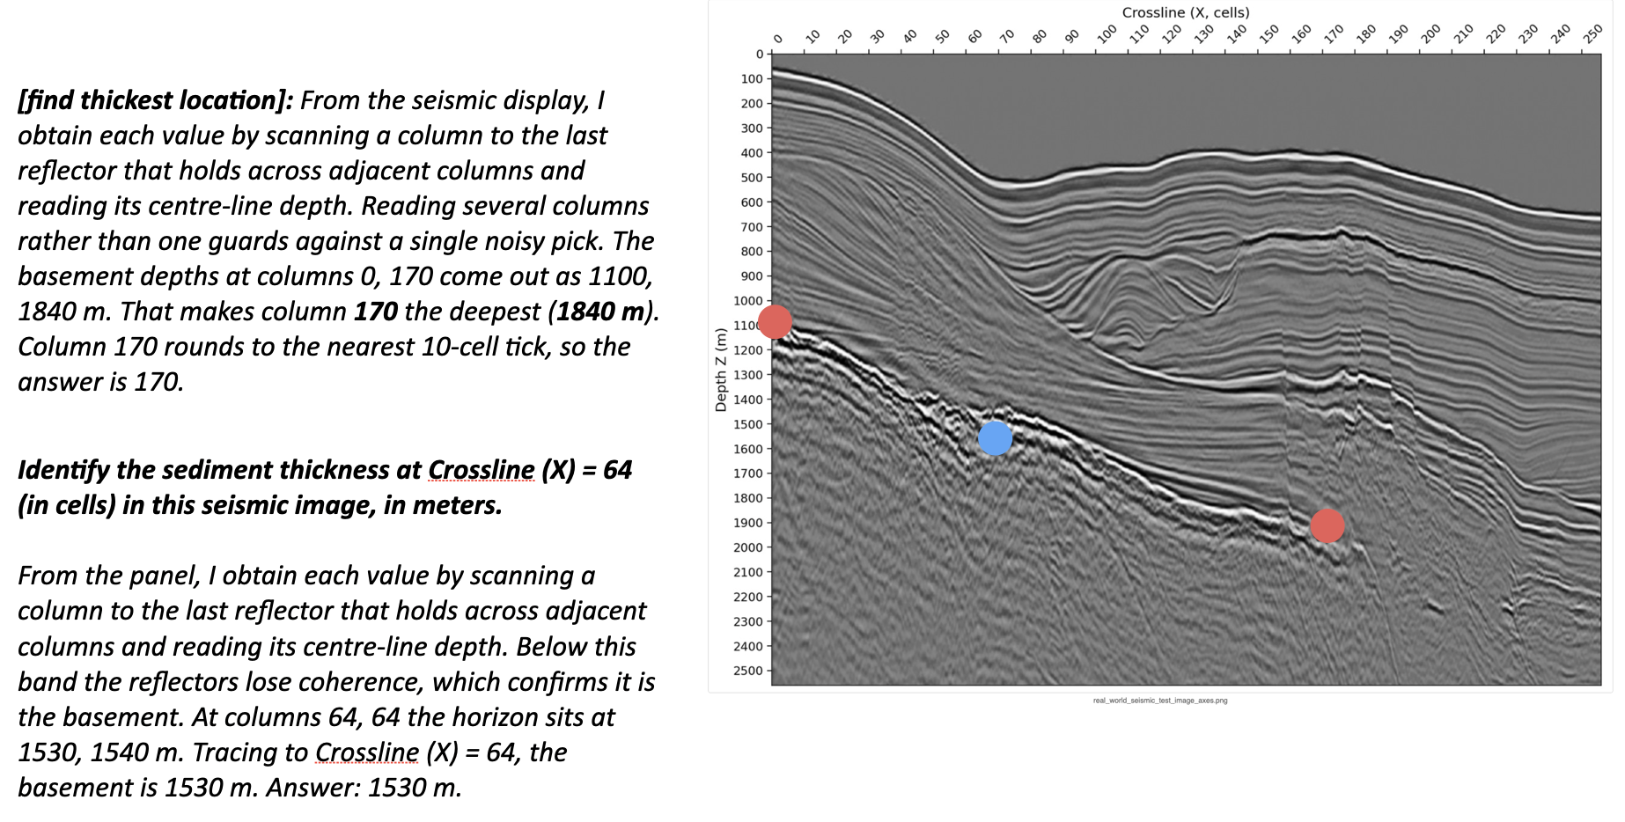

Why it still fails / what's hard

Of 89 depth errors, 63 are near-misses (≤100 m past the accept band).

For location, 17 of 26 location misses are coverage misses — the enumeration samples only 2–3 columns and never lands near the true extremum, so it cannot find it. Because the sampled columns are random, argmax over a sparse random sample does not yield the real argmax.

Analysis: Some Failure Modes:

Biases in training data can degrade VLM quality: due to the underlying models, many of the ground truth locations were at the edge of the image (position 0 or 250).

Predicting the basement mask as a latent reasoning step: In VLMs’ thinking traces, we experimented with them predicting the location of the basement mask with even more explicit points:

“At points 0, 40, 80, 120, 160, 200, 240, the position of the basement is [Z1], [Z2], …”

Unfortunately, this did not return good results with the VLM. The VLM ended up being too biased by the linguistic format of these outputs.

What’s next:

Recommendation: the initial basement mask identification should be done with a separate-trained model. This separate-trained model could be a CNN or a special-purpose VLM.

Then this information can be fed to a VLM for reasoning. The VLM can consume a marked-up image (e.g., deepest coherent reflector annotated with a series of dots or a curve) and largely have to avoid any domain-specific visual reasoning. With a prompt containing SME, it will be able to follow the workflow specified in the prompt and do simple operations like finding the lowest point on a line, reading values off of axes, etc.

In short: use a small specialist model for marking up the image, then a generalist model for reasoning over the results.

Appendix: Hyperparameters

