We know that Windows uses Shutdown.exe to switch off our computer. We have also learned that MS Outlook can [launch applications](http://www.guidingtech.com/19217/outlook-2013-remotely-start-applications-windows/) on receipt of emails and rules verification. Let’s see how we can use this capability of Outlook to trigger a shutdown.

**Note:** You must have Outlook installed (and up and running) on your computer. It should also be connected to the internet so that the desktop email client is ready to receive emails and trigger the shutdown process.

**Step 1:** Create a .bat file. First create a text file and then save it as .bat. Remember the save location.

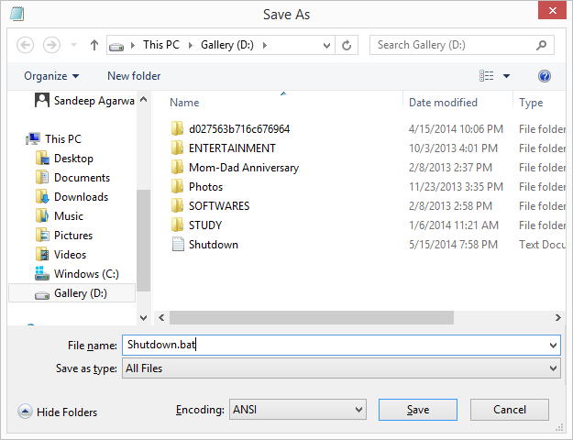

**Step 2:** Before you close the file, put this in it: %systemroot%\system32\shutdown.exe -s -t 0. Also shown in the image below. Save and close the file.

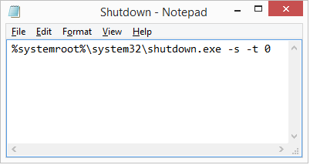

**Step 3:** Now open MS Outlook. Under *Home* tab, go to *Rules* and expand the menu. Select*Manage Rules and Alerts*.

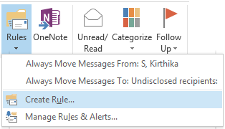

**Step 4:** On the *Rules and Alerts* window chick on *New Rule* while under *Email Rules* tab.

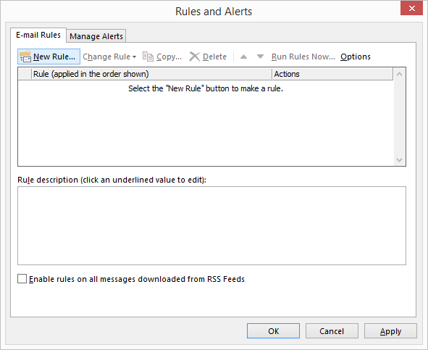

**Step 5:** Start off by selecting your template as *Apply rule on messages I receive*. Click on*Next*.

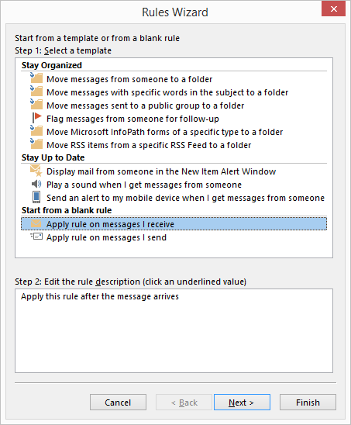

**Step 6:** This is the most important step as it determines what rule should be applied. You may have your own conditions but my suggestion would be to have a mix of many to restrict unwanted shutdowns.

**Step 6 (a):** Select the following rules. For me there is a reason to each:

1. **through the specified account**- If you have multiple email id’s configured with MS Outlook you must choose which account the rule applies to.
2. **sent only to me**- The motive is to restrict the email rule trigger based on recipient list.
3. **with specific words in the subject**- Another constraint so that the receiving email is identified better.
4. **with specific words in the body**- Sometimes, only the subject may be ambiguous. So a body makes it more refined.
5. **on this computer only**- If you have Outlook configured with same email addresses on multiple machines you must be cautious about the machine you want to apply the rule to.

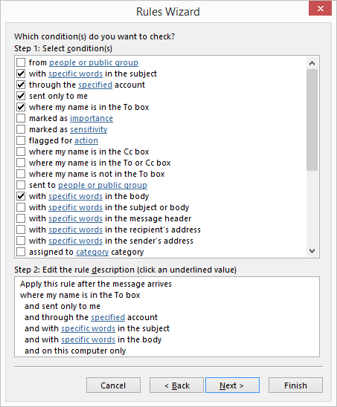

**Step 6 (b):** Once you have selected the conditions you need to specify the content by clicking on each of those links in the second half of the window. Here are my samples:-

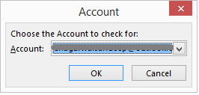

Ads by Google

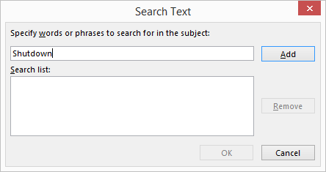

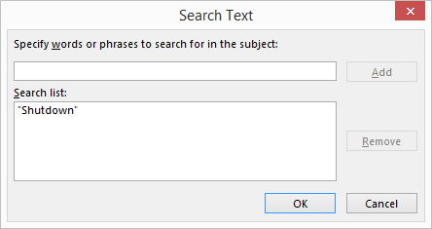

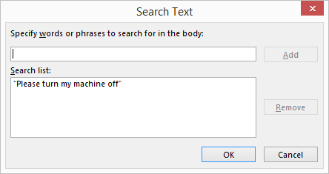

**Step 6 (c):** Back on the main window, verify that you have associated all conditions. Then click on *Next*.

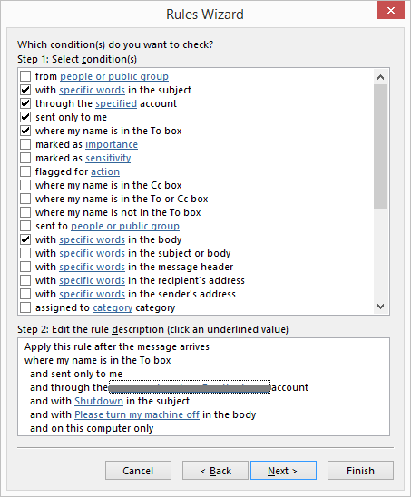

**Step 7:** Next comes the action to be applied when an email is received and all the conditions match. Select *start application* and *delete it*.

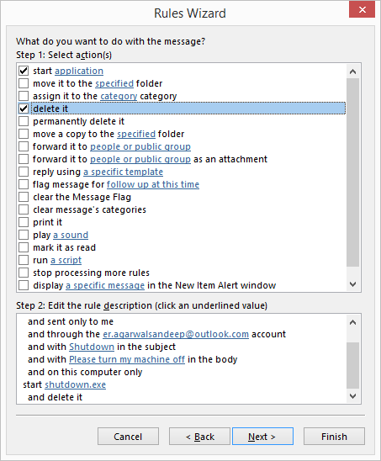

The action for start application will do your job. However, if you do not **delete it** the rule may apply again and again on opening Outlook, resulting in a loop.

**Step 7 (a):** For starting application action, click on the link and select the file you created at the beginning of the tutorial. Click on *Next*.

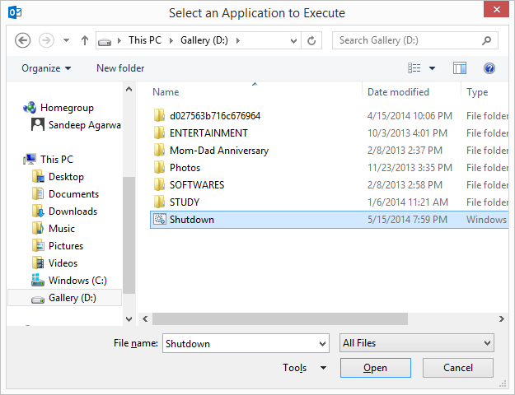

**Step 8:** I do not think you require any exceptions here. So ignore this window and click on*Next*.

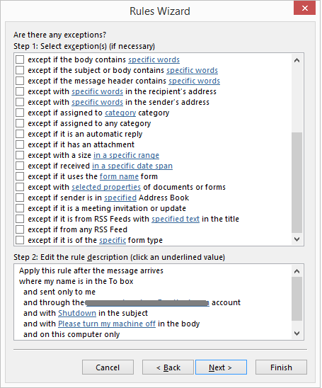

**Step 9:** Give the rule a name for future references, turn it on and click on *Finish*.

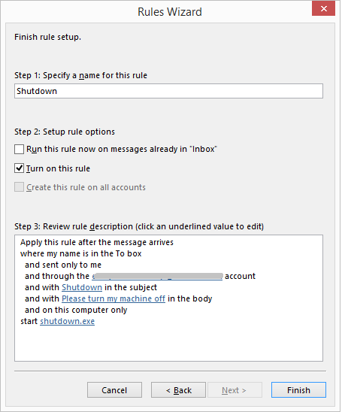

**Step 10:** That’s it. You are done. Now you can turn off you computer remotely.

Triggering Remote Shutdown

When you want to remotely turn off you computer just create a new mail with proper subject and body (as defined in the rule conditions) and send it to the account to which the rule applies. If Outlook is up and running and it receives the mail your computer will be shutdown.

Important

You think you are done? Not yet. With all this effort the computer will be shut down on receipt of a matching email from any email account around the world.

So, go back to Step 6 (a) and select one for the condition *from people or specific group.*Map it to the account you are going to use to send out emails for such Shutdown trigger.

If you like the trick, try to create similar ones to restart, logoff and hibernate your computer. Let us know how it works.

Liked the article? Make sure to check [our previous posts on Outlook](http://www.guidingtech.com/tag/outlook/). We do all sorts of cool and helpful how-tos, guides, lists and more. So if you don’t want to miss those, make sure to[subscribe to our email newsletter](http://www.guidingtech.com/landing/guiding-tech-newsletter/).

*Top Image Credit:*[*free photos & art*](https://www.flickr.com/photos/79818573@N04/10730490594/)

Before You Go...

Just wanted to let you know that [we've got a special eBook on Google Chrome browser, called The Ultimate Chrome Productivity Guide](http://www.guidingtech.com/chrome/guide.html) where we show you how to master Google Chrome to make the most out of it. Make sure you buy it because it is worth much more than the price we're offering it for.

FacebookWhatsAppGoogle+TwitterLinkedInMore

Get Guiding Tech articles delivered to your inbox.

Also get a free ebook when you subscribe.

Top of Form

Your Email



[We will never share your address. Unsubscribe at any time.](http://www.getresponse.com/permission-seal?lang=en)

Bottom of Form