**Volatility as an Asset Class Readings:**

1. **Goldman Sachs: Volatility as an Asset**
   1. Goldman explains how equity index volatility meets the definition of an asset class:
      1. Selling index volatility offers significant, passively generated returns produced by facilitating hedging flow for equity and credit investors
      2. Returns are large enough to justify a nontrivial allocation
      3. Volatility selling tends to outperform long equities in hostile markets, offering appealing diversification benefit
   2. 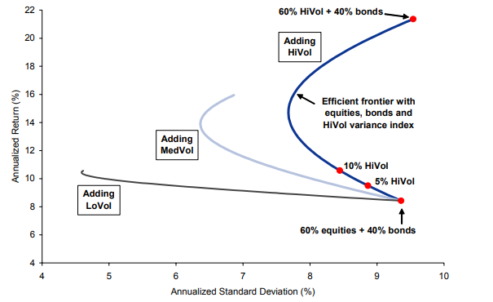Goldman showing how adding a short high volatility trading strategy can add to efficient frontier of a standard equity-bond portfolio
   3. **Big issue with Goldman’s take is that they are only showing benefits of being short volatility. History has shown being short vol can BLOW people up; however, for our project, Goldman’s analysis and use of efficient frontier comparisons is very relevant to us. We can generate portfolios similar to what they did and compare with different allocations of our own ETF**
2. **Stoxx: Volatility as an Asset Class**
   1. Global index provider
   2. Provide indication that use of volatility arbitrage to profit from the risk premium between implied and realized volatilities are important ways to use volatility as an asset class.
   3. Writes that a portfolio mix of volatility and other asset classes, in particular equity to take advantage of negative correlations between volatility and traditional investment markets to smoothen investor’s returns across the business cycle
   4. **Helps us by showing the importance of capitalizing on realized vs implied vol relationships with a mix of other assets. Strategies are extremely general and more theoretical though so we have are actually applying their knowledge**